|  |  |
| --- | --- |
| **Mã đề 6.2.53** | **ĐỀ KIỂM TRA CUỐI HỌC KỲ II**  **Năm học 2022 – 2023**  **Môn:Tiếng Anh – Lớp 6**  *Thời gian làm bài: 60 phút* |

**SECTION A: LISTENING (2 points)**

**Task 1. Listen to Peter talking about his dream house. Circle the correct**

**answer A, B, or C. You will listen TWICE. (1point)**

***1. How will Peter move through his house?(NB)***

A. On foot B. By car C. By train

***2. What will Peter do in his living room?(NB)***

A. Watch films. B. Play computer games. C. Sing a song.

***3. How many swimming pools will there be in Peter’s house?(NB)***

A. One B. Two C. Three

***4. What will be special about Peter’s car?(TH)***

A. It can cook. B. It can swim. C. It can fly.

***5. What are the most modern appliances might his house have?(NB)***

A. a home robot and a smart TV

B. a cooking fridge

C. a home robot and a cooking fridge

**Task 2. Listen to Mr. Wilson talking about tips for three R’s. Fill in each gap**

**with NO MORE THAN TWO WORDS. You will listen TWICE.( 1P)**

|  |  |
| --- | --- |
| **3R’s Actions** | |
| **Reduce** | - (1)………… toys with friends (NB)  - borrow or rent (2)………. and movies (NB)  - buy (3)………….. items (NB) |
| **Reuse** | - should (4)……….water bottle to bring water to school (TH)  - use both sides of the paper |
| **Recycle** | - (5)……………… gifts with used papers (TH) |

**SECTION B: LANGUAGE (2 POINTS)**

**I. Pronunciation**

1. Choose the word whose main stress is placed differently from the others. *(tìm từ có phần trọng âm khác với các từ còn lại)*

A. machine B. perform C. funny D. enjoy (NB)

2. Find the word whose underlined part is pronounced differently from the rest *(Tìm từ có phần gạch chân phát âm khác với các từ còn lại)*

A. house B. cold C. know D. window (NB)

**II. Choose the best option (A, B, C or D) to complete these sentences. (1.6 point)**

3. Turn _____ Disney Channel, Trang. There is a very interesting cartoon on now. (TH)

A. on B. off C. to D. from

4. Da Lat is a …………… and lovely city (NB)

A. peace B. peaceful C. polluted D. awful

5. Are you interested _____ Taekwondo? (NB)

A. of B. about C. at D. in

6. Living in the countryside is more exciting than living in ______ city. (TH)

A. a B. an C. the D. these

7. A: Would you like to drink a cup of tea________ coffee? (VD)

B: Coffee, please.

A. and B. but C. so D. or

8. My mom often __________ aerobics in her free time. (TH)

A. doing B. do C. does D. did

9. A: “__________ do you get up?” - “I get up at six o’clock”. (VD)

A. What time B. Which in

C. How many D. What

10. If we use _________ paper, we will save a lot of trees. (TH)

A. fewer B. less C. more D. much

**SECTION C: READING (2 POINTS)**

**I. Choose the word which best fits each gap.(1P)**

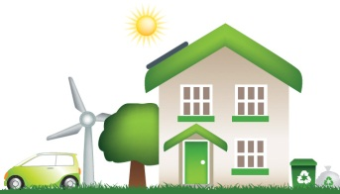**Eco-friendly houses**

How ‘eco-friendly’ is your house? Here are some things that you can do to protect the environment and make the world a better place.

♦ Turn (1) _______ the lights when you are not in a room and don’t leave computersand TVs on standby.

♦ Turn down the heating. If you’re cold, you can put on a jumper!

♦ Put solar panels on the roof. Using energy from the (2)_______ can save a lot of money and electricity.

♦ Don’t keep the (3)________ running when you brush your teeth or wash vegetables.

♦ Don’t (4)_______ away things you don’t want anymore. Remember the three Rs - reuse, repair and recycle.

♦ Grow your own vegetables in your garden - it’s eco-friendly and (5)________.

Saving the planet starts at home and it could start as soon as you get home today!

1. A. on B. off C. up (NB)

2. A. coal B. wind C. sun (TH)

3. A. tap B. pipe C. knob ( TH)

4. A. bring B. throw C. give (NB)

5. A. modern B. healthy C. useful (TH)

**II. Read the passage and choose the correct answer for each question (1 point)**

Technology will allow homes in the future to be "smart." Appliances will communicate with each other-and with you. Your stove, for instance, will tell you when your food is cooked and ready to eat. Refrigerators will suggest recipes based on food items you already have.

The technology is possible because of **tiny** information-storing devices called RFID (radio-frequency identification) chips. People already use them to keep track of pets and farm animals. Future RFID chips will store information about all the items in your cabinets. For example, they will record the date that you bought each item. Other devices will "read" this information using radio waves. When you need more food, your cabinets will tell you to buy it.

***1. How will the future houses be? (TH)***

A. more furnished

B. more animal-friendly

C. more hi-tech

D. more traditional

***2. What can refrigerators of smart homes do?(TH)***

A. give advice about what to eat and how to cook

B. cook food

C. suggest when the food is ready to eat

D. communicate with refrigerators of other homes

***3. What is the function of RFID chips? (NB)***

A. They look after pets.

B. They create new information.

C. They entertain house owners.

D. They keep information.

***4. What does the word tiny likely mean? (TH)***

A. big C. rich

B. small D. enormous

***5. How can information be read? (NB)***

A. using radio waves C. using a cabinet

B. using chips D. using farm animals

**SECTION D: WRITING (2 POINTS)**

**I. Find out the mistake in each following sentence. (0.4 point)**

1. If we planted more trees, we will have more oxygen to breathe (NB)

A B C D

2. We might to have robots to cook our meals. (NB)

A B C D

**II. Rewrite the following sentences as directed ( using the suggested words) so that the meanings stay the same. (0.6 pt)**

3. How beautiful the house is! (VD)

=> What…………………………………………………………!

4. Nobody in my family is older than my grandmother. (VD)

=> My grandmother ………………………………………………

5. There will be many robots in my future house to do housework (VD)

=> My future house ………………………………………………..

**III. Make sentences using the words and phrases given.(1P)( VD)**

1. Not/ throw/ plastic bags/. (VDC)

=> ……………………………………………………………………………

2. Playing/ volleyball/ interesting. (VDC)

=> ………………………………………………………………………………

3. If/ we/ plant/ trees/ air / fresher. (VDC)

=> ……………………………………………………………………….

4. You/ turn off/ lights/ before/ leave/ room. (VDC)

=> ……………………………………………………………………………….

5. Yesterday/ he/ go/ gym /with /me. (VDC)

=> ………………………………………………………………………………

**SECTION E. SPEAKING (2POINTS)**

**1. Introduction: (NB) (0.5pt)**

Introduce yourself with basic information (name, class, age, hobby, family, etc.)

**2. Topic Speaking. (TH, VD)**

**Each of you will now receive a card. On the card there are some questions. You should base on the questions to talk about the topic you choose. (1 point)**

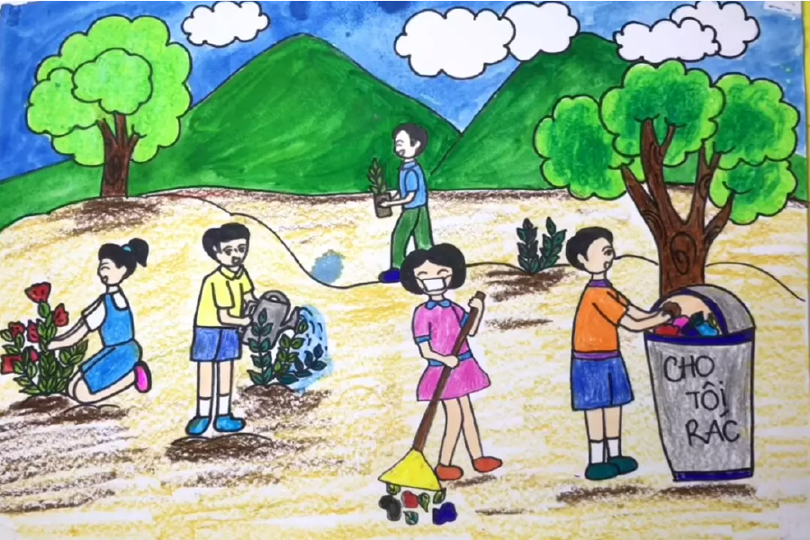

**3. Answer further questions (0.5 point)**

a. What do you do to keep your school green?

b. How do you save water at home?

c. What old items can you recycle?

d. Why do we need to protect the environment?

**ANSWER KEY**

**SECTION A: LISTENING (2 points)**

***Task 1. Listen to Peter talking about his dream house. Circle the correct***

***answer A, B, or C. You will listen TWICE. (1P)***

1.C 2. A 3. B 4. C 5.C

***Task 2. Listen to Mr. Wilson talking about tips for three R’s. Fill in each***

***gap with NO MORE THAN TWO WORDS. You will listen TWICE.***

1. exchange 2. books 3. reusable 4. reuse 5. Wrap

**SECTION B: LANGUAGE (2 POINTS)**

**I.Pronunciation *(0.4 point)***

1. C 2. A

***II. Choose the best option (A, B, C or D) to complete these sentences. (1.6 point)***

3. A. 4. B. 5. D. 6. C. 7. D. 8. C. 9.A 10. B

**SECTION C: READING (2 POINTS)**

***I. Choose the word which best fits each gap.(1P)***

1.B. 2. C 3. A. 4.B. 5.C.

***II. Read the passage and choose the correct answer for each question (1 point)***

***1.*** C. ***2.*** A. ***3.*** D. ***4.*** B. ***5.*** A.

**SECTION D: WRITING (2 POINTS)**

***I. Find out the mistake in each following sentence. (0.4 point)***

1. B 2. B

***II. Rewrite the following sentences as directed so that* *the meanings stay the same. (0.6 pt)***

3. What a beautiful house!

4. My grandmother is the oldest person in my family

5. My future house will have many robots to do housework

***III. Make sentences using the words and phrases given.(1P)( VD)***

1. Don’t throw plastic bags away.

2. Playing volleyball is very interesting.

3. If we plant trees, the air will be fresher.

4. You should turn off the lights before leaving room.

5. Yesterday he went to the gym with me.

**SECTION E. SPEAKING (2POINTS)**

**1. Introduction** (0.5 point)

Introduce yourself with basic information (name, class, age, hobby, family, etc.)

**2. Topic Speaking.**

**Each of you will now receive a card. On the card there are some questions. You should base on the questions to talk about the topic you choose. (1 point)**

**3. Answer further questions (0.5 point)**

Teachers base on students' answers to give appropriate point

**\* Tape script (Listening)**

**Part 1**

Peter: My dream house will be a huge one. There will be a train to take me

through it. The living room will be as large as a cinema because I love watching

films. I might watch films from other planets! Oh, and my house will have one,

no, two swimming pools and three puppy rooms. I might have the most modern

appliances in my house, like a home robot and a cooking fridge. I will have the

nicest and fastest flying car in the world. Every day, I will fly in my car to school.

It’ll be awesome!

**Part 2**

Mr. Wilson: ... It’s never too early to practice three R’s: Reduce, Reuse, and Recycle.

Here’s how. First, reduce. You can exchange your toys with friends. Instead of

buying books and movies, borrow them or rent them. When you are shopping, buy

reusable items, such as refillable pens, or rechargeable batteries. Second, reuse.

You should take a reusable water bottle to school instead of a plastic one. Use both

sides of the paper whenever you can. Third, recycle. Before you throw something

away, check to see if it can be recycled. For example, you can wrap presents with

used papers. Practice three R’s and save the environment!