**CHU VAN AN** Primary School.

**THE SECOND SEMESTER EXAM**

**Time : 35 minutes**

Class: 3..........

Name:..........................................

|  |  |  |  |  |  |  |  |  |  |  |
| --- | --- | --- | --- | --- | --- | --- | --- | --- | --- | --- |
| **Mark** | **Listening** | | | | **Reading** | | **Writing** | | **Speaking** | **Total** |
| Q.1 | Q2 | Q.3 | Q4 | Q5 | Q6 | Q7 | Q.8 |
|  |  |  |  |  |  |  |  |  |  |

**Part I: LISTENING**

**Question 1. Listen and tick** **(1m)**

**1**.

**2**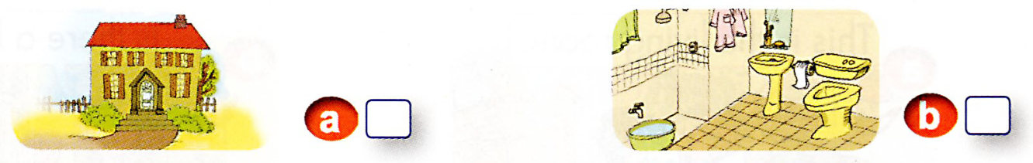

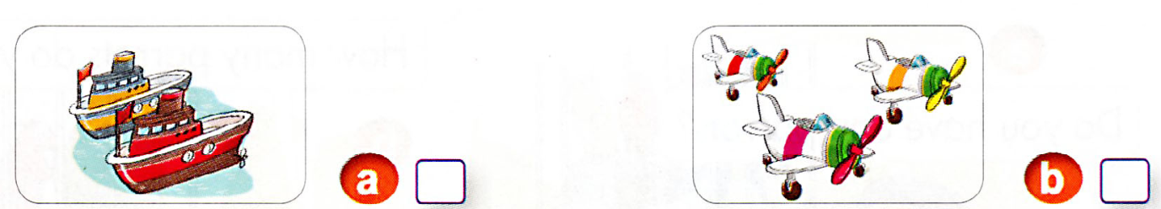

**3**.

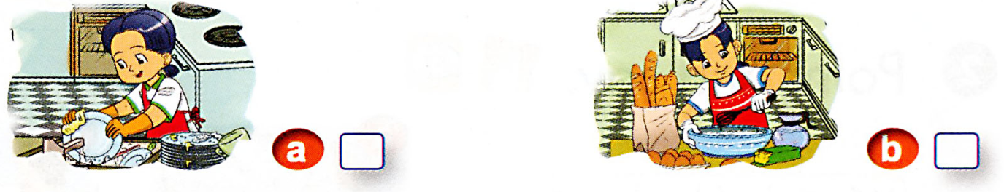

**4.**

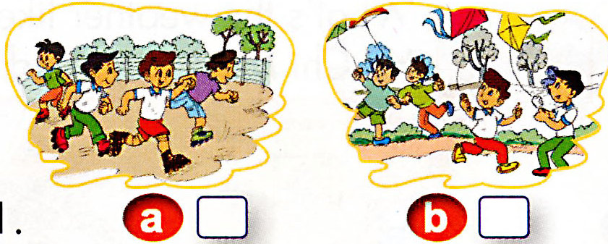

**Question 2.** **Listen and draw the line.(1m)**

|  |  |  |  |
| --- | --- | --- | --- |
| **1.** | **2.** | **3.** | **4** |
|  |  |  |  |

**Question 3: Listen and write True or False ( T) (F)(1m)**

|  |  |  |  |
| --- | --- | --- | --- |
|  |  |  |  |
|  |  |  |  |

**Question 4: Listen and write: (1m)**

1.My sister is ……………

2.Linda is ……………….in her room.

**Part II: READING and WRITING**

**Question 5: Look ,read and complete:(1m)**



It’s (1)………………………and windy today. My friends and I are in the park.



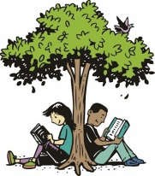TONY is playing the (2)….…………………..While LAN is…………...

Under the tree, PETER and I are (4)………………………….…. books.

**Question 6: Read and match: (1m)**

|  |  |  |
| --- | --- | --- |
| A | B | Answer |
| 1. Do you like toys? | a. I have two dogs | 1. |
| 2.What’s the weather like? | b. Yes, I do | 2. |
| 3. How many dogs do you have? | c. I’m cooking | 3. |
| 4. What are you doing? | d. It’s sunny | 4. |

**Question 7: Read and Write Yes or No (1m)**

|  |  |
| --- | --- |
| 1. Nam is cleaning the floor. | 1. Mai has three dogs. |
| 3. The cat is on the bed. | 4.They are skating. They are skating. |

**Question 8: Reorder the letters(1m)**

|  |  |  |  |
| --- | --- | --- | --- |
| Sunyn  → ………….. | Plena  → ……………….. | Rabtib  → …...…………... | Ranyi  → ……………..… |

**Part 3: SPEAKING (2ms)**

**Part 1: Get to know each other.**

1. What’s your name?
2. How old are you?
3. Do you like pets?

# Part 2: Talk about a pet.

The teacher asks the student to choose one of the pictures and answer the following questions:

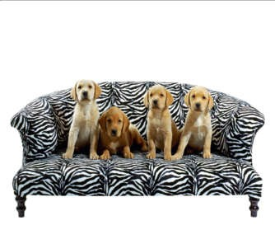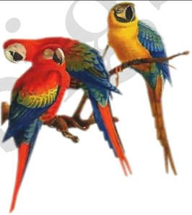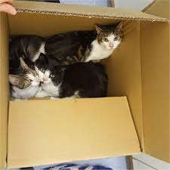

1. What are they?
2. How many goldfish/ rabbits/ dogs/ parrots/ cats are there?
3. Tell me five pets do you know?
4. Where are they?

# Part 3: Describe the picture.

The examiner says, *“Now you have 30 seconds to look at the picture.”*

*The examiner asks the student three questions below:*

1. How many children are there in the picture?
2. What are they doing?
3. What do you usually do with your friends at weekends?

**--- THE END OF THE TEST --**