Period
LESSON PLAN
TIẾNG ANH 10 FRIENDS GLOBAL
UNIT 1: FEELINGS
LESSON 1E: ADJECTIVE ENDINGS
I. OBJECTIVES:
By the end of the lesson, Ss will be able to:
1. Knowledge:
- differentiate adjectives ending in -ed and adjectives in -ing
- Grammar: How + adjective for exclamations
2. Ability:
- main skills: reading and writing skills
- sub skills: listening and speaking skills
- Know how to use different adjectives ending in -ing and -ed prescisely
3. Quality:
- have positive attitude in English language learning so that they can participate enthusiastically in all classroom activities, especially with the topic conducted by the teacher
- keen on studying English
II. TEACHER AIDS AND LEARNING MATERIALS:
Lesson plan, PPT slides, student’s book, workbook, notebook, personal computer (if any), projector/TV, speakers, IWB software.
III. PROCEDURES:
A. Warm-up (5’)
a) Objective: Introduce the new lesson and set the scene for Ss to acquire new language; get students' attention at the beginning of the class by means of enjoyable and short activities as well as to engage them in the steps that followed.
b) Content: Game ‘The Best Goalkeeper’
c) Outcomes: Students can gain more confidence and interest in the lesson.
d) Competence: communication, collaboration, guessing
e) Organisation of the activity:
TEACHER’S ACTIVITIES | STUDENT’S ACTIVITIES | CONTENTS
WARM-UP. T-Ss/ S-S/ Indiv  Game ‘The best goalkeeper’  - Call out some students to choose the correct answer. If students choose the right one, the goal keeper can catch the ball. If students get it wrong, the goal keeper cannot do it.  - Ask student to read aloud the sentence and check students’ pronunciation. Give bonus.  - Lead in the today’s lesson ‘The difference between adjectives ending in -ed and -ing’. | - Volunteer to choose the correct answer to get bonus.  - Read the sentence.  - Open the course book page 15. | 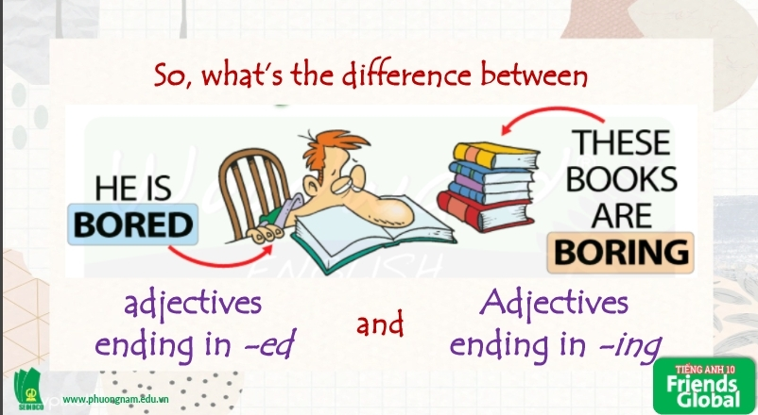    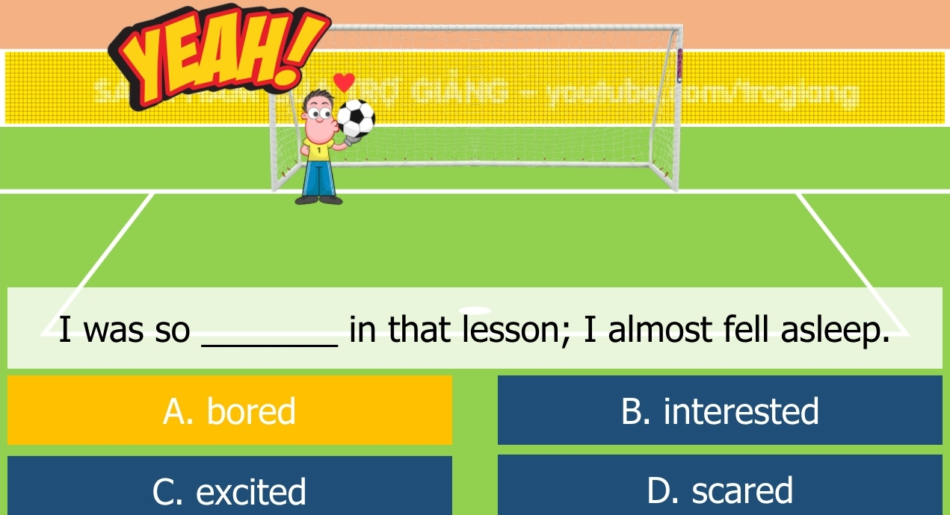  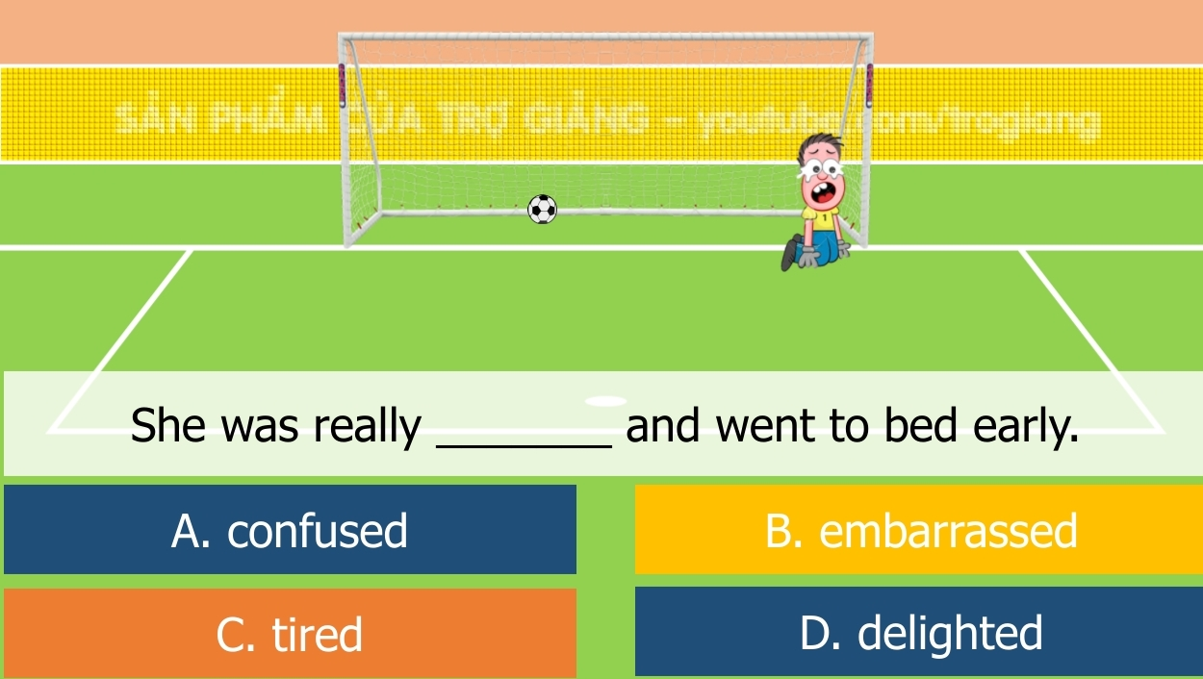

B. New lesson (35’)
- Activity 1: Presentation (10’)
a) Objective: Students get to know some adjectives ending in -ed and -ing in contexts.
b) Content: Underline all the adjectives ending in -ed and -ing in the text.
c) Outcomes: Students know how to pronounce words correctly and differentiate adjectives
d) Competence: communication, presentation, guessing
e) Organisation of the activity:

TEACHER’S ACTIVITIES | STUDENT’S ACTIVITIES | CONTENTS
PRESENTATION. T-Ss/ S-S/ Indiv.  Activity 1 (2’): Underline all the adjectives ending in -ing and -ed in the text.  - Ask students to underline.  - Check the answers.  Activity 2 (4’): Task 2 page 15. Read the text and answer the questions.  - Ask students to read the text answer the questions.  - Check the answers.  Activity 3 (4’): Present the ‘Learn this!’ box and fill in the blanks.  - Introduce ‘Learn this!’ box and ask students to complete the blank spaces.  - Check the answers and emphasize how to use ‘-ed/ -ing adjectives’ | - Listen to the teacher’s instruction and underline adjectives.  - Check the answers with the teacher.  - Read the text and answer the questions.  - Listen carefully and take note.  - Fill in the blanks with correct words.  - Check the answers with the teacher. | Answer:  -ing -ed  tiring, interesting, moving, astonishing, exciting bored, amazed, surprised, delighted  Questions: ‘Who replied to Zoe’s message? When did they reply and from where?’  Answer:  A man replied to the message.  He replied in 2010 from the Netherlands.  Answer:  - -ed  - -ing
- Activity 2 Practice (15’)
a) Objective: Students can answer the questions to critical thinking, and they can finish the tasks in the textbook. Critical thing skills (guessing/ reasoning) and communication can also be practiced.
b) Content: Students choose the correct answers. Then, complete the sentences with words in the brackets.
c) Outcomes: Students read and write, and they can apply the useful language in everyday conversations.
d) Competence: communication, collaboration, presentation
e) Organisation of the activity:
TEACHER’S ACTIVITIES | STUDENT’S ACTIVITIES | CONTENTS
PRACTICE. T-Ss/ S-S/ Indiv.  Activity 1 (6’): Game ‘Doraemon Go Fishing’.  - Invite some students to choose the correct adjective for each statement. Press the clock icon to count the time students have. If the student gets it correct, Doraemon will get a fish. If the student gets the wrong answer, Doraemon will get trash.  - Ask the students to read aloud the sentence and ask them the reason why choosing that answer. If the student cannot answer why, remind them the usage of -ed/ -ing adjectives.  Activity 2 (5’): Task 5 page 15. Complete each pair of sentences with -ed and -ing adjectives formed from the verbs in brackets.  - Ask students to fill in the blank spaces with correct answers. Have students read those pairs aloud.  - Check the answers.  Activity 3 (4’): Present ‘Learn this! How + adjective’ box.  - Introduce ‘How + adjective’ structure. Teach students how to use properly. | - Volunteer to answer.  - Get bonus.  - Read the sentence and explain why the student chose that answer.  - Complete the task.  - Check the answers with the teacher.  - Listen carefully to the teacher.  - Take note and highlight. | 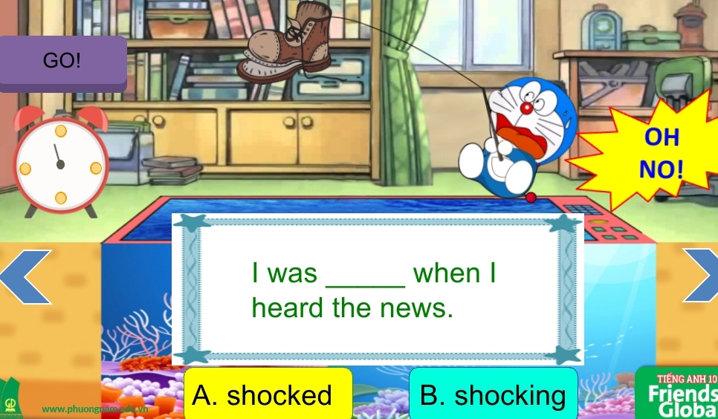  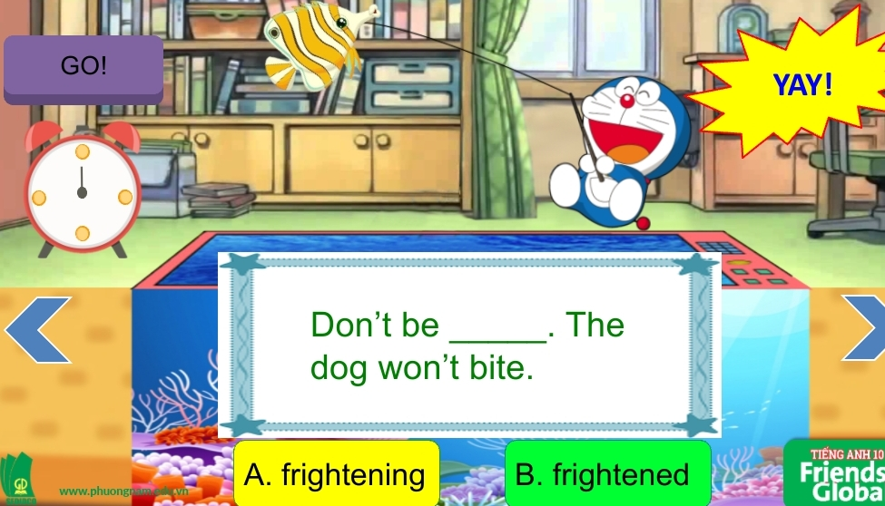  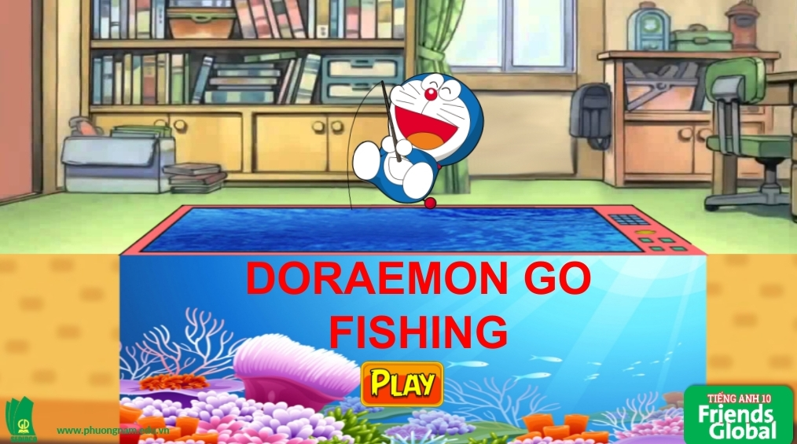  Answers:  - (a) confusing  (b) confused  - (a) embarrassed  (b) embarrassing  - (a) interested  (b) interesting  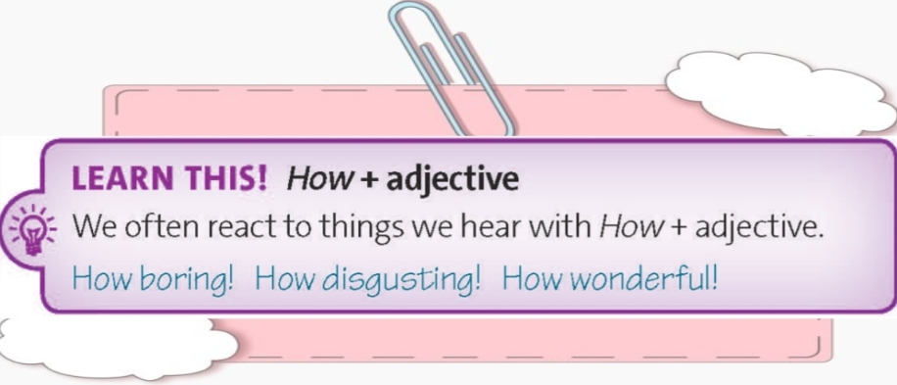

- Activity 3: Outcomes (10’)
a) Objective: Ss work in pairs to ask and answer about some situations in the past.
b) Content: ‘Lucky Number’ Game
c) Outcomes: Ss speak and listen mutually, they can apply the structures they have learnt in their daily conversations.
d) Competence: Collaboration, communication, guessing
e) Organisation of the activity:
TEACHER’S ACTIVITIES | STUDENT’S ACTIVITIES | CONTENTS
PRODUCT. T-Ss/ S-S  Game ‘Lucky Number’  - Ask students to work in pairs and pick a number from 1 to 6 to plan a dialogue with suggestion in each number. Student A makes a sentence using the past simple with hints. Student B reacts to the situations by using ‘How + an -ing adjective’  - Let students discuss with their partners before calling out some pairs to present their ideas. Check students’ pronunciation. After students finish talking, use the wheel to give them points. | - Work in pairs and pick a number to plan a dialogue. Try to use the new expressions properly.  - Volunteer to present their ideas. |   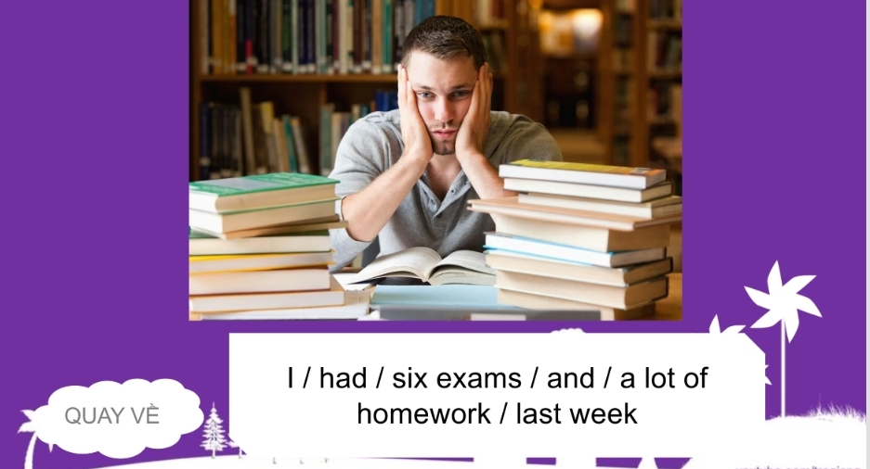  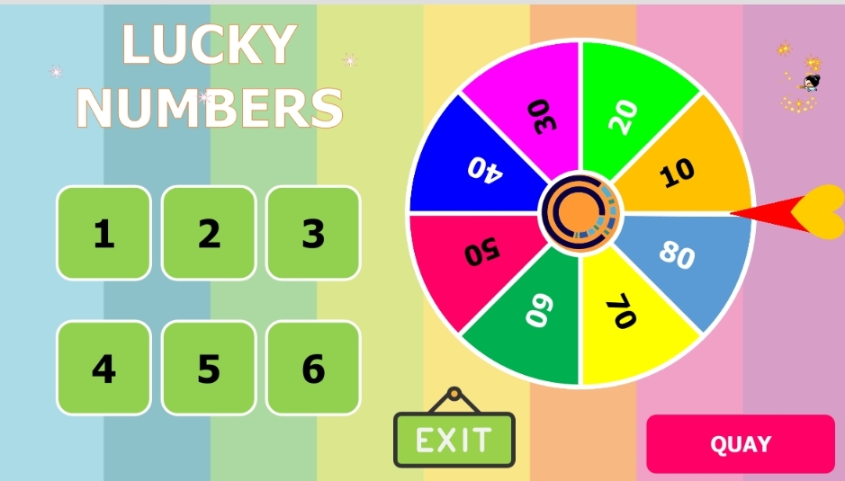
C. Consolidation (3’)
Grammar: The difference between adjectives ending in -ing and -ed, the structure ‘How + adjective’ to react things
D. Homework (2’)
- Learn by heart the structures
- Make sentences about your family using adjectives ending in -ed and -ing
- Do exercise
- Prepare: Unit 1 – F-Grammar (page 14 – SB)

