UNIT 11: SCIENCE TECHNOLOGY

Lesson 1: Getting started – You know what? Great news for students

I. OBJECTIVES
By the end of this lesson, Ss will be able to:
1. Knowledge
- Gain an overview about the topic Science technology
- Gain vocabulary to talk about Science technology
2. Competences
- Develop communication skills and creativity
- Be collaborative and supportive in pair work and teamwork
- Actively join in class activities
3. Personal qualities
- Love talking about themselves and their problems

II. MATERIALS
- Grade 8 textbook, Unit 11, Getting started
- Computer connected to the Internet
- Projector / TV/ pictures and cards
- Phần mềm tương tác hoclieu.vn

Language analysis
Form | Pronunciation | Meaning | Vietnamese equivalent
1. technology(n) | /tekˈnɒlədʒi/ | scientific knowledge used in practical ways in industry, for example in designing new machines | Công nghệ
2. face to face (adj) | /ˌfeɪs tə ˈfeɪs/ | in a way that involves people who are close together and looking at each other | Trực tiếp, mặt đối mặt
3. epidemics (n) | /ˌhəʊm ˈmeɪd/ | a large number of cases of a particular disease or medical condition happening at the same time in a particular community | Đại dịch
4. contact lens (n) | /ˈkɒntækt lenz/ | a thin, curved lens placed on the film of tears that covers the surface of your eye | Kính áp tròng
5. breakout room (n) | /ˈbreɪkaʊt/ | a small meeting room or a separate part of an internet meeting where a small group can discuss a particular issue before returning to the main meeting | Phòng học chia nhỏ, chia nhóm
6. invention (n) | /ɪnˈvenʃn/ | ​a thing or an idea that has been invented | Phát minh

Assumption
Anticipated difficulties | Solutions
Ss may not know enough vocabulary relating to the topic to understand the conversation. | Provide the necessary vocabulary for students to understand the conversation.

III. PROCEDURES
1. WARM-UP (5 mins)
a. Objectives:
- To create an active atmosphere in the class before the lesson;
- To review the previous unit;
- To lead into the new unit.
- Review the previous unit before Ss open their books:
b. Content:
- Have the game HIDDEN WORD to create a friendly and relaxed atmosphere to inspire Ss to warm up to the new class.
c. Expected outcomes:
- Having a chance to speak English and focus on the topic of the lesson.
d. Organisation

TEACHER’S AND STUDENTS’ ACTIVITIES | CONTENTS
GAME: HIDDEN WORD  - T introduces the rule of the game:  + Read the questions or situations  + Find a word to answer each question or fill in each situation.  +  - T leads to the new unit. Write the unit title SHOPPING on the board. Ask Ss to guess what they are going to learn about in this unit. | 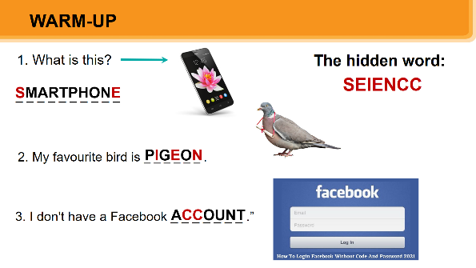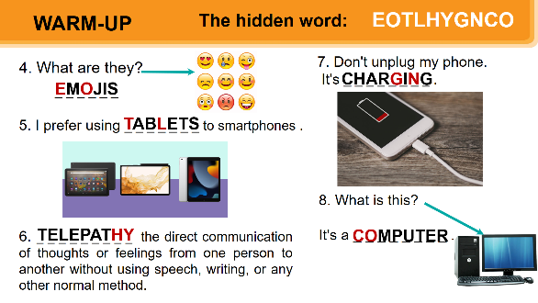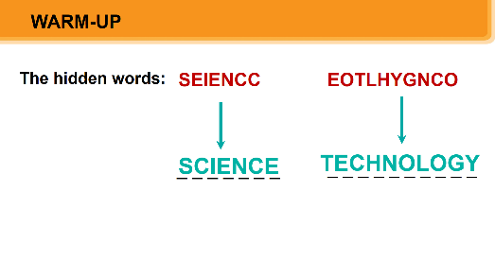  UNIT 11: SCIENCE TECHNOLOGY  Lesson 1: Getting started –  You know what? Great news for students

e. Assessment
- T checks ss’ vocabulary and give feedback

2. ACTIVITY 1: PRESENTATION (5 mins)
a. Objectives:
- To set the context for the introductory dialogue;
- To introduce the topic of the unit.
b. Content:
- Learn some new words. Read the conversation and find out new words.
c. Expected outcomes:
- Know more new words
- Understanding the conversation; topic of the lesson,…
d. Organisation

TEACHER’S AND STUDENTS’ ACTIVITIES | CONTENTS
Vocabulary pre-teaching  - Teacher introduces the vocabulary.  - Teacher explains the meaning of the new vocabulary by pictures/ explanation/ examples.  - Teacher reveals that these seven words will appear in the reading text and asks students to open their textbooks to discover further. | 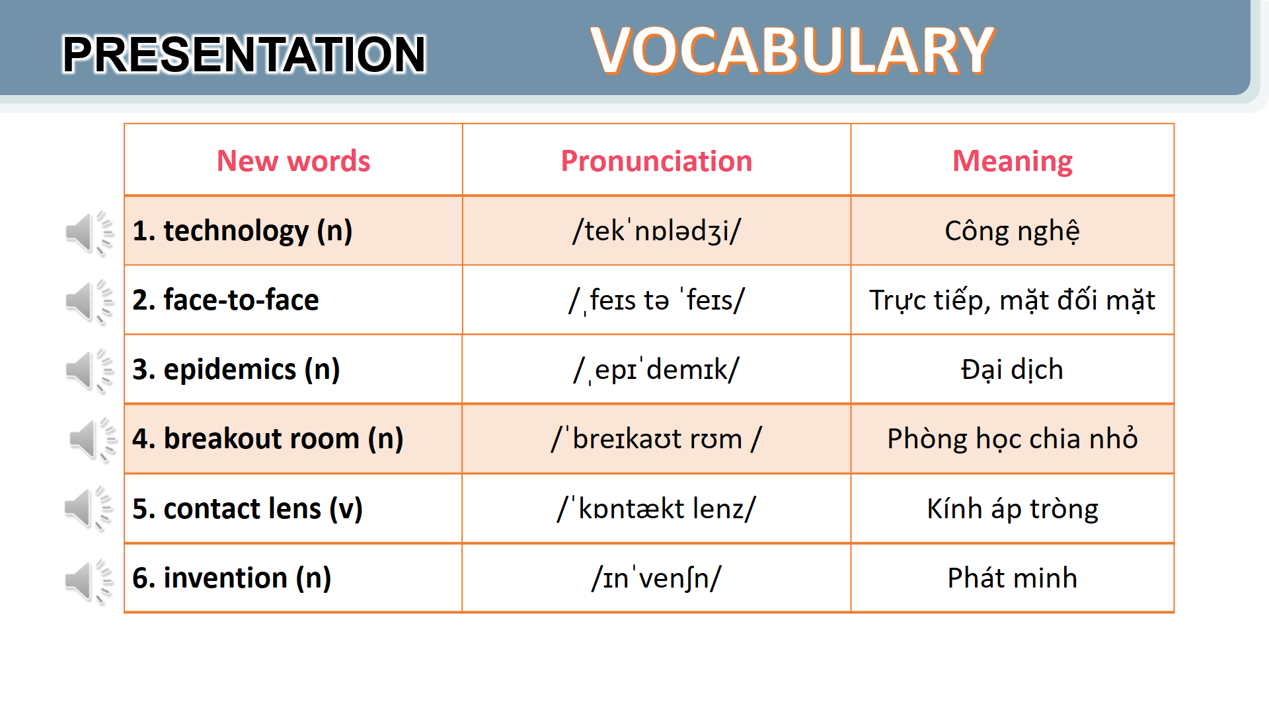
e. Assessment
- Teacher checks students’ pronunciation and gives feedback.

3. ACTIVITY 2: PRACTICE (25 mins)
a. Objectives:
- To help Ss read for specific information about the conversation.
- To help Ss learn words and phrases related to different modern technologies;
- To help Ss have more information about inventions.
b. Content:
- Listen and read the conversation, Labelling the pictures, Sentence completing activity.
- To learn some more words about different modern technologies and inventions.
c. Expected outcomes:
- Know more new words about different modern technologies and inventions, understand the conversation; topic of the lesson.
d. Organisation

TEACHER’S AND STUDENTS’ ACTIVITIES | CONTENTS
Task 1. Listen and read. (6 mins)- IW-PW
Set the context:  - Teacher has Ss to look at the pictures in the book and answer the questions.  - T encourages ss to answer the questions, but doesn’t confirm their answers.  - Teacher plays the recording for ss to listen and read along. Then invite some pairs of Ss to read the conversation aloud.  - T refers to the questions previously asked and confirms the correct answer. | Questions:  - Who are the girl and the boy?  - Where do you think they are?  - What might they be talking about?  - What can you see in the bubble?  Suggested answer:  They are Minh and Ann. They are at school.  They are discussing their online class / robot teacher.
Task 2. Read the conversation again and tick (v) T (True) or F (False) (6 mins)-PW
- Ask Ss to work in pairs to read the conversation.  - Ask them to underline the key words and phrases in the statements. Then have pairs work for one or two minutes to check if the statements are true or false.  - Have Ss read out the statements and say if the statements are true or false.  - Make sure they pronounce the words correctly.  - Check the answers as a class. | Answer key:  1. F 2. T 3. F 4. T 5. T
Task 3. Label each picture with a phrase from the box. (6 mins)- PW
- Ask Ss to say the phrases aloud. Make sure they pronounce the phrases correctly.  - Ask Ss to work in pairs to label the pictures with the appropriate words or phrases.  - Check the answers as a class. | Answer key:  1. computer screen 2. 3D contact lenses  3. online class 4. robot teacher  5. breakout rooms  6. Internet connection
Task 4. Complete the sentences, using the phrases in 3. (7 mins)- IW
- Ask Ss to work independently to complete each sentence with a phrase from the box in 3.  - Allow Ss to refer to the pictures and phrases in Activity 3 or the conversation if needed.  - Check the answers as a class.  - Ask several Ss to read aloud the full sentences. Correct Ss’ pronunciation if needed. | Answer key:  1. computer screen  2. breakout rooms  3. robot teacher  4. online class  5. 3D contact lenses

e. Assessment
- Teacher checks students’ exercise individually and give feedback.

4. ACTIVITY 3: PRODUCTION (5 mins)
a. Objectives:
- To introduce some inventions
- To create a fun atmosphere in the class.
b. Content:
- Find out the things that were invented in the given years
c. Expected outcomes:
- Ss can find out the things that were invented in the given years
d. Organisation

TEACHER’S AND STUDENTS’ ACTIVITIES | CONTENTS
Task 5: Quiz: Do you know what things were invented in these years? Work in pairs and find out.  - Ask Ss to work in pairs to read the information and to make guesses.  - Encourage Ss to guess as many things as possible.  - Ask some Ss to report things they have thought of / work out. | 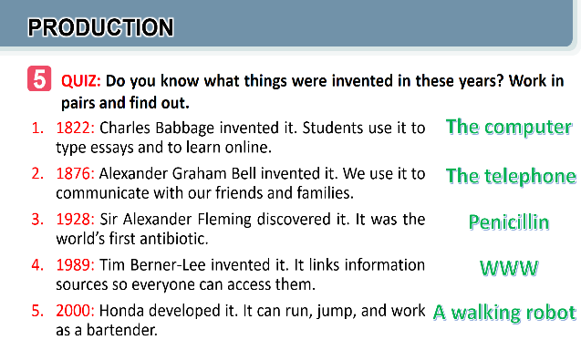
e. Assessment
- T and other Ss listen and comment.
5. CONSOLIDATION (5 mins)
a. Wrap-up
- Ask Ss to use lexical items related to science and technology
- If there is an overhead projector in the classroom, show the dialogue, highlight the key words related to the topic.
b. Homework
- Name technologies and inventions they have learnt about in the lesson.
- Learn the new words and phrases by heart.
- Do Exercise ………..page ……Unit 11/Workbook

BOARD PLAN

Date of teaching
Unit 8: Shopping
Lesson 1: Getting started
* Vocabulary
1. open-air market (n)
2. home-grown (adj)
3. home-made (adj)
4. bargain (v)
5. farmers’ market (n)
6. price tag (n)
7. convenience store (n)
* Practice:
Task 1: Listen and read.
Task 2: Mai and Alice mentioned four places where they can buy things. Complete the list.
Task 3: Match the types of markets with the features.
Task 4: Complete the sentences with words and phrases from the box.
Task 5: Game: Listing.
*Homework

UNIT 11: SCIENCE AND TECHNOLOGY

Lesson 2: A closer look 1

I. OBJECTIVES
By the end of this lesson, Ss will be able to:
1. Knowledge
- Identify some nouns related to the topic of science and technology and some new technologies.
- Identify some new verb phrases that used to talk about inventions, discoveries, creations and development
- Identify sentence stress.
2. Competences
- Develop competencies of communication, cooperation, and self-management.
- Be collaborative and supportive in pair work and teamwork
- Actively join in class activities
3. Personal qualities
- Raise ss’ knowledge of science and technology
- Have good attitude to science and technology
II. MATERIALS
- Grade 8 textbook, Unit 11, A closer look 1.
- Computer connected to the Internet
- Projector / TV/ pictures and cards
- Phần mềm tương tác hoclieu.vn

Language analysis
Form | Pronunciation | Meaning | Vietnamese equivalent
1. face recognition (n) | /feɪsˌrekəɡˈnɪʃn/ | technology that allows a computer to identify a person by their face | Công nghệ nhận biết/ diện gương mặt
2. experiment (n) | /ɪkˈsperɪmənt/ | a scientific test that is done in order to study what happens and to gain new knowledge | Thí nghiệm
3. eye-tracking (n) | /’ai ,trækɪŋ/ | technology that follows the movements of eyes, especially by using special electronic equipment | Công nghệ dõi (cử động) mắt
4. fingerprint scanner(n) | /ˈfɪŋɡəprɪnt ˈskænə(r)/ | a type of technology that identifies and authenticates the fingerprints of an individual in order to grant or deny access to a computer system or a physical facility. | Máy quét vân tay
5. digital communication (n) | /ˈdɪdʒɪtl /kəˌmjuːnɪˈkeɪʃn/ | the use of online tools like email, social media messaging and texting to reach other individuals or a specific audience in order to share a message. | Giao tiếp kỹ thuật số

Assumption

Anticipated difficulties | Solutions
Ss may lack vocabulary related to the topic of science technology, new technologies, and verb phrases that used to talk about inventions, discoveries, creations and development, so they may have difficulty completing the tasks | T is willing to provide them with enough vocabulary related to the topic

III. PROCEDURES
1. WARM-UP (5 mins)
a. Objectives:
- To create an active atmosphere in the class before the lesson;
b. Content:
- Have some warm-up activities to create a friendly and relaxed atmosphere to inspire Ss to warm up to the new class.
c. Expected outcomes:
- Having a chance to speak English and focus on the topic of the lesson.
d. Organisation

TEACHER’S AND STUDENTS’ ACTIVITIES | CONTENTS
Game: Labelling the pictures  - Give Ss a few minutes to play a game. Have Ss play in two groups.  - Give Ss pictures of things and strips of paper with phrases including computer screen, breakout rooms, robot teacher, online class, 3D contact lenses, connection.  - Ask teams to stick the phrases to the right pictures.  - The team with the most correct answers wins.  - Ask Ss to open their books to page 116. | Key:  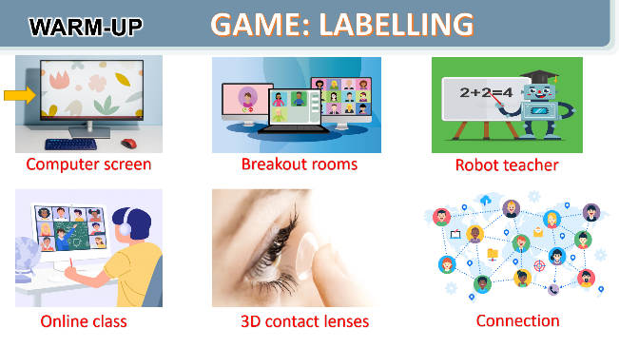
e. Assessment
- T checks ss’ vocabulary and give feedback

2. ACTIVITY 1: PRESENTATION (6 mins)
a. Objectives:
- To introduce visually some nouns related to the topic of science and technology
b. Content:
- Learn some nouns related to new technologies.
c. Expected outcomes:
- Know more new nouns related to new technologies.
d. Organisation

TEACHER’S AND STUDENTS’ ACTIVITIES | CONTENTS
I. VOCABULARY  Task 1. Write the words and phrases under each picture.- PW  - Have Ss read aloud the words / phrases in the box.  - Ask Ss to work in pairs to look at the pictures and describe the pictures.  - Have pairs write the correct words / phrases under the pictures. Explain the meaning of the new words / phrases in Vietnamese, if needed.  - Invite Ss to take turns to read out their answers.  - Correct their pronunciation if needed.  - Check the answers as a class. | I. VOCABULARY  Task 1:  Key:  1. digital communication  2. face recognition  3. eye-tracking  4. experiment  5. fingerprint scanner  6. video conferencing  New words:  1. face recognition (n): Công nghệ nhận biết gương mặt  2. eye-tracking (n): Công nghệ theo dõi cử động mắt.  3. experiment (n): thí nghiệm  4. fingerprint scanner (n): Thiết bị quét vân tay.  5. digital communication (n): Giao tiếp kỹ thuật số
e. Assessment
- Teacher checks students’ pronunciation and gives feedback.

3. ACTIVITY 2: PRACTICE (25 mins)
a. Objectives:
- To introduce some new verb phrases that are used to talk about inventions, discoveries, creation and development
- To allow Ss to use the learnt words / phrases in different contexts.
- To help Ss be aware of which words in a sentence should be stressed, and which are not;
- To help Ss say sentences with the correct stress.
- To help Ss be aware of the words to stress in a sentence;
- To help Ss practise saying sentences with the correct stress.
b. Contents:
- Use the nouns to go with the verbs that are used to talk about inventions, discoveries, creation and development
- To say sentences with the correct stress; Listen and repeat.
c. Expected outcomes:
- Knowing how to use learned words/phrases in context.
- Say sentences with the correct stress.
d. Organisation

TEACHER’S AND STUDENTS’ ACTIVITIES | CONTENTS
Task 2. Choose the option that best completes each phrase. (6 mins)-IW
- Ask Ss to read aloud the given verbs and nouns.  - Explain the verbs and if possible, give some examples. Also explain the verbs in Vietnamese.  - Ask Ss to work in pairs to choose the correct options to complete the phrases.  - Check the answers as a class.  - Have some Ss read aloud the phrases.  - Correct Ss’ pronunciation if necessary.  - Also ask Ss to add more words / phrases to the verbs to make up other phrases. This way, T can broaden Ss’ vocabulary if they are ready. | -To create something = To bring into existence out of nothing.  E.g.: She created a new robot.  - To invent = to design a new process or mechanism. E.g: He invented a new electric cooker.  - To develop = grow gradually or become bigger, stronger, etc.  E.g.: They developed a relationship / a method to work better / a computer programme.  - To discover = to find somebody/something that was hidden or that you did not expect to find.  E.g.: Galileo discovered that Jupiter had moons.  Answer key:  1. A  2. A  3. B  4. B
Task 3. Complete the sentences with the words and phrases from the box. (7 mins)- IW
- Ask Ss to work individually to choose the correct answer for each sentence.  - Have Ss swap their answers with partners. Then check the answers as a class.  - Also ask some Ss to read out their answers. Then have some Ss read the sentences aloud as a class.  Correct Ss’ pronunciation if necessary. | Answer key:  1. discovered  2. invented  3. created  4. experiments  5. fingerprint scanner
Task 4. Listen and repeat the words. Pay attention to the sounds /sp/ and /st/.(6 mins)- IW
- Have Ss listen to the recording once first. Ask them to pay attention to the stressed syllables.  - Play the recording again for them to listen and repeat each word as a class, then as individuals. Play the recording as many times as possible.  - Then ask Ss to read out the sentences. Correct their pronunciation and stress if needed.  - Introduce the rules in the Remember! Box: stress sentences, which words in a sentence should be stressed, and which are not.  - Remind Ss of the words that receive stress in a sentence, which they leant in Unit 11 Tiếng Anh 7. | 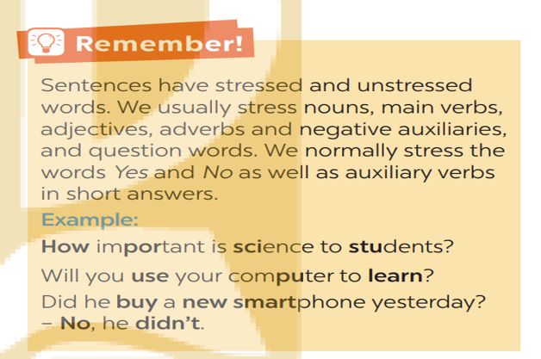
Task 5. Listen and repeat the sentences. How many stressed words are there in each sentence. (6 mins)-IW
- Play the recording for Ss to listen and repeat each sentence after the recording. Correct Ss’ pronunciation if necessary.  - Ask Ss to count the number of stressed words in each sentence. Check if Ss have counted enough stressed words in each of the sentences.  - Call on some Ss to read the sentences. Play the recording multiple times if necessary. | - He is an inventor.  - We won’t have a robot teacher next year.  - She likes learning online.  - Was she checking attendance when you came? - No, she wasn’t.  - What did he invent?  Key: 1. 1 2. 5 3. 3 4. 6 5. 2
e. Assessment
- Teacher checks students’ answers and their pronunciation and gives feedback.
4. ACTIVITY 3: PRODUCTION (5 mins)
a. Objectives:
- To test students' imitation and memorizing ability of stress sentence.
b. Content:
- To practice reading the sentences with their stress correctly; Listen and repeat
c. Expected outcomes:
- Remember the sentences and repeat it correctly in stress and content.
d. Organisation
TEACHER’S AND STUDENTS’ ACTIVITIES | CONTENTS
GAME: BROKEN TELEPHONE-GW
- Teacher explains the rule:  RULE:  - Gather 3 or more players.  - The person starting the game thinks of SENTENCE and whispers it into the next player’s ear only once, with no repeats allowed.  - That listener tries to correctly repeat that SENTENCE into the next player’s ear (Paying attention to the sentence’s stress). The last person in the line or at the end of the circle repeats the SENTENCE  - Allow a moment for giggles if the message is “broken” or changed. The player who started announces the correct SENTENCE  - Players take turns thinking of the next SENTENCE to pass through a whisper. | 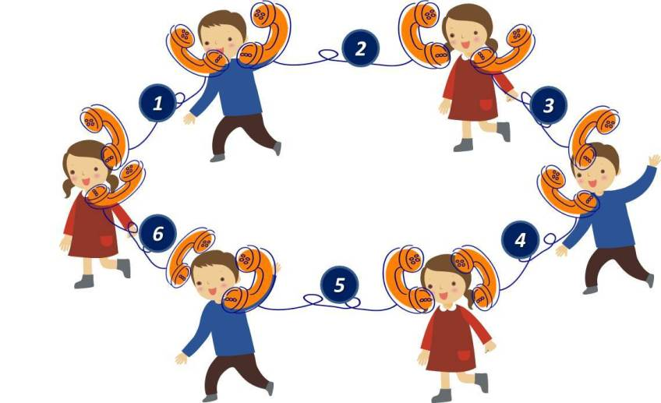

e. Assessment
- T and other Ss listen and give corrections to others’ pronunciation
4. CONSOLIDATION (4 minutes)
a. Wrap-up
- Ask Ss to summarise what they have learned in the lesson.
- Ask them to list words and phrases related to new technologies.
- Ask them to list new verb phrases that are used to talk about inventions, discoveries, creation, and development.
- Ask them to retell the knowledge of sentences stress

b. Homework
- Learn by heart words and phrases related to new technologies and new verb phrases that are used to talk about inventions, discoveries, creation, and development.
- Learn by heart “REMEMBER” about sentence stress
- Do Exercise ………..page ……Unit 11/Workbook

BOARD PLAN
Date of teaching
Unit 11: Science and technology
Lesson 2: A closer look 1
I. Vocabulary
1. face recognition (n): Công nghệ nhận biết gương mặt
2. eye-tracking (n): Công nghệ theo dõi cử động mắt.
3. experiment (n): thí nghiệm
4. fingerprint scanner (n): Thiết bị quét vân tay.
5. digital communication (n): Giao tiếp kỹ thuật số
* Practice:
Task 1: Write a word or phrase from the box under each picture.
Task 2: Choose the option that best completes each phrase.
Task 3: Complete the sentences with the words and phrases from the box.
II. Pronunciation
Task 4: Listen and repeat the sentences. Pay attention to the bold syllables.
Task 5: Listen and repeat the sentences. How many stressed words are there in each sentence?
*Homework

UNIT 11: SCIENCE AND TECHNOLOGY

Lesson 3: A closer look 2
I. OBJECTIVES
By the end of this lesson, Ss will be able to:
1. Knowledge
- identify what direct speech and reported speech are.
- realize some differences between a direct speech and a reported speech (statements).
- be aware of changes in tenses, pronouns, time, and place expressions.
2. Competences
- Develop competencies of communication, cooperation, and self-management.
- Be collaborative and supportive in pair work and teamwork
- Develop self-study skills
- Actively join in class activities
3. Personal qualities
- Have a positive attitude to using reported speech in daily life.
II. MATERIALS
- Grade 8 textbook, Unit 11, A closer look 2.
- Computer connected to the Internet
- Projector / TV/ pictures and cards; phần mềm tương tác hoclieu.vn
Language analysis
 | Direct speech | Reported speech
1. Definition | - a report of the exact words used by a speaker or writer.  - usually placed inside quotation marks and accompanied by a reporting verb, signal phrase, or quotative frame. | - the form of speech used to convey what was said by someone at some point of time.
2. Changes in tenses | 1. Present simple  2. Present continuous  3. Present perfect  4. Past simple  5. Past continuous  6. Past perfect  7. will  8. can  9. may  10. must | 1. Past simple  2. Past continuous  3. Past perfect  4. Past perfect  5. Past perfect continuous  6. Past perfect  7. would  8. could  9. might  10. had to
3. Changes in pronouns  (according to situations) | 1. I/ me  2. We/ us  3. You  4. He/she/it/ they…  5. this  6. these | 1. He/She/ him/her  2. They/ them  3. I/me  4. He/she/it/ they…  5. that  6. those
4. Changes in time and place expressions | 1. now  2. today  3. ago  4. tomorrow  5. this week  6. yesterday  7. last week  8. here | 1. then  2. that day  3. before  4. the following day/ the next day  5. that week  6. the day before/ the previous day  7. the week before/ the previous week  8. there
5. Structures | S1 said: “S2 + V2,”  “S2 + V2,” S1 said | S1 + said/ told sb + (that) +  S2 + V2 lùi thì

Assumption
Anticipated difficulties | Solutions
Ss may get confused about the changes from direct speech to reported speech. | T should be ready to find examples and give clear explanations to the students.

III. PROCEDURES
1. WARM-UP (5 mins)
a. Objectives:
- To create an active atmosphere in the class before the lesson;
b. Content:
- Have some warm-up activities to create a friendly and relaxed atmosphere to inspire Ss to warm up to the new class.
c. Expected outcomes:
- Having a chance to speak English and focus on the topic of the lesson.
d. Organisation

TEACHER’S AND STUDENTS’ ACTIVITIES | CONTENTS
Game: MEMORIZING  RULE:  - Work in 4 groups  - Look at the pictures in 30 seconds and try to remember what each people said.  - Write down on the posters what each of the people in the picture said.  - The group with the most correct answers is the winner. | 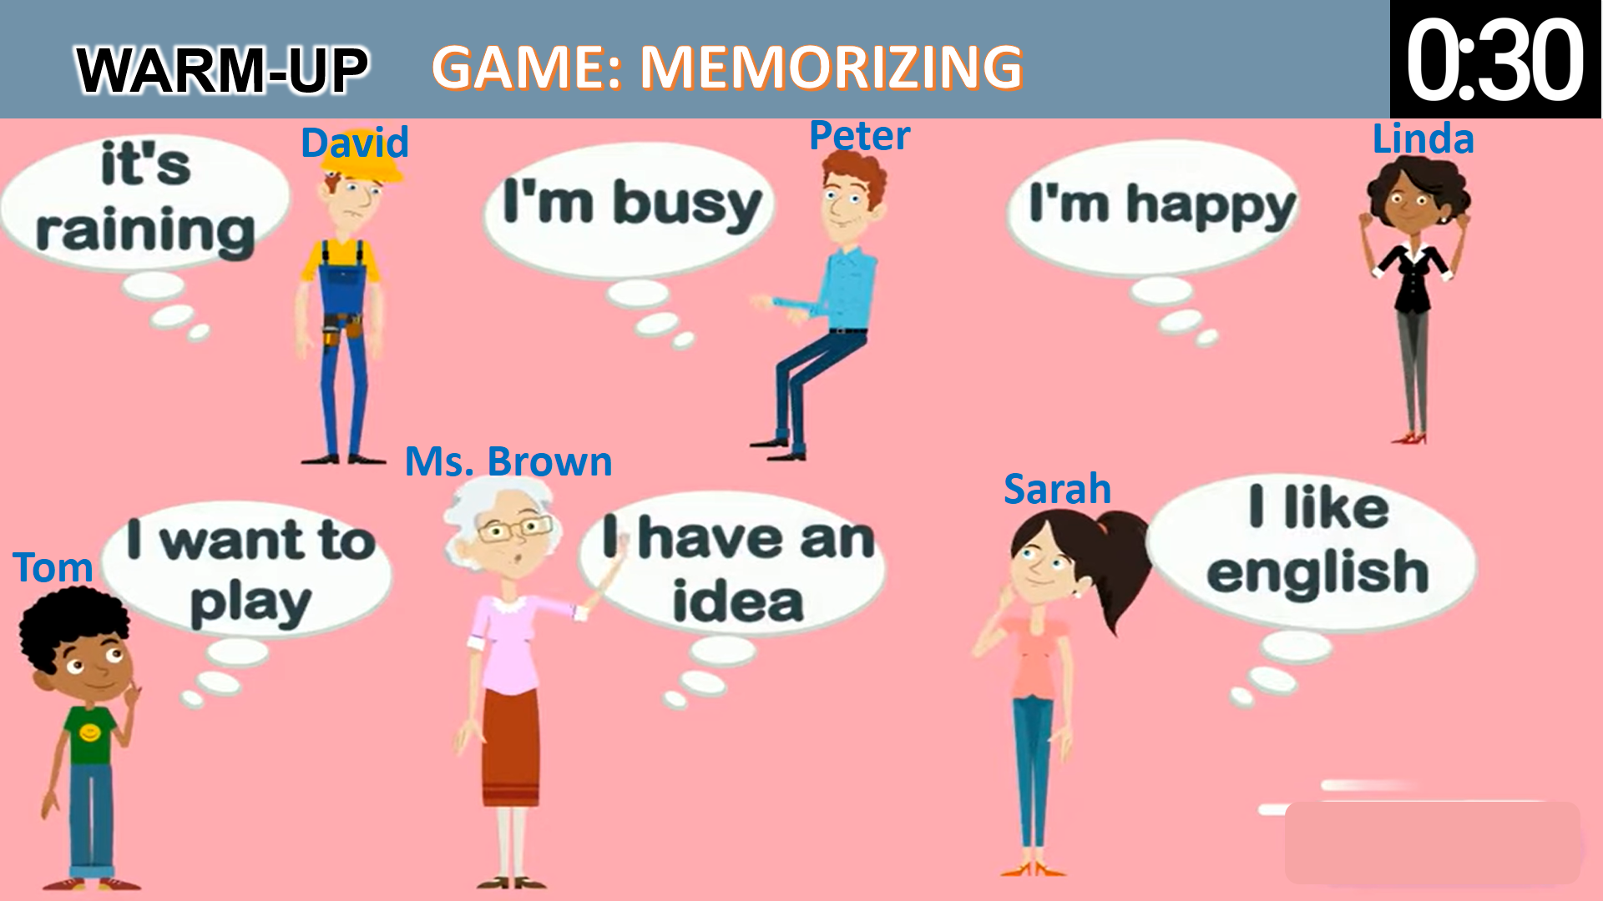
e. Assessment
- T checks ss’ answers and gives feedback
2. ACTIVITY 1: PRESENTATION (12 mins)
a. Objectives:
- To realize some differences between direct speech and reported speech (Statements)
- To be aware of the changes in verb tenses, pronouns, time and place expressions.
b. Content:
- Match direct speech with its reported speech.
- Know the changes in verb tenses, pronouns, time and place expressions.
c. Expected outcomes:
- Know what direct speech and reported speech are.
- Understand the changes in verb tenses, pronouns, time and place expressions.
d. Organisation
TEACHER’S AND STUDENTS’ ACTIVITIES | CONTENTS
Grammar: Reported speech (Statements)  Task 1. Look at part of the conversation in GETTING STARTED again. Then match Minh’s uncle’s direct speech with his reported speech.  - Ask Ss to work individually to look at the part of the conversation from GETTING STARTED  - Ask Ss to underline the sentences in GETTING STARTED  - Have Ss work in pairs to look at direct speech and reported speech boxes to match.  - Check the answers as a class.  - Ask some Ss to underline the differences in the pairs of sentences they have just matched.  - Emphasize will in direct speech is turned into would in the reported speech.  - Ask several Ss to read aloud full sentences. Correct their pronunciation if necessary.  TEACHING POINT  - Have Ss work individually to read the Remember! box.  - Write examples of direct speech and reported speech on the board.  - Ask some Ss to point out the differences between pairs of sentences (direct and reported speech sentences)  - Remark on the differences in (1) verb form, (2) time expressions, (3) time and place expression, and (4) pronouns. | Key:  1. B  2. A  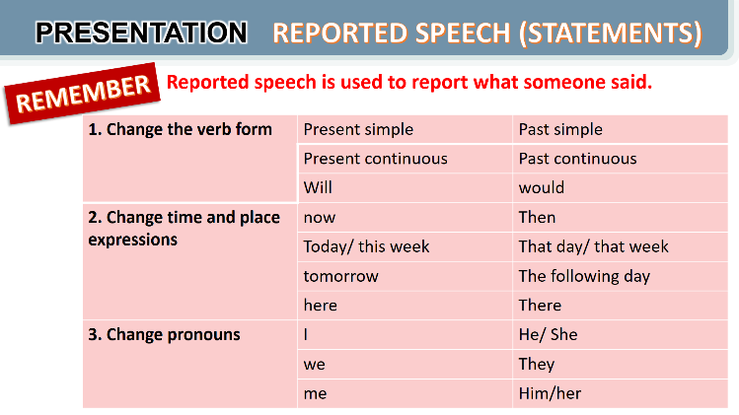
e. Assessment
- Teacher listens to students’ answers and gives feedback.

3. ACTIVITY 2: PRACTICE (28 mins)
a. Objectives:
- to be aware of how to change verb forms when they report information.
- to apply rules of changes in time and place expressions when they report information
- to practise changing direct sentences into reported sentences.
b. Content:
- Apply the changes in verb tenses, time and place expressions to complete the sentences.
- Apply the changes in verb tenses, time and place expressions, and pronouns to transform the direct sentences into reported speech.
c. Expected outcomes:
- Remember the rules of changes in verb tenses, time and place expressions, and pronouns when reporting information.
d. Organisation

TEACHER’S AND STUDENTS’ ACTIVITIES | CONTENTS
Task 2. Complete the second sentences using the correct verb form. (5 mins)-IW
- Remind Ss that they should put the verb one tense back when they report something.  - Have Ss work in pairs to finish the sentences with the correct verb forms.  - Ask some Ss to write their answers on the board.  - Check Ss’ answers. Correct any mistakes and re-explain the rule if necessary.  - Have Ss read out loud sentences again and correct pronunciation if necessary. | Key:  1. was  2. would take  3. was talking  4. were going  5. didn’t have
Task 3. Complete the second sentences with the words and phrases from the box. (5 mins)- PW
- Have Ss work individually to underline the expressions denoting time and place in the direct sentences.  - Ask Ss to choose the correct word / phrase from the box to fill each of the reported sentence. Remind them of the expressions they have just underlined in each of the direct speech sentences.  - Ask some Ss to read out the direct and reported speech sentences. Correct pronunciation if n ecessary.  - Check the answers as a class. | Key:  1. the next day  2. then  3. that day  4. that year  5. there
Task 4. Complete the second sentence in each pair so that it means the same as the first one.
(10 mins)- IW
- Have Ss work individually for five minutes to complete the reported sentences. Then ask them to work in pairs to swap their answers.  - Ask some Ss to write their reported sentences on the board.  - Check the answers as a class.  - Have the class read out the sentences. Correct pronunciation when necessary. | Key:  1. The scientist said that we would live much longer in the future.  2. Our teacher said that our school was going to have a new laboratory there.  3. My dad said that they were developing technology to monitor students better.  4. Tom said that there were no classes the next day because their teacher was ill.  5. The teacher said that they wanted some students to join the science club the next semester.
e. Assessment
- Students do peer correction
- Teacher checks students’ answers as a class and give feedback.

4. ACTIVITY 3: PRODUCTION (4 mins)
a. Objectives:
- To enable Ss to practise reporting speech;
- To create an atmosphere of playing and learning.
b. Content:
- To report the information
c. Expected outcomes:
- Reporting direct sentences correctly.
d. Organisation
Task 5. Work in pairs. One student says a sentence and the other changes that sentence into reported speech. Then swap roles- PW
GAME: He/ She said that…  - Divide the class into groups.  - Instruct Ss to play the game in groups.  - Give groups two minutes to prepare. Tell them that groups can write down their group’s sentences.  - Invite one group to read out or say aloud a direct speech sentence and the other to say out the sentence in reported speech, starting with She / He said...  - Remind them that the group that has the correct reported speech sentence has the right to read out their direct sentence for the other to turn into a reported one.  - Correct any grammar and pronunciation mistakes if necessary.  - The group with the most correct reported sentences wins. | 
e. Assessment
- T corrects any grammar and pronunciation mistakes if necessary.
4. CONSOLIDATION (4 minutes)
a. Wrap-up
- Ask Ss to summarise what they have learnt in the lesson.
- Retell what direct speech and reported speech are
- Retell the rules of changing direct speech to reported speech.
b. Homework
Learn the rules of changing direct speech into reported speech by heart.
Do Exercise ………..page ……Unit 11/Workbook
BOARD PLAN
Date of teaching
Unit 11: Science and technology
Lesson 3: A closer look 2
Grammar: Reported speech (statements)
I. Theory
Task 1: Look at part of the conversation in GETTING STARTED again. Then match Minh’s uncle’s direct speech with his reported speech.
Remember:
 | Direct speech | Reported speech
1. Definition | - a report of the exact words used by a speaker or writer. | - the form of speech used to report what people said
2. Changes in tenses | 1. Present simple  2. Present continuous  3. will | 1. Past simple  2. Past continuous  3. would
3. Changes in pronouns | 1. I/ me  2. We/ us  3. Me | 1. He/She/ him/her  2. They/ them  3. him/her
4. Changes in time and place expressions | 1. now  2. today  3. ago  4. tomorrow  5. this week  6. here | 1. then  2. that day  3. before  4. the following day/ the next day  5. that week  6. there
5. Structures | S1 said: “S2 + V2,”  “S2 + V2,” S1 said | S1 + said/ told sb + (that) +S2 + V2 lùi thì
II. Practice:
Task 2: Complete the second sentences using the correct verb form.
Task 3: Complete the second sentences with the words and phrases from the box.
Task 4: Complete the second sentence in each pair so that it means the same the first one.
Task 5: GAME: He/She said that…
Work in pairs. One student says a sentence and the other changes that sentence into reported speech. Then swap roles.
*Homework
UNIT 11: SCIENCE AND TECHNOLOGY

Lesson 4: Communication

I. OBJECTIVES
By the end of this lesson, Ss will be able to:
1. Knowledge
- identify how to give and respond to good news.
- know about the benefits and problems of online learning.
2. Skills:
- Give and respond to good news.
- Read and talk about the benefits and problems of online learning.
3. Competences
- Develop competencies of communication, cooperation, and self-management.
- Be collaborative and supportive in pair work and group work.
4. Personal qualities
- Raise ss’ awareness of the benefits and problems of online learning.
- Have good attitude to giving and responding to good news.
II. MATERIALS
- Grade 8 textbook, Unit 11, Communication.
- Computer connected to the Internet
- Projector / TV/ pictures and cards
- Phần mềm tương tác hoclieu.vn

Language analysis
Giving good news | Responding to good news
- Great news for us.  - (Tell the news) | - Great!: if good news is general and good for every one.  - Congratulations!: if the news is good for the speaker only

Assumption
Anticipated difficulties | Solutions
Some Ss may have difficulty getting enough information to talk about the benefits and problems of online learning. | T should give suggestions or let ss read more times to get enough information.
III. PROCEDURES
1. WARM-UP (3 mins)
a. Objectives:
- To create an active atmosphere in the class before the lesson;
b. Content:
- Have students watch a clip to create a friendly and relaxed atmosphere to inspire Ss to warm up to the new class.
c. Expected outcomes:
- Having a chance to speak English and focus on the topic of the lesson.
d. Organisation
TEACHER’S AND STUDENTS’ ACTIVITIES | CONTENTS
Clip watching:  - T lets ss watch a clip and ask ss what the clip is about.  - T leads in the new lesson  - Ask Ss to look at COMMUNICATION on page 86. | Expected answers:  - Giving and responding the news

e. Assessment
- T checks ss’ answers and give feedback

2. ACTIVITY 1: PRESENTATION (6 mins)
a. Objectives:
- To introduce how to give and respond to good news
- To help Ss practise giving and responding to good news
b. Content:
- Use everyday expressions to develop language skills (Giving and responding good news)
c. Expected outcomes:
- Leaning how to give and respond to good news
d. Organisation
TEACHER’S AND STUDENTS’ ACTIVITIES | CONTENTS
I. Everyday English: Giving and responding to good news  Task 1: Listen and read the conversation, paying attention to the highlighted parts.  – Play the recording for Ss to listen and read the conversation between Nick and Mi. Ask Ss to pay attention to the highlighted parts. Emphasise the ways to give good news and respond to good news:  - Tell Ss that Great! and Congratulations! are different ways to respond to good news in different contexts. Tell them that if good news is general and good for everyone, we can say Great!; if the news is good for the speaker only, the responder may say Congratulations!  - Have Ss practise the conversation. | Nick: Great news for us. We’ll have school clouds so we won’t have to carry lots of books to school.  Mi: Great!  Nick: And my dad promised to give me a new Ipad to read books from the school clouds.  Mi: Congratulations!  To give and respond to good news, you can use:  - Great news for us.  - Great!  - Congratulations!
Task 2: Work in pairs. Give news and respond to the news in the following situations.
- Ask Ss to work in pairs to make similar conversation. - - Tell them to use the contexts given and the sample expressions.  - Give feedback on their conversation. | 1. You tell your classmate about the new vending machine at your school.  2. You tell your classmate about a new laptop that your dad gave you on your birthday.
e. Assessment
- Teacher listens to students’ pronunciation and gives feedback.

3. ACTIVITY 2: PRACTICE (20 mins)
a. Objectives:
– To help Ss learn the language to describe the benefits and problems of online learning;
– To help Ss practise reading for specific information.
b. Content:
- Read the posts from some students about the benefits and problems of online learning.
- Talk about a platform ss use for online classes or one ss know about.
c. Expected outcomes:
- Knowing the benefits and problems of online learning.
- Practising reading for specific information and practising speaking about a platform ss use for online classes or one ss know about.

d. Organisation

TEACHER’S AND STUDENTS’ ACTIVITIES | CONTENTS
Task 3. Work in pairs. Read the posts from some students about online learning and complete the table. (10 mins)-PW
- Ask some Ss to read the posts aloud.  - Have Ss work in pairs to read the posts to get information from the post and to fill in the table below.  - Ask some pairs to read out their answers. Make corrections if necessary.  - Check the answers as a class.  - If time allows, ask some students to retell information from the posts or to role play the four friends to tell class about the platform their teacher uses for their classes. | Key:  Benefits Problems  1. It’s convenient. 1. Some students don’t have computers or  2. Students don’t have to get up early. smart phones.  2. The Internet connection is poor.  3. It helps students become more 3. It makes some students feel more  independent. stressed when learning online.  4. It helps students avoid traffic jams. 4. Students can’t meet their classmates.  5. Some students get tired eyes and can’t  concentrate well.
Task 4. Work in groups. Talk about a platform you use for your online classes or one you know about. What are the benefits and problems of using it? (10 mins)- PW
– Have Ss work in groups to talk about the benefits and problems of their online learning platform.
- Ask them to think of the platform they use and use the table in Activity 3 to make notes. Tell them to use adjectives or phrases as in Activity 3.
- Invite some Ss to tell about their online learning platforms. Correct any grammar or pronunciation mistakes if necessary.
e. Assessment
- T listens to ss’ reports and gives feedback on their pronunciation and content.

4. ACTIVITY 3: PRODUCTION (10 mins)
a. Objectives:
- To provide Ss with an opportunity to talk about the platform his / her friends use for online learning, the benefits and problems of that online learning platform;
– To help Ss practise reported speech
b. Content:
- Talk about the platform his / her friends use for online learning, the benefits and problems of that online learning platform.
c. Expected outcomes:
- Apply what they have learnt so far in this unit (ideas, vocabulary, grammar) to talk about their the platform his / her friends use for online learning, the benefits and problems of that online learning platform
d. Organization

Task 5. Report the answers of one of your group members to the class- GW
- Have Ss work in groups to discuss their online learning platforms.  - Tell them that they can make notes about what their friends like and dislike about the platform their classes /teachers use.  - Ask them to use ideas from the posts and the table in Activity 3.  - Invite group representatives to report one of their group member’s answers. Give feedback on Ss’ reports. | - You can conclude:  - The name of the platform you use for your online classes or one you know about.  - Its benefits  - Its problems  Example:  Lan said that her extra class used Microsoft Teams. She said that she and her classmates found it difficult to use. However, it is convenient to have online classes on Microsoft Teams when the weather is bad.
e. Assessment
- T corrects any grammar and pronunciation mistakes if necessary.
- T gives feedback on their reports.

4. CONSOLIDATION (4 minutes)
a. Wrap-up
- Ask Ss what they have learnt in the lesson.
- Ss retell ways of giving and responding to good news
- Ss retell some benefits and problems of online learning.
b. Homework
- Learn the ways of giving and responding to good news.
- Write a paragraph of 50-70 words about the benefits and problems of a platform you use for your online classes.
- Do Exercise ………..page ……Unit 11/Workbook

BOARD PLAN

Date of teaching
Unit 11: Science and technology
Lesson 4: Communication
I. Everyday English:
Task 1: Listen and read the conversation, paying attention to the highlighted parts.
Giving and responding to good news:
- Great news for us.
- Great!
- Congratulations!
Task 2: Work in pairs. Give news and respond to the news in the following situations.
II. My favourite shopping place
Task 3: Work in pairs. Read the posts from some students about online learning and complete the table.
Task 4: Work in groups. Talk about a platform you use for your online classes or one you know about. What are the benefits and problems of using it?
Task 5: Report the answers of one of your group members to the class.
*Homework

UNIT 8: SCIENCE AND TECHNOLOGY

Lesson 5: Skills 1

I. OBJECTIVES
By the end of this lesson, Ss will be able to:
1. Knowledge
- improve the skill of reading advertisements for details.
- remember the lexical items related to some new technologies that are applied at schools
- recognize how to make a conversation to ask and answer information about an invention or a technology
2. Skills:
- develop their reading skill for specific and general information through ticking exercise and multiple choice questions.
- practise asking and answering questions for information about an invention or a technology
3. Competences
- develop communication skills and creativity
- be collaborative and supportive in pair work and teamwork
- develop presentation skill
- actively join in class activities
4. Personal qualities
- raise ss’ awareness of some new technologies that are applied at schools
- have a good attitude to applying and using new technology or inventions at schools
II. MATERIALS
- Grade 8 textbook, Unit 11, Skills 1
- Computer connected to the Internet
- Projector / TV/ pictures and cards
- Phần mềm tương tác hoclieu.vn
Language analysis
Form | Pronunciation | Meaning | Vietnamese equivalent
1. biometrics (n) | /ˌbaɪəʊˈmetrɪks/ | A science that use measurements of human features (eyes, finger print…) to identify people. | Khoa học sinh trắc
2. truancy (n) | /ˈtruːənsi/ | the practice of staying away from school without permission | Trốn học, nghỉ học không phép
3. Nanolearning (n) | /’nænəʊlɜːnɪŋ/ | Nano + learning. Nano means very very small = one billionth. Nanolearning means learning small portions. | Dạy học với bài dạy kích thước nhỏ
4. effortless(adj) | /ˈefətləs/ | needing little or no effort, so that it seems easy | Không cần nhiều nỗ lực
5. platform(v) | /ˈplætfɔːm/ | the type of computer system or the software that is used | Nền tảng
6. cheating (n) | /tʃiːtɪŋ/ | acting in a dishonest way in order to gain an advantage, especially in a game, a competition, an exam, etc. | Gian lận
Assumption
Anticipated difficulties | Solutions
1. Ss may lack knowledge about some lexical items. | Provide Ss with the meaning and pronunciation of words.
2. Ss may not have sufficient reading, speaking and cooperating skills. | Let Ss read the text again (if needed).  Create a comfortable and encouraging environment for Ss to speak.  Encourage Ss to work in pairs, and in groups so that they can help each other.  Provide feedback and help if necessary.

III. PROCEDURES
1. WARM-UP (3 mins)
a. Objectives:
- To create an active atmosphere in the class before the lesson;
- To elicit from Ss some reasons why they go shopping
b. Content:
- Have Brainstorming activities to elicit some reasons why Ss go shopping
c. Expected outcomes:
- Having a chance to speak English and focus on the topic of the lesson.
d. Organisation

TEACHER’S AND STUDENTS’ ACTIVITIES | CONTENTS
Brainstorming:  - Ask ss to name the technological applications your school uses  - Ask Ss to look at SKILLS 1 on page 120-121. | Expected answers:  - Fingerprint scanner  - Face recognition

e. Assessment
- T listens to ss’ answers and gives feedback

2. ACTIVITY 1: PRESENTATION (6 mins) PRE-READING
a. Objectives:
- To set the context for the reading;
- To help Ss practice describing pictures.
- To introduce some new words related to some new technologies;
b. Content:
- Learn some new words.
- Read the list of the technological applications
c. Expected outcomes:
- Know more new words and some technological applications
d. Organisation
TEACHER’S AND STUDENTS’ ACTIVITIES | CONTENTS
Task 1: Work in pairs. Name the technological applications in the pictures. Can they be used in schools? (3 mins)- PW
- Have the class work in pairs to describe the pictures and say what technology the pictures are about.  - Ask Ss to discuss if these technologies can be used at schools. |   Key:  1. eye tracking  2. fingerprint scanner  3. face recognition
Vocabulary pre-teaching  - Teacher asks ss to look through the text and pay attention to the underlined words.  - Teacher gets ss to guess the meaning of the new vocabulary through context  - Teacher confirms the answers then gets ss to read orally and take notes of all the four words in their notebooks. | * Vocabulary:  1. biometrics (n) /ˌbaɪəʊˈmetrɪks/ Khoa học sinh trắc  2. truancy (n) /ˈtruːənsi/ Trốn học, nghỉ học không phép  3. Nanolearning (n) /’nænəʊlɜːnɪŋ/Dạy học với bài dạy kích thước nhỏ  4. effortless(adj) /ˈefətləs/ Không cần nhiều nỗ lực  5. platform(v) /ˈplætfɔːm/ Nền tảng  6. cheating (n) /tʃiːtɪŋ/ Gian lận
e. Assessment
- Teacher listens to students’ pronunciation and gives feedback.

3. ACTIVITY 2: PRACTICE (20 mins) WHILE-READING
a. Objectives:
- to improve Ss’ skill of reading advertisements for details
- to improve Ss’ skill of reading for general information and details.
b. Content:
- Read the reading passage about new technologies that are applied at schools and tick B (Biometrics) or N (Nanolearning) and choose the best answer to the questions.
c. Expected outcomes:
- Understanding the text about the benefits of the two new technological applications.
d. Organisation

TEACHER’S AND STUDENTS’ ACTIVITIES | CONTENTS
Task 2. Read the passage and tick (v) B (Biometrics) or N (Nanolearning) (10 mins)-IW
- Ask Ss to work individually to read the texts and to decide if the statements from text are about biometrics or nanolearning. Ask them to write B (Biometrics) or N (Nanolearning).  - Ask Ss to underline the key words in each of the statements then search for the information in the two texts.  - Have Ss to work in pairs to swap answers or to check answers together.  - Ask some Ss to read out loud the statements and say B or N. Ask them to show the parts in the reading where they find the answers.  - Check the answers as a class. | Answer key:  1. N  2. B  3. B  4. N  5. N
Task 3. Read the passage and choose the correct answer A, B, or C. (10 mins)- IW
- Have Ss work individually for five minutes and choose the correct answers. Remind them to underline the key words in the questions and the evidence for the answers.  - Ask Ss to take turns to give the answers. Ask them to show the parts in the reading texts where they find the answers.  - Check the answers as a class.  - T can also ask one or two Ss to say which technology they prefer and why or ask them to orally summarise each of the texts. | Suggested answers:  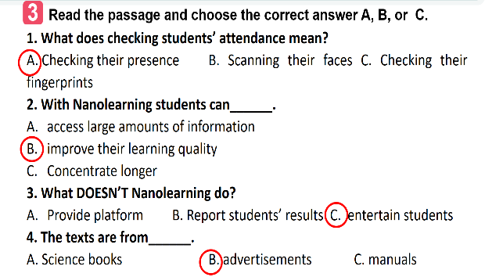
e. Assessment
- T checks the answers as a class and give feedback
4. ACTIVITY 3: PRODUCTION (15 mins)- POST-READING (SPEAKING)
a. Objectives:
- To have Ss practise asking and answering questions for information about an invention or a technology;
- To give Ss an opportunity to practise explaining how the technology can help us;
- To improve Ss’ confidence in speaking in front of the class.
b. Content:
- Practise asking and answering questions for information about an invention or a technology;
- Practise explaining how the technology can help us.
c. Expected outcomes:
- Speak about information about an invention or a technology and its benefits.
d. Organisation

TEACHER’S AND STUDENTS’ ACTIVITIES | CONTENTS
Task 4. Work in pairs. Discuss and match the questions in A with the answers in B, and then make a conversation about an invention. - PW (9 minutes)
- Have Ss work in pairs to match the questions in A with the answers in B.  - Have them practise asking and answering questions about biometrics in the example.  - Assist Ss to make full questions when necessary.  - Ask them to ask and answer questions about an invention or a technology they like or know.  - Ask some pairs to role-play it.  - Ask the class to offer feedback on their questions, answers, and pronunciation.  - Prepare cue cards about different inventions / technologies and ask Ss to practise asking and answering questions about those inventions / technologies.  - This activity helps prepare Ss for 5. | Key:  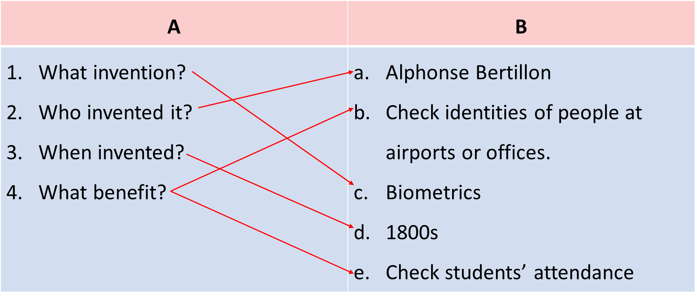  A: What technology do you like?  B: I like biometrics.  A: Who invented it?  B: Alphonse Bertillon  A: When did he invent it?  B: In 1880s  A: How can we use it?  B: It can help us check students’ attendance. We can also use it to check identities of people at airports or offices.
Task 5. Work in groups. Ask and answer questions about a technology or an invention. Use the example in 4 as a cue. Then report your answers to the class. (5 minutes)
- Have Ss work in groups to ask and answer questions about a invention or a technology;  - Ask them to explain what they can use the technology or invention for.  - Invite one representative of each group to report their group’s answers to the class.  - Give feedback on their reports in terms of language, reported verb forms, and pronunciation. | Example:  Mi likes biometrics. Alphonse Bertillon invented it in 1800s. It is a very important technology. We use it to …
e. Assessment
- T asks the class to give feedback on their questions and answers, and pronunciation.
- T gives feedback on their reports in terms of language, reasoning skills, and pronunciation.

4. CONSOLIDATION (3 minutes)
a. Wrap-up
- Ask Ss what they have learnt in the lesson.
- Ss retell some information about the two new technologies in the reading text.
b. Homework
- Learn the new words by heart.
- Do Exercise ………..page ……Unit 11/Workbook

BOARD PLAN

Date of teaching
Unit 11: SCIENCE AND TECHNOLOGY
Lesson 5: Skills 1
I. Reading
Task 1. Work in pairs. Name the technological applications in the pictures. Can they be used in schools?
* Vocabulary:
1. biometrics (n) /ˌbaɪəʊˈmetrɪks/: Khoa học sinh trắc
2. truancy (n) /ˈtruːənsi/: Trốn học, nghỉ học không phép
3. Nanolearning (n) /’nænəʊlɜːnɪŋ/: Dạy học với bài dạy kích thước nhỏ
4. effortless(adj) /ˈefətləs/: Không cần nhiều nỗ lực
5. platform(v) /ˈplætfɔːm/: Nền tảng
6. cheating (n) /tʃiːtɪŋ/: Gian lận
Task 2. Read the passage and tick (v) B (Biometrics) or N (Nanolearning)
Task 3. Read the text again and choose the correct answer A, B, or C.
II. Speaking
Task 4. Work in pairs. Discuss and match the questions in A with the answers in B, and then make a conversation about an invention.
Task 5. Work in groups. Ask and answer questions about a technology or an invention. Use the example in 4 as a cue. Then report your answers to the class.
*Homework

UNIT 11: SCIENCE AND TECHNOLOGY

Lesson 6: Skills 2

I. OBJECTIVES
By the end of this lesson, Ss will be able to:
1. Knowledge
- recognize listening skills for specific information about what a robot teacher can do and can’t do.
- remember the lexical items related to
- recognize how to write a paragraph expressing opinions about whether a robot teacher will replace human teachers at school.
2. Skills:
- improve the skill of listening for details.
- improve listening comprehension and note-taking skills.
- improve the writing skill of writing a paragraph expressing opinions.
3. Competences
- develop communication skills and creativity
- be collaborative and supportive in pair work and group work
- actively join in class activities
4. Personal qualities
- raise ss’ awareness of what a robot teacher can do and can’t do.
- have the right attitude toward whether a robot teacher will replace human teachers at school.
II. MATERIALS
- Grade 8 textbook, Unit 11, Skills 2
- Computer connected to the Internet
- Projector / TV/ pictures and cards
- Phần mềm tương tác hoclieu.vn
Language analysis
Form | Pronunciation | Meaning | Vietnamese equivalent
1. interact with (v) | /ˌɪntərˈækt wɪð/ | to communicate with somebody, especially while you work, play or spend time with them | Tương tác với, giao tiếp với
2. emotional (adj) | /ɪˌməʊʃənl/ | connected with people’s feelings (= with the emotions) | Thuộc tình cảm, cảm xúc

Assumption
Anticipated difficulties | Solutions
1. Ss may lack knowledge about some lexical items. | Provide Ss with the meaning and pronunciation of words.
2. Ss may not have sufficient listening, writing and co-operating skills. | Let Ss listen the text again (if needed).  Encourage Ss to work in pairs, in groups so that they can help each other.  Provide feedback and help if necessary.

III. PROCEDURES
1. WARM-UP (3 mins)
a. Objectives:
- To create an active atmosphere in the class before the lesson;
- To help ss focus on the listening writing topic
b. Content:
- Have Naming the pictures activity to elicit from students some types of robots in which there is a teacher robot
c. Expected outcomes:
- Having a chance to speak English and focus on the topic of the lesson.
d. Organisation

TEACHER’S AND STUDENTS’ ACTIVITIES | CONTENTS
Naming the pictures  - Ask ss to look at the five pictures on the screen and name 5 types of robots.  - Lead in the lesson: There are many types of robots nowadays. Today we are going to learn about teacher robots and what a teacher robot can do and what it can’t do in Lesson 6. SKILLS 2 on page 89. | Suggested answers:  1. doctor robot  2. space robot  3. worker robot  4. home robot  5. teacher robot
e. Assessment
- T check ss’ answers and gives feedback

2. ACTIVITY 1: PRESENTATION (5 mins) PRE-LISTENING
a. Objectives:
- To help Ss focus on the topic and prepare for the listening text.
- To help Ss brainstorm keywords/phrases for listening.
- To set the context for the listening;
b. Content:
- Learn some new words.
c. Expected outcomes:
- Know more new words
d. Organisation
TEACHER’S AND STUDENTS’ ACTIVITIES | CONTENTS
Vocabulary pre-teaching  - Teacher introduces the vocabulary.  - Teacher explains the meaning of the new vocabulary by pictures or explanation  - Teacher reveals that these two words will appear in the listening text and asks students to open their textbooks to discover further.  Task 1. Listen and tick (v) the things that you think a robot teacher can do  - Ask Ss to work in pairs to tick the things that a robot teacher can do. Ask Ss to add more things a robot teacher can do.  - Tell Ss that they are going to listen to a conversation about a robot teacher and fill in each of the blanks with ONE word.  - Also ask Ss to list things robots in general can do (for example: doing boring housework, hard work in factories, delivering letters at workplaces, etc.) | * Vocabulary:  1. emotional (adj): thuộc tình cảm  2. interact with (v): tương tác  Suggested answers:  - 1, 2  - A robot teacher can dance, teach subjects, play with students...
e. Assessment
- Teacher listens to students’ pronunciation and gives feedback.

3. ACTIVITY 2: PRACTICE (20 mins) WHILE- LISTENING
a. Objectives:
- To improve Ss’ skill of listening for specific information.
- To improve Ss’ listening comprehension and note-taking skills.
b. Content:
- Listen to a conversation and fill in each blank.
- Listen to the conversation and tick T or F
c. Expected outcomes:
- Understanding the conversation about what a robot teacher can do and can’t do.
d. Organisation

TEACHER’S AND STUDENTS’ ACTIVITIES | CONTENTS
Task 2. Listen to the conversation and fill in each blank with ONE word. (10 mins)-IW
- Ask Ss to work individually to read the table and guess the possible words to fill in each of the blanks.  - Remind them to think of the part of speech of that word (noun, verb, adjective, adverb or number). and forms of nouns (singular, plural).  - Play the recording once for Ss to fill in the blanks. Remind Ss that they should write only ONE word for each blank.  - Check Ss’ answers and play the recording again for them to better understand the conversation between Tom and Lan. Stop or rewind the recording where necessary. | Answer key:  1. languages  2. maths  3. interact  4. behave  5. problems
Task 3. Listen again and tick (v) T (True) or F(False). (10 mins)- IW
- Ask Ss to work in pairs to read the statements and underline the key words in the statements.  - Play the recording once. Give them two minutes to decide if the sentences are T (True) or F (False).  - Play the recording again and check their answers as a class. | Suggested answers:  1. T 2. T 3. F 4. F 5. F
e. Assessment
- T checks the answers as a class and gives feedback
4. ACTIVITY 3: PRODUCTION (15 mins)- POST-LISTENING (WRITING)
a. Objectives:
- To provide Ss with vocabulary and ideas about whether a robot teacher will replace human teachers at schools
- To improve ss’ skill of writing a paragraph expressing opinions about whether robots will replace teachers at schools.
b. Content:
- Discuss if ss agree or disagree that robots will soon replace teachers at school and give the reasons.
- Write a paragraph to express opinions about whether robots will replace teachers at schools.
c. Expected outcomes:
- Give at least 3 reasons why you agree or disagree on whether robots will replace teachers at schools.
- Have a paragraph to express opinions about whether robots will replace teachers at schools.
d. Organization

TEACHER’S AND STUDENTS’ ACTIVITIES | CONTENTS
Task 4. Work in pairs. Discuss if you agree or disagree that robots will soon replace teachers at schools. Write the reasons in the table.- PW (5 minutes)
- Ask Ss to work in pairs to brainstorm ideas and fill in the blanks.  - Ask Ss to get ideas from the listening and add any more ideas they have.  - Ask some Ss to read out loud ideas for each column.  - Correct their pronunciation where necessary. | 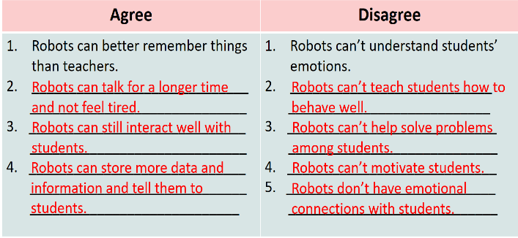
Task 5. Now write a paragraph (80-100 words) to express your opinion. Use the notes in 4. (9 minutes)
- T records the ideas Ss have brainstormed in Activity 4 on the board.  - Ask Ss to work individually to write for 15 minutes. Tell them to use the information in Activity 4 and any other ideas they may think of. Remind Ss to choose only three ideas for their paragraph.  - T asks one student to read out his / her paragraph.  - If time allows, also ask Ss to work in groups to write on an A1 / A0 size piece of paper, then T organises a gallery walk. Ss walk round and offer feedback on peers’ writing in terms of ideas, grammar and connectors. | 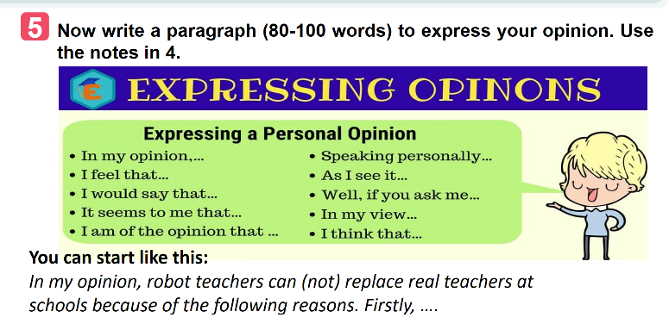
e. Assessment
- T gives feedback on their writing in terms of spelling, grammatical mistakes, cohesion, and content.
4. CONSOLIDATION (3 minutes)
a. Wrap-up
- Ask Ss what they have learned in the lesson.
- Ss tell the whole class:
- What a robot teacher can do and what it can’t do.
- The reasons robot teachers can or can’t replace teachers at school.
- How to write a paragraph expressing opinions.
b. Homework
- Learn the new words by heart.
- Rewrite the paragraph expressing opinions about whether a robot teacher can(not) replace teachers at school.
- Do Exercise ………..page ……Unit 11/Workbook

BOARD PLAN

Date of teaching
Unit 11: Science and technology
Lesson 6: Skills 2
I. Listening
* Vocabulary:
1. interact with (v): tương tác
2. emotional (adj): thuộc tình cảm, gây xúc động
Task 1. Tick (v) the things that you think a robot teacher can do.
Task 2. Listen to the conversation and fill in each blank with ONE word.
Task 3. Listen again and choose the correct answer A, B, or C.
II. Writing
Task 4. Work in pairs. Discuss if you agree or disagree that robots will soon replace teachers at schools. Write the reasons in the table.
Task 5. Now write a paragraph (80-100 words) to express your opinion. Use the notes in 4.
*Homework

UNIT 11: SCIENCE AND TECHNOLOGY

Lesson 7: Looking back and project

I. OBJECTIVES
By the end of this lesson, Ss will be able to:
1. Knowledge
- Memorize the vocabulary about new technologies and words and phrases that are used to talk about inventions, discoveries, inventions, and creations.
- Review reported speech (statements)
- Brainstorm ideas about problems they have at home or at school
- Be creative to deal with problems by imagining an invention.
2. Skills:
- Use the vocabulary about new technologies and words and phrases that are used to talk about inventions, discoveries, inventions, and creations to do exercises.
- Apply the knowledge of reported speech (statements) to do exercises.
- Apply what they have learnt (vocabulary and grammar) into practice through a project.
3. Competences
- Develop communication skills and creativity
- Develop presentation skill
- Develop critical thinking skills
- Be collaborative and supportive in pair work and teamwork
- Actively join in class activities
4. Personal qualities
- consolidate ss’ awareness of science and technology.
- have a positive attitude toward problems that they have at home or at school and think creatively to find solutions to those problems.
II. MATERIALS
- Grade 8 textbook, Unit 11, Looking back and project
- Computer connected to the Internet
- Projector / TV/ pictures and cards
- Phần mềm tương tác hoclieu.vn

Assumption
Anticipated difficulties | Solutions
1. Ss may not have sufficient speaking, writing and co-operating skills when doing the project. | - Encourage Ss to work in pairs, in groups so that they can help each other.  - Provide feedback and help if necessary.

III. PROCEDURES
1. WARM-UP (3 mins)
a. Objectives:
- To create an active atmosphere in the class before the lesson;
b. Content:
- Have ss play the game “Kim’s game”
c. Expected outcomes:
- Having a chance to speak English and focus on the topic of the lesson.
d. Organisation

TEACHER’S AND STUDENTS’ ACTIVITIES | CONTENTS
Kim’s game:  - T asks students to work in groups of three or four students  - Get ss to watch a video clip and try to remember all the inventions mentioned in the clip without taking notes.  - After finishing watching the clip, ss write down as inventions as possible.  - T gets ss to swap the posters and give correction after T shows the answers.  -The group with the most correct answers will win.  - T leads in the lesson. | Answers:  10. The paper  9. The compass  8. The refrigeration  7. The printing press  6. Plumbing  5. Medicine  4. Engines  3. The wheel  2. Communication  1. Electricity
e. Assessment
- T check ss’ answers and gives feedback
2. ACTIVITY 1: PRACTICE- LOOKING BACK (22 mins)
a. Objectives:
- To help Ss review the vocabulary learnt.
- To help Ss review reported statements
- To help Ss use the reported statements correctly
b. Content:
- review some new words related to the topic
- review reported statements
c. Expected outcomes:
- Remember the vocabulary learnt
- Remember the changes in tenses, pronouns, time and place expressions to report information.
d. Organisation
TEACHER’S AND STUDENTS’ ACTIVITIES | CONTENTS
I. VOCABULARY  Task 1. Circle the option that goes with each verb.  - Have Ss work individually to circle the option that can combine with the given verbs.  - Have Ss read out their phrases.  - Check answers as a class.  - Correct Ss’ pronunciation if necessary.  Task 2. Fill in each gap with a word or phrase from the box. You may have to change the form of the word or phrase.  - Have Ss work individually to fill in each blank with the correct form of the words /phrases from the box. Check answers as a class.  - Ask some Ss to read aloud the sentences. Correct Ss’ pronunciation if necessary. | VOCABULARY  Task 1.  Suggested answers:  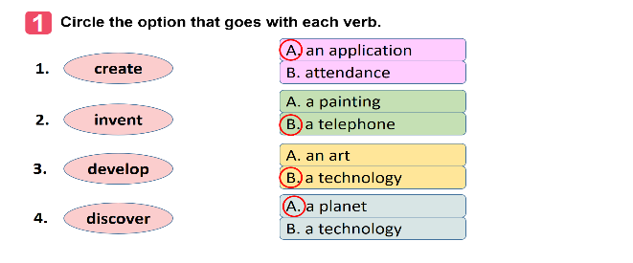  Task 2.  - robot teacher  2. application  3. face recognition  4. eye-tracking  5. check attendance
II. GRAMMAR  Task 3. Which of the underlined parts in each question is incorrect? Find and correct it.  - Have Ss work individually to circle a mistake in each of the sentences. Remind them that only the underlined words will have mistakes.  - Then ask Ss to work in pairs to swap and check their answers.  - Check answers as a class.  - Ask one student to read out his/her sentences. Correct his / her pronunciation if necessary.  Task 4. Rewrite the following sentences, using the words in BOLD.  - Ask Ss to work individually to complete the sentences as requested in the book.  - Ask one or two Ss to go to the board and write their full sentences.  - Then ask the class to work in pairs. Tell them to swap their writings and check their partner’s answers.  - Check the sentences written on the board.  - Have all Ss correct their partner’s answers.  - Ask some Ss to read out their sentences. Correct Ss’ language and pronunciation if necessary. | GRAMMAR  Task 3.  Suggested answers:  1. B (discovers -> discovered)  2. B (is -> was)  3. B (will make ->) would make  4. C (a day ago ->a day before)  5. C ( next year -> the next/following year)  Task 4.  Suggested answers:  1. Tom said they couldn’t connect to the Internet to work online there.  2. Mr. Thompson said (that) science was becoming a more important subject in schools then.  3. The headmaster said (that) the school would use a machine to check students’ attendance the following year.  4. The monitor said to the class (that) they were having a science competition that week.  5. The students said (that) they didn’t like robot teachers at all.
e. Assessment
- Teacher checks students’ answers and corrects Ss’ language and pronunciation if necessary.

3. ACTIVITY 2: PRODUCTION- PROJECT (20 mins)
a. Objectives:
– To help Ss to brainstorm ideas about problems they have at home or at school;
– To raise Ss’ awareness of their ability to be creative to deal with the problems;
– To improve Ss’ teamwork and public speaking skills.
b. Content:
- Think about a problem you have at home or at school.
- Imagine an invention (a tool, a machine, an application…) that helps you deal with your problem.
- Prepare a poster presentation with pictures or a paper model of the invention and present it to your class
c. Expected outcomes:
- Present a poster with pictures or a paper model of the invention.
d. Organisation

TEACHER’S AND STUDENTS’ ACTIVITIES | CONTENTS
Task 1. Think about a problem you have at home or at school. Imagine an invention (a tool, a machine, an application…) that helps you deal with your problem. (3 mins)-GW
- Have Ss work in groups of 3-4 students
- Ask Ss to read the instructions and suggestions carefully.
- Encourage Ss to think about a problem they have at home or at school and imagine an invention (a tool, a machine, an application…) that helps them deal with your problem.
Task 2. Discuss and answer the following questions (10 mins)- GW
- Have Ss work in groups to discuss a problem they have at home or at school. Ask them to think of an invention that can help them deal with their problem.  - Ask them to answer the suggested questions . | - What is the name of the invention?  - What is it look like?  - How can it help you solve the problem?
Task 3. Prepare a poster presentation with pictures or a paper model of the invention and present it to your class.-GW (5mins)
- Tell Ss that they can draw pictures, create models or take photos to illustrate their invention. Ask groups of Ss to pin / tape / glue the pictures / photos / models and write how it can help them on a large piece of paper and present it to the class.  - If time is limited, T can assign the project in earlier lessons such as in GETTING STARTED lesson. Make sure you guide Ss in detail and check their progress after each lesson. In the last lesson (LOOKING BACK), ask Ss to present their poster. | You can include:  - Name of the invention  - What the invention looks like  - How it can help deal with their problems.
e. Assessment
- T checks ss’ grammatical and spelling mistakes on their poster, listens to their presentation, and gives feedback
4. CONSOLIDATION (2 minutes)
a. Wrap-up
- Reviewing vocabulary in Unit 11
- Reviewing reported speech (Statements)
NOW I CAN …
- Ask Ss to complete the self-assessment table.
- Identify any difficulties and provide further practice.
b. Homework
- Do Exercise ………..page ……Unit 11/Workbook

BOARD PLAN

Date of teaching
Unit 11: Science and technology
Lesson 7. Looking back and project
I. Vocabulary:
Task 1. Circle the option that goes with each verb.
Task 2. Fill in each gap with a word or phrase from the box. You may have to change the form of the word or phrase.
II. Grammar
Task 3. Which of the underlined parts in each question is incorrect? Find and correct it.
Task 4. Rewrite the following sentences, using the words in BOLD.
III. Project
Task 1. Think about a problem you have at home or at school. Imagine an invention (a tool, a machine, an application…) that helps you deal with your problem.
Task 2. Discuss and answer the following questions.
Task 3. Prepare a poster presentation with pictures or a paper model of the invention and present it to your class.
*Homework

