Họ và tên: ....................................................  Lớp: ............................................................. | PHIẾU GHI BÀI CHUYÊN ĐỀ HÓA HỌC 11  Bài 2: PHÂN BÓN VÔ CƠ
MỞ ĐẦU
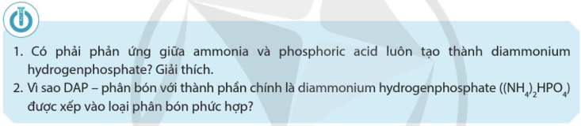
..........................................................................................................................................................................
..........................................................................................................................................................................

I. VAI TRÒ CỦA MỘT SỐ NGUYÊN TỐ DINH DƯỠNG TRONG PHÂN BÓN VÔ CƠ CẦN THIẾT CHO CÂY TRỒNG
1) Phân loại nguyên tố dinh dưỡng
..........................................................................................................................................................................
..........................................................................................................................................................................
..........................................................................................................................................................................
..........................................................................................................................................................................
2) Vai trò của một số nguyên tố dinh dưỡng
..........................................................................................................................................................................
..........................................................................................................................................................................
..........................................................................................................................................................................
..........................................................................................................................................................................
..........................................................................................................................................................................
..........................................................................................................................................................................
..........................................................................................................................................................................
..........................................................................................................................................................................
..........................................................................................................................................................................
..........................................................................................................................................................................
..........................................................................................................................................................................
..........................................................................................................................................................................
..........................................................................................................................................................................
..........................................................................................................................................................................
..........................................................................................................................................................................
..........................................................................................................................................................................
..........................................................................................................................................................................
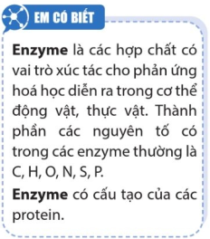
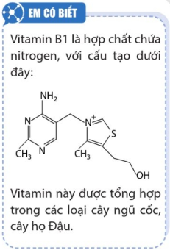
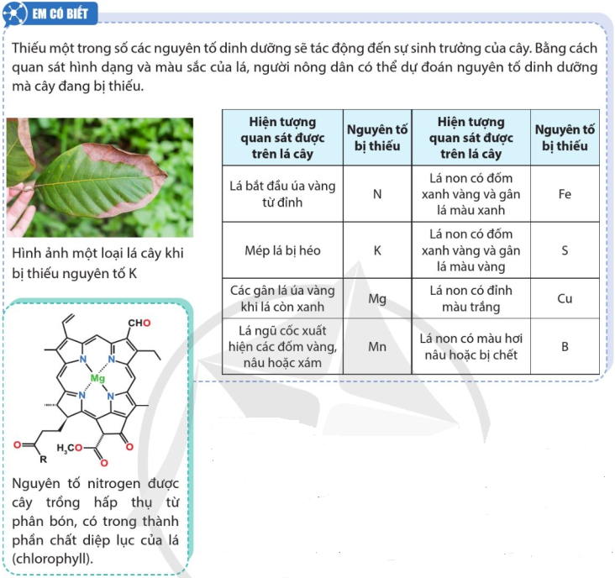

II. PHÂN LOẠI PHÂN BÓN VÔ CƠ
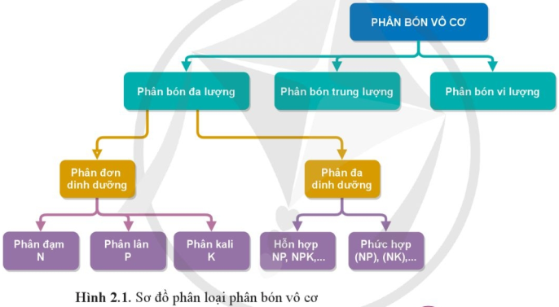

1) Phân bón đa lượng
...................................................................................................................  ...................................................................................................................  ...................................................................................................................  ...................................................................................................................  ...................................................................................................................  ...................................................................................................................  ...................................................................................................................  ...................................................................................................................  ...................................................................................................................  ...................................................................................................................  ...................................................................................................................  ...................................................................................................................  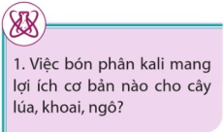  ...................................................................................................................  ...................................................................................................................  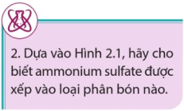  ...................................................................................................................  ...................................................................................................................  ...................................................................................................................  ...................................................................................................................  ...................................................................................................................  ...................................................................................................................  ...................................................................................................................  ...................................................................................................................  ...................................................................................................................  ...................................................................................................................  ................................................................................................................... | 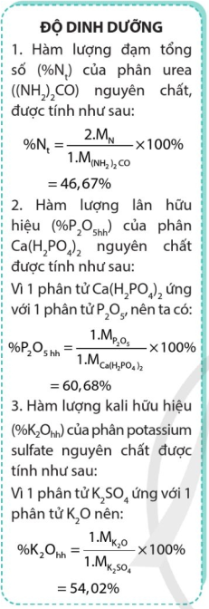  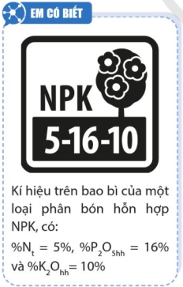

2) Phân bón trung lượng
..........................................................................................................................................................................
..........................................................................................................................................................................
3) Phân bón vi lượng
..........................................................................................................................................................................
..........................................................................................................................................................................
III. QUY TRÌNH SẢN XUẤT VÀ CÁCH SỬ DỤNG MỘT SỐ LOẠI PHÂN BÓN
1) Phân urea  ..................................................................................................................  ..................................................................................................................  ..................................................................................................................  ..................................................................................................................  ..................................................................................................................  ..................................................................................................................  ..................................................................................................................  2) Phân ammonium sulffate (phân bón SA)  ..................................................................................................................  ..................................................................................................................  ..................................................................................................................  ..................................................................................................................  ..................................................................................................................  ..................................................................................................................  ..................................................................................................................  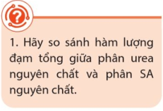  ..................................................................  ..................................................................  ..................................................................  ..................................................................  ..................................................................  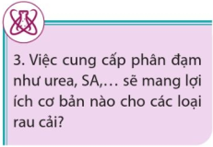  ..................................................................  ..................................................................  ..................................................................  ..................................................................  ..................................................................  .................................................................. | 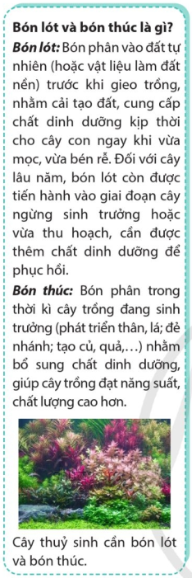

3) Phân hỗn hợp NPK  ..................................................................................................................  ..................................................................................................................  ..................................................................................................................  ..................................................................................................................  ..................................................................................................................  ..................................................................................................................  ..................................................................................................................  ..................................................................................................................  ..................................................................................................................  ..................................................................................................................  ..................................................................................................................  ..................................................................................................................  4) Phân phức hợp chứa N, P và amophos  ..................................................................................................................  ..................................................................................................................  ..................................................................................................................  ..................................................................................................................  ..................................................................................................................  ..................................................................................................................  ..................................................................................................................  ..................................................................................................................  ..................................................................................................................  ..................................................................................................................  ..................................................................................................................  ..................................................................................................................  ..................................................................................................................  ..................................................................................................................  ..................................................................................................................  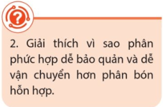  ...................................................................  ...................................................................  ...................................................................  ...................................................................  ................................................................... | 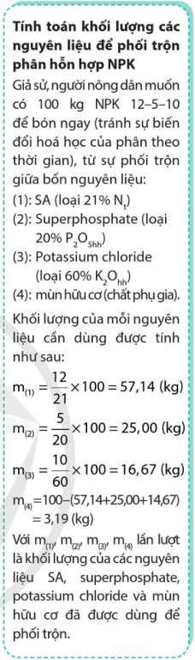

5) Phân superphosphate
..........................................................................................................................................................................
..........................................................................................................................................................................
..........................................................................................................................................................................
..........................................................................................................................................................................
..........................................................................................................................................................................
..........................................................................................................................................................................
..........................................................................................................................................................................
..........................................................................................................................................................................
..........................................................................................................................................................................
..........................................................................................................................................................................
..........................................................................................................................................................................
..........................................................................................................................................................................
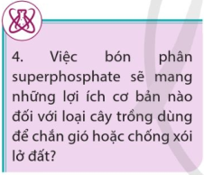 | ....................................................................................................................  ....................................................................................................................  ....................................................................................................................  ....................................................................................................................  ....................................................................................................................
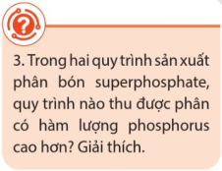 | ....................................................................................................................  ....................................................................................................................  ....................................................................................................................  ....................................................................................................................  ....................................................................................................................
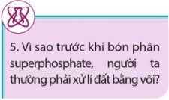 | ....................................................................................................................  ....................................................................................................................  ....................................................................................................................  ....................................................................................................................

III. BẢO QUẢN PHÂN BÓN VÔ CƠ
...................................................................................................................  ...................................................................................................................  ...................................................................................................................  ...................................................................................................................  ...................................................................................................................  ...................................................................................................................  ...................................................................................................................  ...................................................................................................................  ...................................................................................................................  ...................................................................................................................  ...................................................................................................................  ...................................................................................................................  ...................................................................................................................  ...................................................................................................................  ...................................................................................................................  ...................................................................................................................  ...................................................................................................................  ...................................................................................................................  ...................................................................................................................  ...................................................................................................................  ...................................................................................................................  ...................................................................................................................  ...................................................................................................................              