Mã đề 6.1.10
ĐỀ KT GIỮA KÌ I – MÔN TIẾNG ANH 6
A. LISTENING
Part I. There are 5 questions in this part, for each question there are 3 pictures and a short recording. (1.0pt)
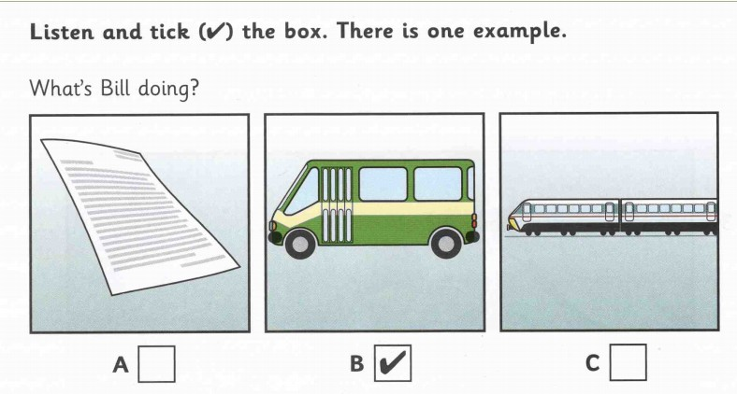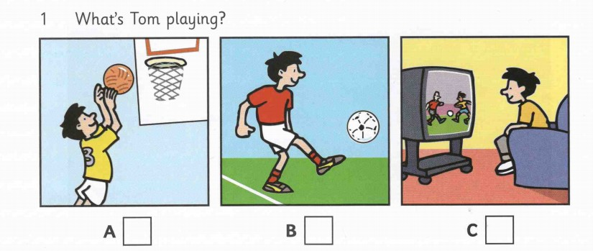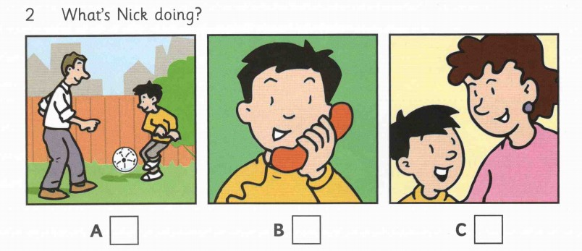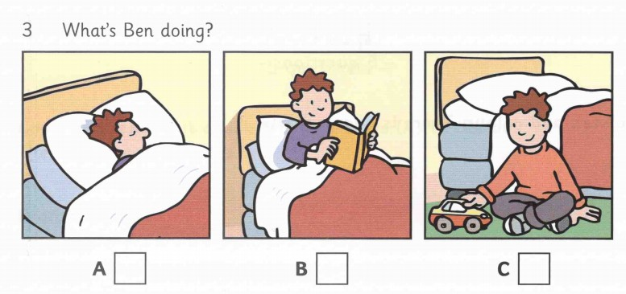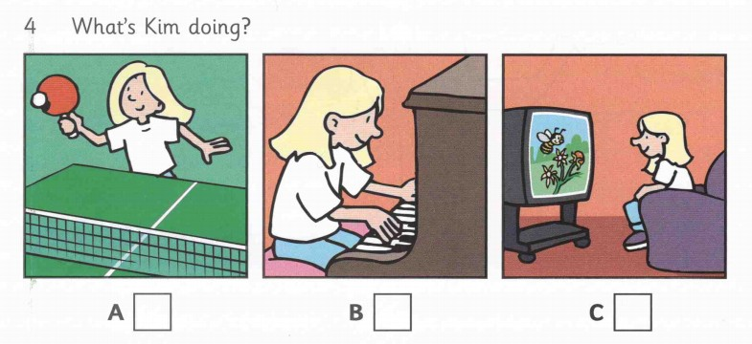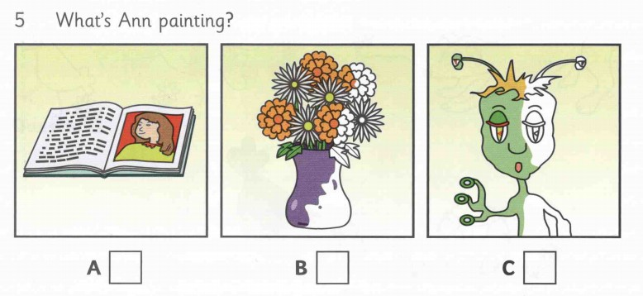
Part II. Listen to Sue talking to her friend, Jim, about the new sports centre. Then complete the sentences below. (no more three words) (1.0pt)
1. The bus to the sports centre is number........................
2. From Monday to Saturday, the sports centre is open from..................
3. If Sue goes swimming, she must take.................
4. At the sports centre, you can buy...............
5. Jim and Sue are going to go to the sports centre next.........................
B. VOCABULARY, GRAMMAR AND LANGUAGE FUNCTION
Choose the best option (A, B, C or D) for each sentence. (3.0 pts)
- It is called the tiger room _______there is a big tiger on the wall.
A. so | B. because | C. but | D. and
2. There is a family photo ____the wall.
A. on | B. at | C. in | D. between
3. My bedroom is big but it doesn’t have much _________. There is just a bed,
a table, a chair and a bookcase.
A. things | B. picture | C. desk | D. furniture
4. Chris doesn’t _________ lunch at home. He has lunch at school.
A. haves | B. having | C. have | D. has
5. My mother ________ short black hair.
A. have | B. is | C. has | D. are
6. Where are you, Tom?
- I'm in my bedroom. I to music.
A. to listen | B. listen | C. am listening | D. listens
7. There_____________five windows in the classroom.
A. are | B. is | C. am | D. have
8. You ______homework every day.
A. do | B. have | C. play | D. work
9. Tomorrow we _______________ to the Art Museum.
A. visit | B. are visiting | C. visits | D. is visiting
10. His hair isn’t long. It is__________
A. big | B. short | C. small | D. long
11. Marie usually helps her friends. She is _______
A. shy | B. creative | C. kind | D. talkative
12. This is my grandfather. ________ lives in the city.
A. I | B. She | C. He | D. We
13. A: Please pass me the pencil!
B: ________
A. Me too | B. You’ll see | C. Here you are | D. Thank you
14. A: Would you like to sit down? We have a lot of food.
B: ________.
A. Sorry, we can’t | B. Yes, I would | C. No, I wouldn’t | D. Bye for now
15. A: It’s Elena’s room. She’s my sister.
B: ________.
A. I see | B. Just a minute | C. Nice to meet you | D. Me too

C. READING
I. Choose the correct word A, B, C or D for each of the gaps to complete the following text. (1.5pts)
Hello. I am Toan. I am a (1)________ at Nguyen Tri Phuong School. My school has two (2)________ and my classroom is on the first floor. I go to school (3)________ Monday to Saturday. I go to school at half past six. (4)________ school, I have classes from 7.00 to 11.15. Today is Monday, I have Math, English and Geography. Every week, I have English on Monday, Thursday and Friday. On Sunday, I don’t go to school. I (5)________ and help my mum.
1. A. student B. teacher C. nurse D. policeman
2. A. teachers B. classes C. floors D. students
3. A. from B. between C. on D. in
4. A. In B. On C. At D. To
5. A. go to bed B. do the housework
C. ride to school D. stay in bed
II. Read the passage. Circle the best answer A, B, C or D to each of the questions. (1.5pts)
A tree house is my most favourite house. It is on a tree, of course. But it is under the big branches of leaves. It’s made of wood. There is a big glass window on the roof. I can watch the birds inside the trees through that. There is a ladder from the ground to the floor of the house. I can run up and down it. The house is small, so I put no table and chair there. I like to store my favourite toys in the house. It’s also a wonderful hide way place. I can play hide and seek with my friends after school.
- What is the passage about?
A. A house in the boy’s dream.
B. The boy’s favourite house.
C. A future house.
D. Building a tree house.
- What is the material of the house?
A. Leaves B. Wood C. Glass D. Sand
- What does the word 'it' in line 4 mean?
A. the ladder B. the ground C. the floor D. the window
- What are there in the tree house?
A. Nothing B. Table and chair C. Toys D. birds
- What does the boy like doing most with the tree house?
A. Watching birds from the house
B. Playing with his favourite toys
C. Running up and down
D. Hiding from his friends
D. WRITING
I. Complete the second sentence so that it has the same meaning as the first. (1pts)
1. There are thirty students in my class.

=> My class…………………………………………………………….………………

2 What is your address?

=> Where do…………………………………………………………….………………

3. The house is beautiful.

=> It is a ..........................................................................................................................

4. Does Phong’s school have forty classrooms?

=>Are ……………………………………………….………………………………….?

5. Mr. Tuan is Nam’s father.

=> Nam is ………………………………………………………………………………

II. Write about one of your friends. The following questions may help you (1pt)
1. What is his/her name?
2. How old is he/she?
3. Where does he/she live?
4. What does he/she look like?
5. What does he/ she often do in his/her free time?
________________________________________________________________________
_____________________________________________________________________
________________________________________________________________________

ANSWER KEY
A. LISTENING
Part I. There are 5 questions in this part, for each question there are 3 pictures and a short recording.(1.0pt- 0.2 for each item)
1. A | 2. B | 3. A | 4. A | 5. C

Part II. Listen to Sue talking to her friend, Jim, about the new sports centre. Then answer the questions below (1.0pt- 0.2 for each item)
1. 18 | 2. 6 a.m | 3. A towel | 4. sandwiches | 5. Thursday

B. VOCABULARY, GRAMMAR AND LANGUAGE FUNCTION
Choose the best option (A, B, C or D) for each sentence. (3.0 pts- 0.2 for each item)

- B | 2. A | 3. D | 4. C | 5. C
6. C | 7. A | 8. A | 9. B | 10. B
11. C | 12. C | 13. C | 14. A | 15. A

C. READING
I. Choose the correct word A, B, C or D for each of the gaps to complete the following text. (1.5pts- 0.3 points for each item)
1. A | 2. C | 3. A | 4. B | 5. B
II. Read the passage. Circle the best answer A, B, C or D to each of the questions.
(1.5pts- 0.3 points for each item)
1. B | 2. B | 3. A | 4. C | 5. D

D. WRITING
I. Complete the second sentence so that it has the same meaning as the first. (1pt- 0.2pts for each item)
- My class has thirty students.
- Where do you live?
- It is a beautiful house.
- Are there forty classrooms in Phong’s school?
- Nam is Mr Tuan’s son.
II. Write about one of your friends. The following questions may help you (1pt)
(Ss’ writing)
Wrong spelling/ article – 0,1, wrong grammar: no point

The end

