TIẾNG ANH 6 – I-LEARN SMART WORLD

UNIT 7 TEST

Note: Each correct answer earns 0.2 points.
I. PRONUNCIATION (0.8 points)
A. Choose the word whose underlined part is pronounced differently.
1. A. action B. attack C. jacket D. battle
2. A. performance B. general C. terrible D. September
B. Choose the word that has a different stressed syllable from the rest.
3. A. soldier B. horror C. author D. dislike
4. A. mystery B. comedy C. adventure D. character
II. VOCABULARY AND GRAMMAR (2.4 points)
Choose the best option (A, B, C or D) to complete each of the following sentences.
5. The movie was so __________ that I cried at the end.
A. awful B. sad C. fantastic D. terrible
6. William can’t watch __________ movies. He thinks they’re too scary and he always has bad dreams after watching them.
A. comedy B. action C. horror D. drama
7. My friends, Susie and Mike, __________ in London last weekend.
A. was B. were C. are D. is
8. I __________ to make an omelet this morning but it __________ horrible.
A. try/ was B. try/ is C. tried/ is D. tried/ was
9. We often go out __________ Friday evenings and come back home at 11 p.m. __________ night.
A. on/ at B. on/ in C. in/ at D. at/ in
10. My birthday is __________ the summer, __________8th July.
A. on/ on B. in/on C. at/ in D. in/ at
11. Napoleon Bonaparte was a great leader and he won many __________.
A. leaders B. soldier C. army D. battles
12. Ratatouille is a/an __________ movie. The characters are drawings, not real people.
A. animated B. science fiction C. drama D. action
13. Trưng Trắc and Trưng Nhị were Vietnamese great female __________.
A. armies B. invaders C. generals D. soldier
14. A: Do you want to see a movie on Sunday?
B: _________
A. Yes, I will. B. Sounds great. C. Yes, you can. D. I didn’t see it.
15. What does the poster mean?
 | A. You cannot bring your camera.  B. Don’t make any videos in this area.  C. There are no movies today.  D. You can record the movie.
16. What does the sign mean?
 | A. You can find tickets here.  B. We don’t sell tickets here.  C. You can buy tickets here.  D. There aren’t any tickets left.
III. WORD FORMATION (1.2 points)
Write the correct form of the words in brackets.
17. It is a very ______________ movie with lots of laughter and the ending is hilarious. (FUN)
18. My little sister loves watching ______________ movies. Her favorite ones are Toy Story series. (ANIMATION)
19. I didn’t like the film at all. It was so ______________. (BORE)
20. My brother likes action movies because they are fast and ______________. (EXCITE)
21. Yesterday I watched a ______________ movie about Napoleon Bonaparte on TV. (HISTORY)
22. Quang Trung fought against ______________ from the north and won the battles. (INVADE)
IV. LISTENING (2 points)
A. You will hear a conversation between a boy and a girl. Write a short answer for each question.
23. When will they go to the movie theater?

24. What kind of movie is Terrible Kitchen?

25. What kind of movie is The Man With Three Feet?

26. What time is the movie The Man With Three Feet on in the evening?

27. What time will they go to see the movie?

B. You will hear someone talking about Marcus Aurelius. Listen and decide whether the following statements are True (T) or False (F).
28. Marcus Aurelius was a great general of Rome.
29. Aurelius was born in 112 AD.
30. Aurelius and his army won against his enemy.
31. Aurelius got married but he didn’t have any children.
32. Aurelius wrote a book about his battles.
V. READING (2 points)
A. Read the passage, then complete the following statements with the missing information. For each statement, write no more than THREE WORDS AND/OR A NUMBER.
Last week, we watched Elizabeth – a historical drama about Queen Elizabeth I of England. I don’t always like drama movies but this was wonderful. Queen Elizabeth I was born in Greenwich on 7th September, 1533. Her mother died when she was only two years old. She was an intelligent child and she was really good at languages and music. When she was 25, she became Queen of England. She was a great leader. Elizabeth built a great navy – the army at sea. In 1588, the English Navy fought against the Spanish Armada invaders and they won the battles. People called this period the Golden Age because England was a very rich and powerful country. Elizabeth was queen for 44 years. She didn’t marry and had no children. She died in Richmond, England on 24th March, 1603.
33. Elizabeth was a ____________________ about Queen Elizabeth I.
34. Elizabeth was excellent at ____________________ and music.
35. She became Queen of England at the age of ____________________.
36. The English Navy won the battles against ____________________ army.
37. When she was queen, England was rich and ____________________.
B. Complete the conversation between Lucas and Grace using the information below. For each blank, write no more than TWO WORDS AND/OR A NUMBER.
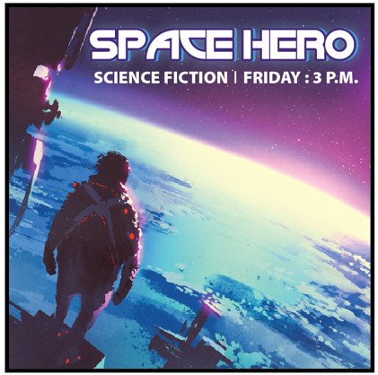 | 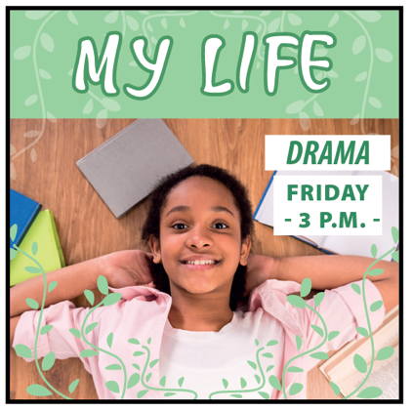
Fantastic | Funny
Lucas: Hey, Grace, I went to the cinema last (38) _________________.
Grace: Really? Me too. What was the movie you saw?
Lucas: I saw Space Hero.
Grace: What kind of movie was Space Hero?
Lucas: It was (39) _________________.
Grace: Was it good?
Lucas: Yes, it was fantastic. The story showed the hero, Clarke. He fought against invaders from Mars to save the Earth. It was very, very exciting.
Grace: What time was it on?
Lucas: At (40) _________________. How about you? What did you see?
Grace: I saw My life at 3p.m, too. It was a (41) _________________ about a young girl, Camelia.
Lucas: Did you like it?
Grace: Yes, absolutely. The story was really (42) _________________ and I laughed so much. This was a great movie. You should watch it.
VI. WRITING (1.6 points)
A. Put the words in the correct order to make correct sentences.
43. The/ ago/ ten/ started/ minutes/ film /.
→
44. watch/ you/ Did/ movie/ wild/ about/ the/ night/ animals/ last/ ?
→
45. is/ an/ movie/ on/ There/ action/ theater/ Saturday/ on/ at/ night/ movie/ the/.
→
B. Make questions for the underlined part.
46. My Spy is a comedy movie.
→
47. Jenna watched How To Train Your Dragon on TV last weekend.
→
C. Use the given words to make complete sentences.
48. Why/ not/ we/ meet/ movie theater/ 6 o’clock?
→
49. be/ football match/ Friday/ exciting/?
→
50. Mandy/ not watch/ drama/ TV/ last night/ because/ she/ tired.
→

***End – Of – Test***

