

Tiết thứ ......
UNIT 4: MUSIC AND ARTS
Lesson 3: A closer look 2
Class | Date of teaching | Attendence
7A | ..../09/2022
7B | ..../09/2022
7C | ..../09/2022
I. OBJECTIVES: By the end of this unit, students will be able to gain the following things:
1. Knowledge:
- Know how to recognize and write comparisons with like, different from, (not) as … as:
+ Vocabulary: - Use the vocabulary to talk about Music and arts:
+ Grammar: - Comparisons with like, different from, (not) as … as:
2. Competence:
a) General competencies:
Students will be able to know more words and phrases about music and arts; Develop communication skills and creativity; Actively join in class activities.
b) Specific competencies:
- Develop communication skills.
- Be cooperative and supportive in pair work and teamwork.
- Actively join in class activities.
3. Qualities:
- To educate the love of music and art.
- Be ready to know the words about music and arts.
- Develop self-study skills.
II. PREPARATIONS
- Teacher: Grade 7 text book, laptop, projector / TV/ pictures and cards.....
- Students : Text books, studying equipment….
III. PROCEDURE:
Notes: In each activity, each step will be represented as following:
* Deliver the task.
* Implement the task.
* Discuss.
* Give comments or feedback.
Activity 1. WARM UP (5’-IW, GW)
* Aim:
To activate students’ prior knowledge and vocabulary related to the targeted grammar.
To introduce the targeted grammar of the lesson.
* Content:
To have some warm-up activities to create a friendly and relaxed atmosphere to inspire Ss to warm up to the subject and new lesson.
* Product: Having a chance to speak English and focus on the topic of the lesson..
* Implementation:Teacher’s instructions…
Teacher’s & Student’s activities | Content
GAME: BRAINSTORMING  * Teacher asks students to work in 2 teams to think of as many adjectives to describe as possible.  ** Students work in 2 teams.  *** In 1 minute, students from each team, turn by turn, run to the board and write down one adjective.   Teacher comments and counts how many correct answers for each team.  - The team which has more correct answers will be the winner.  * Teacher shows the picture and asks students to use one adjective they have found to make comparisons.  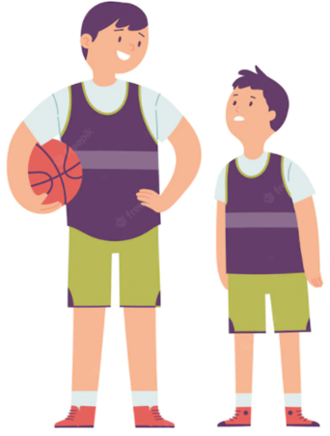  ** Students work individually.  *** Students give teacher a sentence:  “The boy on the left is taller than the boy on the right.”   Teacher gives feedback, then lead to the new lesson. | Suggested answers:  Adjectives  big, small, heavy, light, cheap, expensive, boring, interesting, special, fun, thin, fat, tall, short, handsome, ugly, etc.
Activity 2. KNOWLEDGE FORMATION (15'- PW, IW)
* Aim:
To introduce the form of comparisons to students.
* Content: Teach some new words.
* Product: Knowing more new words. Understanding the conversation; topic of the lesson, grammar points…
* Implementation: Teacher’s instructions…
Teacher’s & Student’s activities | Content
COMPARISONS  * Teacher prepares some pictures and asks students to make comparisons.  ** Students make comparison, using the pictures teacher shows on the screen.  Elicit the model sentences:  *** Students find out the form and the usage of comparisons using “like, different from, (not) as … as”   Teacher gives comments and writes on the board the form and the usage. | COMPARISONS  1. Teacher points to the yellow pencil and the orange pencil.    Students: The yellow pencil is shorter than the orange one.  Teacher: Right! Or I can say: “The yellow pencil is not as long as the orange one.”  2. Teacher points to the yellow pencil and the pen and asks students to focus on the length of the two things.    The pen is as long as the yellow pencil.  3. Teacher points to the yellow pencil and the pen again and has students focus on their shape.  The pen is different from the yellow pencil.  4. Teacher says: “This is Robert’s pencil case and this is Mary’s pencil case” and asks them make comparison with “like”.  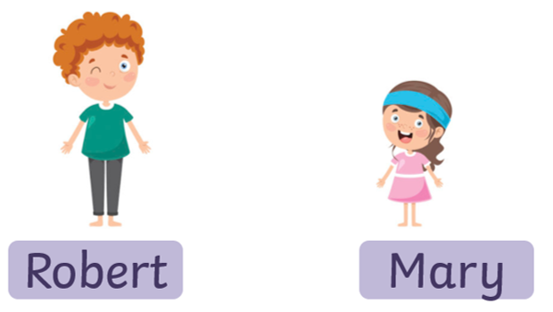  Robert’s pencil case is like Mary’s pencil case.  Concept checking:  + Form:  1. (not) as + adj + as  2. as + adj + as  3. to be different from  4. like  + Use: ask students to read “Remember box”, then teacher asks students some questions to check understanding.   Teacher gives comments and writes on the board the form and the usage.
Activity 3. PRACTICE (15’-IW, PW, GW)
* Aim:
To help students identify the correct form of comparisons using like, different from, (not) as … as.
To help students use the correct comparisons using like, different from, (not) as … as.
To help student practiSe using like, different from, (not) as … as.
To help students revise to write comparisons using like, different from, (not) as … as.
* Product: Ss can learn how to use the comparisons to do the excersises.
* Implementation: Teacher’s instructions…
Teacher’s Student’s activities | Content
1. Write like, as, or different in the blanks. (Ex 1, p. 43)  * Teacher asks students to do the exercise individually and then compare their answers with a classmate.  ** Students do the task individually.  *** Some students explain their choices.   Teacher confirms the correct answers. | 1. Write like, as, or different in the blanks. (Ex 1, p. 43)  Answer key:  1. as  2. like  3. different  4. as  5. different
2. Finish the second sentence in each pair, using like, as … as, or different from. (Ex 2, p. 43)  * Teacher has students do this exercise individually.  ** Students do the task individually.  *** Students give and explain their answers.  ****Teacher confirms the correct answers. | 2. Finish the second sentence in each pair, using like, as … as, or different from. (Ex 2, p. 43)  Answer key:  1. different from  2. like  3. as … as  4. different from  5. as … as
3. Compare the two museums: history and science, using like, as … as, or different from. (Ex 3, p. 43)  * Teacher asks students to work in pairs and helps them interpret the table first.  ** Students work in pairs to do the task and teacher encourages students to talk as much as possible.  *** Teacher calls on students to read aloud the complete sentences.   Teacher confirms the correct answers and helps them to correct mistakes if needed. | 3. Compare the two museums: history and science, using like, as … as, or different from. (Ex 3, p. 43)  Suggested answers:  1. The History Museum is not as modern as the Science Museum.  2. The staff in History Museum is as friendly as ones in Science Museum.  3. Things in History Museum are more interesting than things in Science Museum.  4. The price in History Museum is like in Science Museum.
4. Rewrite the sentences, using the words given at the beginning. (Ex 4, p. 43)  * Teacher asks students to do the task individually to write down the sentences in their notebooks.  ** Students do the task individually and compare with their partners.  *** Some students write their answers on the board.   Teacher confirms the correct answers. | 4. Rewrite the sentences, using the words given at the beginning. (Ex 4, p. 43)  Suggested answers:  1. I think comedies are not as interesting as action films.  2. Our history homework is not as difficult as our maths homework.  3. This year’s music contest is not like last year’s.  4. The characters in the film are different from the ones in the play.  5. That picture is not as bright as this one.
Activity 4. APPLICATION (7’-IW, PW, GW)
* Aim: To help students practise speaking, using like, different from, (not) as … as through pictures.
* Content: like, different from, (not) as … as
* Product: Ss can remember the words. Revise and learn more new words.
* Implementation: Teacher’s instructions
5. Look at the two pictures and compare them. (Ex 5, p. 43)  * Teacher asks students to work in groups to find out the similarities and differences between the two pictures and the things in them.  ** Students work in groups to do the task.  *** Students give as many sentences as possible.   Teacher listens to students to correct common errors after finishing speaking.  * Home assignment  Do exercises in the workbook. | 5. Look at the two pictures and compare them. (Ex 5, p. 43)  Suggested answers:  - Picture A is not as big as picture B.  - The cat in picture A is different from the cat in picture B.  - The cat in the house in picture A is like the cat in the house in picture B.  - The fish in picture A is not as big as the fish in picture B.  - The flower in picture A is not as small as the flower in picture B.  * Home assignment  Do exercises in the workbook.
V. FEEDBACK:
With 7A ……………………………………………………………………………..…
With 7B …………………………...……………………………………..……………
With 7C ………………………………………………………………………….……

