Date of planning:………….  Date of teaching: ………..…  WEEK: | Peroid .....: UNIT 3: COMMUNITY SERVICE  Lesson 2 : A CLOSER LOOK - 1
THIS UNIT INCLUDES:
Vocabulary  - Community activities  Pronunciation:  - Pronunciation Sounds: /t/, /d/, and /id/  Grammar  - Past simple | Skills:  - Reading about community activities at a school  - Talking about the reasons why students join different community activities  - Listening to a talk about some community activities and their benefits  - Writing an email about community activities one did last summer  Everyday English  - Giving compliments
I. OBJECTIVE: By the end of this lesson, students will be able to gain the following things :
1. Knowledge:
- To introduce topic of the lesson Community serv ice. To teach some new words .
- Vocabulary: Use words related to community activities.
- Pronunciation: Correctly pronounce the sounds: /t/, /d/, /ɪd/ in isolation and in context.
+ Vocabulary: Use the lexical items related to community activities.
- Pronouncing the sounds /t/, /d/, and /id/ .
+ Grammar: - Past simple
2. Competence: Students will be able to practice listening for specific information about some community activities and their benefits; Practicing writing an email about community activities one did last summer.
- Develop communication skills and creativity.
- Be co-operative and supportive in pair work and teamwork.
- Actively join in class activities
3. Qualities : - Raise students’ awareness of the need to keep their neighbourhood green.
- Have the good attitude to working in groups, individual work, pair work, cooperative learning.
- Develop self-study skills.
II. TEACHING AIDS:
- Teacher: Grade 7 text book, laptop, projector / TV/ pictures and cards.....
- Students : Text books, studying equipment….
- Computer connected to the Internet.
- Sach mem.vn
III. PROCEDURE:
Notes: In each activity, each step will be represented as following:
* Deliver the task.
* Implement the task.
* Discuss.
* Give comments or feedback.

1. WARM UP & INTRODUCTION (5’)
Vocabulary
Aim: To introduce some verbs and verb phrases that are often used to describe community activities.
* Content: Review the previous lesson. Guessing game
* Outcome: Having a chance to speak English and focus on the topic of the lesson..
* Organisation :Teacher’s instructions…
Teacher’s & Student’s activities | Content
+ Greeting  + Playing game: Matching game  * Teacher has students play in two groups and explains the game rules.  - Each group will have a list of verbs and nouns. Students match the verbs they have with the correct nouns.  -Teacher and students discuss the answers. The group with the most correct answers wins.  -Teacher confirms the answers and gives feedback.  - Show the winners.  - Ask Ss to open their book and introduce what they are going to study…. | + Greeting  + Playing game : Matching game  - T_ Ss  - Students (Ss) listen and learn how to do.  Set of word cards:  recycle help plant  trees vegetables small children old people  books bottles litter homeless children  - Open their book and write .
2. PRESENTATION/ NEW LESSON (12’)
ACTIVITY 1:
Aim: To introduce some verbs and verb phrases that are often used to describe community activities.
* Content: Teach some new words . Match a verb in A with a word or phrase in B
* Outcome: Ss know more new words. Learn how to use them . Do the Matching correctly.
* Organisation :
Teacher’s & Student’s activities | Content
1. Match a verb in A with a word or phrase in B.  *) Pre- teach vocabulary:  - Teacher uses different techniques to teach vocabulary (situation, realia, translation .....)  + Teacher may introduce the vocabulary by:  - providing explanations of the words;  - showing picture illustrating the word.  + Follow the steps to teach vocabulary  - Repeat in chorus and individually  + Check vocabulary  - Have Ss read aloud the verbs in A and words / phrases in B.  - Ask Ss to work in pairs to match the verbs in A with words / phrases in B. The only new word is tutor, and it can also be inferred when all other options have been matched.  - Tell Ss that to tutor means to teach.  - Invite Ss to take turns to read out their answers. Correct their pronunciation if needed.  - Check the answers as a class.  - T can also ask Ss to add more words / phrases to the verbs to make up other activities they can do. This way, T can broaden Ss' vocabulary if they are ready. | 1. Match a verb in A with a word or phrase in B.  - T_ Ss  * Vocabulary:  1. exchange (v) trao đổi  2. pick up (phr. v.) nhặt lên  3. tutor (v) dạy kèm  .......  + Students (Ss) listen to the instructions carefully and learn how to do the tasks.  * Key:  1. e 2. a 3. d 4. c 5. b
3. PRACTICE (15’)
ACTIVITY 2:
Aim: To allow Ss to use the learnt words / phrases in contexts
* Content: Complete the sentences with a suitable word or phrase.
* Outcome: Ss can complete the sentences correctly. Learn how to use the words.
* Organisation :
Teacher’s Student’s activities | Content
2. Complete each of the sentences with a suitable word or phrase from the box.  - Ask Ss to work individually to complete each of the sentences with a suitable word / phrase from the box. All of these words / phrases have been learnt in 1.  - Check the answers as a class.  - Have some Ss read aloud the complete sentences.  - Correct Ss' pronunciation if necessary. | 2. Complete each of the sentences with a suitable word or phrase from the box.  - Listen carefully and learn how to do.  - Give the answer  * Key:  1. litter 2. used paper for notebooks  3. water 4. donate 5. tutor
ACTIVITY 3:
Aim: To have Ss practise producing full sentences using the learnt phrases.
* Content: Write full sentences under the correct pictures
* Outcome: Ss can write full sentences under the correct pictures correctly:
* Organisation :
3. Use the phrases from the box to write full sentences under the correct pictures.  - Ask the whole class to read aloud the six phrases. Correct their pronunciation if necessary.  - Ask Ss to work in pairs to describe the pictures, using the given phrases. Ask some Ss to re-describe the pictures to the class.  - Then ask them to work individually to write full sentences, using the given phrases. Then they share their answers with a partner.  - Check the answers as a class.  - T can also ask some Ss to write answers on the board, then check their answers as a class.  - T and other Ss give comments.  * Key:  1. She's reading books to the elderly.  2. They're giving gifts to old people.  3. He's exchanging used paper for notebooks.  4, They're donating clothes to poor children.  5. She's planting trees in the park. | 3. Use the phrases from the box to write full sentences under the correct pictures.  - Ss to work individually.  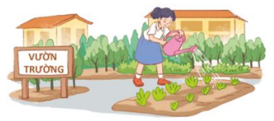  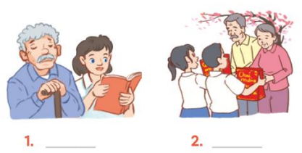  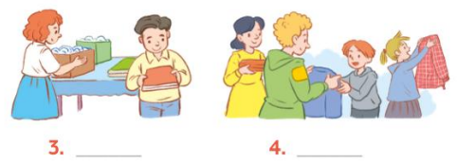  * Key
II. PRONUNCIATION: (10’)
Sounds /t/, /d/, and /id/
ACTIVITY 4
Aims:
- To help Ss identify how to pronounce the sounds /t/, /d/, and /id/;
- To help Ss practise pronouncing the sounds in words.
* Content: Listen and repeat the word to pay attention to the sounds: /t/, /d/, and /id/.
* Outcome: Ss can learn how to pronounce the sounds: /t/, /d/, and /id/.
* Organisation :
Teacher’s Student’s activities | Content
4. Listen and repeat. Pay attention to the sounds /t/, /d/, and /id/.  - Have Ss listen to the recording once first. Then ask Ss to read out the words.  - Play the recording for them to listen again and repeat each word as a class, then as individuals.  - Play the recording as many times as possible.  - Call on some Ss to say the words In front ofthe class.  - Check their pronunciation If necessary.  - Call on some Ss to read the words aloud. | 4. Listen and repeat. Pay attention to the sounds /t/, /d/, and /id/.  - Listen carefully  - Listen and repeat  * Audio script- track:  /t/ /d/ /id/  cooked passed helped watered cleaned voluteered collected donated provided
4. FURTHER PRACTICE (8’)
ACTIVITY 5:
Aim: To help Ss practise pronouncing the sounds /t/, /id/, and /id/ in sentences.
* Content: Listen and pay attention to the underlined parts
* Outcome: Ss will be able to pronounce the sounds correctly.
* Organisation :

5. Listen to the sentences and pay attention to the underlined parts. Tick (✓) the appropriate sounds. Practise the sentences.  - Have some Ss read the sentences first. Ask them to pay attention to the underlined parts.  - Play the recording for Ss to listen then have them tick the appropriate sounds.  - Invite some Ss to share their answers. Confirm the correct ones.  - Play the recording again and ask Ss to repeat each sentence after the recording.  - Correct Ss if necessary.  - Call some Ss to read the sentences individually.  - Comment on their pronunciation . | 5. Listen to the sentences and pay attention to the underlined parts.Tick (✓) the appropriate sounds. Practise the sentences.  - T_ Ss  - S do the tasks  * Audio script  * Key + Audio script-Track 16:  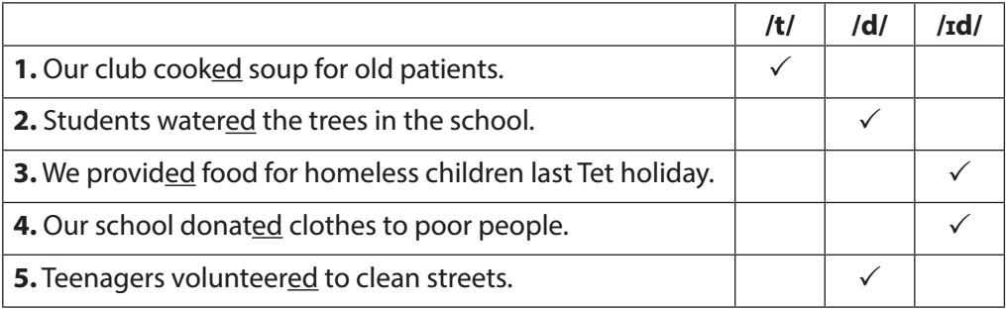
5. WRAP-UP & HOME WORK (2’)

- Ask Ss to summarise what they have learnt in the lesson.
- Ask them to list some phrases about community activities they learnt in the lesson.
- Ask them to list some verbs in the past simple, paying attention to their pronunciation.
* HOME WORK
- remember some verbs in the past simple
- Do more exercises in workbook.
- Prepare new lesson. A CLOSER LOOK_2

=======================================

