UNIT 2: HEALTH

A. VOCABULARY
Lesson 1
No | Words | Class | Transcription | Meaning
1 | drink | (v) | /drɪŋk/ | uống
2 | eat | (v) | /it/ | ăn
3 | fast food | (n) | /fæst fud/ | thức ăn nhanh
4 | fruit | (n) | /frut/ | trái cây
5 | get | (v) | /gɛt/ | nhận được
6 | healthy | (a) | /ˈhɛlθi/ | khoẻ mạnh, có lợi cho sức khoẻ
7 | junk food | (n) | /ʤʌŋk fud/ | thức ăn nhanh có hại cho sức khỏe
8 | lifestyle | (n) | /ˈlaɪfˌstaɪl/ | cách sống, cách sinh hoạt
9 | sleep | (v) | /slip/ | giấc ngủ
10 | soda | (n) | /ˈsoʊdə/ | nước xô-đa
11 | unhealthy | (a) | /ənˈhɛlθi/ | ốm yếu, có hại cho sức khoẻ
12 | vegetable | (n) | /ˈvɛʤtəbəl/ | rau củ

Lesson 2
No | Words | Class | Transcription | Meaning
10 | feel | (v) | /fil/ | có cảm giác, cảm thấy
11 | fever | (n) | /ˈfivər/ | cơn sốt
12 | get rest | (v) | /gɛt rɛst/ | nghỉ ngơi
13 | have | (v) | /hæv/ | sở hữu, có
14 | keep | (v) | /kip/ | giữ, duy trì
15 | late | (a) | /leɪt/ | trễ
16 | lazy | (a) | /ˈleɪzi/ | lười
17 | medicine | (n) | /ˈmɛdəsən/ | thuốc
18 | sore throat | (n) | /sɔr θroʊt/ | đau họng
19 | stay up late | (v) | /steɪ ʌp leɪt/ | thức khuya
20 | take | (v) | /teɪk/ | ăn uống
21 | vitamin | (n) | /ˈvaɪtəmən/ | vitamin
22 | warm | (a) | /wɔrm/ | ấm
23 | weak | (a) | /wik/ | yếu

Lesson 3
No | Words | Class | Transcription | Meaning
24 | cafeteria | (n) | /ˌkæfəˈtɪriə/ | quán ăn, căn tin
25 | effectively | (a) | /ɪˈfɛktɪvli/ | hiệu quả
B. GRAMMAR
I. Indefinite quantifiers
1. Cách dùng:
a little: 1 vài, 1 chút, 1 ít (dùng trong câu khẳng định với danh từ không đếm được)
some: 1 vài, 1 chút, 1 ít (dùng trong câu khẳng định với danh từ đếm được số nhiều hoặc danh từ không đếm được)
any: 1 vài, 1 chút, 1 ít (dùng trong câu phủ định hoặc nghi vấn)
many: nhiều (dùng với danh từ đếm được)
(not) much: nhiều (dùng với danh từ không đếm được, thường dùng trong câu phủ định và nghi vấn)
lots of/ a lot of: nhiều (dùng với danh từ đếm được số nhiều và danh từ không đếm được)

2. Ví dụ:
- I drink a little orange juice every morning.
- My mother eats some fruit after lunch.
- She doesn’t eat any meat.
- My sister bought many oranges and apples yesterday.
- I don’t do much exercise so I am getting fat.
- We should drink a lot of water every day.
- We should eat lots of vegetable and fruit. It’s good for our health.

II. Should and shouldn’t
1. Cách dùng:
We can use should to give advice and we can use should to ask for advice.
(Chúng ta dùng should và shouldn’t để đưa ra lời khuyên và chúng ta cũng có thể dùng should để hỏi về lời khuyên)

2. Ví dụ:
- You should do morning exercise to be healthier.
- We should eat fresh food.
- They should get some rest now.
- You shouldn’t drink much beer. It isn’t good for your health.
- We shouldn’t eat much fast food.
- They shouldn’t play online games much more. It can be addictive.
- Should I eat fast food? No, you shouldn’t.
- Should I sleep more? Yes, you should.
- Should I do morning exercise? Yes, you should.
- What should I do to keep my body fit?
C. PRACTICE
Lesson 1
I. Look at the words in the box and write the suitable word for each picture.

get some sleep eat fruit and vegetables eat fast food drink soda healthy unhealthy

 | 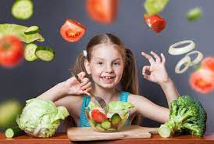 | 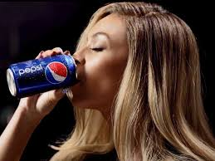
1. | 2. | 3.
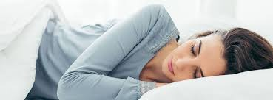 | 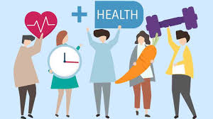 | 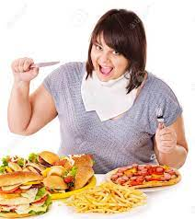
4. | 5. | 6.

II. Fill in the blanks with words in the box to complete the sentences.

fruit soda sleep fast food unhealthy healthy vegetables
1. My mom usually gives me an apple or oranges for snacking. She wants me to eat more__________.
2. It's a good idea to eat__________ like carrots and onions, with meat and fish.
3. My brother is unhealthy because he eats too much__________.
4. __________ drinks such as cola has a lot of sugar.
5. I try to get at least eight hours of__________ every night.
6. You should do more exercise to stay__________.
7. Hannah's eating habits is__________. She has sweets and soda drinks with every meal.

III. Choose the suitable word to complete the sentences.
1. I don’t eat any/ some fast food.
2. We should drink any/ some fruit juice now.
3. She doesn’t do any/ some exercise today.
4. My brother can play any/ some sports such as: soccer, volleyball, badminton, table tennis…
5. She does many/ a little exercise in the morning.
6. How much/ any fruit do you eat every day?
7. We should drink lots of/ much water every day.
8. My daughter doesn’t watch much/ many TV every day.
9. Tommy doesn’t eat any/ a little salad every day.
10. How much/ many beer does your father drink every week?

Lesson 2
I. Look at the words/ phrases in the box and write the suitable word for each picture.
feel weak have a sore throat get some rest take vitamins
have a fever take medicine stay up late keep warm have a stomachache
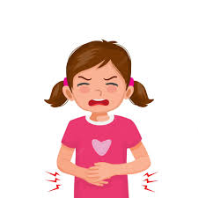 | 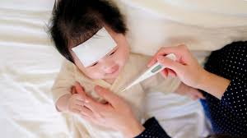 | 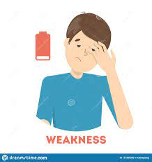
1. | 2. | 3.
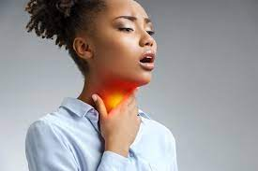 | 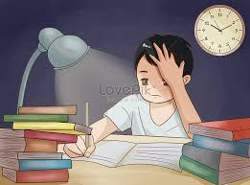 | 
4. | 5. | 6.
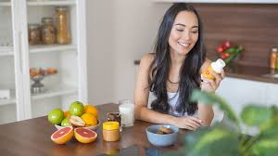 | 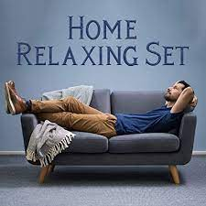 | 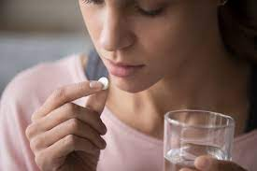
7. | 8. | 9.
.
II. Fill in the blanks using the words in the box from exercise I.
1. I have no energy and can't do any work. I feel__________.
2. I feel very hot and sick. I think I have a__________.
3. The doctor told me to__________ __________ after eating, three times a day.
4. If you eat a healthy diet, you don't need to__________ __________.
5. You should wear a thick jacket and scarf to__________ __________ in winter.
6. I have a cough and a__________ __________. It hurts when I drink.
7. Many teens__________ __________ __________ to do homework or watch TV. That's bad for their health because they won't get enough sleep.
8. You look tired. You should__________ __________ __________.
9. My little daughter ate some strange seafood at the restaurant yesterday. So she __________ __________ __________now.

III. Use should/ shouldn’t to complete the sentences.
1. She has a toothache. She should/ shouldn’t eat so much candy.
2. I have a headache. I should/ shouldn’t take some medicine.
3. Mary wants to lose weight. She should/ shouldn’t eat junk food more.
4. What should I do to lose weight? - You should/ shouldn’t eat more fruit and vegetables.
5. You look very tired. You should/ shouldn’t get some rest.
6. Linda has a stomachache. - She should/ shouldn’t drink so much soda.
7. I feel tired. You should/ shouldn’t take a rest and sleep enough.
8. I have a sore eye. You should/ shouldn’t play a lot of video games.
9. I am putting on weight. You should/ shouldn’t do more exercise.
10. This food contains a lot of fat and sugar. You should/ shouldn’t eat too much.

Lesson 3
TEST FOR UNIT 2
I. Choose the words whose underlined part is pronounced differently from that of the others in each group.
1. A. fast B. stay C. take D. lazy
2. A. ice cream B. medicine C. vitamin D. life
3. A. hand B. hurt C. hour D. health
4. A. sleep B. soda C. sick D. sugar
5. A. headache B. meat C. eat D. weak
6. A. enough B. should C. trouble D. amount
7. A. news B. things C. students D. brains
8. A. vegetables B. smoothies C. lifestyles D. lunches
9. A. rested B. asked C. helped D. placed
10. A. sounded B. presented C. visited D. checked

II. Choose the word whose main stressed syllable is placed differently from that of the other in each group.
11. A. healthy B. lifestyle C. soda D. advice
12. A. candy B. doctor C. address D. dentist
13. A. midnight B. problem C. structure D. repeat
14. A. solution B. chocolate C. principal D. exercise
15. A. understand B. interview C. introduce D. underline
III. Choose the best answer to complete each sentence.
16. How much exercise__________ your brother do every week?
A. do B. does C. did D. is
17. Let’s go to the__________. I would like to eat seafood.
A. restaurant B. cafeteria C. sports centre D. school
18. I have a lot of energy and I can do a lot of work. I feel__________.
A. weak B. unhealthy C. strong D. tired
19. She feels hot and sick. I think she has__________.
A. a fever B. a headache C. earache D. sore eye
20. We don’t enjoy__________ fast food. It isn’t good for our health.
A. eat B. ate C. eaten D. eating
21. How much soda__________ you drink every week?
A. do B. did C. does D. are
22. My mother doesn’t eat__________ junk food.
A. some B. any C. a little D. many
23. Fast food is a (an)__________ food for children who are putting on weight.
A. healthy B. unhealthy C. good D. better
24. My sister should__________ medicine because she has a fever now.
A. taking B. having C. have D. take
25. If you__________ vitamins every day, your skin will be very fair.
A. take B. took C. taking D. taken

IV. Supply the correct forms of the given words to complete the sentences.
26. Having a________ lifestyle is very important. (health)
27. Unhealthy habits will make you tired and________. (weight)
28. Having enough sleep will help you focus and remember things more________. (easy)
29. She should go to the doctor because she has a________. (ear)
30. My________ even falls asleep at her desk because she stayed up too late last night. (class)

V. Choose the word which best fits each gap.
My friend, John, has had a few problems with his health. He didn't feel well, (31)__________ he told his parents about that. His mum said, "You should eat more vegetables. You shouldn't eat (32)__________ every day." His dad said, "You should go to bed earlier. You (33)__________ stay up so late at night." He phoned me and told me about the problems. I said, "Don't play so many computer games. Go outside and play football."
He didn't go to school last week. He went to (34)__________ the doctor. The doctor said, "You should stay at home for a week. Don't go out and don't turn on your computer."
At school today, he looked sad. We asked him, "What's wrong? You should be happy. You weren't here last week."
John is (35)__________ his school work from last week. He's not happy at all.
31. A. because B. or C. and D. but
32. A. ready food B. fresh food C. traditional food D. junk food
33. A. should B. shouldn’t C. must D. mustn’t
34. A. see B. look C. look at D. find
35. A. taking B. making C. doing D. playing

VI. Read the text and choose the correct answer.
KEEPING OUR TEETH HEALTHY
It's very important to have healthy teeth. Good teeth help us chew our food. They also help us look nice. How does a tooth go bad? The decay begins in a little crack in the enamel covering of the tooth. This happens after germs and bit of food have collected there. Then the decay slowly spreads inside to the tooth. Eventually, poison goes into the blood, and we may feel quite ill.
How can we keep our teeth healthy? First, we ought to visit the dentist twice a year. He can fill the small holes in our teeth before they destroy the teeth. He can examine our teeth to check that they are growing in the right way.
Secondly, we should brush our teeth with a toothbrush and fluoride toothpaste at least twice a day once after the breakfast and once before we go to bed. We can also use wooden toothpicks to clean between our teeth after a meal.
Thirdly, we should eat food that is good for our teeth and our body: milk, cheese, fish, brown bread, potatoes, red rice, raw vegetables, and fresh fruits. Chocolates, sweets, biscuits and cakes are bad, especially when we eat them between meals. They are harmful because they stick to our teeth and cause decay.
36. Good teeth help us__________ our food.
A. be nice B. have good eyesight
C. chew D. be important

37. When food and germs collect food in a small crack, our teeth__________.
A. become hard B. send poison into the blood
C. begin to decay D. make us feel quite ill

38. A lot of people visit the dentist only when__________.

A. their teeth grow properly B. they have holes in their teeth
C. they have toothache D. they have brush their teeth
39. we ought to clean our teeth__________.
A. once a day B. at least twice a day
C. between meals D. before breakfast

40. We shouldn’t eat too much__________.
A. red meat B. fresh fruit
C. fish D. chocolate

VII. Rewrite the following sentences without changing the meaning.
41. My mother loves doing morning exercise. (fond)
→ My mother is__________________________________________________________________
42. Let’s go to the cafeteria this afternoon!
→ How_________________________________________________________________________
43. Eating fruit and vegetables is healthy.
→ It is__________________________________________________________________________
44. I would to drink some orange juice now.
→ I want________________________________________________________________________
45. Don’t forget to sleep at least eight hours a day. It’s enough for you!
→ Remember____________________________________________________________________

VIII. Put the words in the correct order to make correct sentences.
46. I/ do/ every day./ think/ we/ morning exercise/ should _______________________________________________________________________________
47. You/ junk food./ so/ much/ eat/ shouldn’t
_______________________________________________________________________________
48. How much/ do/ eat/ every week?/ fast food/ you
_______________________________________________________________________________
49. The dentist/ me/ to/ told/ brush / teeth/ my/ three times/ a day.
_______________________________________________________________________________
50. I/ am/ to/ keep my/ health/ doing/ by/ trying/ exercise every day.
_______________________________________________________________________________

