Question 29. Question 30.
What does the sign say?
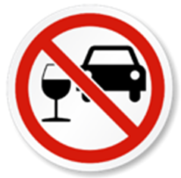 | A. You mustnt’ be careful with drunk drivers.  B. You shouldn’t carry glasses in your car.  C. You should be careful as there is a pub ahead.  D. You mustn’t drive if you drink alcohol.

What does the notice say? | 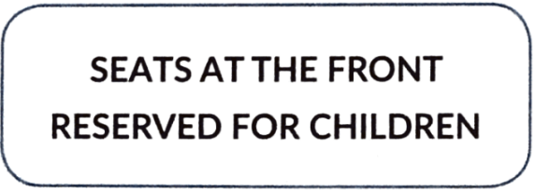
A. The front seats are only for children.
B. Children are not allowed to sit here.
C. Adults have to sit at the front.
D. There is no more seat for adults.

