SPEAKING TEST ENGLISH 7
UNIT 3: COMMUNITY SERVICE
A. Introduction: (0.4 pt)
B. Pictures Cue (Vocabulary): 1.0 pt (5 questions):

  1  2  3  4  5  6  7  9  10  11  12  8 | 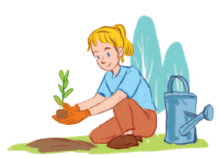 |  | 
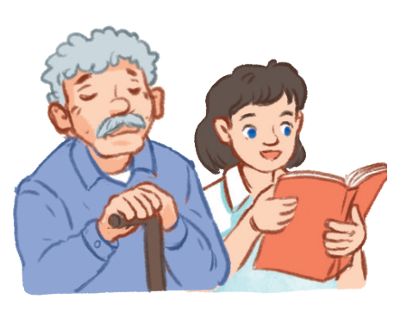 | - What’s this?/What are these? (1,9)  - What does she like doing? (2,7,11,12)  - What did they do last summer?(4,5,10)  - It’s an activity that helps the old people relax?(4,12)  - It’s an activity that helps the street children to learn?(11)  - It’s a verb that means giving s.th to s.o/ helping children how to know to read and write. |  | 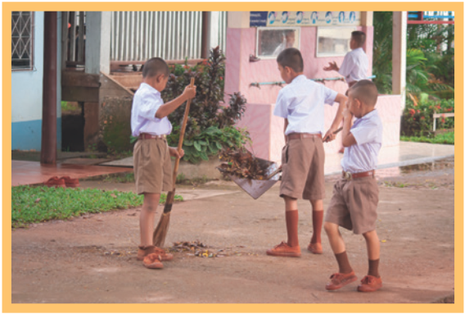
 |  |  | TUTOR
 |  |  | 