School: ……………………………………….. | Date:………………………………..
Class: ……………………………..................... | Period: ……………………….........

UNIT 6: LIFE ON OTHER PLANETS
Lesson 2.1 – Grammar (pages 59 & 60)

I. OBJECTIVES
By the end of the lesson, Ss will be able to
1.1. Language knowledge and skills
- listen to song-based activities using target structures/ expression.
- practice and use Past Continuous and Past Simple correctly.
1.2. Competences
- improve Ss’ communication, collaboration, analytical and critical thinking skills.
1.3. Attributes
- be aware of what will happen in the future.
II. TEACHING AIDS AND LEARNING MATERIALS
1. Teacher’s aids: Student book and Teacher’s book, class CDs, Digital Book (DCR phần mềm tương tác SB, DHA (từ vựng/ cấu trúc) phần mềm trò chơi tương tác), projector/interactive whiteboard / TV (if any), PowerPoint slides, handouts.
2. Students’ aids: Student’s book, workbook, notebook.
III. ASSESSMENT EVIDENCE
Performance Tasks | Performance Products | Assessment Tools
- Listen to the song and identify verbs. | - Ss’ performance. | - T’s feedback.
- Study the grammar box. | - Ss’ task. | - T’s observation.
- Fill in the blanks with the form of verbs in brackets. | - Ss’ answers. | - T’s feedback/Peers’ feedback.
- Write sentences using the prompts ‘when’ | - Ss’ answers. | - T’s feedback/Peers’ feedback.
- Ask and answer using the prompts (in pairs). | - Ss’ performance/ presentation. | - T’s observation, T’s feedback/Peers’ feedback.

IV. PROCEDURES
A. Warm up: (5’)
a) Objective: Introduce the new lesson and set the scene for Ss to acquire new language; get students' attention at the beginning of the class by enjoyable and short activities as well as to engage them in the follow-up steps.
b) Content: Reviewing phrases about possible UFO and alien sightings in the past and introducing Past Continuous and Past Simple.
c) Expected outcomes: Ss review their previous knowledge and have general ideas about the grammar point they are going to study in the new lesson.
d) Organization of the activity:
TEACHER’S ACTIVITIES | STUDENTS’ ACTIVITIES
* OPTION 1: Listen to the song and write down verbs in the past simple.  - Introduce the song Because You Loved Me by Celine Dion: https://www.youtube.com/watch?v=n582rjoeE2o    - Play the song and ask Ss in four groups to write down as many verbs in the Past Simple as they can remember in two minutes in a sheet of paper.  - Have Ss write their answers on the board.  - Tell that the group with more correct past tense verbs will be the winner.  - Show the answers of 19 verbs.  - If there is time left, have Ss identify regular and irregular verbs they listened in the song.  - Lead to the new lesson.  * OPTION 2:  - Have Ss look at the picture – page 59.    - Have some Ss read the sentences in the bubbles aloud.  - Have Ss fill in the blank.  - Give feedback.  - Lead to the new lesson. | -Listen to the song.  - Work in groups.  - Give answers.  Answers keys  19 verbs: lifted, believed, loved, carried, blessed, stood, made, brought, found, held, let, saw, were, was, could, gave, lost, said, had.  Regular Verbs: lifted, believed, loved, carried, blessed.  Irregular Verbs: stood, made, brought, found, held, let, saw, were, was, could, gave, lost, said, had.  - Look at the picture.  - Read the sentences aloud.
B. New lesson (35’)
- Activity 1: Presentation (10’)
a) Objective: Introduce Past Continuous and Past Simple.
b) Content: Practicing the grammar point.
- Listen and repeat.
- Introduce the grammar point: Past Continuous and Past Simple.
c) Expected outcomes: Ss know how to use Past Continuous and Past Simple to do some following exercises.
d) Organization of the activity:
TEACHER’S ACTIVITIES | STUDENTS’ ACTIVITIES
Tasks a & b. Read about Past Continuous and Past Simple and fill in the blank. Listen and check your answers. Listen again and repeat.  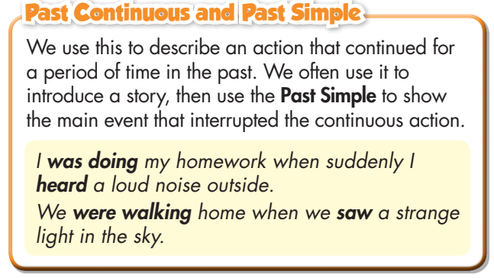  - Have students look at the grammar explanation, regarding the box with the different forms.  - Have some students read the sentences aloud.  - Play audio (CD2 – Track 9) and have Ss listen, check answers, then read the speech bubbles.  - Play the audio again and have Ss listen and repeat.  - Briefly explain meaning and use of the grammar point, using the time line as follows:  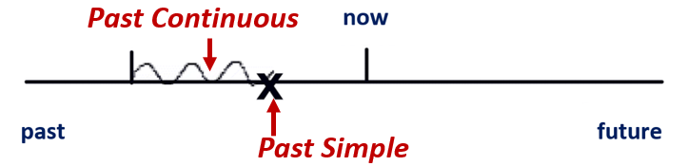  - Ask Ss to give more verbs and make sentences with them.  →Lead to the grammar box as follows:  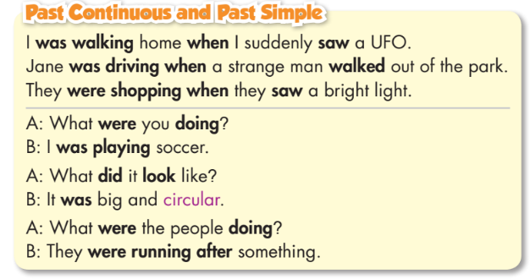  - Have Ss look at the grammar explanation with the different forms of the verbs.  - Summarize the form, use and time makers of the tenses.  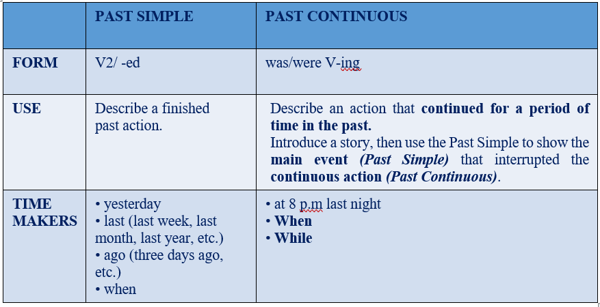  - Focus on the forms of the Past Continuous.  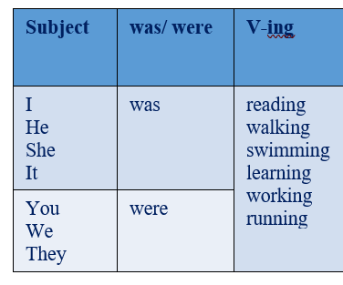  -Have some Ss read the sentences aloud.  - Give feedback. | - Look.  - Listen, then read.  - Listen and repeat.  - Give more verbs and make sentences.  - Look and read.  - Read the sentences aloud.

- Activity 2: Practice (19’)
a) Objective: Students can use Past Continuous and Past Simple correctly.
b) Content: Performing the tasks, using the grammar point.
- Read the examples above and fill in the blanks with the words from the box.
- Write sentences using the prompts, when, and the correct form of the verbs.
c) Expected outcomes: Students can use Past Continuous and Past Simple in their speaking.
d) Organization of the activity:
TEACHER’S ACTIVITIES | STUDENTS’ ACTIVITIES
Task a. Read the examples above and fill in the blanks with the words from the box.  - Demonstrate the activity using the example.  - Have students fill in the blanks with the words from the box.  - Have pairs check each other's work.  - Have some students share their answers with the class.  - Give feedback and correct Ss’ answers if necessary. | - Look and listen.  - Work individually.  - Work in pairs.  - Write answers on the board.  Keys  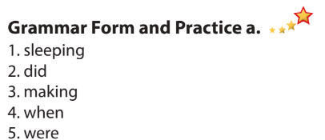
Task b. Write sentences using the prompts, when, and the correct form of the verbs.  - Demonstrate the activity using the example.  - Have students write the answers.  - Have pairs check each other's work.  - Have some students share their answers with the class.  - Check Ss’ answers, give feedback. | - Look and listen.  - Work individually.  - Work in pairs.  - Read or write answers.  Answer keys  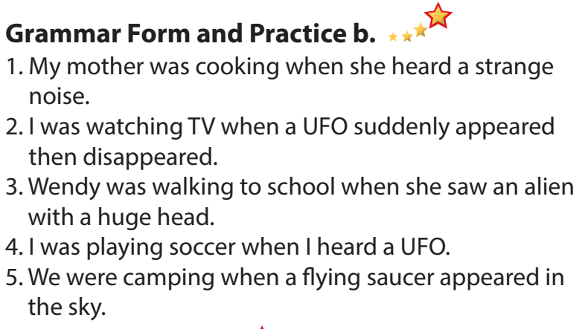
- Activity 3: Production (6’)
a) Objective: Students master the grammar point they study in the lesson.
b) Content: Speaking: Ask and answer using the information in Task c.
c) Expected outcomes: Ss produce the new language successfully, and they can apply the grammar point they have learnt in speaking and writing.
d) Organization of the activity:
TEACHER’S ACTIVITIES | STUDENTS’ ACTIVITIES
Task c. In pairs: Practice making sentences using the prompts below.  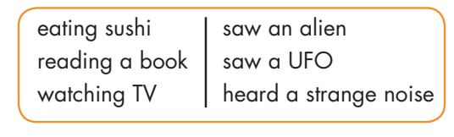  - Divide the class into pairs.  - Have students take turns making sentences using the prompts.  - Have some students demonstrate the activity in front of the class.  - Encourage Ss to add their own ideas.  - Have some pairs demonstrate the activity in front of the class.  - Give feedback. | - Work in pairs.  - Have conversation in pairs.  - Present.  - Listen.  Suggested Answers  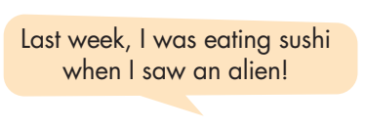

C. Consolidation and homework assignments (5’)
*Consolidation: Meaning, form and use of Past Continuous and Past Simple, using when.
WHAT WERE YOU DOING THEN?
- Work in pairs.
- Talk about what you saw/ felt/ did… when you were doing something yesterday.
* Homework:
- Make three sentences, using Past Continuous and Past Simple.
- Do the exercises in WB: Grammar (page 35).
- Complete the grammar notes in Tiếng Anh 8 i-Learn Smart World Notebook (page 51).
- Play the consolidation games in Tiếng Anh 8 i-Learn Smart World DHA App on www.eduhome.com.vn
- Prepare: Lesson 2.3 – Pronunciation and Speaking (pages 60 & 61 – SB).
V. Reflection
a. What I liked most about this lesson today:
…………………………………………………………………………………………
- What I learned from this lesson today:
…………………………………………………………………………………………
c. What I should improve for this lesson next time:
…………………………………………………………………………………………

