SPEAKING TEST ENGLISH 6
UNIT 1: MY NEW SCHOOL
A. Introduction - 0.4 pt (~3 ideas):
B. Cue pictures (Vocabulary) – 1.0 pt (~5 questions):

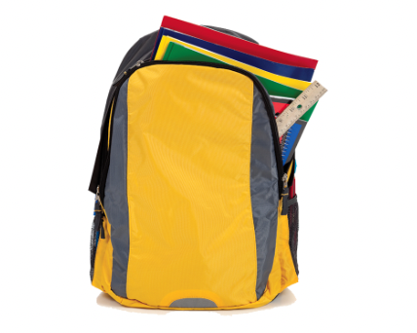  1 | 2   | 3  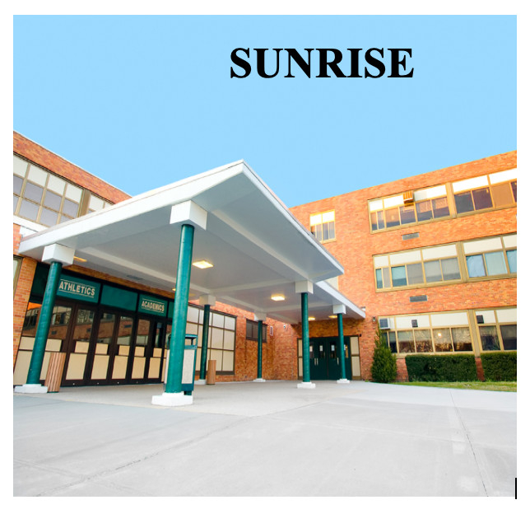 | 4  
12   | - What school thing is it? 1/5/8/11  - Which subject does he/she like? 9/10  3. Students have to wear it when they go to school. 6  4. This is a school where students live and study. They only go home at weekends. 3  5. What does he often do after school? 2/7  6. What do the students usually do to relax? 4,12 |  | 5  
11  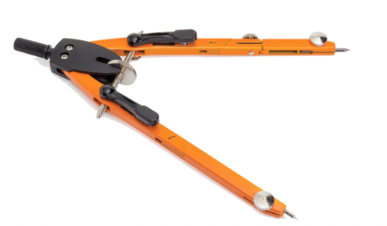 |  |  |   6
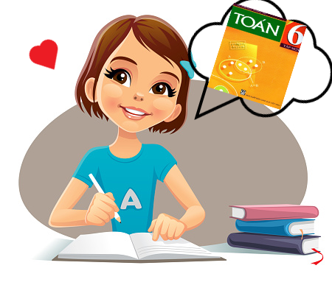  100 | 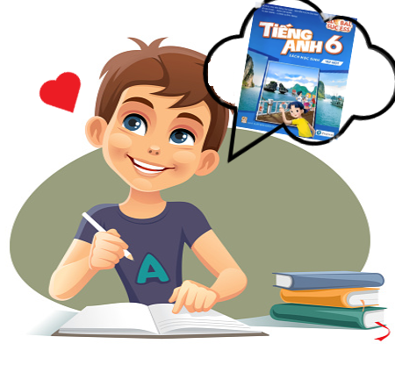  9 | 8   | 7  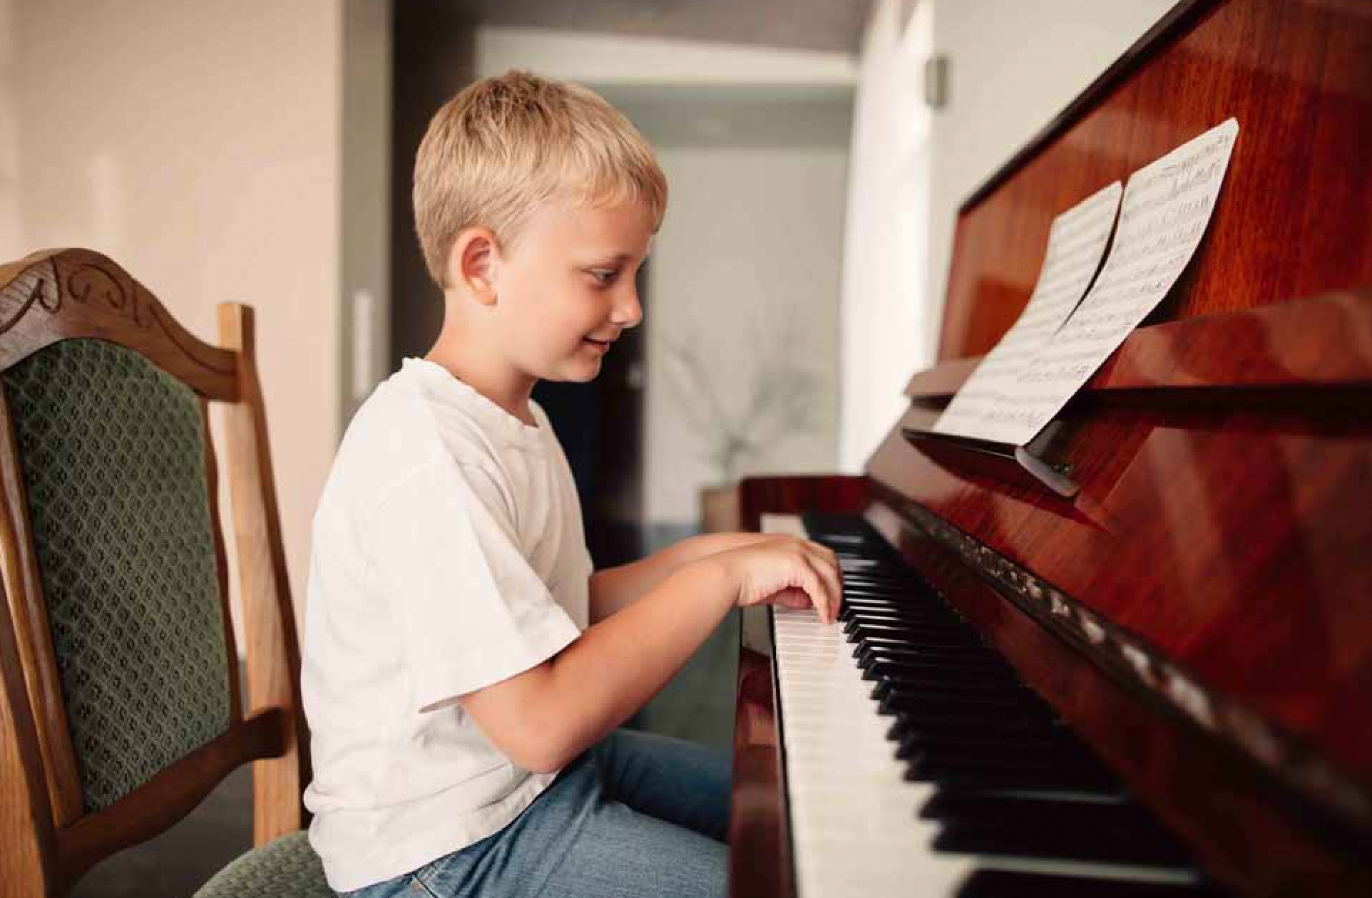

C-Interview/ Role-play – 0.6 pt (~3 questions/ 1 student)
Student A - B/ / Student - Teacher
1.What time do you go to school?
2. How do you go to school?
3. What is your favourite subject at school?
4. How many students are there in your class?
5. What do you like about your school?Why?
6. Which school would you like to go to: boarding school or international school? Why?

SUGGESTED KEY for SPEAKING:

A. Introduction - 0.4 pt (~3 ideas):
B. Cue pictures (Vocabulary) – 1.0 pt (~5 questions):
1-school bag | 2-do homework | 3- boarding school | 4 – play football
5-calculator | 6- uniform | 7-play the piano | 8- rubber
9- English | 10-Maths | 11-compass | 12- play music/the guitar
C-Interview/ Role-play – 0.6 pt (~3 questions/ 1 student)
Student A - B/ / Student - Teacher
1. (Time) eg: at 6.30– Speaking part in WB
2. By bike/ By motorbike/ On foot - Communication
3. English/ Maths/ History - Communication
4. About 40 students
5. I like my teachers/ school yard… - Skills 2
6. I would like to go to an international school. Because I want to study with the English-speaking teachers… - Skills 1
***Teachers depend on Ss’ answers to mark their speaking test flexibly

