|  |  |
| --- | --- |
|  | *Thời gian làm bài: 40 phút (Không kể thời gian giao đề)*  *-------------------------* |

**Họ tên thí sinh: .................................................................**

**Số báo danh: ......................................................................**

**Mã Đề: 004.**

**Câu 1.** What does the sign say?

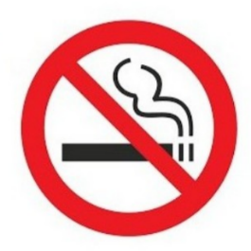

**A.** Smoking is optional here.  **B.** Smoking is compulsory here.

**C.** Smoking is not permitted here.  **D.** Smoking is useful here.

**Câu 2.** **Look at the signs. Choose the best answer for the question.**

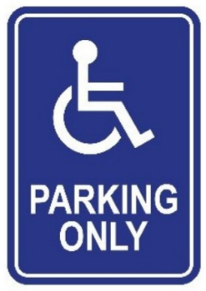

**A.** This parking space is for people with disabilities.  **B.** This place is used for parking vehicles.

**C.** People can put their wheelchairs here.  **D.** Disabled people are allowed to enter this place.

**Câu 3.** What are the new students instructed to do?

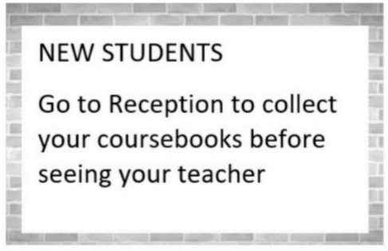

**A.** Go to their teacher first  **B.** Collect their coursebooks from their teacher

**C.** See their teacher before going to Reception  **D.** Go to Reception to collect their coursebooks

**Câu 4.** What did the person run out of?

“Hi, I hope your day is going well. I ran out of notebook paper and I have a lot of notes to take in class today. Would it be possible for me to borrow some paper from you? I’ll make sure to return the favor if you ever need anything. Thank you!”

**A.** Pencil  **B.** Notebook paper  **C.** Eraser  **D.** Ruler

**Câu 5.** What is the unique feature of the sports smartwatch?

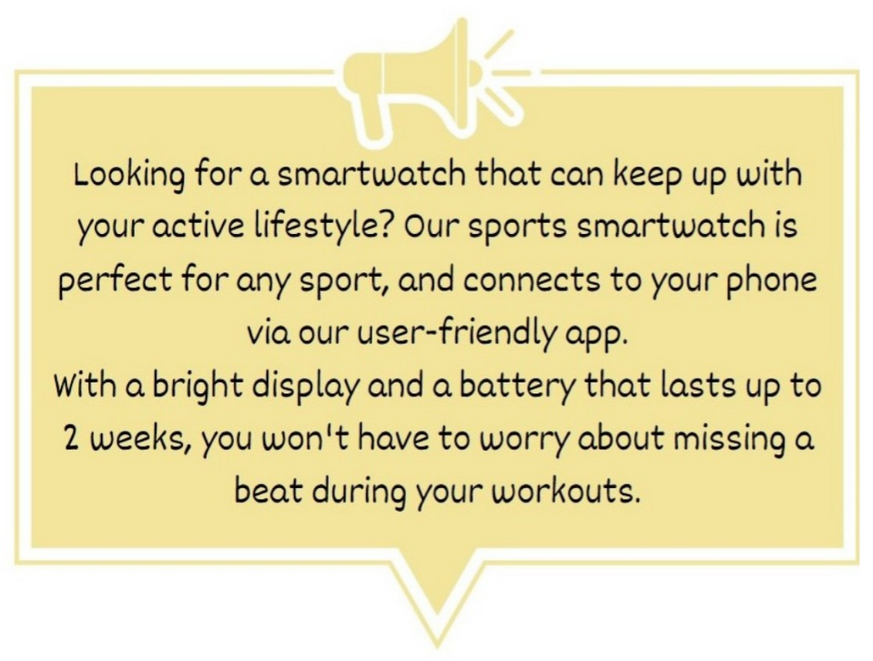

**A.** It can last up to 2 years without charging  **B.** It is perfect for any sport

**C.** It has a built-in camera  **D.** It can connect to your laptop

**Câu 6.** **Look at the signs. Choose the best answer for the question.**

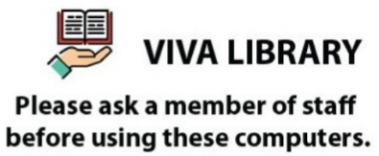

**A.** You must ask for a computer when you go to Viva Library.

**B.** You have to be a member of staff in order to use the computers.

**C.** You need to ask for permission when you want to use the computer.

**D.** A member of staff will give you a computer.

**Câu 7.** What is the main reason James cannot attend the concert?

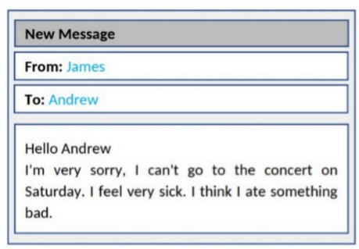

**A.** He lost his ticket  **B.** He doesn't like the music

**C.** He is feeling unwell  **D.** He has another commitment

**Câu 8.** **Look at the signs. Choose the best answer for the question.**



**A.** Cameras can only be used for security purposes.  **B.** This area is supervised by camera.

**C.** You must look after your cameras in this area.  **D.** Cameras can be used in this area.

**Câu 9.** **Look at the signs. Choose the best answer for the question.**



**A.** You must use this voucher to pay for your meals.

**B.** You can pay less for your meals with this voucher.

**C.** This voucher is used to buy two meals.

**D.** Without this voucher, you cannot buy meals.

**Câu 10.** **Look at the signs. Choose the best answer for the question.**

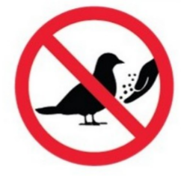

**A.** Do not feed the birds.  **B.** Do not touch the birds with your hands.

**C.** You can’t catch any birds in this area.  **D.** There aren’t any birds in this area.

**----HẾT---**