Full name: ...............................................  Class: ...................................................... | ENGLISH LANGUAGE TEST  Time: 45 minutes
I. LISTENING
Questions 1-6: There are six questions in this part. For each question, decide whether the statement is TRUE or FALSE. Tick (√) the correct boxes. You will listen to the recording twice.

 |  | TRUE | FALSE
1. | Toothpaste was invented about 1600 years ago. | 
2. | The earliest people used toothpaste were Ancient Greeks.
3. | Ancient Greeks used some ingredients similar to those in modern toothpaste.
4. | Umbrellas appeared in ancient sculptures of the Greeks and Persians.
5. | The umbrella used to symbolise high social class.
6. | The umbrella was first used to protect people from the sun.
Questions 7-10. There are four questions in this part. For each question, choose the correct answer A, B, or C. You will listen to the recording twice.

7. Which is John's purpose of seeing Steve?
A. He wants to know more about the manufacturing condition of Lintel.
B. He wants to understand the manufacturing process in Lintel.
C. He wants to know more about the financial flows in Lintel.
8. Which is NOT mentioned as a stage of the Lintel's production process?
A. Receiving customer-order information.
B. Ordering materials from suppliers.
C. Transporting the finished products.
9. How is Lintel controlling the quality of the raw materials?
A. Limiting the quantity of purchased materials.
B. Working with the Quality Control group.
C. Issuing the quality requirements.
10. What is the Material Request form used for?
A. Ordering new materials from the suppliers.
B. Transporting new materials from suppliers to Lintel.
C. Moving materials from department to department.
II. LANGUAGE USE
Questions 11-15: The following compound words have either (Oo) or (oO) stress pattern. Choose the word (A, B, C, or D) with a different stress pattern from the other three.
11. A. laptop | B. washing machine | C. traffic jam | D. green house
12. A. online game | B. flying car | C. solar charger | D. pencil case
13. A. hearing aid | B. video game | C. smartphone | D. mobile phone
14. A. website | B. whiteboard | C. White House | D. tall boy
15. A. washing machine | B. food processor | C. alarm clock | D. medical mirror
Questions 16-21: Write the correct form of the verb in brackets. Use the passive voice if necessary.

16. | One fifth of the workers in this company (make, probably) _______________ redundant next year.
17. | I don't like them because they (always, complain) ________________ about everything.
18. | Yesterday, while Mai (clean)_____________ out the attic, she (find) _______________ her grandmother’s wedding photos.
19. | Mike is a very smart boy. I think he (solve) ______________ this difficult math problem in 5 minutes.
20. | Lan is still working on my assignment. She (do, already)_________ half of it.
21. | He started his career as a salesman and finally (become) _____________ a billionaire.
Questions 22-26: Match the word with its definition. Write your answers (A, B, C, D, or E) in the provided spaces.

WORD | DEFINITION
19. acupuncture __________ | A. | a small piece of work that is done regularly
20. prestige __________ | B. | the practice of inserting thin needles into specific body points.
21. breadwinner __________ | C. | good reputation or high esteem.
22. chores __________ | D. | a person who regularly makes speeches about religion in a church or other public places
23. preacher __________ | E. | a person who earns money to support a family
III. READING
Questions 27-30: Read each text below. What does it say? Choose the best option A, B, or C for each question.

27. | 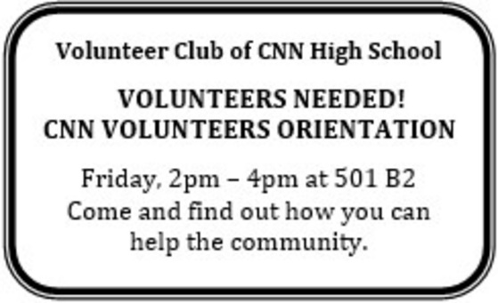
Choose the best explanation for this text.
A. | Volunteers of CNN High School will tell about how they can help the community on Friday afternoon.
B. | Volunteers of CNN High School will gather on Friday afternoon to do community activities.
C. | CNN students who want to become volunteers can go to an information session on Friday afternoon.

28. | 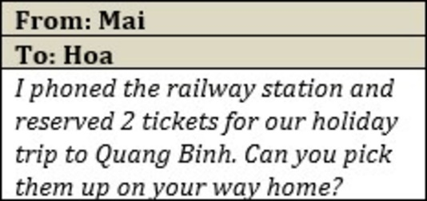
What does Mai ask Hoa to do?
A. Go to the railway station to buy tickets.
B. Call the railway station to book tickets.
C. Collect railway tickets from the station.
29. |  | 
Choose the best explanation for this text.
A. The discounted prices apply to all products in one day.
B. Some products are sold quickly than the others today.
C. You can get a discount on some products in one day.

30. | 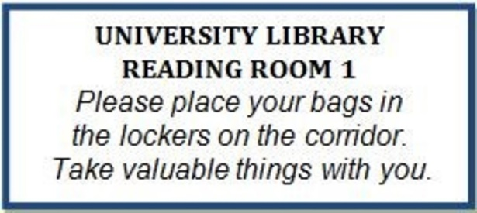
Choose the best explanation for this text.
A. Students are not allowed to bring anything to the reading room.
B. Students need to lock their valuables before entering the reading room.
C. Students need to leave their bags outside the reading room, but not their valuables.
Questions 31-36: Read the text and answer the questions that follow.

Many people worry about the effects of television on family life in the United States. In the average home, the TV is on more than six hours a day. But do people always keep their mind on the programs? And do people who watch TV really spend less time on other free-time activities?
A study by some New York researchers found out that watching TV is the most popular free-time activity in the United States. More than 70% of Americans say that they watch TV every day, or almost every day. The second most popular activity is reading the newspaper. Listening to music at home is third. Talking on the phone to friends and relatives is fourth. Exercising or jogging is fifth.
Surprisingly, television does not seem to take time away from free-time activities at home. Six out of ten people said that when the TV is on, they seldom pay attention to it. During a typical television program, people may eat dinner, do housework, read a newspaper or magazine, or talk or read to their children. The TV becomes 'background music'.
The researchers learned that in some ways Americans are very traditional. Teenagers and single people may be interested in activities and excitement outside the home. However, eight out of ten Americans like to spend their free time at home with family member and friends.
(Adapted from "Reading Explorations")
Choose the best answer A, B, C, or D for each of the following questions.
31. What is the passage mainly about?
A. The bad effects of TV on American family life
B. The fact that Americans are very traditional
C. Americans’ television viewing habits
D. How Americans spend their spare time
32. According to the research, which is the most popular leisure activity in America?
A. listening to music
B. watching TV
C. going out with friends
D. doing housework
33. What does the word "it" in paragraph 3 refer to?
A. family activity
B. free-time activity
C. television
D. TV viewers
Fill in each blank with NO MORE THAN THREE WORDS from the text.
34. __________________________ ranks as the second most favourite pastime in the US.
35. While watching TV, people rarely ______________________________ to it because they are also doing something else.
36. Four-fifths of Americans like to enjoy their free time at home with their ___________________.
IV. WRITING
Questions 37-40: Complete the second sentence so that it has a similar meaning to the first sentence, using the given words. Do not change the form of the word in brackets.

37. This temple was built under the Ly Dynasty. (BUILT)
-> They ________________________________________ under the Ly Dynasty.
38. I have never seen such a good film before. (EVER)
-> This is the best film ________________________________________.
39. People use the corkscrew to open wine bottles. (USED)
-> The corkscrew ________________________________________ wine bottles.
40. People say that Minh has a healthy lifestyle. (SAID)
-> Minh ________________________________________ a healthy lifestyle.
The New Star Foundation is recruiting volunteers to help homeless children. Write a formal letter (120-140 words) to apply for the job.

NEW STAR FOUNDATION
VOLUNTEER RECRUIMENT
SUMMER PROGRAM FOR HOMELESS KIDS
We need creative and reliable volunteers to work as event organizers and teachers for our Summer Classes. Your job will be teaching English and organizing extra activities for homeless children in Long Bien District.
Please apply in writing to: 10 Ngoc Thuy Street, Ha Noi, Viet Nam
The New Star Foundation is recruiting volunteers to help homeless children. On your answer sheet, write a formal letter (120-140 words) to apply for the job. Follow the writing plan below or your own outline.
Paragraph 1: Mentioning the job you are apply for and where you see the advert
Paragraph 2: Telling why you are right for the jobs, mentioning your personal experiences and responsibilities
Paragraph 3: Listing your personal qualities and offering to send references
Paragraph 4: Saying you are available for the interview and when you could start work
Dear Sir or Madam,

