|  |  |
| --- | --- |
| **School: “A” Long Giang Primary School.**  **Name:**  **Class: 3** | **KIỂM TRA CUỐI HỌC KỲ I**  **MÔN: TIẾNG ANH – LỚP 3**  **NĂM HỌC: 2022 - 2023**  **Thời gian: 35 phút** |

|  |  |  |  |  |  |
| --- | --- | --- | --- | --- | --- |
| **SKILL** | **Listening** | **Reading** | **Writing** | **Speaking** | **TOTAL** |
| **MARK** |  |  |  |  |  |
| **COMMENT** |  | | | | |

**PART I. LISTENING (20minutes)**

***Question 1. Listen and tick. (1pt) Nghe và đánh dấu*** √

|  |  |  |
| --- | --- | --- |
| **1** | ***U4-1***  **a.**❑ | ***U4-1***  **b.**❑ |
| **2** | ***U2_L2_5_35fbd***  **a.**❑ | ***U2_L2_5_2639de***  **b.**❑ |
| **3** | ***2***  **a.**❑ | ***3***  **b.**❑ |
| **4** | ***U8_L1_5_4d7c9***  **a.**❑ | ***U8_L1_5_20d1***  **b.**❑ |

***Question 2.******Listen and number. (1pt)*** ***Nghe và đánh số***

|  |  |  |  |  |  |  |  |
| --- | --- | --- | --- | --- | --- | --- | --- |
| **a** | **❑** | **b** | ❑ | **c** | ❑ | **d** | ❑ |

***Question 3: Listen and circle (1pt) Nghe và khoanh tròn***

1. Let’s go to the\_\_\_\_\_\_\_\_\_\_\_\_

a. library b. classroom c. computer room

1. Is that our \_\_\_\_\_\_\_\_\_\_\_\_\_\_\_\_?

a. music room b. gym c. playground

3. I have\_\_\_\_\_\_\_\_\_\_\_\_\_\_\_

a. an eraser b. a pencil case c. a school bag

4. Do you have\_\_\_\_\_\_\_\_\_\_\_\_\_\_\_\_\_\_?

a. a pen b. a book c. a ruler

***Question 4: Listen and write (1pt) Nghe và viết***



1. Open your \_\_\_\_\_\_\_\_\_\_\_\_\_\_\_ .

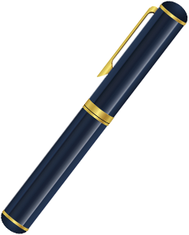

2. I have a \_\_\_\_\_\_\_\_\_\_\_\_\_\_\_\_\_ .

3. May I \_\_\_\_\_\_\_\_\_\_\_\_\_\_\_\_\_ . 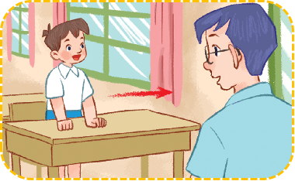

4. Let’s go to the\_\_\_\_\_\_\_\_\_\_\_\_\_\_\_\_ . 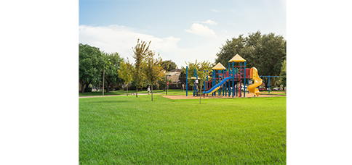

**PART II. READING AND WRITING**

***Question 5:******Read and match. (1pt) Đọc và nối***

|  |  |  |  |
| --- | --- | --- | --- |
| **1.** Open your mouth! |  | **a** |  |
| **2.** It’s drawing |  | **b** |  |
| **3.** Touch your face! |  | **c** |  |
| **4.** It’s singing |  | **d** |  |

***Question 6:* Read and complete (1pt) Đọc và điền vào chỗ trống**

|  |  |  |  |
| --- | --- | --- | --- |
| **colour** | **have** | **gym** | **blue** |

A: I (1) ………. a book.

B: What (2) …………….. is it ?

A: It’s (3) …. ……….

B: Oh. Let’s go to the (4) …………………

***Question 7: Look at the pictures and write the words. (1pt) Nhìn tranh và viết từ***

|  |  |  |  |
| --- | --- | --- | --- |
|  | 1. r e a   => \_ \_ \_ |  | 2. o o i n g c k  => \_ \_ \_ \_ \_ \_ \_ |
|  | 3. s e h c s  => \_ \_ \_ \_ \_ |  | 4. b l a l f t o o  => \_ \_ \_ \_ \_ \_ \_ \_ |

**Question 8: Put the words in order (1pt): *(Xếp các từ theo đúng vị trí)***

|  |
| --- |
| **1. is / What / name / your / ?**  🡪 |
| **2. name / Bill / My / is / .**  🡪 |
| **3. What / are / colour / they / ?**  🡪 |
| **4. are / red / They / .**  🡪 |

### **--- THE END ---**

**ĐÁP ÁN**

**ĐỀ KIỂM TRA CUỐI KỲ I**

**MÔN: TIẾNG ANH – KHỐI 3**

**NĂM HỌC: 2022-2023**

**PART I: LISTENING**

**Question 1: Listen and tick (1pt)**

|  |  |  |  |
| --- | --- | --- | --- |
| 1. a(0,25ms) | 2. b(0,25ms) | 3. b(0,25ms) | 4. a(0,25ms) |

**Question 2: Listen and number (1pt)**

|  |  |  |  |
| --- | --- | --- | --- |
| 1. c (0,25ms) | 2. b(0,25ms) | 3. d(0,25ms) | 4. a(0,25ms) |

**Question 3: Listen and circle (1pt)**

|  |  |  |  |
| --- | --- | --- | --- |
| 1. b(0,25ms) | 2. c(0,25ms) | 3. a(0,25ms) | 4. b (0,25ms) |

***Question 4: Listen and write (1pt) Nghe và viết***

1. book 2. pen 3. go out 4. playground

**PART II. READING AND WRITING**

***Question 5:******Read and match. (1pt)***

|  |  |  |  |
| --- | --- | --- | --- |
| 1. b(0,25ms) | 2. d (0,25ms) | 3. a (0,25ms) | 4. c (0,25ms) |

***Question 6:* Read and complete (1pt)**

|  |  |  |  |
| --- | --- | --- | --- |
| 1.  have(0,25ms) | 2. colour(0,25ms) | 3. blue(0,25ms) | 4. gym(0,25ms) |

***Question 7: Look at the pictures and write the words. (1pt)***

1. ear (0,25)

2. cooking(0,25)

3. chess (0,25)

4. football (0,25)

***Question 8:* Put the words in order (1pt):**

1. What is your name ?
2. My name is Bill.
3. What colour are they ?
4. They are red.

**III. SPEAKING (2pts)**

-------- The End--------