Mã đề 7.1.12
ĐỀ KIÊM TRA GIỮA HỌC KỲ I
NĂM HỌC 2022 – 2023
Môn : TIẾNG ANH - LỚP 7
Thời gian làm bài: 60 phút

A. LISTENING (2.5 pts)
Part I. You will hear five short conversations. You will hear each conversation
twice. There is one question for each conversation. For questions 1-5, put ($V$) under the right answer or write correct answer. (1pt)

1. Who else going with Aunt May? (NB)  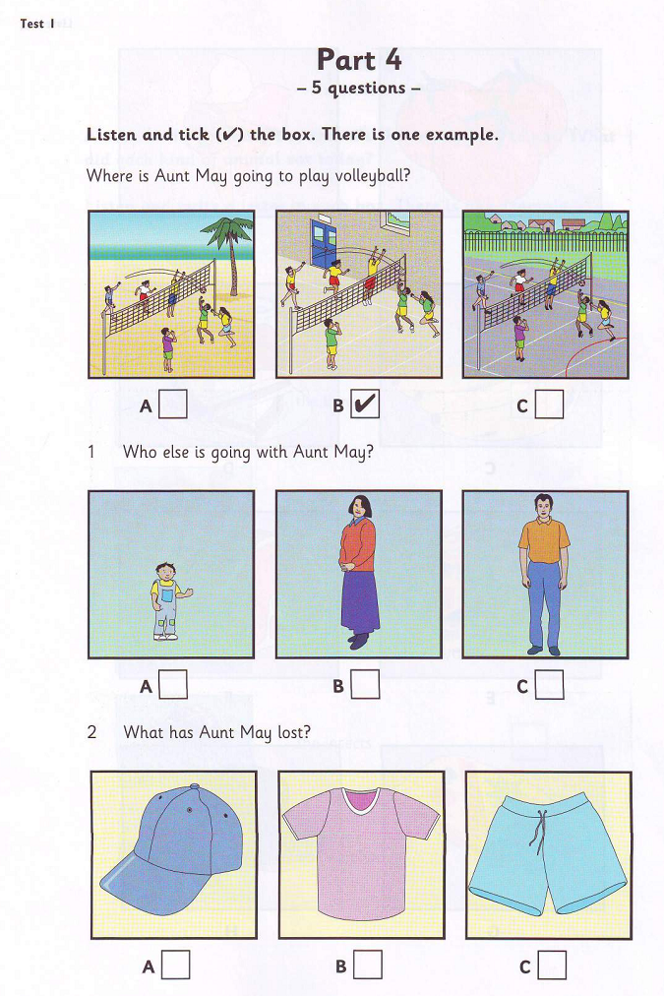  2. What has Aunt May lost? (NB)  3. What time will the game start? (NB)  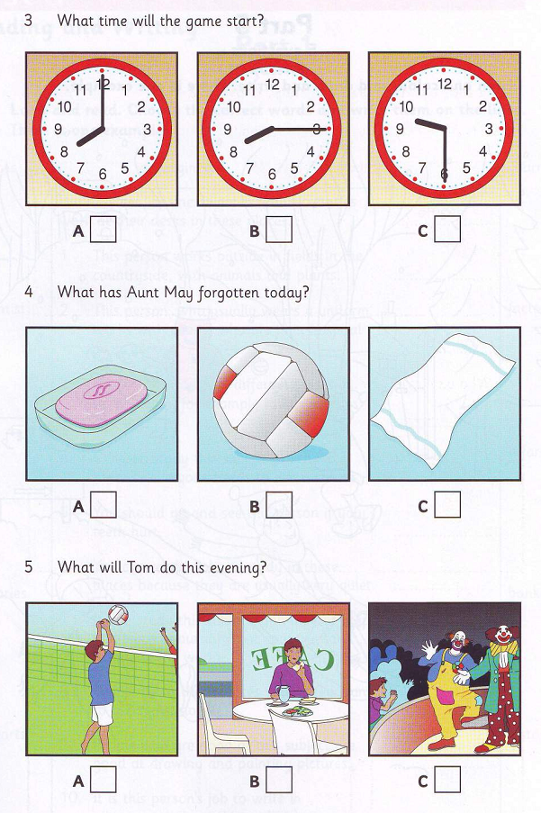 | 4. What has Aunt May forgotten today? (NB)  5. What will Tom do this evening?(TH)  ..... ….

Part II. You will hear a girl talking about her brother, Toni. Listen and complete questions 1-5. You will hear the conversation twice.(1,5)
Toni’s had an accident
He’s hurt his: leg
Name of hospital: (1)……………………………….…….... (NB)
Room: (2)………………………………………. (TH)
Floor: (3)……………………………………….. (TH)
Visiting hours: (4) 4 p.m to………………………every day(TH)
Please take: (5) ………………………………………..(TH)

B. LANGUAGE-VOCABULARY-GRAMMAR (3 pts)
Choose A, B or C to complete the following sentences.
1. Chinese people ……………… a lot of rice.TH
a. are eating b. eating c. eat
2. - “We’ll go to the theatre next Saturday. Can you go?” - “………………….”VD
a. Let me see. I’ll have to ask my parents first. b. No, I haven’t. c. Come on
3. I haven’t got…………………bread left for breakfast. NB
a. a b. some c. any
4. What kind of painting is it? -“……………….”NB
a. Portrait b. Rock and roll c. Camera
5. Mozart was one of the most famous ………………….of classical music. NB
a. actors b. artists c. composers
6. All of us enjoy …………… to classical music.NB
a. listen b. listens c. listening
Choose the word whose underlined part pronounced differently from that of the
7. A. photo B. favour C. volleyball
8. A. shy B. sugar C. television
9. “What’s your favorite food?” -“……………….”VD
a. I like fried chicken. b. It’s lemonade. c. It’s delicious.
10. Kate hasn’t got ……………… friends. NB
a. a lot b. much c. any
11. She can’t swim, and I can’t ………………TH
a. too b. either c. neither
12. She looks very red. She was outdoors yesterday. I think she has ..............NB
a. flu b. toothache c. sunburn
13. They worked very hard,......... they passed the exams. TH
a. so b. and c. but
Circle the mistake in each sentence below
14. She is the most tallest girl in her class.NB
A B C
15. My sister’s personality is very different as mine.TH
A B C
C. READING (2,5 pts)
I. Choose A, B or C to complete the following sentences. Read and choose the best option A, B or C to complete the text. (1pt)
Minh’s hobby is singing. She (1)....... singing very much. When her brother (2)........... a karaoke set last month, Minh was so glad that she (3)......... every day after dinner. She likes to sing only English songs. In fact, she has already sung all the songs found (4)............ the karaoke discs. Minh is singing in the karaoke (5)........... organized by the RC Centre this Saturday. Her family is going there to support her.
1. A. wants | B. enjoys | C. hates (NB)
2. A. invented | B. discovered | C. bought(TH)
3. A. sings | B. sang | C. sung(TH)
4. A. of | B. under | C. on (NB)
5. A. competition | B. company | C. factory (TH)
II. Read the passage, and then choose the best option. (1,5 pts)
Charlie Chaplin was an English actor, director, producer, and composer. He is known as the most creative person of the silent-film era. Charlie Chaplin's portrayal of the tramp won the hearts of people all over the world.
Chaplin was born in London on the 16th of April, 1889. He spent his childhood in poverty and hardship. In 1910 he began to perform pantomime in the United States. He first appeared on screen in 1914. He created his world-famous character, the Tramp, and he played this classic role in more than 70 films during his career. He also composed background music for most of his films. In 1972 Chaplin received an Honorary Academy Award for 'the incalculable effect he has had in making motion pictures the art form of this century'. Chaplin died on the 25th of December, 1977,at his home in Switzerland.
1. In 1910 he began to perform pantomime in........(NB)
A. the US | B. London | C. Switzerland
2. When did he start appearing in films? (NB)
A. ln 1910 | B. ln 1914 | C. 1972
3. In about how many films did he play the Tramp? (TH)
A. Seventy | B. Seventeen | C. Twenty-five
4. Charlie Chaplin is very famous for ........(TH)
A. his background music | B. his stage performance | C. his character "the Tramp"
- Which of the following is NOT true? (VD)
A. Charlie Chaplin was an English artist. | B. He received an award in 1972. | C. He played classical music.
D. WRITING (2,0 pts)
I. Complete the second sentence so that it has similar meaning to the first sentence. (1.0 pt)
1. Her book is not the same as mine. -> Her book is …………………(VD)
2. Lan is a better painter than Mai. -> Mai can’t………………………(VD)
3. Peter started recycling rubbish two months ago. -> Peter has……………………(VD)
4. I like lemonade. He likes lemonade. -> I like lemonade, and so…………(VD)
5. They use the computer every day. -> The computer…………………(VD)
II. Write a paragraph about eating habits in your family (about 80-100 words). (1,0pt)
These questions may help you: (VD)
- How many meals does your family have a day?
- What food does your family like eating for breakfast/ lunch/ dinner?
- What time does your family often have breakfast/ lunch/ dinner?
- What do you think about food in your family?
- What do you think about eating habits in your family?
-------The end--------

HƯỚNG DẪN CHẤM ĐỀ KIÊM TRA GIỮA HỌC KỲ I
NĂM HỌC 2022 – 2023
Môn : TIẾNG ANH - LỚP 7
Thời gian làm bài: 60 phút

Đáp án - Biểu điểm
Questions | Keys | Marks
A, Listen (2,5pts)  part 1. Listen and choose the right picture (1pt).  part 2. Listen and complete the notes (1,5pt): | I.  1.B 2.A 3.B 4.A 5.the circus  II.  - (the) City  - G8  - 3rd/ third  - 7 o’clock/ 7 p.m  - (some) magazines/ something to read | - 0,2pt for each right sentence.  - 0,3pt for each right sentence
B, LANGUAGE-VOCABULARY-GRAMMAR (3 pts) | - C 2. A 3. C 4. A 5. C 6. A 7. C 8. C 9. A 10.C 11.B 12.C 13. C 14. B 15. C | - 0,2pt for each right sentence
C – READING (2,5pts)  I. Choose the best word A, B or C to fill in the text.(1pt)  II. Read the text then choose the best answer A, B or C. (1,5pt) | I.  1.B 2.C 3.B 4.C 5.A  II.  1.A 2.B 3.A 4.C 5.C | - 0,2pt for each.  - 0,3pt for each.

