READING
PART 1
Look at the picture. Read the words. Which words go with the picture? Fill in the correct circles on your answer sheet.
1.

(A) The boy is drawing a picture. | (B) The boy is taking a photo. | (C) The boy is talking on the phone
The answer is “B”. Fill in “B” on your answer sheet.
2.
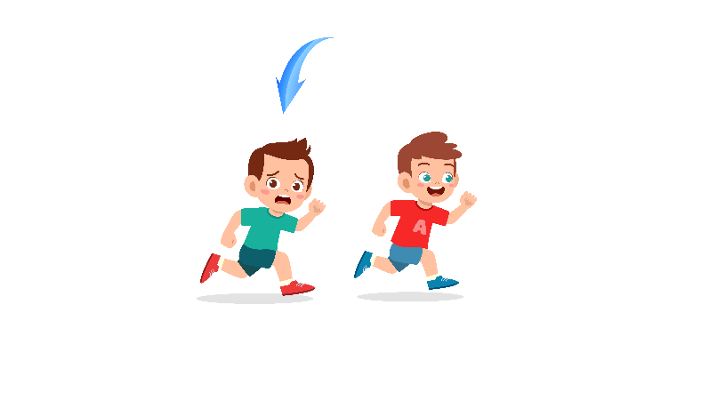
What does the arrow show?
The boy with the arrow is ahead of the other boy.
(A) Ahead | (B) Beside | (C) Under
The answer is “A”. Fill in “A” on your answer sheet.

3.

(A) Mountain | (B) River | (C) Green field
4.
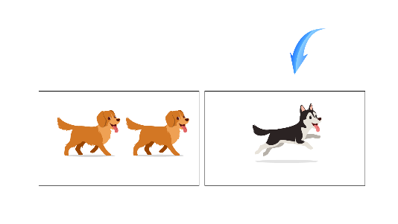
(A) Alone | (B) A pair | (C) Different
5.

(A) A ball | (B) A cap | (C) A toy car
6.
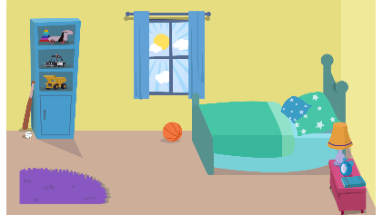
(A) Bedroom | (B) Kitchen | (C) Garden
7.
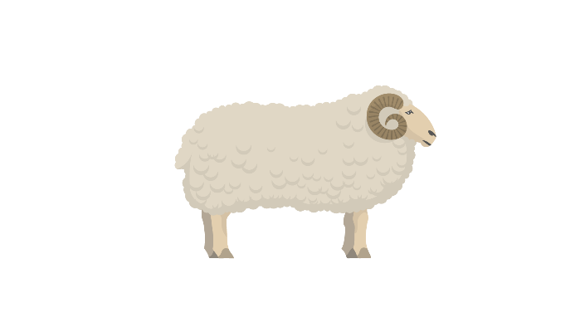
(A) A sheep | (B) A cow | (C) A chicken
8.

(A) Orange | (B) Pear | (C) Grapes
9.
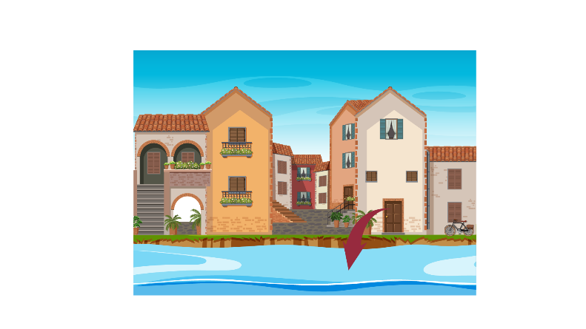
(A) In front of | (B) Behind | (C) Next to
10.

(A) They are throwing apples. | (B) They are buying apples. | (C) They are picking up apples.
11.

(A) The boy is sleeping. | (B) The boy is laughing. | (C) The boy is singing.
12.
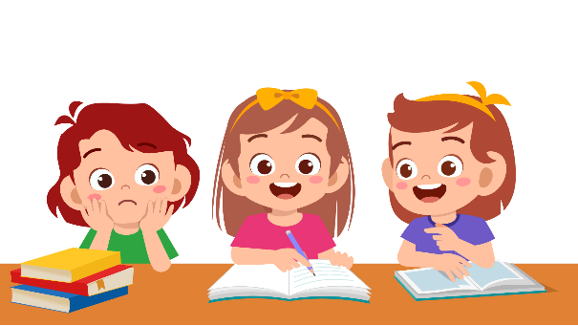
(A) The girls are studying. | (B) The girls are playing basketball. | (C) The girls are going shopping.
13.
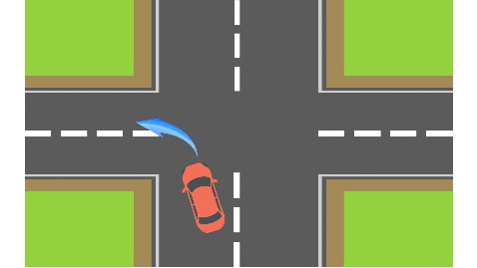
(A) The truck is stopping for red light.  14. | (B) The truck is turning right.   | (C) The truck is turning left.
(A) The boy is drinking water. | (B) The boy is watching TV. | (C) The boy is cooking.
15.

(A) They are practicing indoor. | (B) They are sitting down. | (C) They are practicing outdoor.
16.
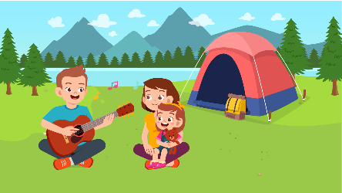
(A) The family went camping. | (B) The family went fishing. | (C) The family went shopping.
17.
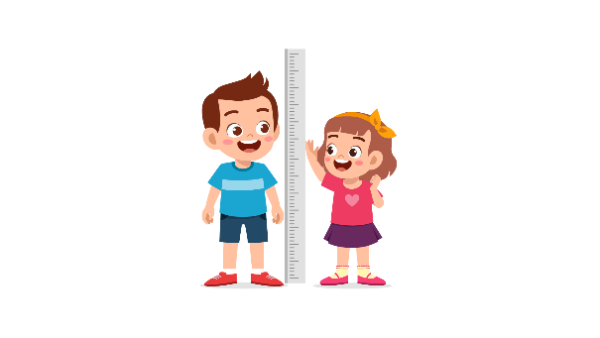
(A) The boy is as tall as the girl. | (B) The girl is taller than the boy. | (C) The boy is taller than the girl.
PART 2
Read and find the answer.
Fill in the correct circles on your answer sheet.
Let’s do an example.
- Students go to class here. Teachers work here. It has many desks. What is it?
  - (A) A house
  - (B) A school
  - (C) A bank
The correct answer is a school. Fill in "B" on your answer sheet.

- It is a shop. People sell books here. There are many books.
Where is it?
(A) A bakery
(B) A flower shop
(C) A bookstore

- This is a school object. You put your pens and pencils in it. It is often rectangular.
What is it?
(A) A ruler
(B) A notebook
(C) A pencil case

- This takes people from one place to another. You cycle it. This travels on the road.
(A) A car
(B) A bike
(C) A ship

- You can’t breathe. You feel sick. You use a lot of tissues. You have a _________.
(A) broken leg
(B) sore throat
(C) runny nose

- You do this when you want to say things in words. You often do it on paper.
You _________.
(A) listen
(B) read
(C) write

- It is quite dark outside. There are lots of clouds in the sky. The weather is _________.
(A) windy
(B) cloudy
(C) rainy

- You put these on eyes. They protect you from the light. They are __________.
(A) sunglasses
(B) shoes
(C) gloves

PART 3
Read the map. Answer questions 26 to 29.
Fill in the correct circles on your answer sheet.

- The zoo is opposite ____________.
(A) the school
(B) the park
(C) the cinema

- The bookstore is next to ____________.
(A) The bakery
(B) The zoo
(C) The hospital

- The school is on your ____________.
(A) behind
(B) right
(C) left

29. You want to get to the cinema. You need to ____________.
(A) Go straight ahead, turn right and go to the end of the road.
(B) Go straight ahead, turn left and go to the end of the road.
(C) Go straight ahead, turn right and stop in the middle of the road.

Read the schedule. Answer questions 30 to 33.
FLIGHT SCHEDULE
FLIGHT NUMBER | From | To | Departure
No. 054 | Los Angeles | Hanoi | 7 a.m
No. 423 | Kuala Lumpur | Hanoi | 8 a.m
No. 260 | Paris | Hanoi | 8:30 a.m
No. 721 | Bangkok | Hanoi | 9 a.m
30. How many flights are there to Hanoi?
(A) 1
(B) 3
(C) 4

31. When does flight No.054 depart?
(A) 7 a.m
(B) 8 a.m
(C) 9 a.m

32. Which flight is from Bangkok?
(A) No.423
(B) No.260
(C) No.721

33. How many flight departures are there before 9 a.m?
(A) 2
(B) 3
(C) 4

Read the letter. Answer questions 34 to 35.
Dear Ania,

This is Dania. I am writing this to tell you about my new Maths teacher. Her name is Mandy. She is really kind and nice. We all love her and her lessons. She teaches Maths in a very fun way.

Our previous teacher, Mr. Smith is still sick. He is quite old so he needs more time to rest. We still love him much, and we hope he will get back to the classroom soon. I will tell you more about my teachers in the next letter.

Love you,
Dania
34. Why does Dania write to Ania?
(A) To invite her to a birthday party.
(B) To tell her about her new teacher.
(C) To greet her after a long time.

35. What is probably true about Mr. Smith?
(A) He is healthy.
(B) He is young.
(C) He needs time to rest.
Read the email. Answer questions 36 to 37.
To: Mrs. Linda
From: Beth
Subject: About the lessons

Dear Mrs. Linda. I’m Beth, writing this email to ask you some questions about the lessons in class. Because my writing was slow, I missed some details about the lessons. Can you please send me the slides of today’s lessons, so I can take notes in my notebook again? Looking forward to you reply.
Your student,
Beth
36. Why does Beth write to Mrs. Linda?
(A) To ask about the lessons
(B) To send her homework
(C) To talk about her friends

37. Why does Beth ask for the slides?
(A) Because her writing was slow.
(B) Because she didn’t pay attention
(C) Because she was absent

Read the poster about the school book club. Answer questions 38 to 39.
LOST DOG
Yesterday, my dog was lost at Baker Street.
His name is Star.
He has long black fur, black eyes and a scar under his eyes.
If you see him anywhere, please contact my number: 0395 048 832
38. What is this poster for?
(A) Selling a dog
(B) Finding a dog
(C) Buying a dog

39. What does the dog look like?
(A) He has long white fur.
(B) He has blue eyes.
(C) He has a scar.
You finished the reading test.

LISTENING
PART 1
Listen to the words. Look at the pictures.
Fill in the correct circles on your answer sheet.
1.
 | 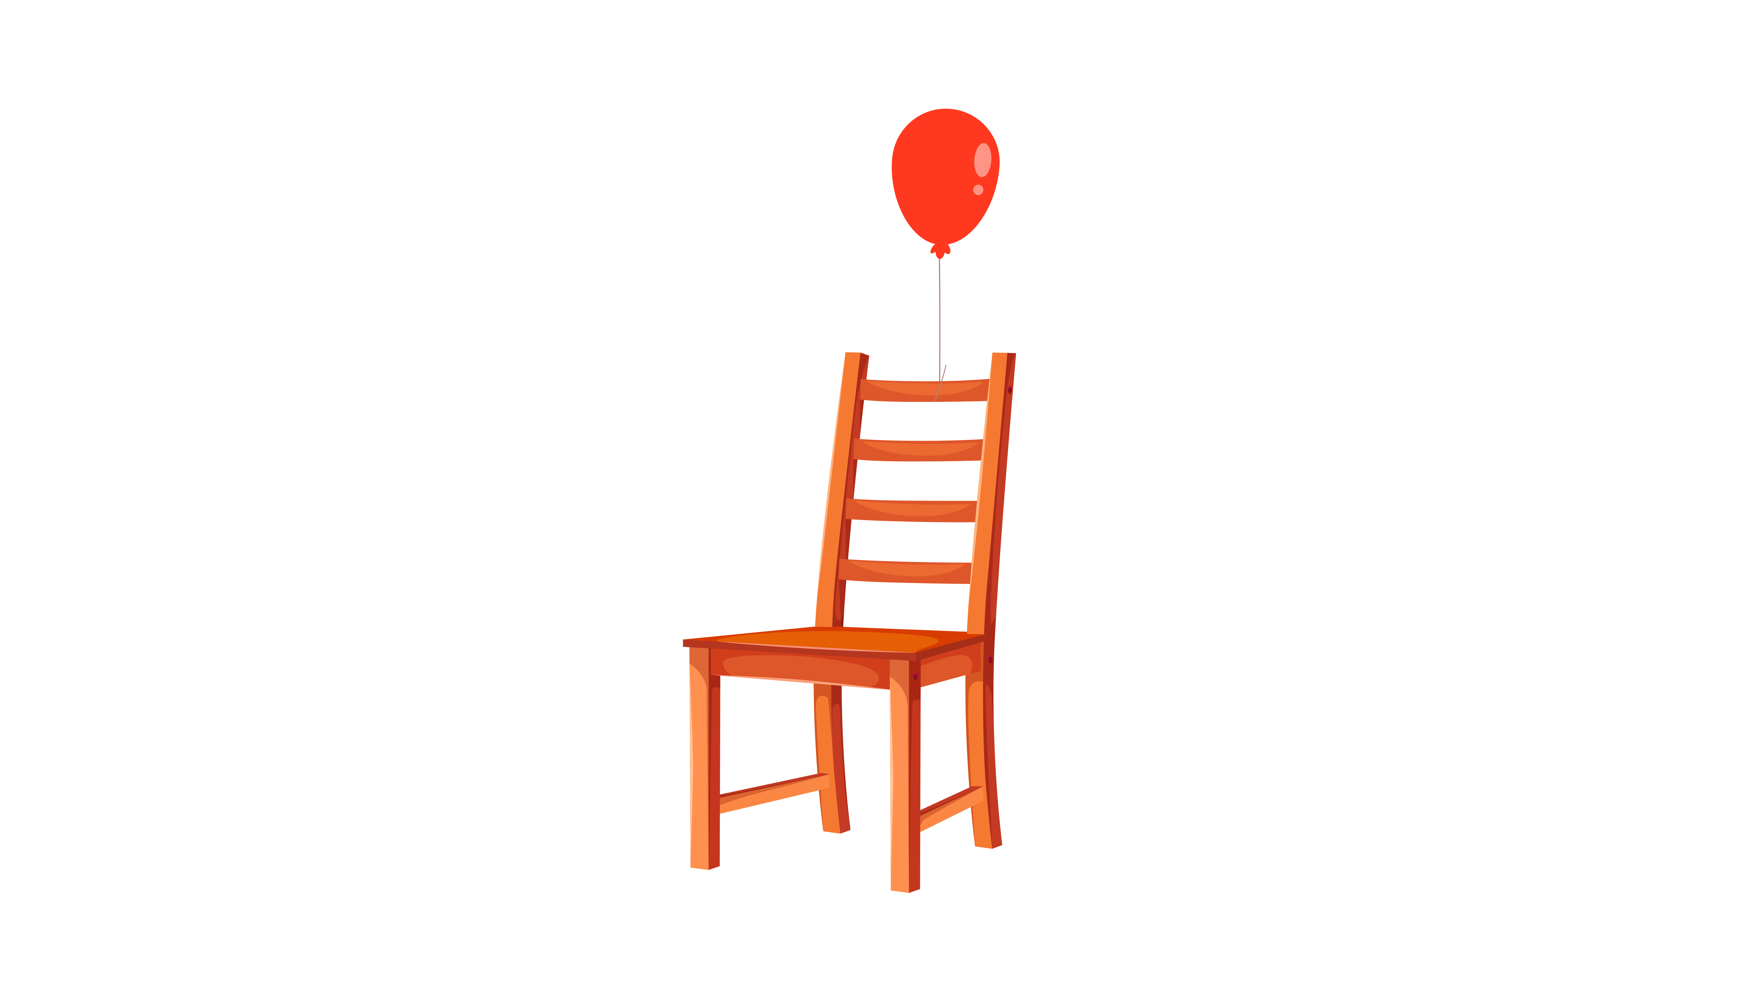 | 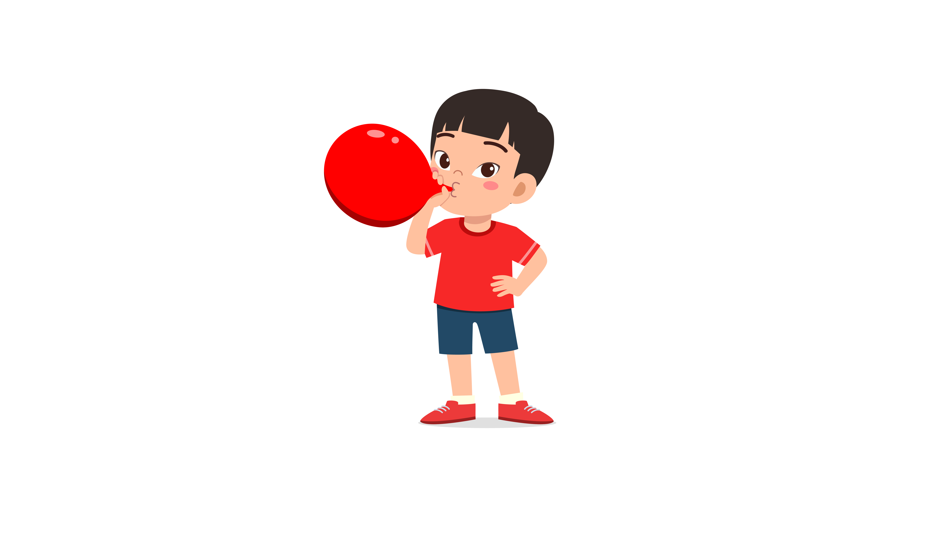
(A) | (B) | (C)
2.
 |  | 
(A) | (B) | (C)
3.
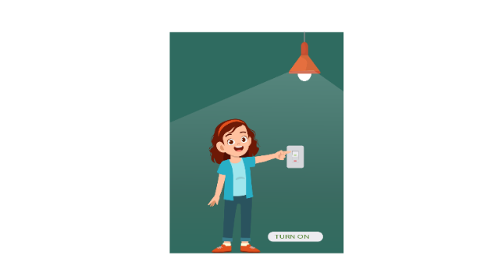 |  | 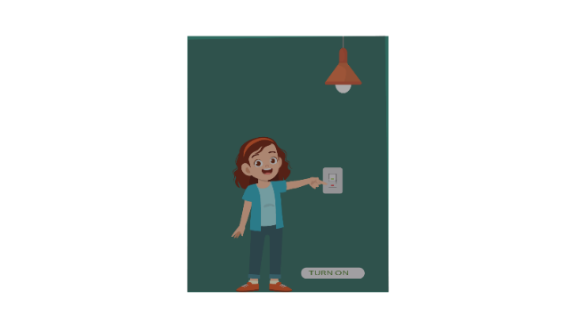
(A) | (B) | (C)
4.
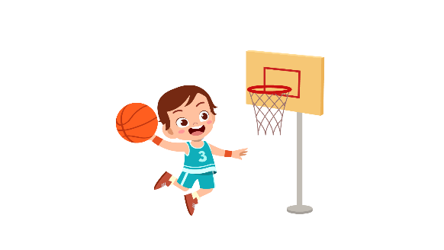 | 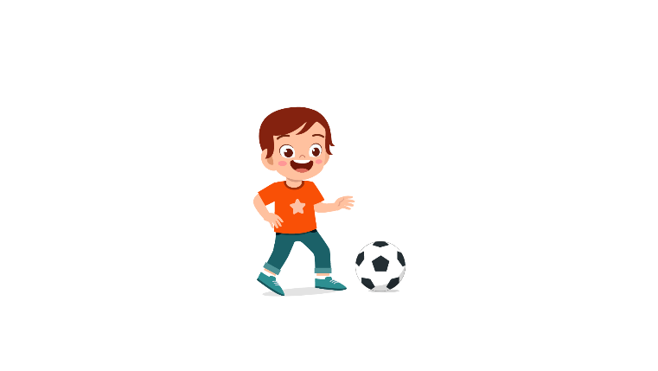 | 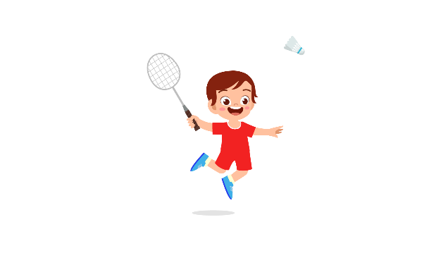
(A) | (B) | (C)
5.
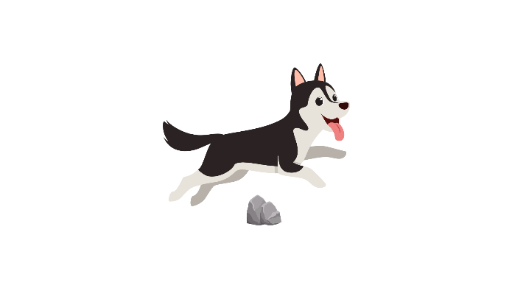 | 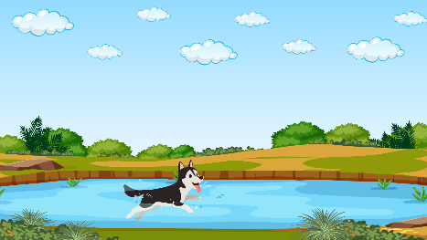 | 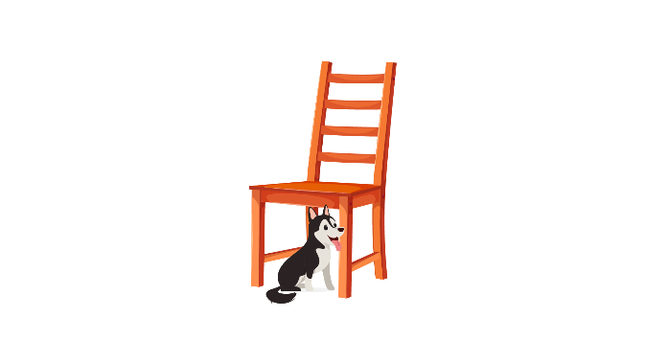
(A) | (B) | (C)
6.
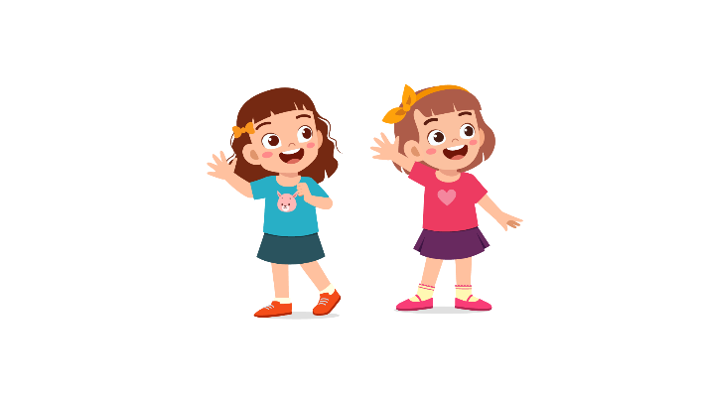 | 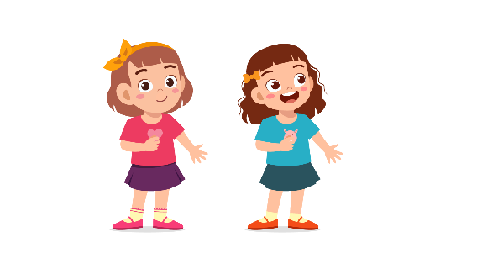 | 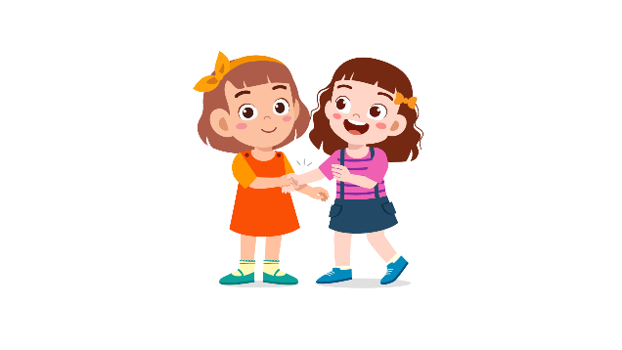
(A) | (B) | (C)
7.
 | 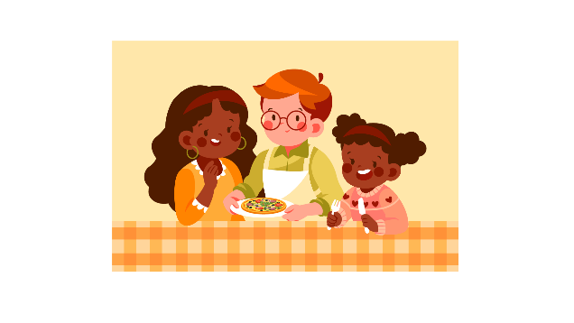 | 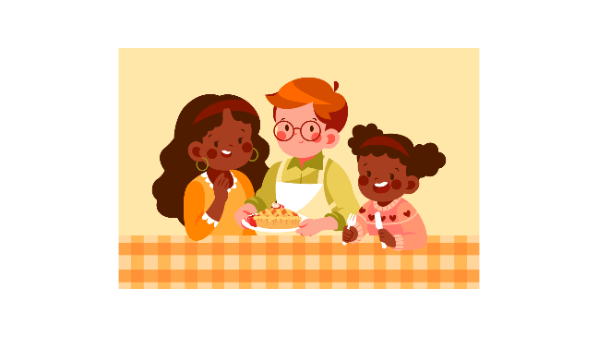
(A) | (B) | (C)
8.
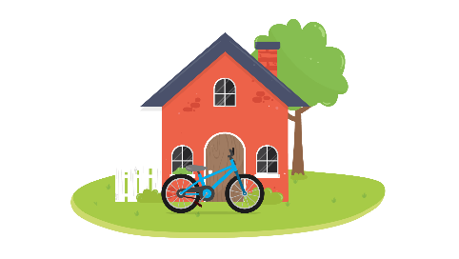 |  | 
(A) | (B) | (C)

PART 2
Fill in the correct circles on your answer sheet.
9.
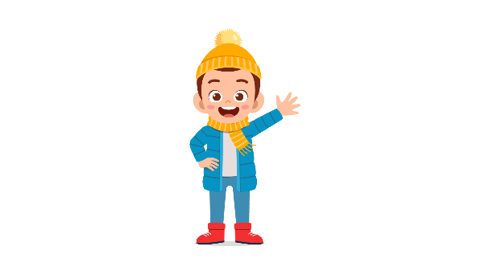 | 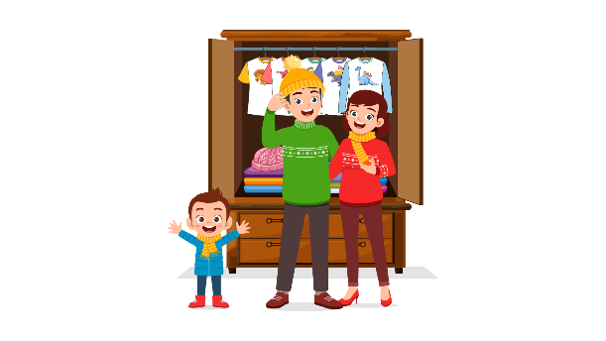 | 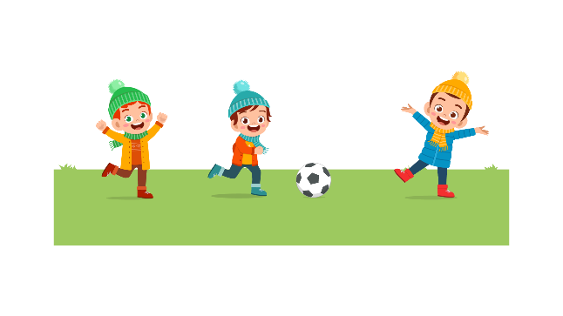
(A) | (B) | (C)
10.
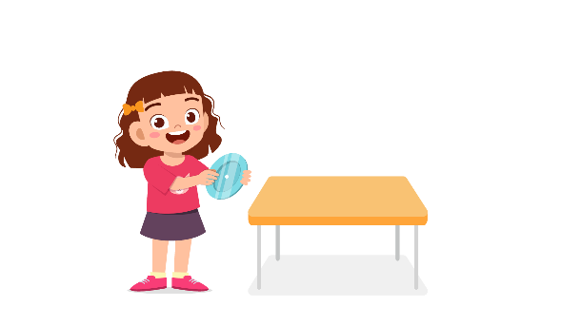 | 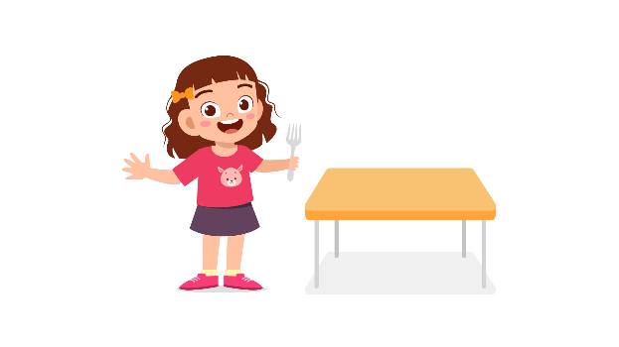 | 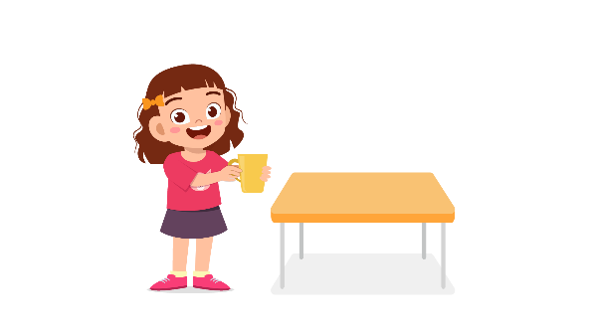
(A) | (B) | (C)
11.
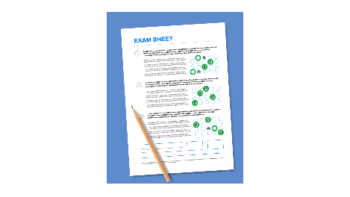 |  | 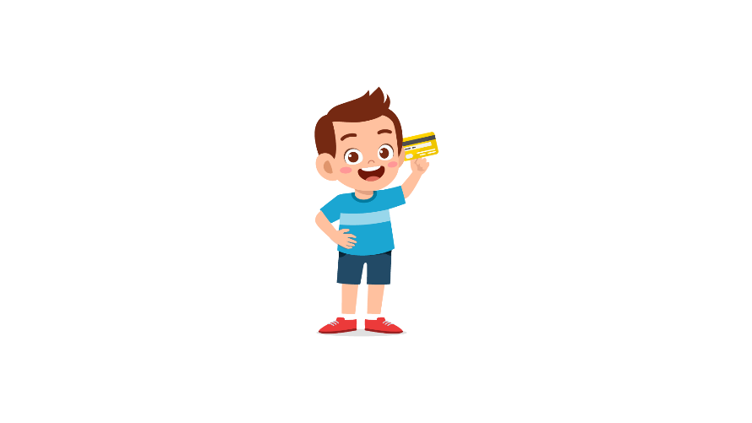
(A) | (B) | (C)
12.
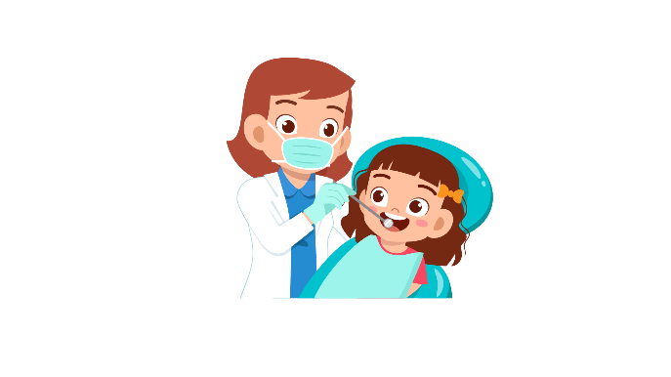 | 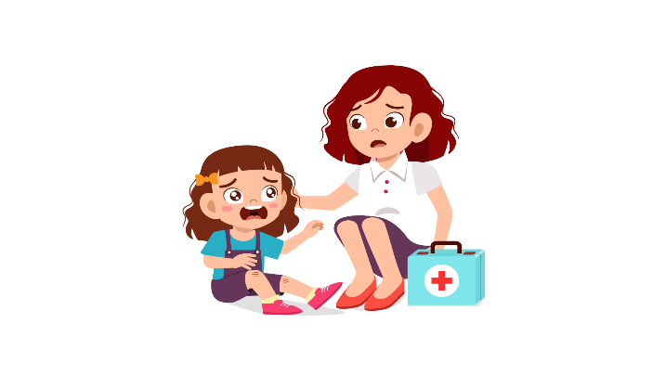 | 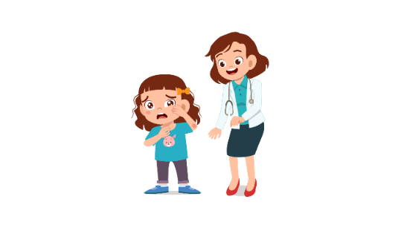
(A) | (B) | (C)
13.
 | 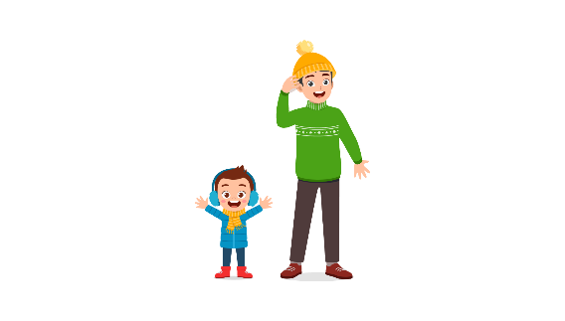 | 
(A) | (B) | (C)
14.
 |  | 
(A) | (B) | (C)
15.
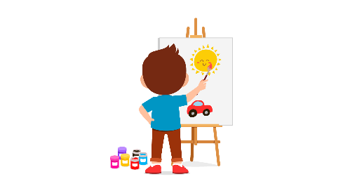 |  | 
(A) | (B) | (C)
16.
 |  | 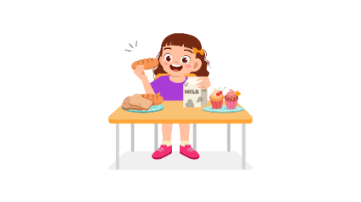
(A) | (B) | (C)
17.
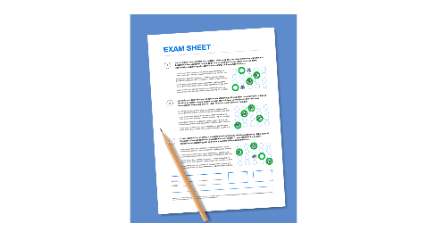 | 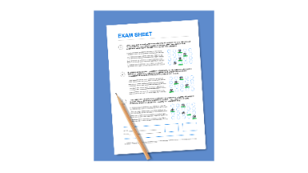 | 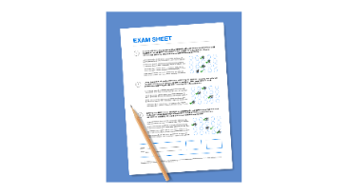
(A) | (B) | (C)
PART 3
Fill in the correct circles on your answer sheet.
Look at your answer sheet. Listen to a conversation. Which conversation sounds correct?
Let’s do an example.
(Narrator): A
(Boy): Hello. What’s your name?
(Girl): I’m fine, thanks.
(Narrator): B
(Boy): How are you today?
(Girl): I’m six years old.
(Narrator): C
(Boy): Nice to meet you!
(Girl): Nice to meet you, too!
The answer is "C." Fill in "C" on your answer sheet. Now, you do it.
18.
(A) | (B) | (C)
19.
(A) | (B) | (C)
20.
(A) | (B) | (C)
21.
(A) | (B) | (C)
22.
(A) | (B) | (C)
23.
(A) | (B) | (C)
24.
(A) | (B) | (C)
25.
(A) | (B) | (C)
26.
(A) | (B) | (C)
27.
(A) | (B) | (C)

PART 4
Listen to a conversation and answer the question. Fill in the correct circle on your answer sheet.
Let’s do an example.
28. When is the girl's party?
(A) Tonight
(B) Next week
(C) This weekend
The answer is "C." Fill in "C" on your answer sheet. Now, you do it.
29. What does the girl do in her free time?
(A) Listen to music
(B) Play chess
(C) Read comic books
30. What do they want to buy?
(A) Some bread
(B) Some juice
(C) Some strawberry
31. How do they go to the park?
(A) By taxi
(B) By bus
(C) On foot

32*. Who is Jim talking to?
(A) A parent
(B) An officer
(C) A teacher
33*. What is the girl trying to do?
(A) ask her mother about the TV shows
(B) tell her mother to focus
(C) ask her mother to turn the TV down
34. What are the friends planning to do?
(A) eat cheese cakes
(B) meet their teacher
(C) go home

PART 5
Listen and answer the question.
Fill in the correct circle on your answer sheet.
Let’s do an example.
- What did Mike call about?
(A) Homework
(B) A movie
(C) A library book
The answer is "B." Fill in "B" on your answer sheet. Now, you do it.

36. Why did Tom call?
(A) To invite his friend to join a club
(B) To tell his friend he can’t join the club
(C) To remind his friend about joining a club
37. Why did Lindsay call?
(A) To describe the jacket
(B) To tell the story about twins
(C) To ask what to wear to the party
38. Why did the neighbor call?
(A) To tell the news that they are moving
(B) To ask about the landlord
(C) To greet his new neighbor
39. Why did the teacher call?
(A) To invite Milly to join a competition
(B) To tell Milly’s mother about the grades
(C) To talk about how Milly is at school
40*. Why did the shop assistant call?
(A) To ask the customer to buy a purse
(B) To talk about a new product through phone call
(C) To give information about the lost purse
41*. Why did Helen’s father call?
(A) To pick Helen up right now
(B) To ask Helen the pickup time
(C) To ask what time it is

