Period
LESSON PLAN
TIẾNG ANH 10 FRIENDS GLOBAL
UNIT 1: FEELINGS
LESSON 1A: HOW DO YOU FEEL?
I. OBJECTIVES:
By the end of the lesson, Ss will be able to:
1. Knowledge:
- Get some more knowledge about describing feelings
- Vocabulary: ashamed, cross, embarrassed, envious, relieved, proud
2. Ability:
- main skills: listening and speaking skills
- sub skills: reading and writing skills
- Describe how people are feeling, using new adjectives
- Ask and answer about the students’ feelings
3. Quality:
- have positive attitude in English language learning so that they can participate enthusiastically in all classroom activities, especially with the topic conducted by the teacher
- know how to express their feelings
II. TEACHER AIDS AND LEARNING MATERIALS:
Lesson plan, PPT slides, student’s book, workbook, notebook, personal computer (if any), projector/TV. Speakers, IWB software.
III. PROCEDURES:
A. Warm-up (5’)
a) Objective: Introduce the new lesson and set the scene for Ss to acquire new language; get students' attention at the beginning of the class by means of enjoyable and short activities as well as to engage them in the steps that followed.
b) Content: Warm-up game
c) Outcomes: Students can gain more confidence and interest in the lesson
d) Competence: communication, guessing, collaboration
e) Organisation of the activity:

TEACHER’S ACTIVITIES | STUDENT’S ACTIVITIES | CONTENTS
Warm-up T-Ss- T/ Ss – Ss  Game “CROSSWORD PUZZLE”  - Divide class into groups.  - There are 8 numbers about feelings on the screen. Each group will choose a number to answer. With a correct answer, students will get one point. If any group can get the word in the vertical column fastest, that group can earn two points.  - The group has the most correct answer will be the winner.  - After revealing the words, teacher asks students a question:  “What is the word in the vertical column?” | - Play game in groups.  - Each group will choose a number.  - With a correct answer, students will get one point.  - Students answer, “FEELINGS” | 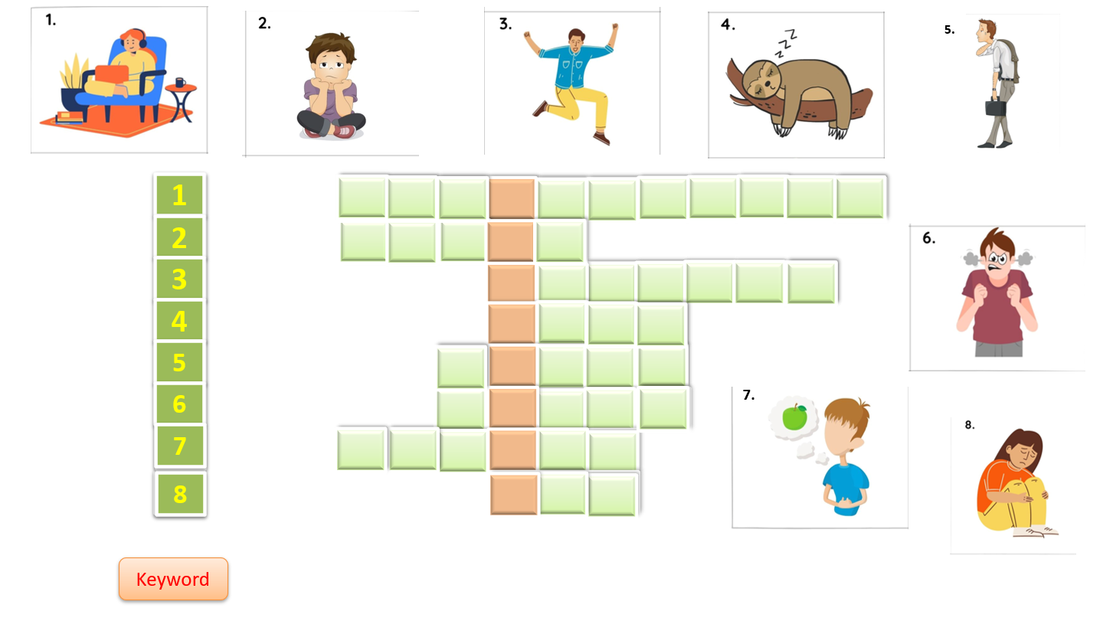  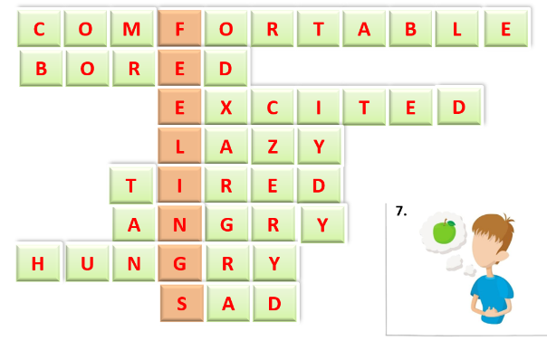

B. New lesson (35’)
- Activity 1: Vocabulary (8’)
a) Objective: Ss know more words about feelings
b) Content:
Vocabulary: ashamed, envious, cross, proud, embarrassed, relieved, suspicious
Listening
c) Outcomes: Ss know how to pronounce the new words precisely and use them in appropriate contexts.
d) Competence: communication, collaboration, presentation
e) Organisation of the activity:

TEACHER’S ACTIVITIES | STUDENT’S ACTIVITIES | CONTENTS
PRESENTATION. T -Ss- T/ Ss- Ss/ Individual  Set context:  - Call out some students to answer the question: “How are you feeling right now?”  - Lead to the topic of the lesson – How do you feel?  Teach new vocabulary:  - Use pictures and explanation to present new words.  - Have students practice their pronunciation drills.  New words:  Suspicious (a)  Relieved (a)  Embarrassed (a)  Ashamed (a) picture +  Cross (a) meaning  Envious (a)  Proud (a) | - Some students will answer the question.  - Listen to the teacher.  - Look, listen, and repeat in chorus and individuals | Question: “How are you feeling right now?”  New words:  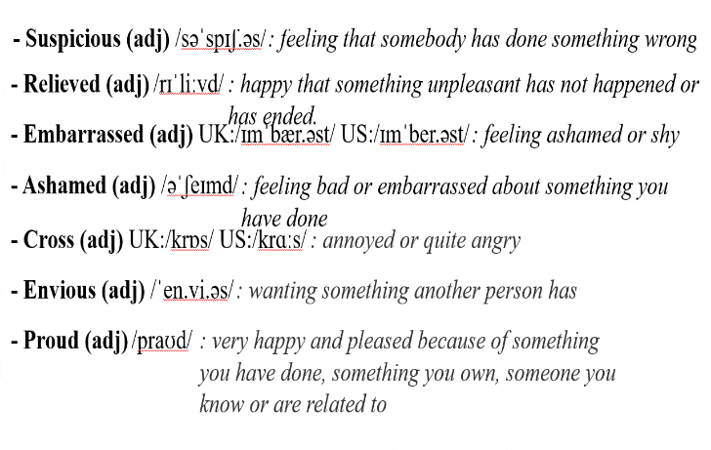
- Activity 2 Practice (22’)
a) Objective: Ss can answer the questions to critical thinking, and they can also finish the tasks in the textbook. Critical thinking skills (guessing/ reasoning) and communication can also be practiced.
b) Content: Students answer questions, classify words, choose the correct answer, read and complete, listen and match.
c) Outcomes: Ss read and listen, and they can apply the useful language in everyday listening and speaking.
d) Competence: collaboration, guessing, matching, communication
e) Organisation of the activity:
TEACHER’S ACTIVITIES | STUDENT’S ACTIVITIES | CONTENTS
PRACTICE. T-Ss- T/ S – S/ Indiv.  Activity 1 (3’) Look at the photos and answer the questions.  - Ask students to look at the photos and answer the questions.  - Give some possible answers.  Activity 2 (3’) Listen and match the adjectives with the photos in exercise 1.  - Play the audio for students to listen to the words.  - Have student match the adjectives to the photos above.  Activity 3 (2’) Put the adjectives in exercise 2 into categories A and B below.  - Ask students to work in pairs and fill in the columns A and B.  - Ask students to add other adjectives if they know some more.  Activity 4 (4’) Listen and repeat. Pay attention to the ending sounds.  - Have students listen and repeat the ending sounds.  - Let student say the word with -ed endings. Have students listen and check it again.  Activity 5 (2’) Match how the person is feeling.  - Ask student to work in pairs and match the picture with the correct answer.  - Check students’ answers.  Activity 6 (3’) Read and complete with adjectives from exercise 2.  - Have students read and complete the task.  - Check students’ answers.  Activity 7 (3’) Listen and match one adjective from the list with each speaker (1-4). There are four extra adjectives.  - Play the audio for students.  - Let students match.  - Check the answers.  - Lead to the Recycle box and have students read it to review ‘Present Continuous tense’. Notice students some verbs cannot be used in continuous tenses (believe, belong, etc.), we use present tenses instead.  Activity 8 (2’) Listen and complete the sentences with correct present tense form of the verbs in brackets.  - Play the audio again.  - Let students do the task.  - Show the answers. | - Look at the photos and do the task.  - Listen and identify the words.  - Match the words with the photos.  - Work in pairs and fill in the columns.  - Check the answer in pairs.  - Check the answer with the teacher.  - Add more adjectives  - Listen and write the ending sound of each word.  - Say the word and decide if the endings are pronounced /id/, /d/, or /t/.  - Work in pairs.  - Check answer with teacher.  - Do the task.  - Check answers with the teacher.  - Listen carefully to the audio.  - Match from 1 to 4  - Check the answers with the teacher.  - Read the Recycle box and focus on how to use the present continuous tense.  - Notice some stative verbs which cannot be used in continuous tenses.  - Listen and write down the correct tense form.  - Check the answers with teacher | Suggested answers:  1. The man in picture A looks worried. Two girls in picture B looks cheerful. The girl in picture C seems bored and tired.  2. The man in A is feeling worried because he might not know anyone. The girls in B are feeling happy because they’ve got good marks in their exam. The girl in C looks tired and bored because she might not know the answer.  Suggested answers:  The people in photo A look anxious/ confused.  The people in photo B look delighted/ excited.  The people in photo C look bored/ upset.  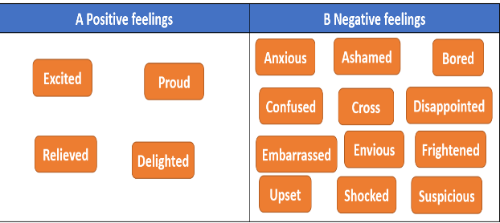  Suggested answers:  Suggested answer:  1. Shame /m/; bored /d/; confuse /z/; delight /t/; embarrass /s/; excite /t/; frighten /n/; relieve /v/ ; shock /k/  2.  /id/ /t/ /d/  Delighted Excited Embarrassed Relieved shocked Shamed Bored Confused frightened  Answer:  1A 2C 3C 4B  Answer:  2. bored  3. excited/ relieved  4. delighted/ relieved  5. cross/ upset  6. embarrassed  Answer:  1. excited  2. disappointed  3. confused  4. embarrassed  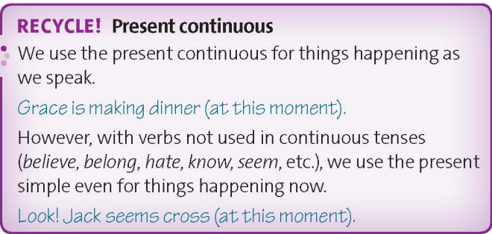  Answer:  1. doesn’t know  2. doesn’t understand  3. has  4. is making

- Activity 3: Outcomes (5’)
a) Objective: Ss can answer the question to describe feelings in some situations. Communication is also be practiced.
b) Content: Students work in pairs, speak and discuss
c) Outcomes: Ss speak and listen mutually, they can new words they have learnt in their conversation.
d) Competence: Collaboration, communication
e) Organisation of the activity:
TEACHER’S ACTIVITIES | STUDENT’S ACTIVITIES | CONTENTS
PRODUCT. S – S/ T – Ss  Activity 9 (5’) Play a game ‘Clean up the Ocean’  - Ask students to pick the number from 1 to 6 and answer the question. | - Work in pairs, take turn to ask and answer.  - Some can volunteer to present their ideas. | Questions:  “How do you feel when…”  1. You have an exam in 10 minutes?  Suggestive answer:  I feel anxious and tense…  2. your exam finishes?  3. you see a large spider in your bedroom?  4. friends or family members are arguing?  5. you arrive at a party?  6. you can’t sleep?
C. Consolidation (3’)
a) Vocabulary: ashamed, cross, embarrassed, envious, relieved, proud
b) Describe how people are feeling
D. Homework (2’)
- Learn by heart the vocabulary about feelings
- Practice asking and answering about feelings
- Do exercise in the workbook
- Prepare: Unit 1 – B-Grammar (page 12 – SB)

