# SPEAKING ASSESSMENT ENGLISH 6 UNIT 12: ROBOTS

1. **Introduction - 0.4 pt (~2 ideas):**

Share something about your *family, school, house, friends, neighborhood,…*

1. **Topic Speaking (Cue pictures) – 1.0 pt (~4 questions):**

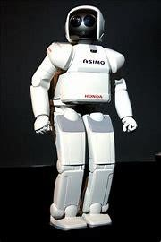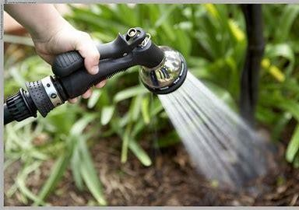

**1 2 3**

* 1. - What is this?

- What do you see in the picture?

- How do you spell it?

* 1. Where can robots work?
  2. What can robots do at home/school/factory…?

**8 4**

**7 6 5**