Period
LESSON PLAN
TIẾNG ANH 10 FRIENDS GLOBAL
UNIT 3: ON SCREEN
LESSON 3F: READING – VIDEO GAMES AND HEALTH
I. OBJECTIVES:
By the end of the lesson, Ss will be able to:
1. Knowledge:
- Vocabulary: health effect, combat, dimension, concern, assume, social skills, mental skills, etc.
- Understand the importance of online habits, screen time reduction in keeping our health
2. Ability:
- main skills: reading and speaking skills
- sub skills: listening and writing skills
- Conduct an discussion about how video games affect our health and how to balance our screen time
3. Quality:
- Have positive attitude in English language learning so that they can participate enthusiastically in all classroom activities, especially with the topic conducted by the teacher
- Students know how to ask and answer questions about their online habits and how to reduce their screen time in order to be healthy.
II. TEACHER AIDS AND LEARNING MATERIALS:
Lesson plan, PPT slides, student’s book, workbook, notebook, personal computer (if any), projector/TV, speakers, IWB software.
III. PROCEDURES:
A. Warm-up (10’)
a) Objective: Introduce the new lesson and set the scene for Ss to acquire new language; get students' attention at the beginning of the class by means of enjoyable and short activities as well as to engage them in the steps that followed.
b) Content: Task 1 page 40
c) Outcomes: Students can gain more confidence and interest in the lesson.
d) Competence: communication, collaboration, guessing
e) Organisation of the activity:
TEACHER’S ACTIVITIES | STUDENT’S ACTIVITIES | CONTENTS
WARM-UP. T-Ss/ S-S/ Indiv  Task 1 page 40  - Ask students to look at the headlines  - Divide class into 2 groups  - Ask students to divide which headline is about positive effects and which is negative effects  - Ask students: “Do you think playing computer games is bad for your health? Why/ Why not?”  - Lead in the new lesson: Video games and health | - Read the headlines  - Work in groups  - With one correct answer, that group get bonus.  - Volunteer to answer  - Open the course book page 40 | 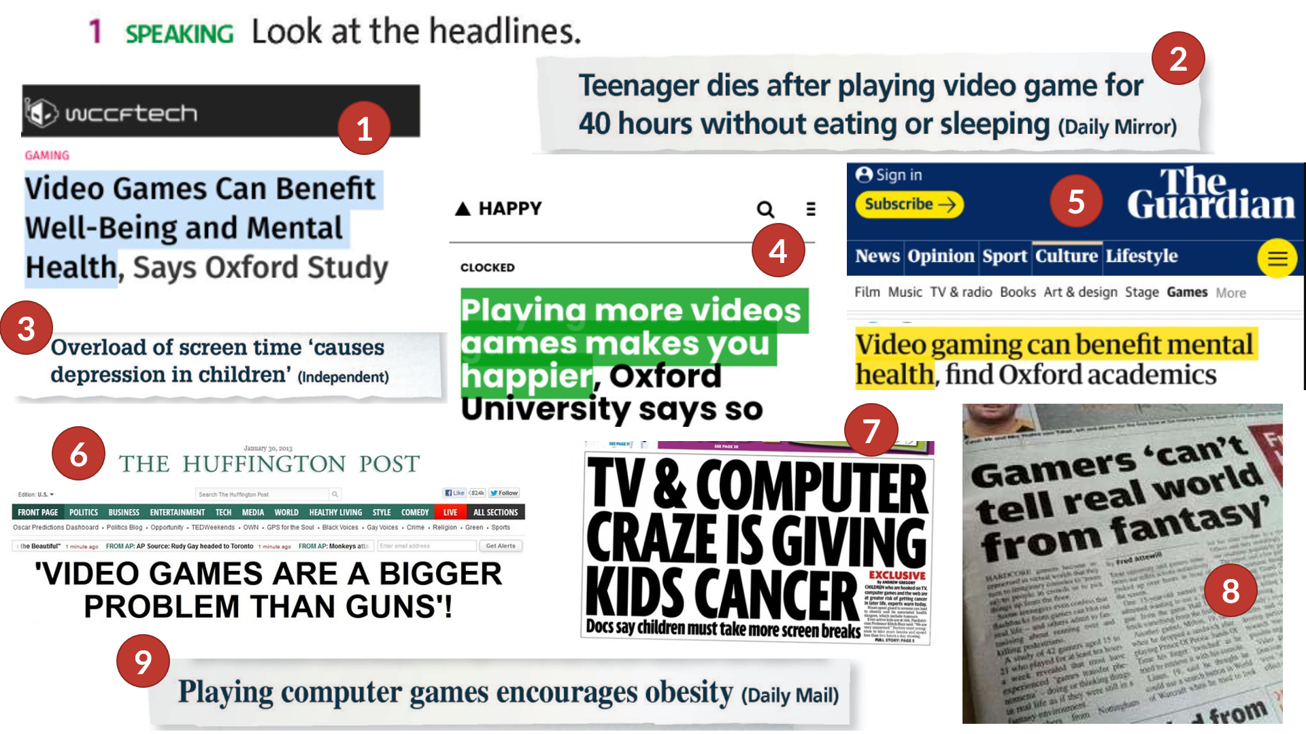  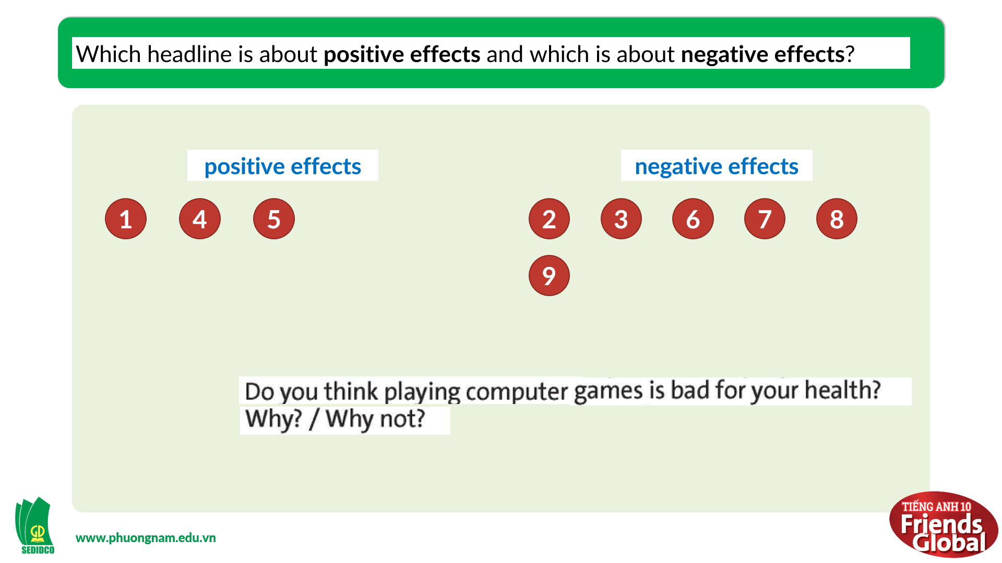  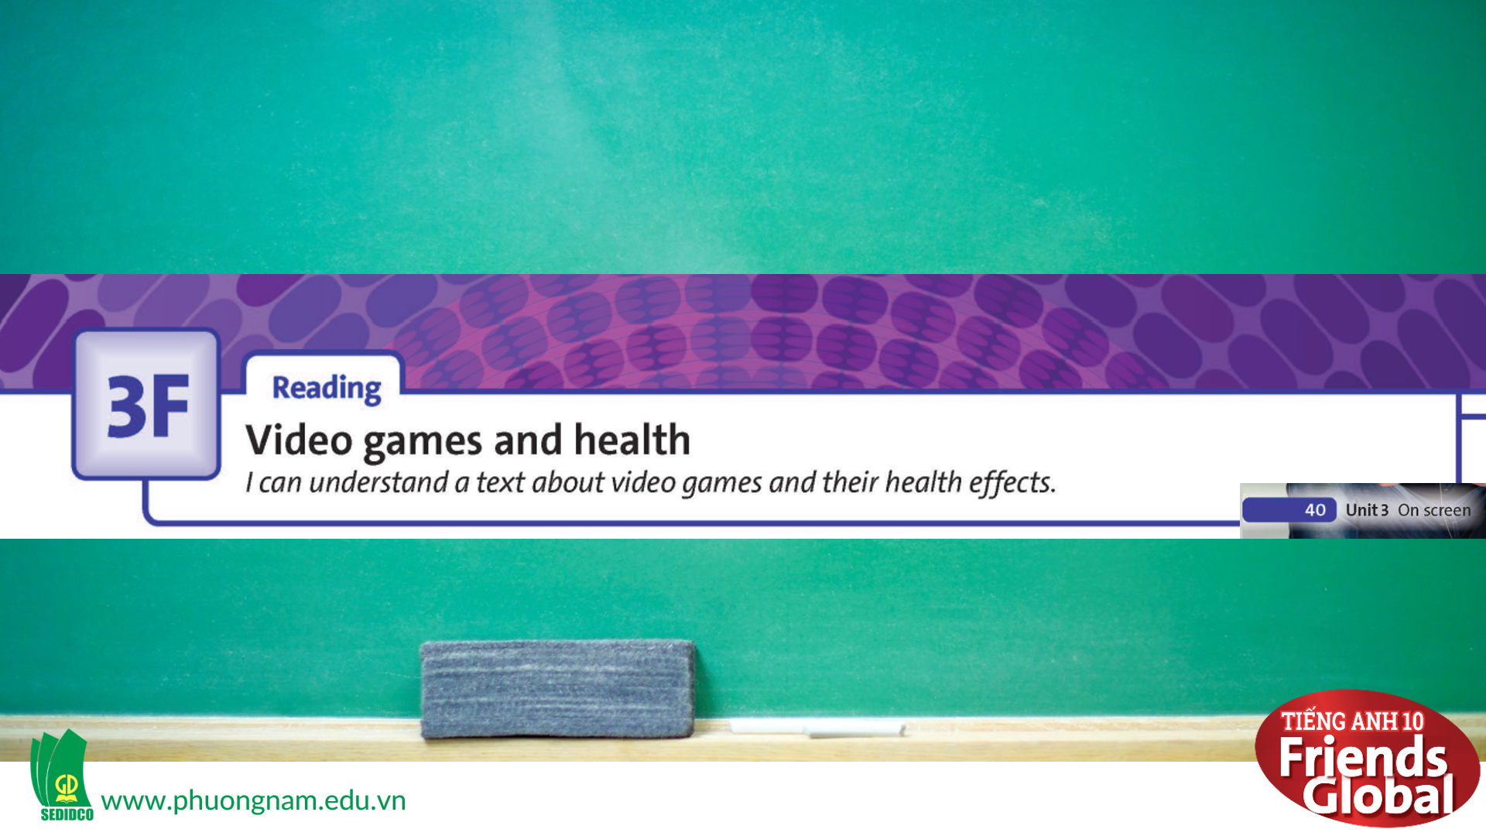

B. New lesson (75’)
- Activity 1: Presentation (7’)
a) Objective: Students get to know some new words in the lesson.
b) Content:
Vocabulary study
Listening
c) Outcomes: Students know how to pronounce the new words precisely and use them in appropriate contexts.
d) Competence: communication, presentation, guessing
e) Organisation of the activity:
TEACHER’S ACTIVITIES | STUDENT’S ACTIVITIES | CONTENTS
PRESENTATION. T-Ss/ S-S/ Indiv.  Teach new vocabulary:  - Use pictures and explanation to present new words  - Have students practice their pronunciation drills  New words:  health effect (n)  combat (n)  dimension (n)  concern (v)  assume (v)  social skills (n)  mental skills (n) | - Look, listen, and repeat in chorus and individuals | 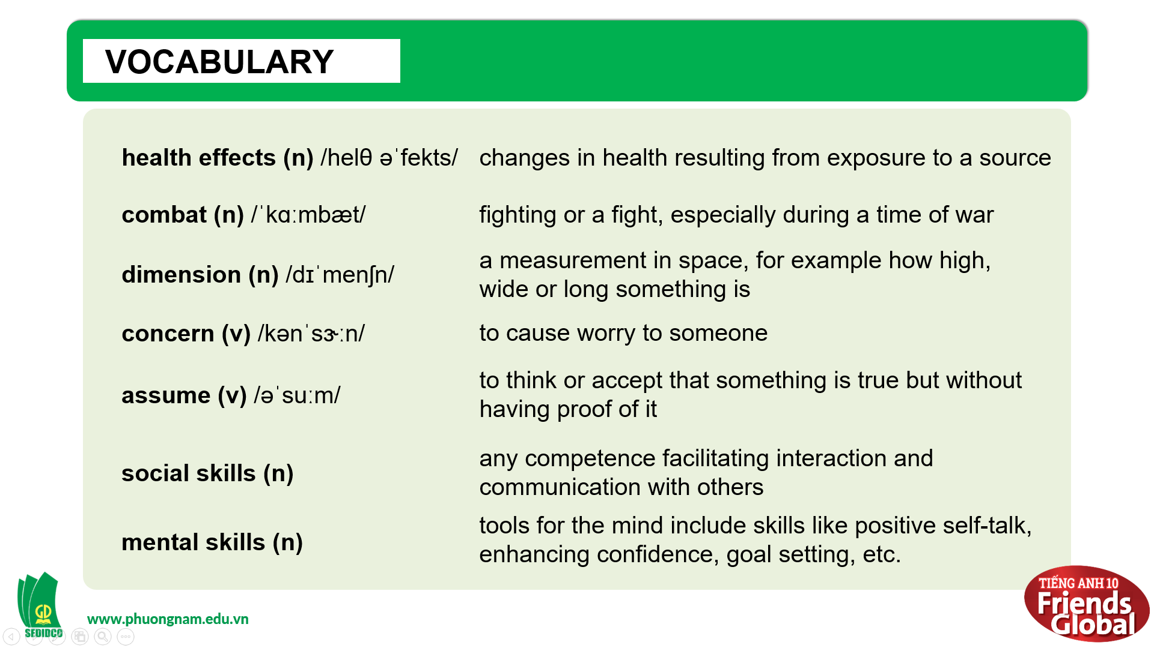
- Activity 2: Practice (38’)
a) Objective: Students can answer the questions to critical thinking, and they can finish the tasks in the textbook. Critical thing skills (guessing/ reasoning) and communication can also be practiced.
b) Content:
Reading
Speaking
c) Outcomes: Students can read and use the strategy in exams.
d) Competence: communication, collaboration, presentation
e) Organisation of the activity:
TEACHER’S ACTIVITIES | STUDENT’S ACTIVITIES | CONTENTS
PRATICE. T-Ss/ S-S/ Indiv  Activity 1 (5’): Task 2 page 40  - Ask students to read the text and answer the questions in a limited time  - Check the answers  Activity 2 (8’): Task 3 page 41  - Go through the Reading Strategy together  - Ask students highlight some main ideas  - Ask students to read the text again quickly to find main ideas of each paragraph and complete the task  - Check the answers and show students where to get the answers  Activity 3 (5’): Task 4 page 41  - Ask students read the text again carefully to circle the correct option  - Check the answers and show students where to get the answers  Activity 4 (7’): Task 5 page 41  - Ask students to complete these verb and noun collocations from the text  - Check the answers  Activity 5 (7’): Task 6 page 41  - Ask students to work in pairs and answer the questions using the information from the text  - Check the answer  Activity 6 (6’): Task 7 page 41  - Ask students to work in groups and complete the questions with How much or How many  - Check the answer | - Read the text and answer the questions quickly  - Check the answers with the teacher  - Read the Reading Strategy  - Highlight or underline main ideas  - Work in pairs to complete the task  - Listen to the teacher carefully and take notes  - Read the text in details to complete the task  - Check the answers with the teacher  - Complete the task  - Check the answers with the teacher  - Work in pairs to complete the task  - Check the answers with the teacher  - Work in groups to complete the task  - Check the answer with the teacher | 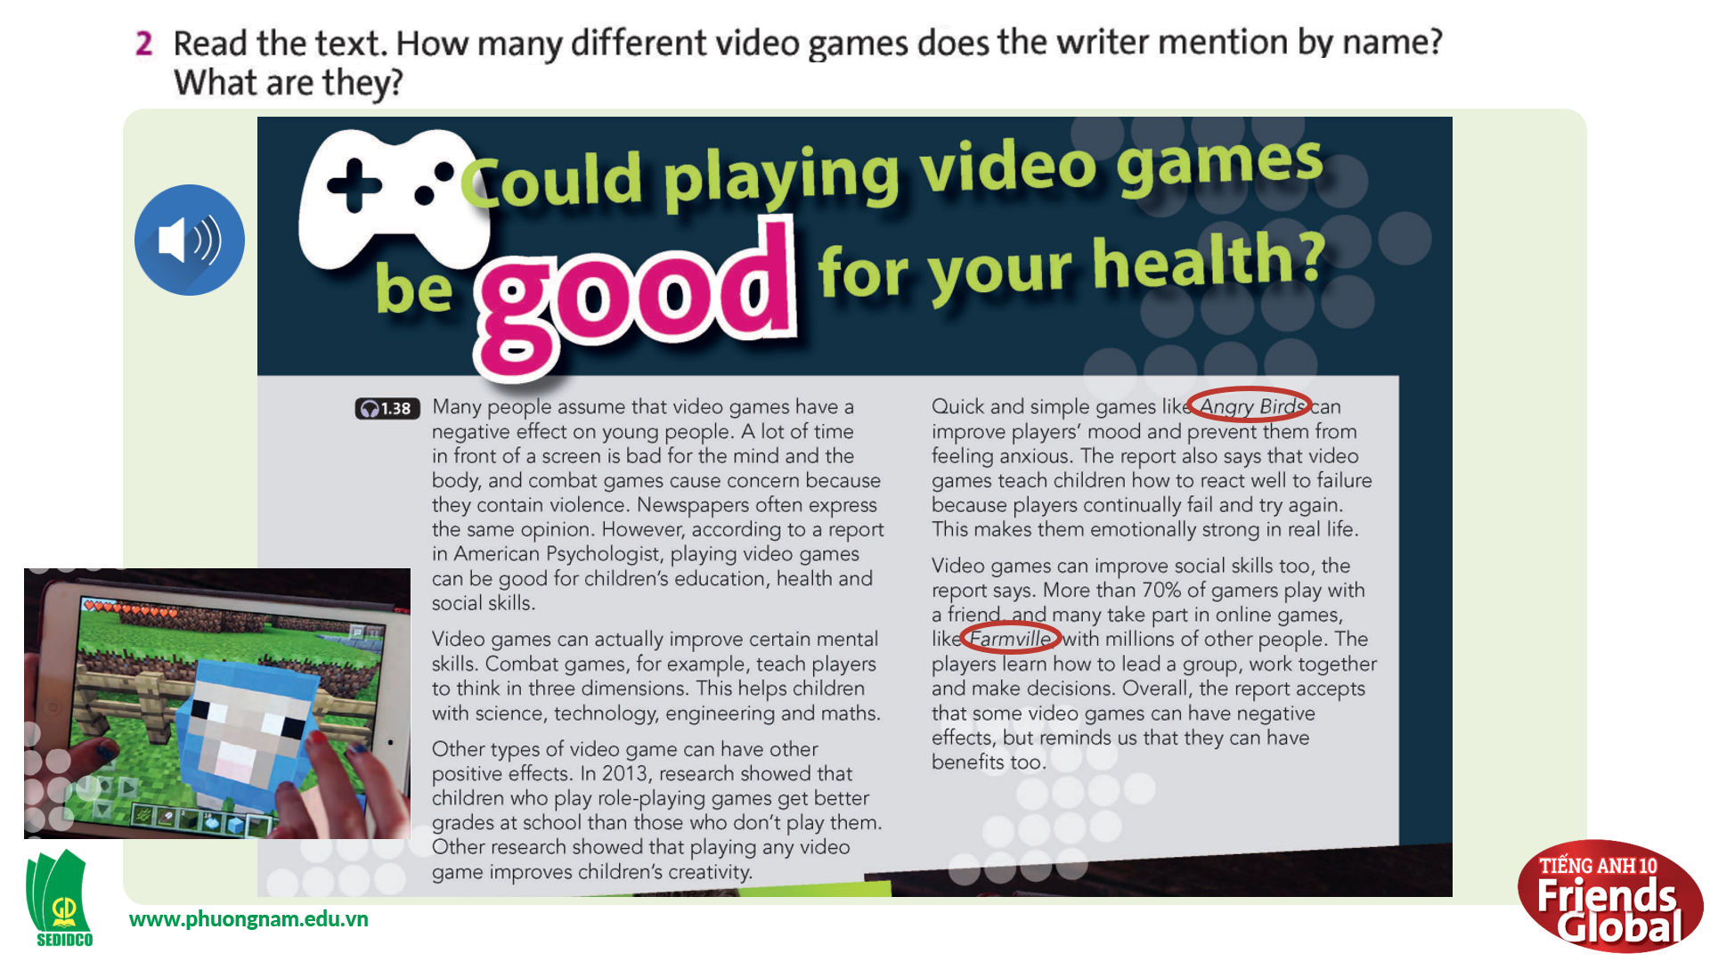  Answer: Angry Bird, Farmvilles  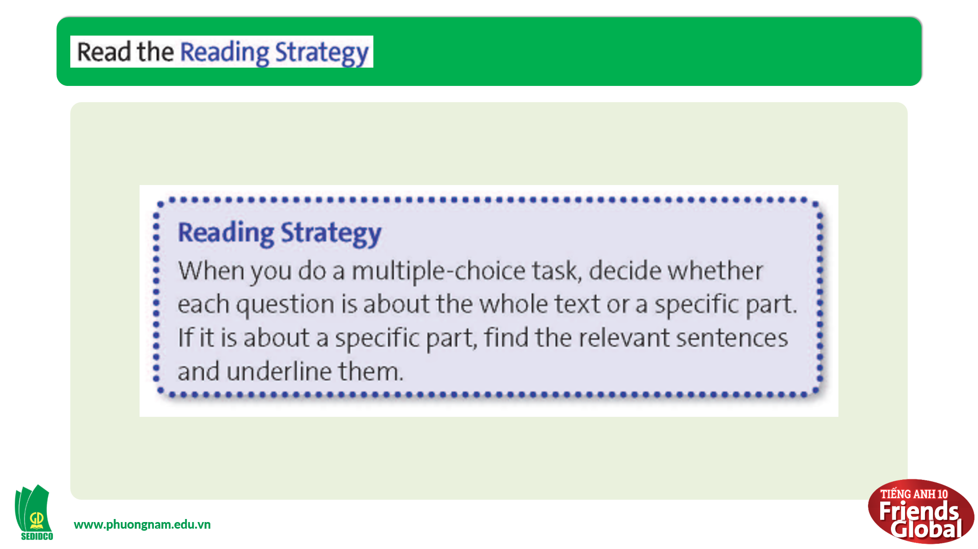  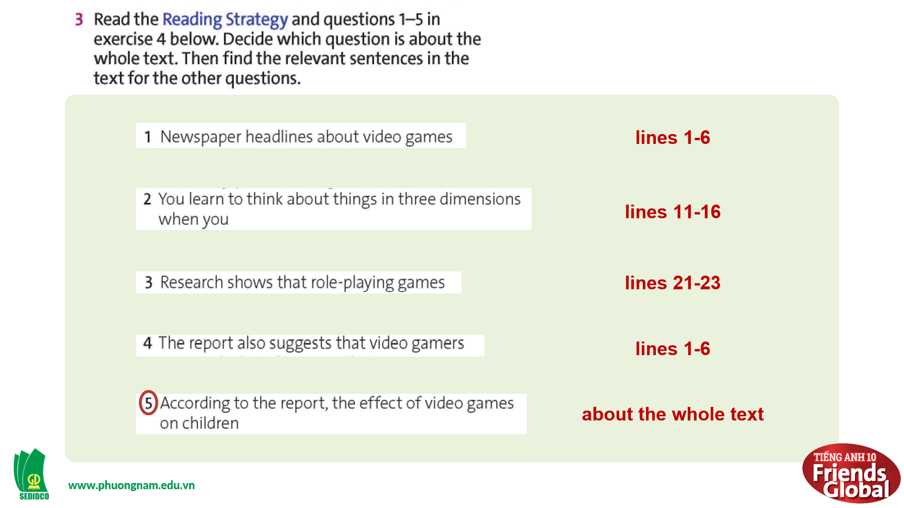  Answers:  1. lines 1-6  2. lines 11-16  3. lines 21-23  4. line 1-6  5. about the whole text  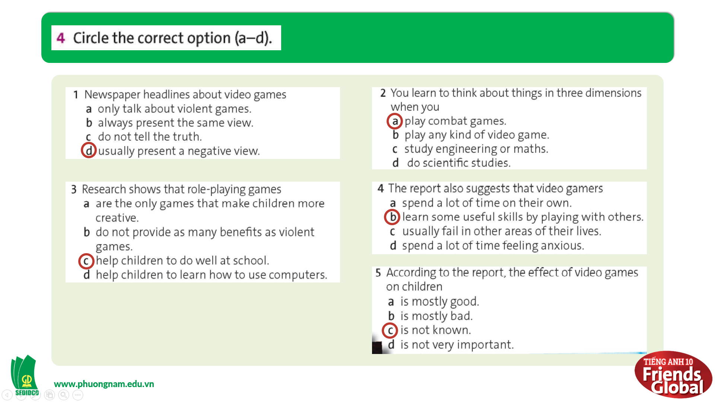  Answers:  1. d  2. c  3. a  4. b  5. c  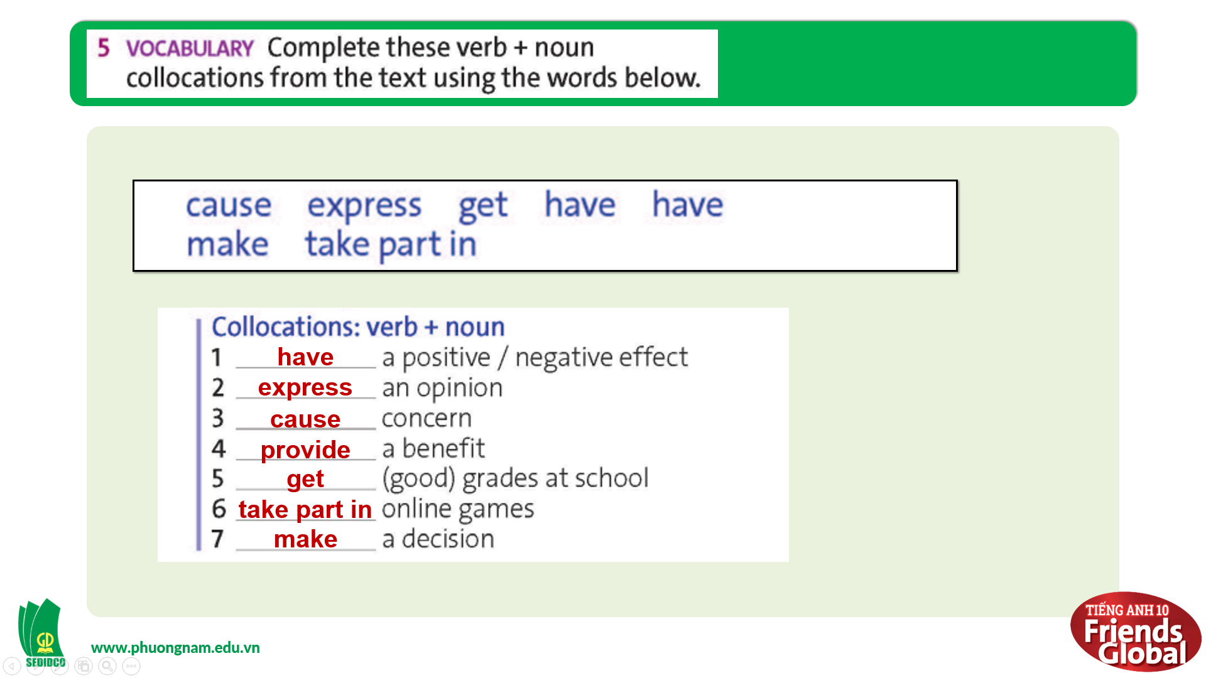  Answers:  1. have 2. express  3. cause 4. provide  5. get 6. take part in 7. make  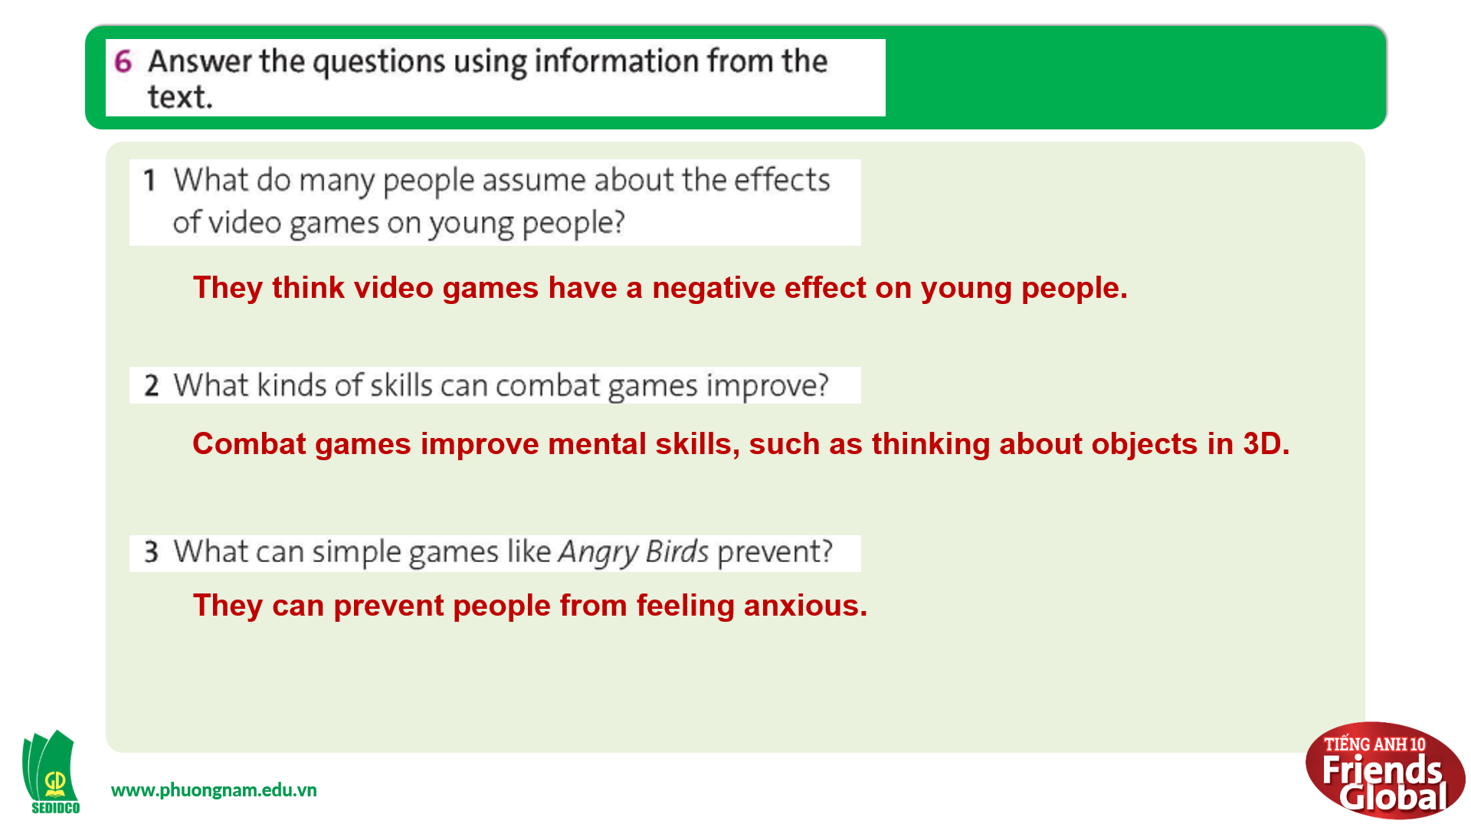  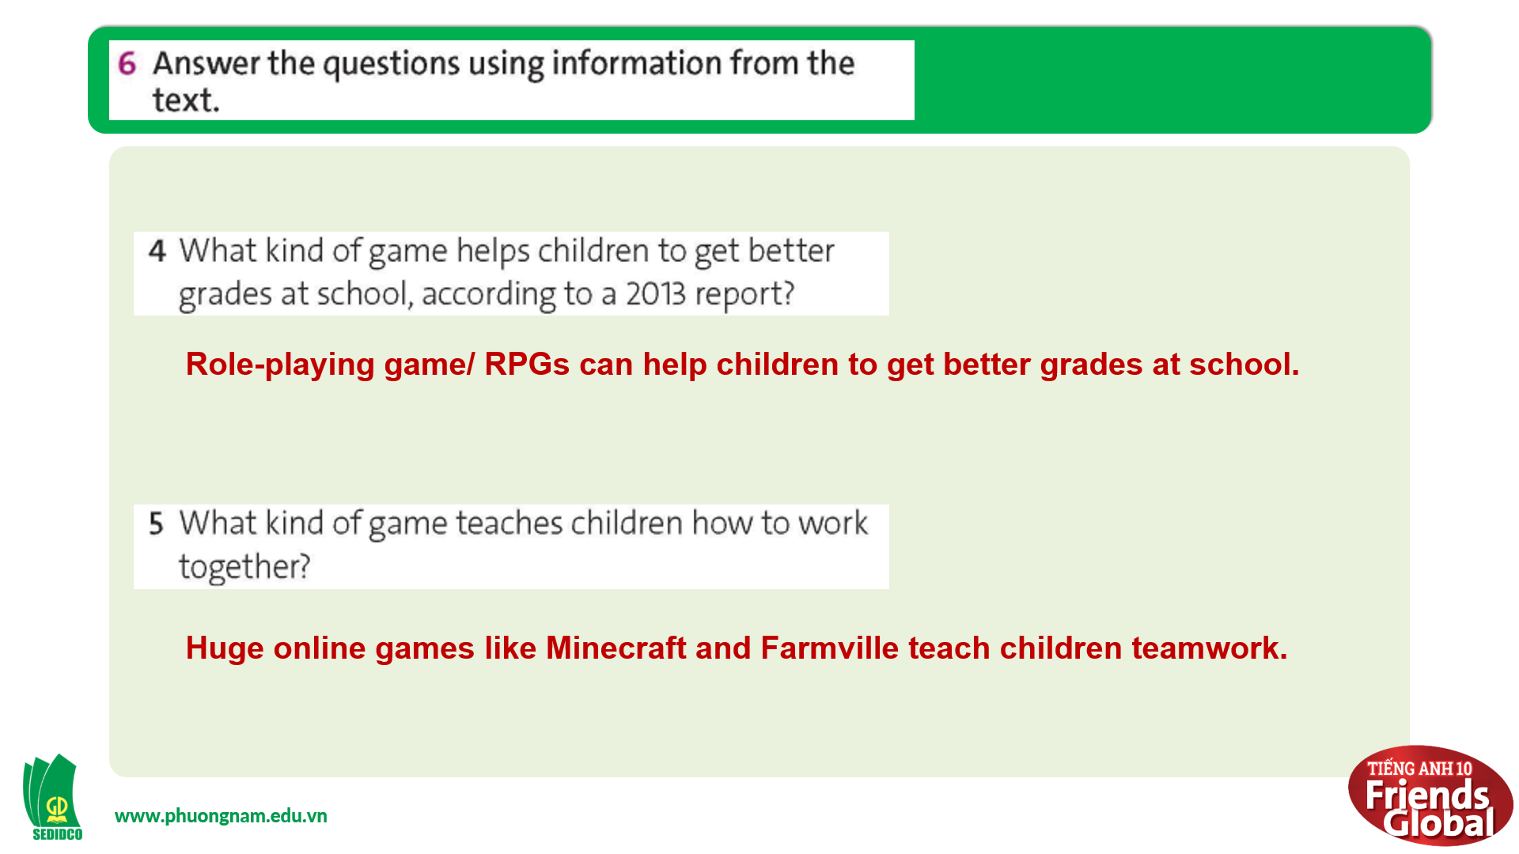  Answers:  1. They think video games have a negative effect on young people.  2. Combat games improve mental skills, such as thinking about objects in 3D.  3. They can prevent people from feeling anxious.  4. Role-playing game/ RPGs can help children to get better grades at school.  5. Huge online games like Minecraft and Farmville teach children teamwork.  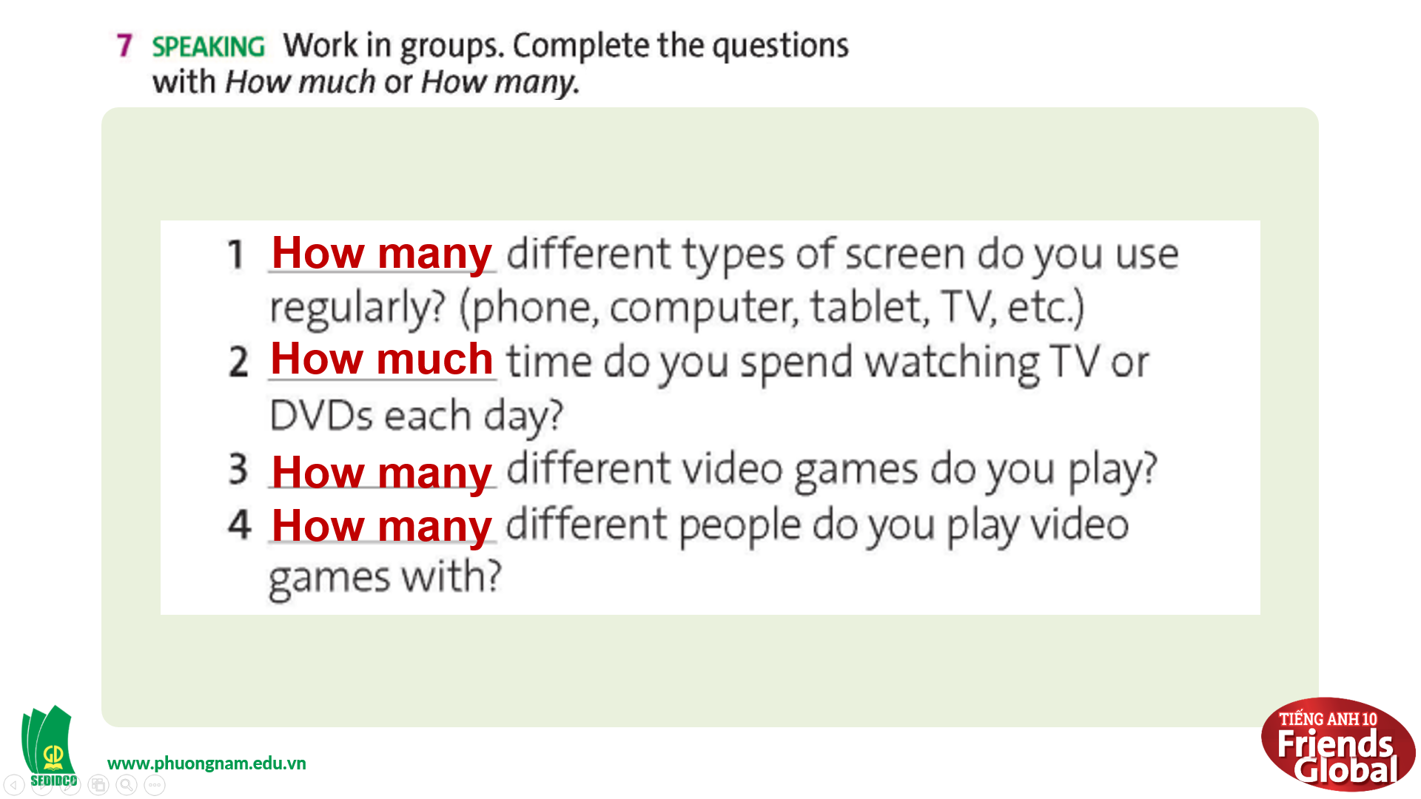  Answers:  1. How many 2. How much  3. How many 4. How many

- Activity 3: Outcomes (30’)
a) Objective: Students can answer the questions to critical thinking. Communication can also be practiced.
b) Content: Students work in groups, then ask and answer some questions about their online habits.
c) Outcomes: Students know how to ask and answer questions about their online habits and how to reduce their screen time in order to be healthy.
d) Competence: Collaboration, communication
e) Organisation of the activity:
TEACHER’S ACTIVITIES | STUDENT’S ACTIVITIES | CONTENTS
PRODUCT. T-Ss/ S-S/ Indiv  Task 6 page 41  - Ask students to work in groups, ask and answer four questions they have completed above  - Monitor and help with grammar and vocabulary where necessary  - Give students some examples  - Invite some pairs to perform in front of class  - Ask students to look at the picture and answer questions  - Present some tips to help reduce screen time | - Work in groups and practice speaking together  - Take notes their friends’ answers while listening  - Share their ideas in pairs  - Volunteer to answer based on the information given in the previous activity  - Listen to the teacher and take notes if needed | 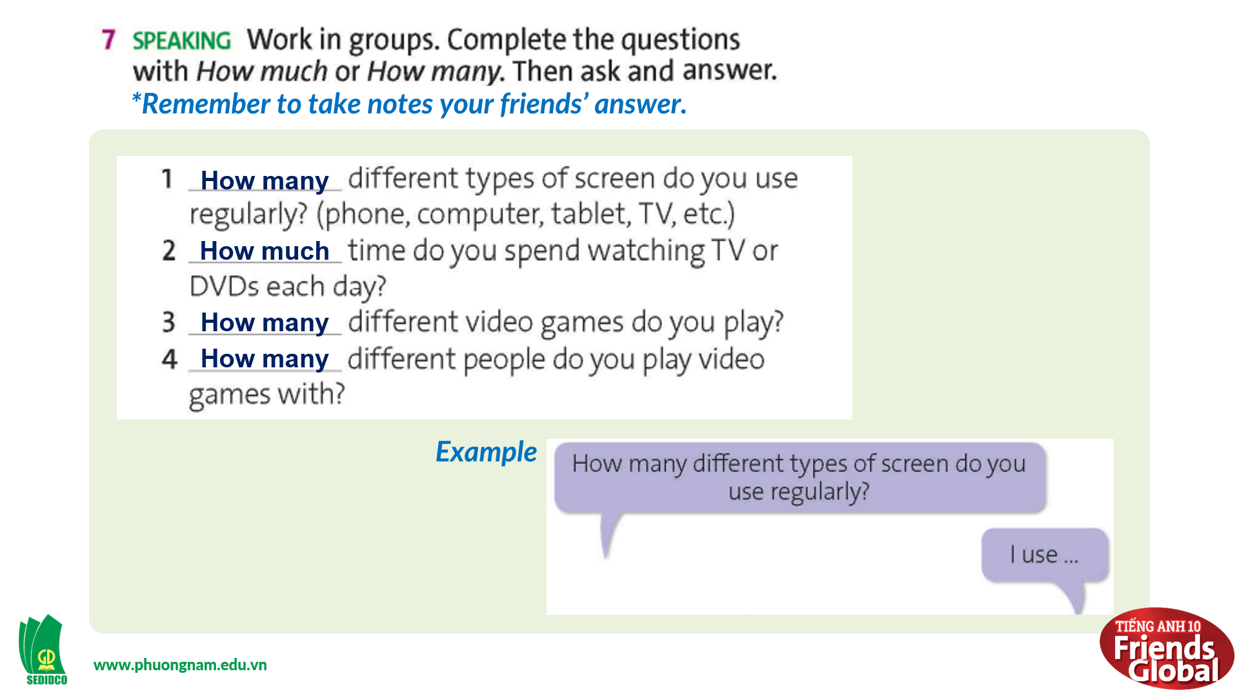  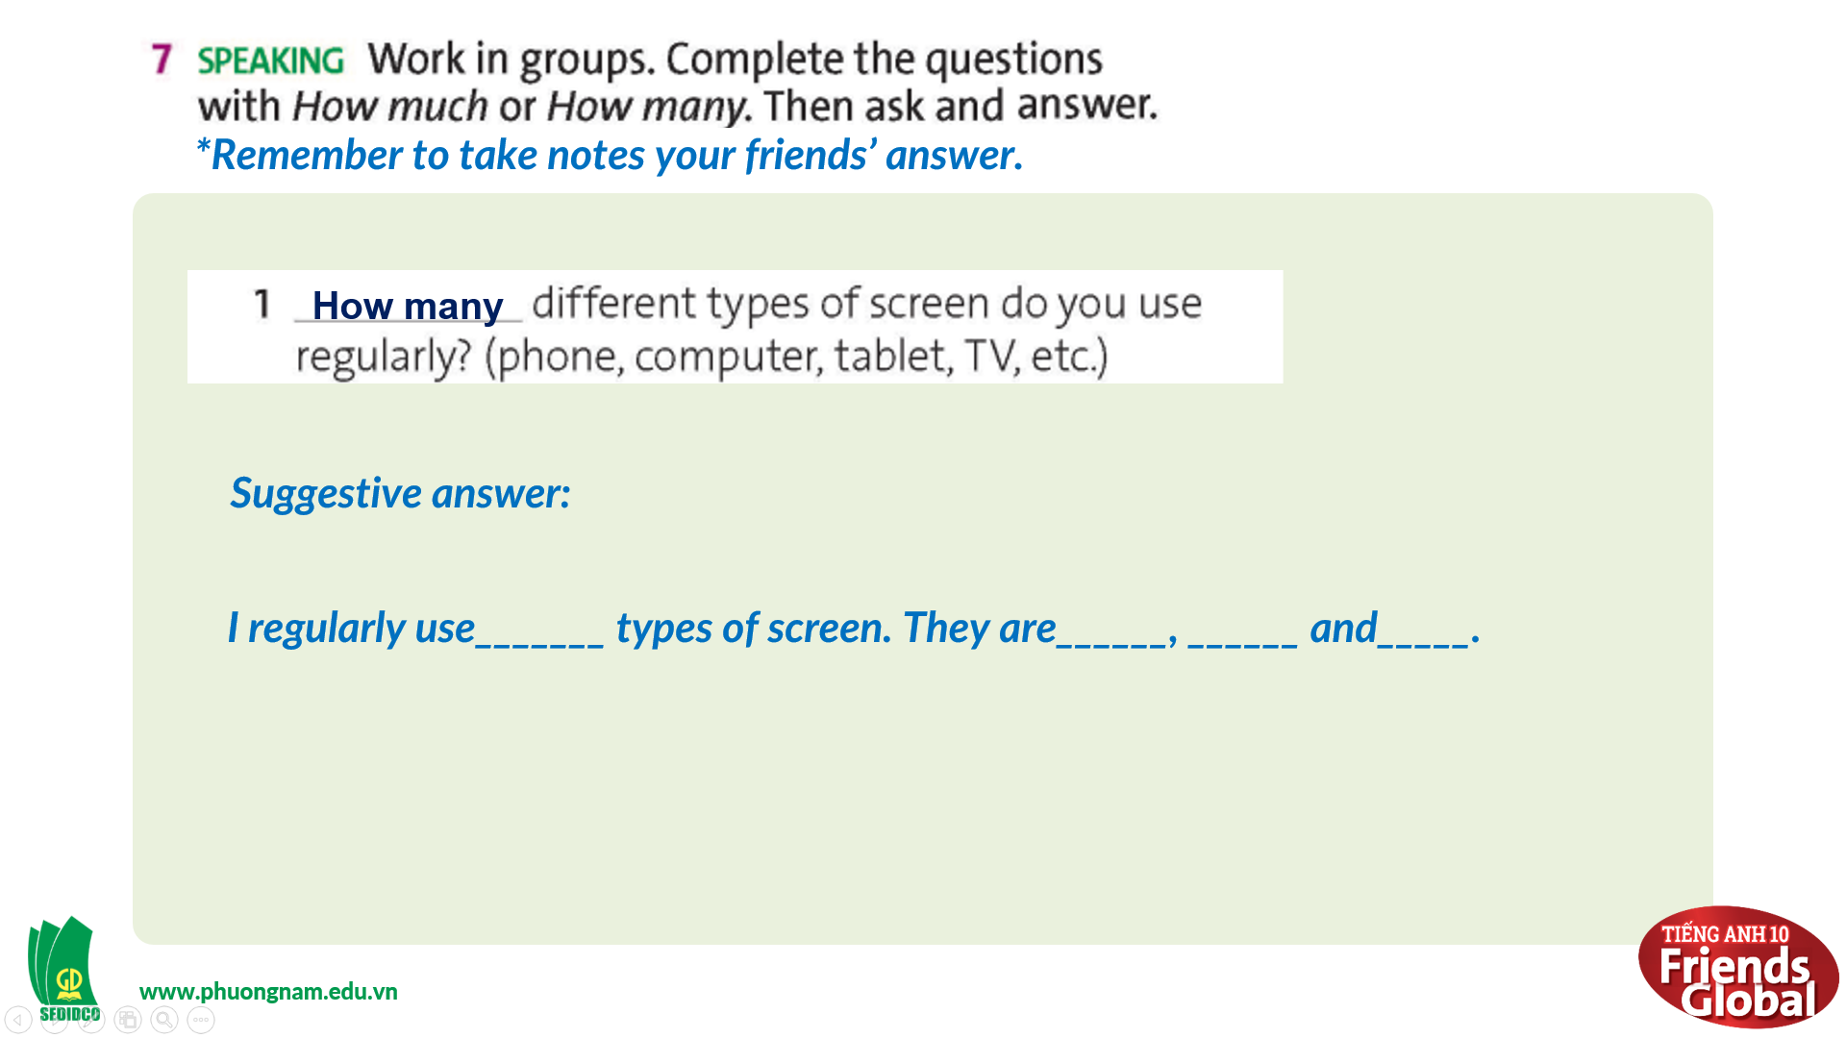  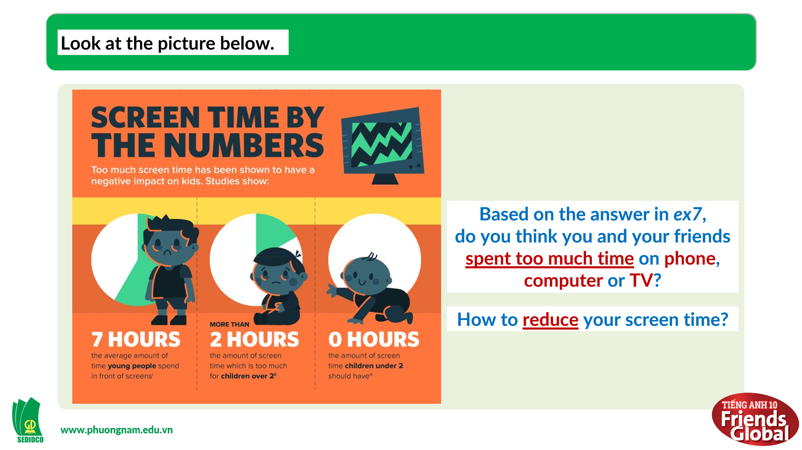  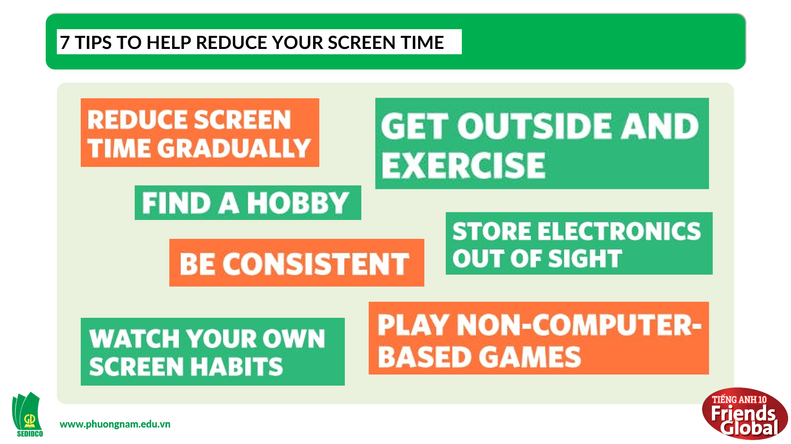

C. Consolidation (3’)
- Vocabulary: health effect, combat, dimension, concern, assume, social skills, mental skills, etc.
- Understand the importance of online habits, screen time reduction in keeping our health
D. Homework (2’)
- Learn by heart new words
- Do exercise
- Prepare: Unit 3G: Speaking (page 42 – SB)

