|  |  |
| --- | --- |
| **PHÒNG GIÁO DỤC - ĐÀO TẠO**  **CẨM GIÀNG** | **HƯỚNG DẪN CHẤM**  **ĐỀ THI HỌC SINH GIỎI CẤP HUYỆN**  **NĂM HỌC: 2024- 2025**  **MÔN: Tiếng Anh 9**  **Hướng dẫn chấm gồm 02 trang** |

**A. LISTENING. (20 POINTS)**

**Part 1. (5 points) 1.0 point for each correct answer**

**1**. A 2. C 3. A 4. B 5. C

**Part 2. (5 points): 1.0 point for each correct answer**

6. B 7. A 8. C 9. C 10. B

**Part 3. (5 points): 1.0 point for each correct answer**

11. graves 12. their/ the owner 13. original clothes

14. maker’s name(s) 15. plastic

**Part 4. (5 points) : 1.0 point for each correct answer**

16. F 17. F 18. T 19. T 20. F

**B. LEXICO-GRAMMAR (25 pts)**

**Part 1. (9 points) 1.0 point for each correct answer**

**21**. C **22**. B **23**. A **24**. C **25**. C **26**. B **27**. A**28**. B**29**. C

**Part 2. (3 points) 1.0 point for each correct answer**

30. C 31. A 32 .C

**Part 3. (3 points) 1.0 point for each correct answer**

33 .B 34.B 35.A

**Part 4. (5 points) 1 point for each correct answer.**

|  |  |  |  |
| --- | --- | --- | --- |
|  | **Line** | **Error** | **Correction** |
| **36** | **1** | Traditional | Traditionally |
| **37** | **2** | acquiring | acquired |
| **38** | **3** | explicitness | explicitly to |
| **39** | **4** | and | to |
| **40** | **5** | but | to |

**Part 5. (5 points) 1 point for each correct answer**

41. eruption 42. evacuation 43. destructive 44. survivors 45. accommodation

**C. READING (25 POINTS)**

**Part 1. (5 points): 1.0 point for each correct answer**

46 E 47.A 48.A 49.G 50.C

**Part 2. (10 points): 1.0 point for each correct answer**

|  |  |  |  |  |  |  |  |  |  |
| --- | --- | --- | --- | --- | --- | --- | --- | --- | --- |
| 51. D | 52. A | 53. B | 54. D | 55. B | 56. C | 57. D | 58. B | 59. D | 60. C |

**Part 3. (10 points): 1.0 point for each correct answer**

|  |  |  |  |  |
| --- | --- | --- | --- | --- |
| 61.A | 62.B | 63.D | 64.B | 65.A |
| 66.B | 67.C | 68.B | 69.B | 70.C |

**D. WRITING (30 pts)**

**Part 1. (5 points) 1.0 point for each correct answer**

71. Minh advised me not to drink too much coffee at night.

72. If you learn hard, you won’t fail the exam./

If you don’t learn hard, you will fail the exam.

73. There has been a considerable change in our lifestyle since the

introduction of Western culture.

74. We find it (extremely) difficult to make ends meet these days.

75. I asked Bill what time you had gone to bed the previous night / the night before.

**Part 2. (10 points)**

**1. Form:**

*- Correct form of an informal letter* ***(****1.0 point)*

**2. Task fulfillment:**

*- Task completed with relevant information (2.0 points)*

*- Well-organized (2.0 points)*

**3. Language**:

*- Accurate grammar (2.0 points)*

*- Appropriate vocabulary (2.0 points)*

*- Correct spelling and punctuation (1.0 point)*

**Part 3. (15 points).**

**Score of 14-15: A paragraph at this level:**

* *shows very effective writing skills*
* *is very well organized and well developed*
* *uses details clearly and properly to support a thesis or illustrate ideas*
* *displays consistent ability in the use of language*
* *demonstrates variety in sentence structure and proper word choice*

**Score of 11 - 13: A paragraph at this level:**

* *shows effective writing skills*
* *is well organized and well developed*
* *uses details clearly and properly to support a thesis or illustrate ideas*
* *displays consistent ability in the use of language*
* *demonstrates variety in sentence structure and proper word choice*

**Score of 9 - 10: A paragraph at this level:**

* *may address some parts of the task more effectively than others*
* *is generally well organized and developed*
* *uses details to support a thesis or illustrate an idea*
* *displays ability in the use of the language*
* *shows some variety in sentence structure and range of vocabulary*

**Score of 7 - 8: A paragraph at this level:**

* *addresses the writing topic adequately but does not meet all of the goals of the task*
* *is adequately organized and developed*
* *uses some details to support a thesis or illustrate an idea*
* *shows adequate but possibly inconsistent ability with sentence structure*
* *may contain some usage errors that make the meaning unclear*

**Score of 5 - 6: A paragraph at this level may reveal one or more of the following weaknesses:**

* *inadequate organization or development*
* *poor choice of details or does not provide enough details to support or illustrate generalizations*
* *a noticeably improper choice of words or word forms*
* *numerous errors in sentence structure and/or usage*

**Score of 3 - 4: A paragraph at this level is seriously flawed by one or more of the following weaknesses:**

* *serious disorganization or underdevelopment*
* *little or no detail, or irrelevant specifics*
* *serious and frequent errors in sentence structure or usage*
* *serious problems with focus*

**Score of 1- 2: A paragraph at this level:**

* *may be incoherent*
* *may be undeveloped*
* *may contain severe and persistent writing errors*

**Score of 0: A paragraph will be rated 0 if it:**

* *contains no response*
* *merely copies the topic*
* *is off-topic, written in a foreign language or consists only of keystroke characters*

**Học sinh làm cách khác đúng, giáo viên linh hoạt cho điểm.**

**=== THE END ===**

**TRANSCRIPT**

**Part 1**

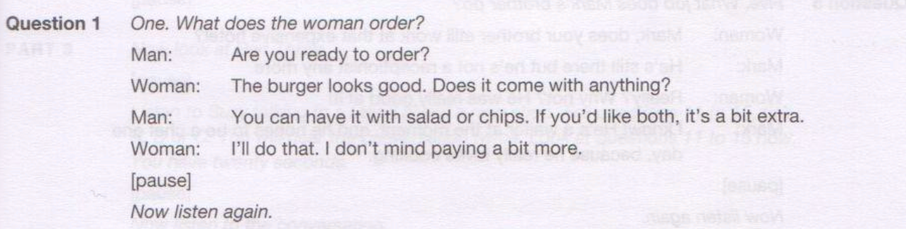

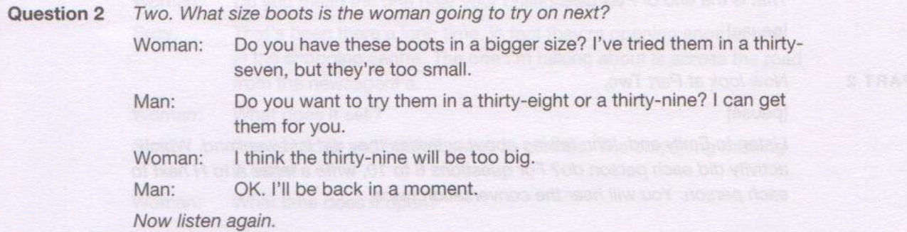

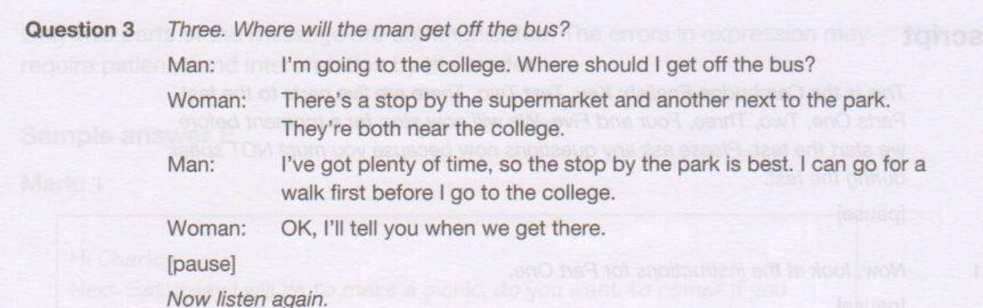

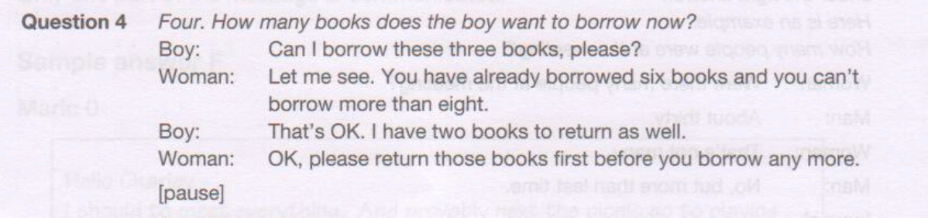

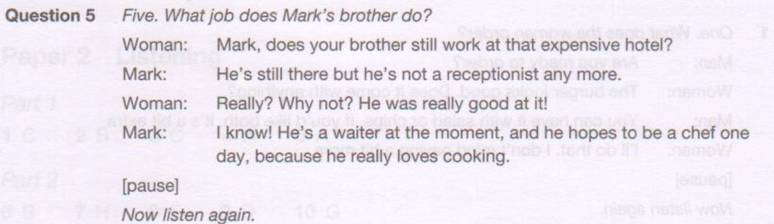

**Part 2**

**Interviewer:** My guest today is the star of the London Ballet Company, twenty-two-year-old Elena

Karpov. Elena, you were born in Bulgaria. Did you always want to be a dancer?

**Elena:**

Well, I was a very lively little girl, so at the age of seven my mother sent me to gymnastics classes. When I was nine, I went on to ballet lessons and from that moment I knew that I wanted to spend my life dancing. Two years later, when I was eleven, I won a place at the New York Ballet School.

**Interviewer:** So you had to move to the United States. Did you miss your family?

**Elena:** Oh yes. At first it was difficult being away from home and not knowing a lot of English. But it taught me how to look after myself and not to depend on others. There were other Bulgarian students there, and we actually found it quite easy to learn enough English to take part in the lessons with the other students.

**Interviewer**: Tell us about your latest role with the London Ballet Company. Elena:

**Elena:** I'm going to dance the part of *Cinderella*. It's a story about a poor girl who marries a handsome prince. My parents used to read it to me when I was little. I'd never seen the ballet before, but I already knew the music really well. I'm sure children will love the ballet.

**Interviewer**: What do you do when you're not practising or performing?

**Elena:** Before I joined this company I spent two weeks going round London as a tourist. I don't have time for sightseeing now, but I love trying on the latest fashions with my friends. I'm always buying new jeans and trainers! I'm not too keen on discos and nightclubs - I dance enough during the day!

**Interviewer:** You must have lots of fans.

**Elena:** Quite a few! They always ask for a photograph of me, but unfortunately I don't have many to give away. I sometimes sign their programmes instead, and if I can I give them one of the flowers I've received from the audience. They always ask for tickets, but of course that's not possible.

**Interviewer:** What's been the best thing that's happened in your career so far?

**Elena:** Well, I've been a guest dancer with ballet companies in Moscow and Vienna, and I appeared twice on television in Bulgaria and met the president! I shall never forget that! But the most satisfying thing for me is that I'm paid for doing what I really enjoy dancing!

**Interviewer**: Elena, thank you for talking to us.

**Elena:**

[Pause]

Thank you.

**PART 3**

Dolls have always fascinated me, and that's why, five years ago, I was delighted to be offered the job of running a doll museum.

Dolls have existed for thousands of years, and the earliest dolls we know about were found in graves in ancient Egypt. I only wish we could get one or two for our museum, but we haven't unfortunately got anything as old as that in the museum. All the same, we have got examples from Europe from the twelfth century, but my favourite early dolls are actually from the seventeenth century. They interest me not just because they are early, or fairly early, but also because of the clothes they're wearing. They have their original clothes, and from them we know what the owners wore, since dolls in those days were always dressed like their owners. They were made of the only material readily available for things like this at the time: solid wood, and they were painted in great detail. In fact, on the best examples, like the ones in the museum, the detail includes the seventeenth-century make-up.

Dolls like these were very expensive then, and only the very rich could afford them. These days, they're popular with collectors and if you want one today, you have to pay anything up to ten thousand pounds for a doll in perfect condition from this time! By the way, what makes them so valuable is that, as far as a collector is concerned, a doll is only worth collecting if it is in perfect condition, and that means having the original clothes.

Doll collecting has become very fashionable since the museum opened, with people interested in dolls from every period, including later dolls. There's great interest in nineteenth-century examples, when dolls were no longer made of wood, but began to have soft bodies and real hair. They were very delicate and few have survived, meaning such a doll would be worth about two thousand pounds, perhaps a bit more. Later, in the nineteenth century, you could often take off the doll's hair. If you can, you can often see the maker's name underneath, and of course the right one increases a doll's value.

There was a really big change in dolls at the beginning of the twentieth century. In the museum we have one of the earliest examples, from about 1909, of a doll that's a model of a baby. Previously all dolls, the earlier ones, were little adults. That's just one of the changes that have occurred in the last hundred years. Another, again, is to do with what dolls are made of. Although dolls with soft bodies continued, after about 1930, plastic began to be used. In fact, dolls from the 1930s and 40s are now very popular with collectors, some of them selling for very, very high prices.

**PART 4**

**Greg:** Hi Julie. Wasn't the indoor wildlife centre fantastic? I've never seen such an amazing building, with its glass walls and all those different floors.

**Julie:** Hi Greg. Didn't you find it tiring though, walking up so many stairs, and it was so hard to find your way round? That's not what I call good design.

**Greg:** I didn't really think about that.

**Julie:** It was an interesting start down in the basement, where it was so dark that I didn't see the sharks at first in the water behind the glass.

**Greg:** They were quite scary. You must know how dangerous they are.

**Julie:** Only if you're silly enough to swim with them! Anyway, what did you think of the temperature in the building?

**Greg:** It has to be so high in there because of all those tropical trees growing. They need a lot of heat.

**Julie:** I suppose so. It felt really uncomfortable to me. I loved the banana trees though. Those butterflies right at the top of the building were amazing - so huge and colourful. But I thought there would be a lot more insects to see. There were hardly any really.

**Julie:** Just as well! Who wants to see a load of insects! I don't find them especially interesting at the best of times. Did you manage to see any tree frogs? They're so cute.

**Greg:** I spent ages hunting for them. They manage to hide by having skin that looks like part of a tree and they lie still without moving. I couldn't find a single one.

**Julie:** Yeah, they're not stupid - making sure they can't be seen by hungry birds! I really can't wait to go back 'cos there was just too much to see.

**Greg:** I'd like to read more about the wildlife before I think of going back there. Don't you think we'd enjoy it more if we knew more about the animals?

**Julie:** I'm not so sure really.