School: ……………………………………….. | Date:………………………………..
Class: ……………………………..................... | Period: ……………………….........

UNIT 5: SCIENCE AND TECHNOLOGY
Lesson 2.1 – Grammar (pages 49 & 50)

I. OBJECTIVES
By the end of the lesson, Ss will be able to
1.1. Language knowledge and skills
- practice and use comparative adverbs correctly.
1.2. Competences
- improve Ss’ communication, collaboration and critical thinking skills.
1.3. Attributes
- to understand how electronic devices work and their impacts on daily life.
II. TEACHING AIDS AND LEARNING MATERIALS
1. Teacher’s aids: Student book and Teacher’s book, class CDs, Digital Book (DCR phần mềm tương tác SB, DHA (từ vựng/ cấu trúc) phần mềm trò chơi tương tác), projector/interactive whiteboard / TV (if any), PowerPoint slides, handouts.
2. Students’ aids: Student’s book, workbook, notebook.
III. ASSESSMENT EVIDENCE
Performance Tasks | Performance Products | Assessment Tools
- Listen to the song and fill in the gaps. | - Ss’ performance. | - T’s feedback.
- Study the grammar box. | - Ss’ task. | - T’s observation.
- Fill in the blanks with the form of comparative adverbs in brackets. | - Ss’ answers. | - T’s feedback/Peers’ feedback.
- Write sentences using the adverbs and information given. | - Ss’ answers. | - T’s feedback/Peers’ feedback.
- test your memory with your partner. (in pairs). | - Ss’ performance/ presentation. | - T’s observation, T’s feedback/Peers’ feedback.
IV. PROCEDURES
A. Warm up: (5’)
a) Objective: Introduce the new lesson and set the scene for Ss to acquire new language; get students' attention at the beginning of the class by enjoyable and short activities as well as to engage them in the follow-up steps.
b) Content: Introducing comparative adverbs.
c) Expected outcomes: Ss review their previous knowledge and have general ideas about the grammar point they are going to study in the new lesson.
d) Organization of the activity:
TEACHER’S ACTIVITIES | STUDENTS’ ACTIVITIES
* OPTION 1: Listen to the song and fill in the gaps.  - Introduce the song Stronger (What Doesn't Kill You) by Kelly Clarkson: https://www.youtube.com/watch?v=Xn676-fLq7I    - Give Ss handouts. Have Ss work in pairs, listen to the song and fill the gaps:  HANDOUT:  Listen to the song and fill the gaps:  STRONGER (What Doesn't Kill You)  by Kelly Clarkson  You know the bed feels __________ (warm)  Sleeping here alone  You know I dream in colour  And do the things I want  You think you got the best of me  Think you've had the last laugh  Bet you think that everything good is gone  Think you left me broken down  Think that I'll come running back  Baby, you don't know me, 'cause you're dead wrong  What doesn't kill you makes you ____________(strong)  Stand a little __________(tall)  Doesn't mean I'm lonely when I'm alone  What doesn't kill you makes a fighter  Footsteps even ___________ (light)  Doesn't mean I'm over cause you're gone  - Play the song and ask Ss in pairs to write down as many words of comparative adjectives as they can remember in two minutes in a sheet of paper.  - Have Ss write their answers on the board.  - Tell that the group with more correct words will be the winner.  - Show the answers.  - Lead to the new lesson.  * OPTION 2:  - Have Ss look at the picture – page 49.  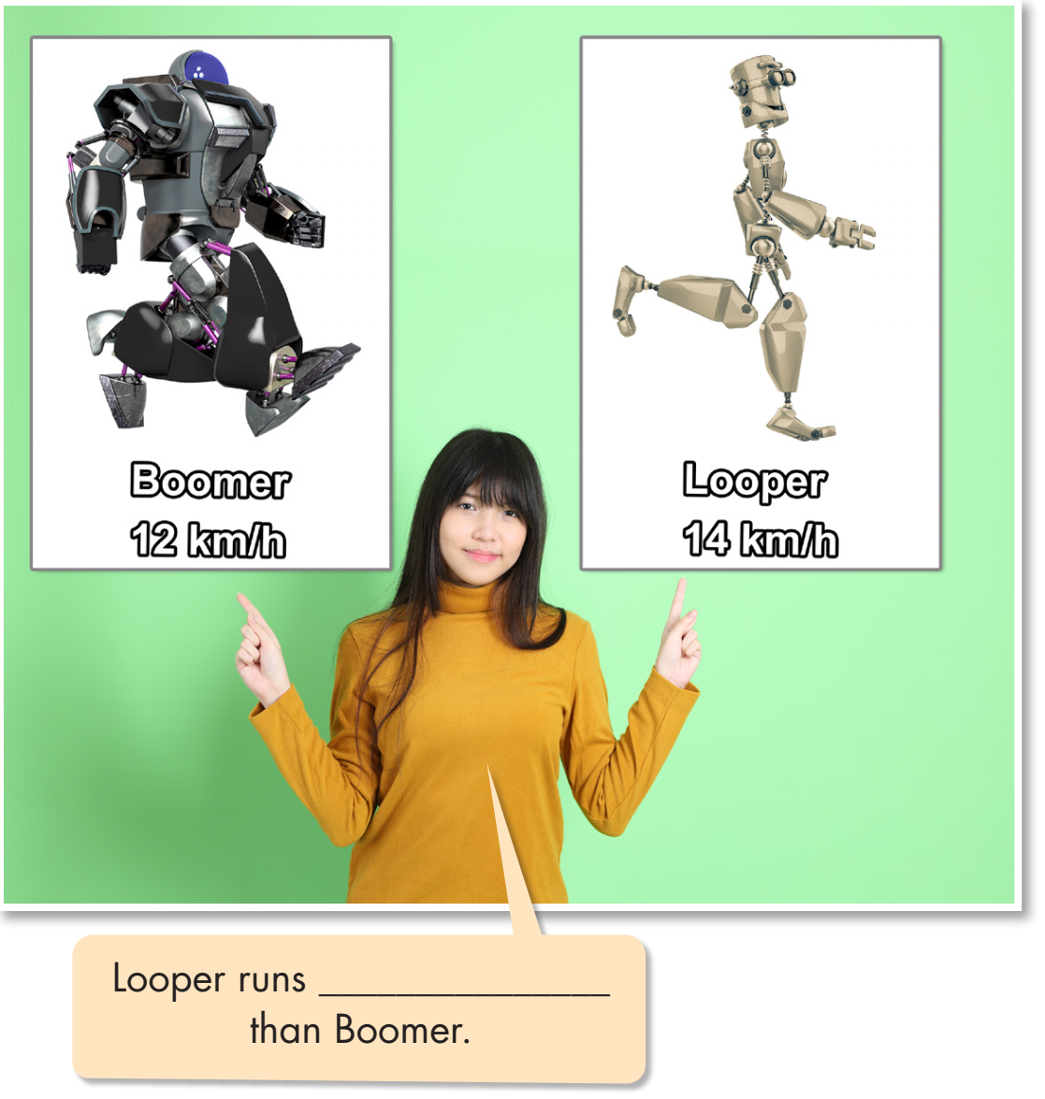  - Have some Ss read the sentence in the bubble aloud.  - Have Ss fill in the blank.  - Give feedback.  - Lead to the new lesson. | - Work in pairs.  - Give answers.  Answers keys  warmer, stronger, taller, lighter  - Look at the picture.  - Read the sentence aloud.
B. New lesson (35’)
- Activity 1: Presentation (10’)
a) Objective: Introduce comparative adverbs.
b) Content: Practicing the grammar point.
- Listen and repeat.
- Introduce the grammar point: comparative adverbs.
c) Expected outcomes: Ss know how to use comparative adverbs to do some following exercises.
d) Organization of the activity:
TEACHER’S ACTIVITIES | STUDENTS’ ACTIVITIES
Tasks a & b. Read about comparative adverbs and fill in the blank. Then, listen and check your answers.  Listen again and repeat.  - Have Ss look at the grammar explanation.  - Have Ss look at the examples.  - Have some Ss read the examples aloud.  - Have Ss look at the picture.  - Have Ss fill in the blanks.  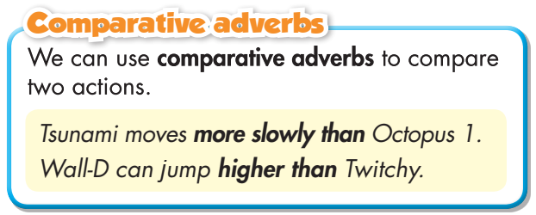  - Play audio (CD1 – Track 58) and have Ss listen, check answers, then read the speech bubble.  - Play the audio again and have Ss listen and repeat.  - Ask Ss to give more comparative adverbs and make sentences with them.  →Lead to the grammar box as follows:  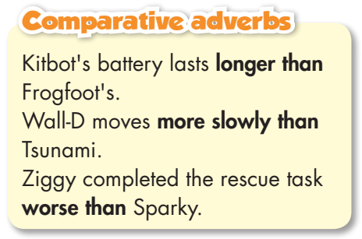  - Have Ss look at the grammar explanation with the use of verbs followed by adverbs:  Comparative adverbs are used to compare two actions. They modify verbs and indicate that one action is more or less than another.  - Focus on kinds of adverbs.  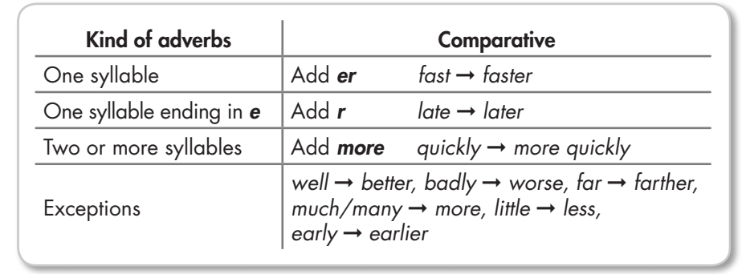  -Have some Ss read the comparative adverbs aloud.  - Emphasize some adverbs having the same form as adjectives  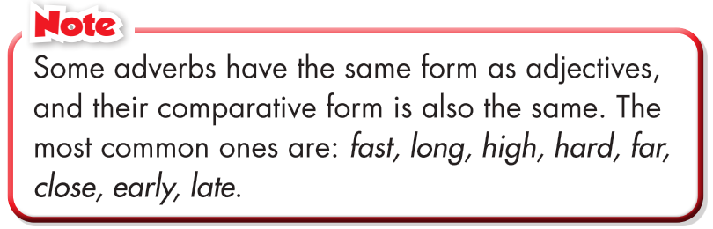  - Give feedback. | - Look.  - Read the examples aloud.  - Listen, then read.  Answer keys:  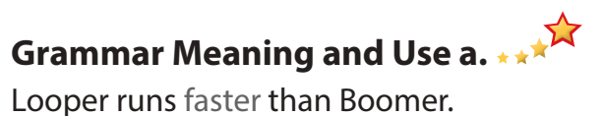  - Look and read.  - Read the adverbs aloud.
- Activity 2: Practice (19’)
a) Objective: Students can use comparative adverbs correctly.
b) Content: Performing the tasks, using the grammar point.
- Read the examples and notes above, then fill in the blanks.
- Write sentences using the adverbs and information on the right (to compare Stumpy with Flying Chicken).
c) Expected outcomes: Students can use comparative adverbs in their speaking.
d) Organization of the activity:
TEACHER’S ACTIVITIES | STUDENTS’ ACTIVITIES
Task a. Read the examples and notes above, then fill in the blanks.  - Demonstrate the activity using the example.  - Have Ss read the sentences and fill in the blanks.  - Have pairs check each other's work.  - Have some Ss share their answers with the class.  - Give feedback and correct Ss’ answers if necessary. | - Look and listen.  - Work individually.  - Work in pairs.  - Write answers on the board.  Answer keys  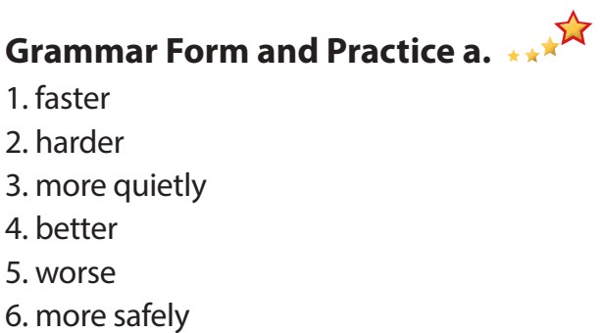
Task b. Write sentences using the adverbs and information on the right.  - Demonstrate the activity using the example.  - Have Ss write sentences using the adverbs and  information on the right (to compare Stumpy with Flying Chicken).  - Have pairs check each other's work.  - Have some Ss share their answers with the class.  - Check Ss’ answers, give feedback. | - Look and listen.  - Work individually.  - Work in pairs.  - Read or write answers.  Answer keys  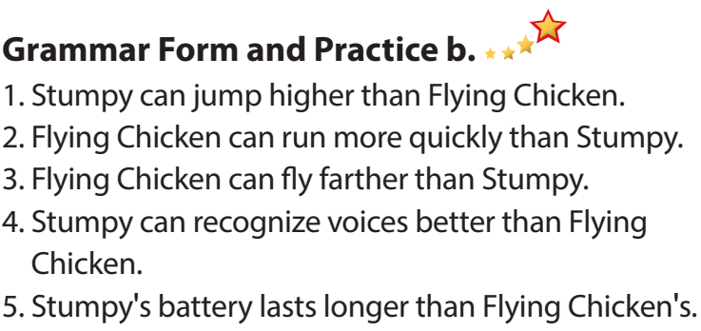
- Activity 3: Production (6’)
a) Objective: Students master the grammar point they study in the lesson.
b) Content: Speaking: Ask and answer using the information in Task c.
c) Expected outcomes: Ss produce the new language successfully, and they can apply the grammar point they have learnt in speaking and writing.
d) Organization of the activity:
TEACHER’S ACTIVITIES | STUDENTS’ ACTIVITIES
Task c. In pairs: Take three minutes to memorize the information in Tasks a. and b. Then, close your book and test your memory with your partner.  - Divide the class into pairs.  - Have Ss take three minutes to memorize the  information in Tasks a. and b. then test their partner.  - Have some pairs demonstrate the activity in front of the class.  - Give feedback. | - Work in pairs.  - Have conversation in pairs.  - Present.  - Listen.  Suggested Answers  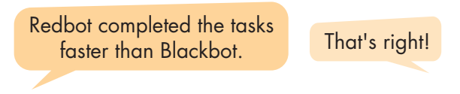

C. Consolidation and homework assignments (5’)
*Consolidation: Meaning, form and use of comparative adverbs.
- Read the sentences about two robots. Give the correct form with the words given.
WHICH ROBOT IS BETTER?
- D-19 moves much ( quick) ________ than Apex1.
- D-19 works (quiet) ________ than Apex1
- Apex1's battery lasts (long) ________ than D-19's
- D-19 can dance (beautiful) ________ than Apex1.
Answer keys: 1. more quickly 2. more quietly 3. longer 4. more beautifully
* Homework:
- Make three sentences, using comparative adverbs.
- Do the exercises in WB: Grammar (page 29).
- Complete the grammar notes in Tiếng Anh 8 i-Learn Smart World Notebook (page 43).
- Play the consolidation games in Tiếng Anh 8 i-Learn Smart World DHA App on www.eduhome.com.vn
- Prepare: Lesson 2.3 – Pronunciation and Speaking (pages 50 & 51 – SB).
V. Reflection
a. What I liked most about this lesson today:
…………………………………………………………………………………………
- What I learned from this lesson today:
…………………………………………………………………………………………
c. What I should improve for this lesson next time:
…………………………………………………………………………………………

