**TIẾNG ANH 8 – FRIENDS PLUS**

**UNIT 5 – TEST 1**

**I. PRONUNCIATION**

**Câu 1.** Which word has the underlined part pronounced differently from that of the others?

**A.** adapt **B.** planet **C.** agile **D.** alter

**Câu 2.** Which word has the underlined part pronounced differently from that of the others?

**A.** soldier **B.** produce **C.** student **D.** dollar

**Câu 3.** Which word has a different stress pattern from that of the others?

**A.** account **B.** comment **C.** degree **D.** explore

**Câu 4.** Which word has a different stress pattern from that of the others?

**A.** atmosphere **B.** gravity **C.** karate **D.** family

**II. Choose the answer (A, B, C or D) that best fits the space in each question.**

**Câu 5.** The human brain has an incredible capacity for ______ information from sensory data to casual conversations.

**A.** processing **B.** surviving **C.** connecting **D.** adapting

**Câu 6.** Decision on bringing forward UK ______ age rise to 68 delayed until after election.

**A.** penthouse **B.** pension **C.** penalty **D.** penny

**Câu 7.** Enter your age and sex in our calculator to find out your life ______ and the likelihood of you living to be 100 years old.

**A.** insurance **B.** experience **C.** expectancy **D.** lesson

**Câu 8.** They put up the tents and ______ for the night.

**A.** settled down **B.** started up **C.** tied down **D.** traveled around

**Câu 9.** Marcus gets involved ______ youth clubs and charity work.

**A.** to **B.** at **C.** on **D.** with

**Câu 10.** I ______ live on the other planets.

**A.** definitely won’t **B.** won’t definitely **C.** will definitely not **D.** not definitely will

**Câu 11.** If the drought continues, plants and animals ______.

**A.** perish **B.** would perish **C.** will perish **D.** perished

**Câu 12.** Sean thinks that one day he ______ a scientist.

**A.** is becoming **B.** is going to become **C.** has been becoming **D.** will become

**Câu 13.** Jimmy decided to reward ______ with a dinner out.

**A.** himself **B.** themselves **C.** yourself **D.** itself

**Câu 14.** Sean: “Don’t forget about the meeting this afternoon!” – Joe: “______”

**A.** I hope so. **B.** What time does it start?

**C.** I am telling you now. **D.** Can you help to book a taxi?

**III. Look at each sign or notice. Choose the best answer (A, B, C or D) that matches its meaning.**

**Câu 15.** What does this label on fruit mean?

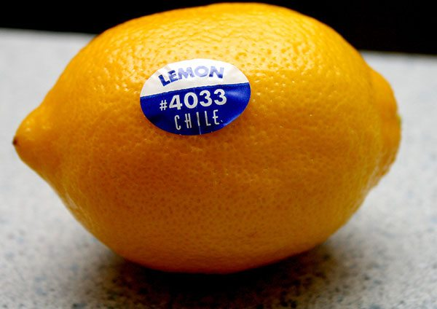

**A.** It is certified organic. **B.** It is genetically modified.

**C.** It is conventionally grown. **D.** It is free from pesticides.

**Câu 16.** What does the notice say?

|  |
| --- |
| **Wanted: Kitchen Assistants**  Evenings or weekends  Free meals  Full training provided  Apply inside |

**A.** Only people who are trained in kitchen work should apply for these part-time jobs.

**B.** There are part-time opportunities for people without experience of work in a kitchen.

**C.** We offer cheap meals to people who work part-time in our kitchen.

**D.** Part-time assistants must work both in the evenings and at weekends.

**IV. Read the following and do as directed.**

As global population growth continues, it creates the problem of food insecurity around the world. To solve the food crisis, genetically modified organisms (GMOs) have been suggested as the only way to feed the growing population. Do they really work?

Some scientists believe that GMOs are beneficial to farmers in developing countries. With genetic engineering, the farmers can attain higher crop yields although the farmlands are expected to shrink. This makes food become plentifully available at cheaper prices. As a result, there is enough food to feed the whole population and the farmers can earn more money. Moreover, GMOs help to fight global warming. Through genetic modification, crops are given an engineered resistance to insects and diseases. In turn, there is less need for pesticides that cause potential harm to the environment.

By contrast, other scientists believe that GMOs are a serious risk to the environment. For example, **the cross-pollination** of their seeds creates “super weeds” that are threaten nearby crops and wild plants. Opponents of genetically modified foods also raise concerns over possible links to cancer, reproductive malfunction and digestive disorders due to increased resistance to antibiotics. Anyway, further research on the long-term effects of GMOs are required.

**True/False Questions:**

**Câu 17.** It is believed that GMOs help to improve agricultural productivity.

**A.** True **B.** False

**Câu 18.** With GMOs, farmers in developing countries fail to earn more livelihoods.

**A.** True **B.** False

**Câu 19.** The fear is that GMOs can make medicines more effective.

**A.** True **B.** False

**Câu 20.** It now is too soon to reach any conclusions about the effects of GMOs.

**A.** True **B.** False

**Choose the correct answer to each question:**

**Câu 21.** What does the passage mainly discuss?

**A.** The introduction of GMOs. **B.** Ways to solve the food crisis.

**C.** Causes of the world’s population growth. **D.** Controversy over GMOs.

**Câu 22.** Why does the author mention “the cross-pollination”?

**A.** To support the fight against global warming. **B.** To oppose the use of antibiotics.

**C.** To illustrate the harmful effects of GM foods. **D.** To advise creating “super weeds”.

**V. Choose the word (A, B, C or D) that best fits each blank space in the following passage.**

Have you ever thought of moving to somewhere else in this vast universe if the Earth (23) ______ too crowded? Honestly, I would like to set (24) ______ on the planet whose inhabitants are aware of protecting the environment. I imagine that this place will be destroyed again (25) ______ we try to keep it clean. Moreover, there should be enough resources on the planet so that we will be able to adapt (26) ______ the new environment. Natural resources, together with human intelligence, play an important role in (27) ______ our life. We are going to develop new technologies and vehicles such as flying cars or teleporting portals on the (28) ______ ground.

**Câu 23.** Choose the correct answer.

**A.** puts **B.** takes **C.** gets **D.** makes

**Câu 24.** Choose the correct answer.

**A.** fire **B.** time **C.** foot **D.** table

**Câu 25.** Choose the correct answer.

**A.** if **B.** unless **C.** or so **D.** otherwise

**Câu 26.** Choose the correct answer.

**A.** to **B.** at **C.** in **D.** with

**Câu 27.** Choose the correct answer.

**A.** losing **B.** devoting **C.** returning **D.** bettering

**Câu 28.** Choose the correct answer.

**A.** foreign **B.** outdoor **C.** exotic **D.** abroad

**VI. Supply the correct form of the word given in each sentence.**

**Câu 29.** Scientists still believe that a ______ event caused the mass extinction of dinosaur species. **(CATASTROPHE)**

**Câu 30.** The fragile ______ in Sơn Đoòng Cave would suffer enormous damage if tourists didn’t take great care. **(SYSTEM)**

**Câu 31.** The program will analyze your speech patterns and ______ expressions or body language for subjective traits. **(FACE)**

**Câu 32.** ______ to change can be stressful because some changes may be negative and affect your life quality. **(ADAPT)**

**Câu 33.** According to new research, children who spend more time playing ______ have lower symptoms of anxiety or depression. **(VENTURE)**

**Câu 34.** The school had sent us a ______ schedule that showed my teachers’ names and classroom numbers. **(COMPUTER)**

**VII. Rearrange the groups of words in a correct order to make complete sentences.**

**Câu 35.** remind me / about / Can you / the new plans? / to tell him

**Câu 36.** people in their twenties / When they have got / often get a job. / finished their studies / a degree or

**VIII. Rewrite each of the following sentences in another way so that it means almost the same as the sentence printed before it.**

**Câu 37.** It’s my plan to have a family after finishing university. **(AM)**

🡪 After I’ve

**Câu 38.** It is likely that Dustin’s father will buy him a new bike. ***(Use modal verb)***

🡪 Dustin’s

**Câu 39.** Obey traffic regulations or you will be fined.

🡪 If

**Câu 40.** Christine is making the poster on her own. ***(Use reflexive pronouns)***

🡪 Christine

**------ HẾT ------**