Week 14
Period 40
Teaching date: 07/12/2021

UNIT 5 :NATURAL WONDERS OF VIET NAM (DHLH) LESSON 7: LOOKING BACK + PROJECT
I.OBJECTIVES: By the end of the lesson, students will be able to:
1. Knowledge:
- Vocabulary: Review some words related to the topic “things in nature” and “travel items”
- Grammar: Review + Modal verbs / There is… There are …
+ Countable and uncountable nouns
2. Competence: Ss can make sentences with must / mustn’t .
3. Educational aims: To educate SS to love and conserve the nature .
II. TEACHING AIDS: Text books, laptop , smart TV , video clips
IV. PROCEDURES:
Contents |  |  |  | Teacher’s and Ss’activities
I.ACTIVITY 1:(7’)
To revise the vocabulary related to “things in nature” and “travel items”and lead in the next part of the lesson.
* Warm up :Game “Brainstorming”  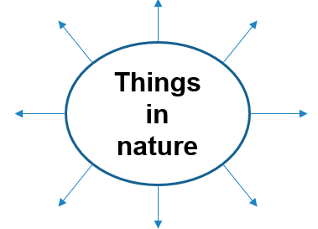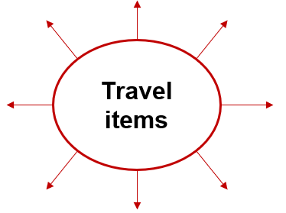  * Suggested answers:  + Things in nature: desert, forest, mountain, lake, river, valley, cave, island, beach,…  + Travel items: lighter, scissors, sleeping bag, compass, plastic, backpack,…. |  |  |  | -T:divides the class into 2 teams  -Ss :work in groups  -Ss:Write 2 main words on the board.  One team ( G.1) finds all the words related to things in nature. Another team (G.2) finds all the travel items they know.  -T: asks Ss to make a web map in 2 minutes, try to add as many words as possible.  -The fastest group with the most correct answers is the winner.
II. ACTIVITY 2: (15’)
To help students revise the vocabulary items they have learnt in the unit.
1.Write the name for each picture.  * Answers:  1. waterfall 4. lake  2. cave 5. beach  3. desert 6. island  2.Match the name of a natural wonder on column A with a word indicating it in column B.  *Answers:  1. d 2. c  3. a 4. e  5. f 6. B  3. Write the words under the pictures.  *Answers:  1. scissors 2. sleeping bag  3. compass 4. backpack  5. plaster | -T: encourages Ss to complete the task individually.  -T: asks Ss to swap their books with their partners.  -T:shows the answer and check  -T: asks Ss to work in pairs.  -Ss: work in pairs  -T: lets each pair answer.  -T:checks the answers  -T: asks Ss to do this exercise individually.  -T: lets Ss compare their answers before checking as a class.  - T: gives feedback-corrections
III. ACTIVITY 3:(5’)
-To help Ss revise the use of countable and uncountable nouns in sentences.
-To help Ss revise the use of must /mustn't in context.
4.Find the mistake in each sentence and correct it.  * ANSWERS:  1. is - are 2. are - is  3. instrument - instruments  4. are - is 5. luggages - luggage |  | -T: asks Ss to work independently.  -T: asks Ss to read the sentences carefully and correct the mistakes.  -Ss complete the task and discuss about the answers.  -T:gives feedback as a class discussion
IV. ACTIVITY 4:(5’)
-To help Ss revise the use of must /mustn't in context.
5. Complete the dialogue, using must / mustn’t.  * Answer key:  1. must 2. must 3. mustn’t  4. must 5. mustn’t |  | -T:lets Ss to work in pairs and complete the activity.  -T: asks Ss to stand up and make a role play.  -T:checks the answers -corrects
V. ACTIVITY 5: (10’)
Students can apply what they have learnt (vocabulary and grammar) into practice through a project.
PROJECT: DREAM DESTINATION  *In groups, make a poster about a natural wonder you would like to visit. In the poster, draw / print a picture of the place. Then give some information about the place:  - what the natural wonder is  - where it is  - how you can go there  - what it is special about  - what you can do there |  |  | -Ss: work in groups  - A representation in each group to introduce the attraction to the class .
IV. Home work: (3’)
- Talk abot a travel attraction you like .
- Prepare Unit 6: Getting started (new words related to things and activities at Tet)

