Date of preparing: ………………………………….
Date of teaching: ………………………………….

Period …
UNIT 5: AROUND TOWN
Lesson 1 - Part 1 (Page 38) - Vocabulary and Listening

I. OBJECTIVES
By the end of the lesson, Ss will be able to…
1. Knowledge
- talk about clothes, sizes and prices
- start a conversation to offer help
2. Ability
- improve Listening and Speaking skills
3. Quality
- have positive attitude in English language learning so that they actively participate in all classroom activities
- choose and buy clothes for themselves with suitable prices

II. TEACHING AIDS AND LEARNING MATERIALS
Lesson plan, PPT slides, student’s book, workbook, notebook, personal computer (if any), projector/TV, speakers, DCR & DHA on Eduhome, handouts…
III. PROCEDURES
A. Warm up: (5’)
a) Objective: Introduce the new lesson and set the scene for Ss to acquire new language; get students' attention at the beginning of the class by means of enjoyable and short activities as well as to engage them in the steps that follow.
b) Content: Introduction of vocabularies about types of clothes/clothing store
c) Product: Ss have general ideas about the things they are going to study in this new lesson
d) Competence: collaboration, communication, critical thinking
e) Organization of the activity:
Teacher’s Activities | Students’ Activities
- Give greetings  - Check attendance  - Option 1: MATCHING  - Show pictures and names of clothes  - Have Ss match each picture with its correct name  - Call Ss to give answers  - Give feedback and show correct answers  - Lead to the new lesson.  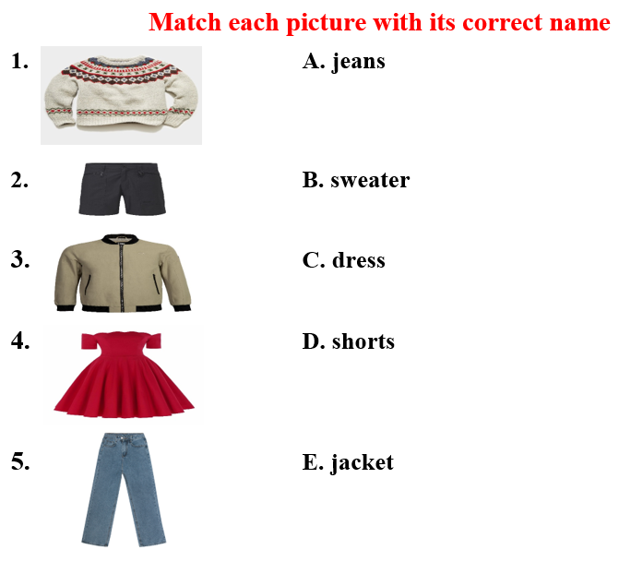  - Option 2: Number the pictures  - Show a picture of a clothing store (or give handouts)  - Set a limit time (3-4’)  - Have Ss number the pictures (in groups or as a whole class)  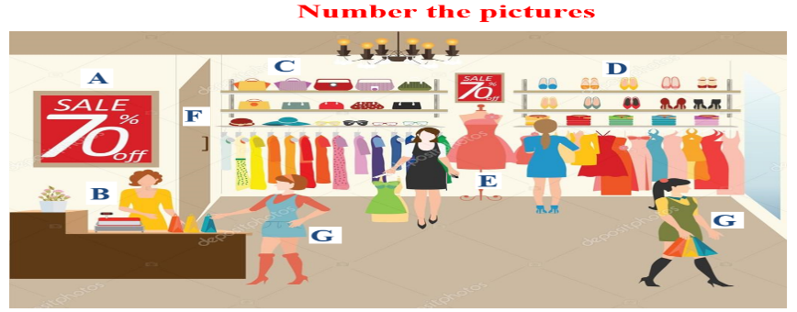  1. shop assistant  2. customers  3. bags  4. shoes  5. changing room  6. dresses  7. promotion  - Call Ss to give answers  - Give feedback and lead to the new lesson | - Greet T  - Work in pairs  - Give answers  - Listen  Answer keys  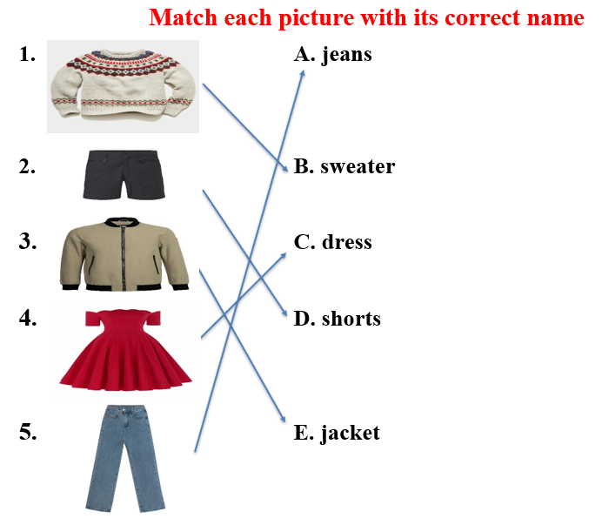  - Look and number the pictures, then read answers in front of the class  Answer keys  1. shop assistant - B  2. customers - G  3. bags - C  4. shoes - D  5. changing room - F  6. dresses - E  7. promotion - A

B. New lesson (35’)
- Activities 1: Vocabulary (18’)
a) Objective: Ss know words about clothing store.
b) Content:
- Vocabulary study
- Speaking
c) Products: Ss know how to pronounce the new words correctly and use them in appropriate situations.
d) Competence: communication, collaboration, presentation, creativity, public speaking
e) Organization of the activity:
Teacher’s Activities | Students’ Activities
a. Fill in the table. Listen and repeat.  - Demonstrate the activity, using the examples  - Have Ss write the words in the correct column  - Remind Ss that the words in Warm-up activity will help them  - Divide class into pairs and have them check their answers with their partners  - Call Ss to give answers (read or write)  - Check answers as a whole class  - Play audio (CD1 – Track 54). Have Ss listen and repeat  - Correct Ss’ pronunciation  b. Add more words to the table. Use the words in sentences.  - Option 1:  - Have Ss work in pairs to think of more words to fill in the table  - Have Ss use words in sentences  - Have Ss share their ideas with the class  - Give feedback and evaluation  - Option 2: (for class with better students)  - Follow the same steps as option 1  - Give an extra activity: Have Ss describe their friends’ clothes or their own clothes-using new words in the lesson  - Call some pairs / groups to share their idea with the class  - Give feedback and evaluation | - Look and listen  - Work individually  - Work in pairs  - Give answers  - Listen and repeat  Answer keys  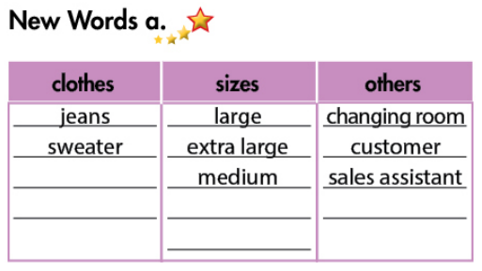  - Work in pairs  - Present  Suggested answers  Clothes: skirt, shorts, sandals, coat, pants, trousers, …  Sizes: small, extra small, double extra large, …  Others: shop assistant, mirror, accountant, desk, cashier, …  - Work in pairs / groups  Suggested answers  My friend, Lan, is wearing a black pants and a blue sweater. Her sweater is small size. She looks beautiful in this sweater. She also has brown sandals …
- Activity 2: Listening (17’)
a) Objective: Ss can make questions or answer the questions to develop a conversation, and they can also finish the listening task in the textbook.
b) Content: Listening to a girl talking to her mom in a clothing store
c) Products: They can enhance listening for main ideas and for details.
d) Competence: collaboration, guessing, communication, listening
e) Organization of the activity:

Teacher’s Activities | Students’ Activities
a. Listen to Cassie talking to her mom in a clothing store Do they buy any clothes?  - Have Ss look at the question and the picture  - Play the audio once (CD 1 – Track 55)  . Have Ss listen and answer the question by circling “Yes” or “No”  - Play the audio again. Check answers as a whole class.  b. Now, listen and circle “True” or “False”  - Have Ss read the sentences  - Play the audio (CD1 – Track 55). Have Ss listen and circle “True” or “False”  - Call Ss to give answers, explain  - Check answers as a whole class.  *Conversation Skill  - Option 1:  - Play the first 5 sentences of the recording, ask Ss to find which sentence / phrase that the sale assistant uses to offer help  - Give feedback and lead to the Conversation Skill box  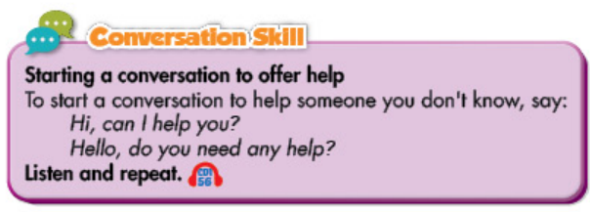- Explain  - Play audio (CD 1 – Track 56). Have Ss listen and repeat  - Have some Ss practice the conversation skill in front of the class  - Have Ss think of other ways to start a conversation to offer help and make up a conversation that contains these phrases  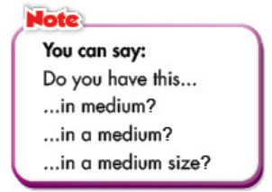  - Have Ss look at the Note box, read  - Briefly explain the Note box  - Option 2:  - Follow the same steps as option 1  - Have Ss work in groups to role-play the scene of buying clothes in a clothing store: Ss are in a clothing store (Student A: shop assistant, student B: cashier, student C, D, E: customers).  - Have Ss demonstrate the activity in front of the class  - Give feedback and evaluation | - Look at the picture and the question  - Listen and circle  - Check answers  Answer key: Yes  - Look and read  - Listen and fill in the blanks  - Give answers  - Check answers  Answer keys  1. False 2. True  3. False 4. True  - Try to find the indicator that speaker uses to offer help  - Look and listen  - Listen and repeat  - Work in pairs  Suggested answers  Other ways to offer help:  - Sorry, (do you need) any help?  - Hello, may I help you?  - Hi, would you like me to …  - Work in groups  - Present

C. Consolidation (3’)
* Vocabularies about clothing store: clothes, sizes and other things in the clothing store
* Start a conversation to offer help: Say “Hi, how can I help you?” / “May I help you?” / “Do you need help?”
* Talk about size: in + size

D. Homework (2’)
- Learn by heart the new vocabularies.
- Practice talking about clothes, sizes and prices.
- Do exercises in Workbook: Lesson 1 - New words and Listening (page 26).
- Prepare: Lesson 1 – Grammar (page 39 – SB).

