BEN DINH PRIMARY SCHOOL  Full name: .................................................  Class: 5…… |  | THE FIRST TERM TEST  SCHOOL YEAR 2017-2018  SUBJECT: ENGLISH - GRADE 5  TIME: 35 minutes

Marks | Listening | Reading and writing | Speaking | Comments

PART 1: LISTENING
Question 1. Listen and number ( 1 pt ) .
 .  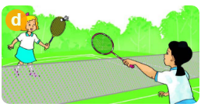

A B C D
Question 2 . Listen and tick ( 1 pt ) .
- Where was Tony going in the morning?
A 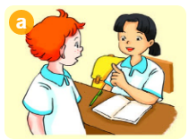 B. 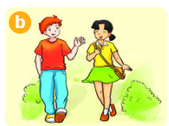 C. 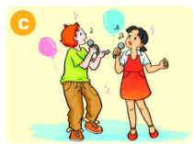

- Where did you go last summer ?
A.  B.  C. 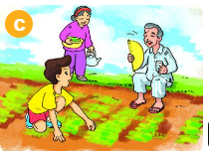

- How many lesson does Quan have today ?
A. 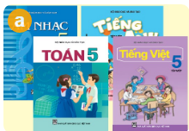 B. 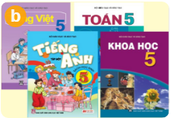 C. 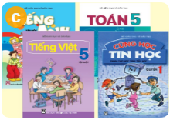

4. How does Nam practice English ?
A.  B.  C. 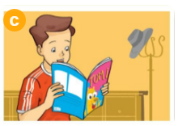

Question 3. Listen and complete ( 0.5 pt ) .
- What did you see at the zoo ? I saw lots of ……………….
- What did the ……………………….. do when you were there?

PART 2. READING AND WRITING
Question 4. Read the text carefully. Tick () True or False.(1,25 pt)
Tom likes reading. On Sunday, he often stays at home and reads comic books. He like Case Closes very much. It is a Japanese story. The main character is a schoolboy called Jimmy Kudu. He often helps the police. He is good at his job. Jimmy Kudu is Tom’s favourite character because he is clever and brave.

 | True | False
1. Tom likes reading books in his free time
2.Case Closed is a Malaysian story.
3.The main character is Jimmy Kudo
4.Jimmy Kudu is a policeman
5.Jimmy Kudu is clever and brave
Question 5. Fill in each gap with a suitable word from the box ( 1,25 pt ) .
friendly Science favourite week school
It is Wednesday today . Trung is at Hung Duong Primary(1)……. . . He has four lessons : Vietnamese , Maths , English and (2) …………………..Trung has English four times a (3)………………. Miss Hien is his English teacher . She is a kind and (4) …………….teacher . English is one of Trung’s (5)………………..subjects because he loves reading English short stories and comic books . Trung also likes chatting online with his foreign friends like Akiko , Tony , Linda and Peter .
Question 6.Fill in the blank with a suitable word(0.5)
- C__mic 2. G__ntle
Question 7. Put the letters in the correct order to make a correct word.(1pt)

1.ecdrioolc→___________  2.ckeaocp→__________


3.dungounnerr→__________ stamounin→_________
Question 8. Reorder the words to make sentences .(1 pt)
- pandas /saw/ two /at /the /She /zoo/. ………………………………………………………..
2. I /times /have /a /English /four /week/……………………………………………………….
3.are /the /your/ zoo /favourite/ animals/ What/ at/?.............................................................
4.We/ learn/ friends /talk /English/ our /because /we/ to /with/ want/ foreign.
……………………………………………………………………………..

THE END.

MA TRẬN HKI MÔN ANH VĂN 5-2017-2018
Kỹ năng | Nhiệm vụ đánh giá/kiến thức cần đánh giá | Mức/Điểm |  |  |  | Tổng số câu, số điểm, tỷ lệ %
Nghe | Nhiệm vụ đánh giá/kiến thức cần đánh giá | M1 | M2 | M3 | M4 | 10 câu  2,5 điểm  25%
Nghe | Listen and number | 2  0,5đ | 1  0,25đ | 1  0,25đ |  | 10 câu  2,5 điểm  25%
Nghe | Listen and tick | 1  0,25đ | 1  0,25đ | 1  0,25đ | 1  0,25đ | 10 câu  2,5 điểm  25%
Nghe | Listen and complete |  | 1  0,25đ | 1  0,25đ |  | 10 câu  2,5 điểm  25%
Đọc | Read the text and tick True or False | 2  0,5đ | 1  0, 5đ | 1  0,25đ | 1  0,25đ | 10 câu  2,5 điểm  25%
Đọc | Read the passage and write the correct word | 1  0, 5đ | 2  0,5đ | 1  0,25đ | 1  0,25đ | 10 câu  2,5 điểm  25%
Viết | Fill in the blank with a suitable word(0.5) | 1  0,25đ | 1  0,25đ |  |  | 10 câu  2,5 điểm  25%
Viết | Put the letters in the correct order to make a correct word.(1pt) | 1  0,25đ | 1  0,25đ | 1  0,25đ | 1  0,25đ | 10 câu  2,5 điểm  25%
Viết | Order the word to make sentences | 1  0,25đ | 1  0,25đ |  | 2  0,5đ | 10 câu  2,5 điểm  25%
Nói | Getting to know each other | 1  0,25đ | 2  0,5đ |  |  | 10 câu  2,5 điểm  25%
Nói | Talking about familiar object |  |  | 3  0,75đ | 1  0,25đ | 10 câu  2,5 điểm  25%
Nói | Describing the picture |  | 1  0,25đ | 1  0,25đ | 1  0,25đ | 10 câu  2,5 điểm  25%
Tổng |  | 10  25% | 12– 30% | –10 25% | 8 – 20%

KEY FOR TEST – GRADE 5
Question | Answer | Point | Total
1 | a.3 b.4 1.c 2.d | 0.25/ each | 1
2 | 1.b 2.c 3.c 4.b | 0.25/ each | 1
3 | 1.animals 2.peacocks | 0.25/ each | 0.5
4 | 1.T 2.F 3.F 4.F 5T | 0.25/ each | 1.25
5 | 1. school 2.science 3.week 4.friendly 5.favourite | 0.25/ each | 1.25
6 | 1.comic 2.gentle | 0.25/ each | 0.5
7 | 1.Crocodile , 2. Underground ,  3. Peacock , 4. Mountain | 0.25/ each | 1
8 | - She saw two padas at the zoo  - I have English four times a week.  - What are your favourite animals at the zoo?  - We learn English because we want to talk with our foreign friends | 0.25/ each | 1

SPEAKING TEST
- Getting to know each other
Ask 3 questions below
1.What is your name?
2.How are you?
3.How do you spell your name?

- Talking about a familiar object
Give some story book and ask some question
- What are you reading?
- What is he/ she like?
- Who is the main character?
- Describing the picture
- What subjects do you have today?
- Do you like English? Why/ why not?
- What’s your favourite subjects?

