UNITS | VOCABULARY | GRAMMAR
Unit 5  TRAVEL & TRANSPORTATION | - Shops & Services  - Transportation in the future  - Travel & Transport  - Wonders of the world | - Comparative  - Superlative  - as … as, not so/as … as, much  - like/ the same as/ different from
Tiếng Anh 7 – RIGHT ON

UNIT 5 TEST
Note: Each correct answer earns 0.2 points.

I. PRONUNCIATION (0.8 points)
A. Choose the word whose underlined part is pronounced differently.
1. A. transport B. cable C. baker’s D. same
2. A. ships B. sights C. trains D. trucks
B. Choose the word that has a different stressed syllable from the rest.
3. A. wonder B. statue C. ancient D. canoe
4. A. hoverboard B. museum C. monument D. ambulances

II. VOCABULARY AND GRAMMAR (2.4 points)
Choose the best option (A, B, C or D) to complete each of the following questions.
5. Mike would love to learn how to __________ a helicopter when he grows up.
A. drive B. take C. fly D. ride
6. There’s a __________ at the end of our street that sells only newspapers and magazines.
A. supermarket B. department store C. shopping mall D. newsagent’s
7. How do you go to your school, by bus, by bike or __________ foot?
A. by B. on C. in D. with
8. Andy overslept this morning and __________ the bus. His father had to drive him to school.
A. missed B. lost C. caught D. took
9. Double-decker buses are __________ way to get around London.
A. the better B. the same C. the best D. the good
10. In my city, fares for metro lines are __________ bus fares. They both cost $2.
A. like B. different from C. similar as D. the same as
11. The countryside is ______ the city because there aren’t so many cars.
A. as clean as B. cleaner than C. the cleanest than D. more clean
12. Last year, we went on a __________down the River Thames. It gave us fantastic views of London in the evening.
A. plane B. express train C. cruise D. tram
13. Person A: Excuse me, is there a post office near hear?
Person B: Yes, go __________ King Street and turn left __________ Hill Street. The post office is on your right, next to the florist’s.
A. along / into B. up / across C. down / out of D. through / to
14. Customer: Excuse me, I’d like a ticket to Cambridge for Friday morning, please.
Ticket agent: _________
A. How long is your trip? B. Right. Will that be single or return?
C. Have a nice journey. D. Do you pay by cash or credit card?
15. What does the sign mean?
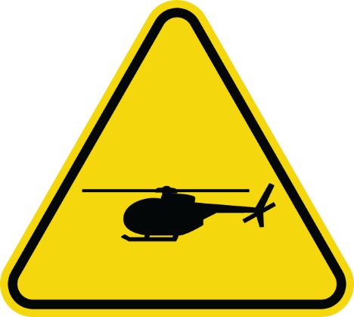 | A. Passengers get on the helicopter here.  B. Be careful when you go on a helicopter here.  C. There are many helicopters here.  D. Helicopters take off and land here.

16. What does the sign mean?
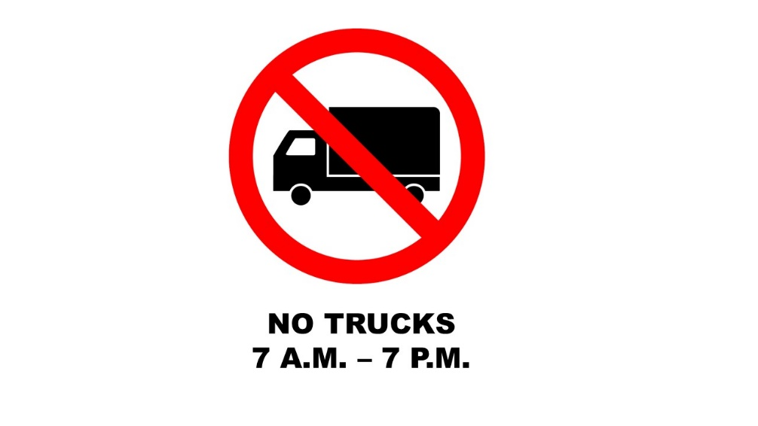 | A. There aren’t any trucks on this street.  B. This street is closed to trucks from 7 a.m. to 7 p.m.  C. People can drive trucks from 7 a.m. to 7 p.m.  D. It’s the rules to go by truck from 7 a.m. to 7 p.m.

III. WORD FORMATION (1.2 points)
Write the correct form of the words in brackets.*
17. ___Electric_______ vehicles are becoming popular because they are more environmentally-friendly. (ELECTRICITY)
18. Bản Giốc waterfall is one of the most ____impressive______ waterfalls in Vietnam. (IMPRESS)
19. There are many tourist __attractions_________ in Vietnam, such as Hội An Ancient Town, Hạ Long Bay or Huế Imperial City. (ATTRACT)
20. When it’s rainy, I often take the bus to school. It’s more ___comfortable_______ than riding my bike. (COMFORT)
21. The weather in Vietnam is completely ___different_______ from the weather in London. It’s much colder in London. (DIFFER)
22. People should treat ancient wonders ___carefully_______, or they will damage them. (CARE)

IV. LISTENING (2 points)
A. You will listen to an advertisement about a package holiday. For questions 23-27, complete the notes with the correct information. Write NO MORE THAN TWO WORDS AND / OR ONE NUMBER.

HOLIDAY IN MALTA
Destination: Malta – an (23) ___island________ in the Mediterranean
How long: two weeks
Accommodation: Seaside Inn - (24) ___100 metres/ 100m________ from the beach
Activities: swimming, (25) ___snorkelling________, diving in the sea
visiting museums and 7,000-year-old (26) __stone buildings______ in Valletta – the capital city
Cost of the trip: £(27) ___1,250________ (including flights, hotel room and one meal per day)

B. You will hear Tommy talking about his holiday. For each question from 28 to 32, choose the correct option A, B, C or D.

28. How did Tommy and his family go to San Francisco?
A. by plane B. by car C. by bus D. by tram
29. In San Francisco, _____.
A. it’s difficult to rent a car
B. there are lots of parking spaces
C. buses are cheaper than other means of public transport
D. people travel around the city by tram
30. What did Tommy do on Saturday afternoon?
A. hiking to the top of a hill B. getting around the city
C. visiting the China Town D. shopping on Grand Avenue
31. On Sunday morning, Tommy’s family ______.
A. went to the department store B. went on a boat trip
C. bought some souvenirs D. took photos of the Golden Gate Bridge
32. When will Tommy come back to London?
A. on Friday B. on Saturday C. on Monday D. on Tuesday

V. READING (2 points)
A. Read the following passage. For each question from 33 to 37, match the information with the suitable means of transport. Write C for Coco taxis, G for Gondola, or B for both means of transport.

People are used to travelling by bus, car, plane or boat, etc. However, there are lots of other unique and unusual means of transportation around the world. These types of transport are sure to be a memorable experience.
Coco taxi – Havana, Cuba
Coco taxis have got three wheels and a back seat for two people behind the driver. These yellow taxis look like coconuts and are most common in Havana. They are slower but cheaper than regular black taxis. They have a speed of 30km/h. They are also really noisy. The famous yellow coco taxis are mainly for tourists, so people can find them easily in places of tourist destinations or in front of famous hotels.
Gondola – Venice, Italy
Venice is famous for its large network of canals, and the best way to get around them is by using a traditional narrow long wooden gondola boat. Gondolas were the main means of transport in Venice centuries ago, but today they carry only tourists. A gondola ride in Venice ranks among one of the most romantic experiences for travellers. However, it is quite expensive. A 40-minute trip costs about €80 during the day and €120 after 7 p.m. A gondola can hold up to six people.

Which means of transport …
33. has got the appearance of a kind of fruit? C
34. is more popular with tourists than with local people? B
35. is cheaper during the day than in the evening? G
36. makes a lot of noise? C
37. isn’t as common as it was in the past? G

B. Read the following passage on a travelling blog. For each question from 38 to 42, choose the correct option A, B, C or D.

Last year, my parents wanted to have a peaceful and quiet holiday away from big cities, so we decided to go to La Cumbrecita, a little village in the Calamuchita Valley in Córdoba, Argentina. We travelled from Buenos Aires to Cordoba by plane. The direct flight (38) _________ only 1.5 hours. Then, we took the bus to La Cumbrecita. La Cumbrecita is (39) _________ than other cities in Argentina, but it is worth a visit. We stayed in Las Cascadas Hotel for three nights. The hotel was very cozy and made us feel (40) _________ being in our grandparents’ house. Every morning, we went hiking in the mountain. The views were really beautiful, overlooking the hills with the town below. There was a tea house opposite our hotel. We went there every afternoon to enjoy a cup of herbal tea and wonderful cakes made out of raspberry. One special thing about La Cumbrecita is that it’s (41) _________ the rules to drive cars in this city from 10 a.m. to 6 p.m. People have to leave their vehicles before the entrance of the village, and get around the town on foot. There are also no (42) _________ or ATMs, so make sure you bring enough money for your stay.

38. A. had B. spent C. took D. covered
39. A. smaller B. much small C. smallest D. as small
40. A. similar B. as C. the same D. like
41. A. under B. against C. in D. following
42. A. post offices B. supermarkets C. banks D. stores

VI. WRITING (1.6 points)
A. Rewrite the following sentences without changing their meaning. Use the given word(s) if any.
43. Travelling by car is often faster than travelling by bus.
→ Travelling by bus isn’t as fast as travelling by car.
44. The Pyramid of Djoser is older than any other pyramids in the world.
→ The Pyramid of Djoser is the oldest pyramid in the world.
45. The number of passengers on Airbus A380 is bigger than that on the Boeing 777. (PASSENGERS)
→ The Airbus A380 has got more passengers than the Boeing 777.
46. I think people will ride hoverbikes to work in the future. (BY)
→ I think people will go to work by hoverbike in the future.
B. Use the given words or phrases to make complete sentences.
47. The library / not / interesting / as toy shops.
→ The library is not as interesting as toy shops.
48. Colosseum / most popular / sight / Italy.
→ Colosseum is the most popular sight in Italy.
49. It / take / long / go / Phú Quốc Island / boat / than / plane.
→ It takes longer to go to Phú Quốc Island by boat than by plane.
50. There / little traffic / the countryside / in the city.
→ There is less traffic in the countryside than in the city.

***End – Of – Test***

Audio scripts;
Listening 1:
Hello, everyone. I’m Perry Baker from Sunset Travel Agency – the best travel agency in town! We’ve got a great deal for you this summer! Malta is a beautiful island in the Mediterranean Sea, and we’re offering a two-week package holiday there! Malta gets over 300 sunny days a year, so you’re sure to get nice weather! Your hotel is the Seaside Inn. It’s only 100 metres from a beach where you can go swimming, snorkelling and diving! And the hotel is just 15 kilometres from the capital city Valletta. There you can visit museums and see old stone buildings from its 7,000-year history! This holiday includes flights, your hotel room and one meal a day – all this for just £1,250 per person! This is a chance you don’t want to miss!

Listening 2:
Julie: Hi, Tommy. Where are you now?
Tommy: I’m in San Francisco with my family right now.
Julie: Wow, that’s great. When did you get there?
Tommy: We took the early morning flight on Friday and got here in the afternoon. San Francisco is amazing. I think it’s the most beautiful city in the world.
Julie: What have you done in San Francisco? Did your family rent a car?
Tommy: No, my father didn’t want to drive. He said it was difficult to find parking spaces in San Francisco, so we travelled around the city by bus. It’s the cheapest means of public transport in this city. On Saturday morning, we took a tram to the top of a hill. We could see many places from there. Then, we spent the afternoon walking around the city. In the evening, we visited China Town and had dinner there. The food was fresh and delicious. There were lots of souvenir shops on Grand Avenue, but we didn’t buy anything.
Julie: That was interesting. How about Sunday?
Tommy: In the morning, we sailed under the Golden Gate Bridge. This bridge is much bigger than the bridge in our city. In the afternoon, we went to the largest department store I have ever seen. I bought some souvenirs for you.
Julie: Really? Thanks a lot. When will you come back?
Tommy: Our flight takes off at 9 o’clock on Monday night, so I will be in London on Tuesday morning.
Julie: See you then.

