Full name: ……………………………………………….  School: ………………………………………………….  Class: ……………………………………………………. | Mark:

SPEAKING TEST 6 (UNITS 11 & 12)

TASK 1 |  |  | Tell your friend an English-speaking country you have visited or you will visit. The following questions may  help you.
 | 1. | What is the name of the country and its capital?
 | 2. | Where is the country?
 | 3. | What is its weather like?
 | 4. | What are its famous attractions?
 | 5. | What do you like most about this country?

TASK 2 | Work in pairs. Each of you receives a card. Use the clues on your card to make questions about your friend’s picture. Use the picture on your card to answer your friend’s questions.

CARD A
Ask your friends about his / her picture. Listen to his / her answers

1. | What / kind of train? | 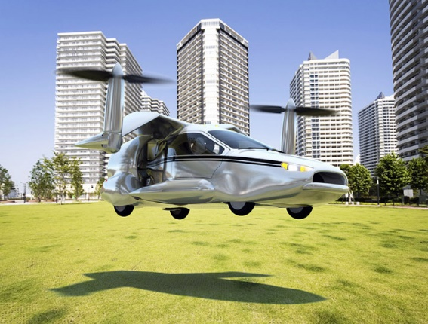
2. | What / special / about it?
3. | What / advantages?
4. | What / disadvantages?
5. | Do / like / this means of transport? Why?
 |  | Answer your friend’s questions about this picture.

CARD B
Ask your friends about his / her picture. Listen to his / her answers.

1. | What / kind of car?
2. | What / special / about it? | 
3. | What / advantages?
4. | What / disadvantages?
5. | Do / like / this means of transport? Why?
 |  | Answer your friend’s questions about this picture.

