**Unit 5 | CITIES AND EDUCATION IN THE FUTURE**

**C. EXERCISE (BÀI TẬP)**

**❶ PHONETICS**

***I. Choose the words whose underlined part is pronounced differently from that of the others in each group.***

**1.** **A.** data                         **B.** smart                    **C.** marble                      **D.** glass

**2.** **A.** select                       **B.** sensor         **C.** measure                 **D.** solar

**3.** **A.** house                **B.** vehicle         **C.**hologram                **D.** hurricane

**4.** **A.** sensor                   **B.** resident            **C.** desert                     **D.** vertical

**5.** **A.** underground                   **B.** digital                 **C.** hunger              **D.** guide

**6.** **A.** mirror                **B.** socialise                  **C.**wildlife**D.** child

**7.** **A.** cheap                       **B.** headset                    **C.** meat**D.** heatwave

**8.** **A.** drone                **B.** foldable              **C.** solar**D.** cyborg

**9.** **A.** farm                      **B.**glass                    **C.** walkway**D.** mask

**10.** **A.** school                 **B.**classroom                **C.** book**D**. wood

***II. Choose the word whose main stressed syllable is placed differently from that of the other in each group.***

**11.** **A.** delivery                         **B.** oragnise               **C.** socialise                      **D.** foldable

**12.** **A.**vacuum               **B.** resident **C.** vehicle                        **D.** historical

**13. A.** window                       **B.** exchange              **C.**skybridge                  **D.** threaten

**14.** **A.** demand                 **B.** walkway**C.**repair               **D.** device

**15.** **A.**reality             **B.** monument **C.**motorway                 **D.**valuable

**❷ WORD FORMATION**

***Complete the sentences with the correct form of the words.***

1. I think we'll need to pay a builder to take this wall down. **(build)**
2. Please don't ask me to make any **predictions** about tomorrow's meeting. **(predict)**
3. Most Indian restaurants offer free delivery. **(deliver)**
4. Driverless cars could possibly help ease traffic congestion, lower pollution, and prevent accidents. **(drive)**
5. He has a valuable collection of stamps. **(value)**
6. The forecast said that there's a possibility of snow tonight. **(possible)**
7. The weather there can be unpredictable - one minute it's blue skies and the next minute it's pouring rain. **(predict)**
8. The driver of the van was killed in the accident. **(drive)**
9. He may possibly decide not to come, in which case there's no problem. **(possible)**
10. She ate three plates of spaghetti and a dessert? That's impossible. I don't believe it! **(possible)**
11. The ending to the film was just so predictable. **(predict)**
12. The building caught fire and blazed up. **(build)**
13. The book is an invaluable source of reference for the art historian. **(value)**
14. He has made an accurate measurement of my garden. **(measure)**
15. People don't socialize with their neighbours as much as they used to. **(society)**

**❸ FURTHER PRACTICE**

**UNIT OPENER**

***I. Write the suitable word for each picture.***

|  |  |  |
| --- | --- | --- |
| TRL | Digital roads for local roads | New jet-powered flying concept vehicle is the future - and it's not too far  away. | The Sun | THE WORLD GEOGRAPHY: 10 Fascinating Skybridges |
| **1. digital roads** | **2. flying vehicles** | **3. skybridges** |
|  |  |  |
|  |  |  |
| Why Do Airports Have Moving Walkways?  **4. moving walkways** | The Longest Tunnel in Texas Feels Like an Endless Underground Adventure -  A-Z Animals  **5. underground motorways** | What is a Smart Home & Smart Home Solutions | Swann  **6. smart homes** |

***II. Complete the sentences with the words in exercise I.***

1. The digital roadways can combine ‘live’ data from “intelligent” materials in the road surface with a visualisation of the road.
2. Central cable and phone connections inside the home form the backbone of a smart house.
3. Driving through underground motorways is faster but it’s hotter.
4. Flying vehicles are types of transport which can function both as road vehicles and as airplanes.
5. The new terminal has a half kilometre long moving walkway, which connects the two terminals.
6. The shopping mall levels in each gasometer are connected to the others by skybridges.

***III. Put the words into the correct column. Then practise saying them with a partner.***

|  |  |  |  |  |  |
| --- | --- | --- | --- | --- | --- |
| often | all | hot | small | wrong | chalk |
| top | warn | long | door | watch | bought |
| lock | also | shop | naughty | chop | floor |
| clock | more | online | call | want | taught |
| holiday | mall | soft | caught | fox | ball |

**Keys**

|  |  |
| --- | --- |
| / ɒ /  often  hot  long  clock  holiday  soft  wrong  fox  top  lock  shop  online  watch  chop  want | **/** ɔː**/**  all  small  door  more  mall  caught  chalk  ball  warn  also  naughty  call  bought  floor  taught |

**LESSON 5A. READING**

1. ***Look at the picture and match the words with the correct pictures.***

|  |  |  |  |
| --- | --- | --- | --- |
| a. floating building | | g. 3D printed house | |
| b. rooftop garden | | h. vacuum tube train | |
| c. vertical farm | | i. solar window | |
| d. interactive mirror | | j. drone delivery | |
| e. city planners | | k. smart street lights | |
| f. foldable car | | l. driverless car | |
| ***1. …………………………………….*** | Floating House Architecture: 12 Wow Designs on the Water  ***2. …………………………………….*** | | ROOFTOP GARDEN: A COMFORTABLE PLACE THAT REVIVES YOUR LIFE - Furnizing  ***3. …………………………………….*** | |
| Xu hướng nông trại thẳng đứng | BÁO QUẢNG NAM ONLINE - Tin tức mới nhất  ***4. …………………………………….*** | Virtual Mirror Technology - It Will Change the Way You Shop  ***5. …………………………………….*** | | To Screen or Not to Screen? A case study on home solar screens -  Sustainable Energy Group  ***6. …………………………………….*** | |
| Cheap Home 3D Printer | Overview | Wikifactory  ***7. …………………………………….*** | 43 Fantastic Foldable Vehicles  ***8. …………………………………….*** | | Buy DMak 36 Watt Sensor Street Light With Best Prices | Sensor Street Light  – DMak India  ***9. …………………………………….*** | |
| Are We Ready for Driverless Cars? | UC Davis Graduate School of Management  ***10. …………………………………….*** | ***11. …………………………………….*** | | EuroTube – Hyperloop  ***12. …………………………………….*** | |

*Answers*

1. e 2. a 3. b 4. c 5. d 6.i

7. g 8. f 9. k 10. l 11. j 12. h

***III. Reading***

1. **Read the passage and choose the correct answer for each question.**

The era of “smart cities”, controlled by an ecosystem of sensors, cameras and algorithms, is fast approaching. In China, state media claim 500 are under construction. In Canada, Alphabet has plans for turning parts of Toronto into a timber-framed tech town as a prototype. **Incremental** steps are also making cities smarter. Last week, Transport for London announced plans to track Tube passengers through WiFi to monitor congestion. In the US, fast-food drive-throughs will trial number plates scanners to make ordering faster. Individually these services can improve daily life. Integrating **them** will create something more powerful than the sum of its parts.

Though convenience and safety are the end goals, serious questions about how city authorities will both store and share vast bodies of data must be answered. The fact that surveillance is built into key transport infrastructure will also make it increasingly difficult to avoid without disrupting daily life. The smart city risks creating a panopticon in the name of an easier and better life. The risks of anonymity disappearing will be increased by the use of different data sets, making it more likely that identifiable characteristics may appear. Closely linked to this is the question of data storage and sharing. The treasure trove of personal information will be a tempting target for hackers. This information might also be used by law enforcement, feeding into the existing dangers of mass surveillance and profiling, as is already the case in China.

These concerns have long been levelled at social media and internet-enabled home appliances. Smart city surveillance can be even more insidious. Users can avoid Facebook or hardware such as Alexa. Avoiding basic infrastructure will be near impossible without seriously affecting day-to-day life. TfL has put up signs warning customers of the WiFi tracking, yet the only choice is between tracking and having no signal. Reports on the facial recognition at airports in America suggest that avoiding being automatically scanned will be tough as well. As these systems become more closely enmeshed, avoiding snooping will become increasingly tricky.

The inevitable rise of smart cities is not inherently negative. **Harnessing** the power of technology and data can potentially help urban environments adapt to challenges such as climate change and overcrowding. Politicians, programmers and academics must work to ensure that does not come at the cost of all-seeing, 24-hour surveillance.

*(Source: https://www.ft.com)*

**Question 1:** Which best serves as the title for the passage?

**A.** Being overly advanced displays various benefits.

**B.** Following the footprints of ancient civilisation.

**C.** Building the cities of the future on other planets.

**D.** The cities of the future can become a dystopian.

**Question 2:** The word “**Incremental**” in paragraph 1 is closest in meaning to _______.

**A.** Small **B.** Extra **C.** Consistent **D.** Sudden

**Question 3:** The word “**them**” in paragraph 1 refers to _____.

**A.** plates **B.** scanners **C.** passengers **D.** services

**Question 4:** According to paragraph 2, what is the mentioned unwanted consequence for the future of high-tech societies?

**A.** People would become dependent on mass surveillance.

**B.** Smart cities could cost citizens any sense of privacy.

**C.** It would be more difficult to travel to another country.

**D.** The Internet would be overflowing with misinformation.

**Question 5:** According to paragraph 3, what is the other problem regarding the mass surveillance system?

**A.** The incompetent users. **B.** The handiness of devices.

**C.** The price of opting out. **D.** The tech-savvy extremists.

**Question 6:** The word “**Harnessing**” in paragraph 4 is closest in meaning to _______.

**A.** Managing **B.** Producing **C.** Abusing **D.** Utilising

**Question 7:** Which of the following statements is **TRUE**, according to the passage?

**A.** Digital transformation of smart infrastructure requires full level of automation.

**B.** Social media have continually received criticism concerning privacy issues.

**C.** Many smart-city opportunities remain underutilised despite immense effort.

**D.** People would capitalise on vehicle plate number to solve traffic jams problem.

**Question 8:** Which of the following can be inferred from the passage?

**A.** Integrated technologies must not become tools of mass surveillance.

**B.** Modern cities need to stay competitive in the face of globalisation.

**C.** Getting the smart cities projects past the pilot stage can be a real hurdle.

**D.** The potential to improve life quality has driven the demand for smart cities.

**ANSWERS**

|  |  |  |  |  |  |  |  |
| --- | --- | --- | --- | --- | --- | --- | --- |
| [1.**D**](/) | [2.**A**](/) | [3.**D**](/) | [4.**B**](/) | [5.**C**](/) | [6.**D**](/) | [7.**B**](/) | [8.**A**](/) |

1. **Read the following passage and choose the correct answer for each question.**

According to the report, we can expect some pretty remarkable changes to our homes and our personal spaces, **overlooked** things that make up so much of our daily routine. As human populations soar, our cities and homes will have to adapt; interior living spaces will change as a cloud changes, easily reconfigured and rearranged to suit our fickle tastes, or accommodate different purposes.

Imagine walls and floors made of a malleable “skin,” and embedded with tiny sensors and actuators so that the shape and size of living spaces can quickly change, or even be divided into smaller rooms; imagine fully programmable “smart homes” that can be controlled remotely, and provide feedback to their owners - yes, there’ll even be an app for that.

Virtual decorations will alter with changing tastes, moods and whims; and the entire interior surface of the home will be implanted with LED technology - television screens and computer displays will form and unform in any room, as needed. Even our furniture will be adaptable, **molding** to custom fit our bodies, responding to changes in posture, or disappearing altogether when not needed.

It will be the ultimate evolution of the “Internet of Things.” Misplaced something? Can’t find your keys? No problem. Just use an online search function to find it. Hate the color of that accent wall? Delete it. Need more storage space? Watch new shelves appear, as if by magic.

And the amenities are fantastic. Every home will come standard with a 3D printer; they’ll be able to churn out just about anything you could wish, using downloadable patterns, probably including even complex electronic devices. **They** may even print out your meals, designed and programmed by the world’s master chefs.

Walk-in “medical pods,” meanwhile, will contribute to the decentralization of healthcare - their imaging sensors will diagnose your ills and, for the more easily treatable maladies, dispense drugs, inject antibiotics, and recommend health regimens. It may even be possible to undergo remote, robot-mediated surgery, in the comfort of your own home.

This barely scratches the surface. Imagine homes whose very building material is salted with dormant limestone-producing bacteria, which awaken upon contact with moisture and repair any cracks or structural damage.

There will be “digestion tanks” full of anaerobic bacteria, to dispose of our waste; and our homes will produce, store, and reuse their own energy, using “microbial fuel cell stacks” and more efficient solar panels to generate electricity, and power-banks like the Tesla power wall to store it against future use. Personal homes will be almost fully independent of a dangerously overtaxed energy grid.

One hundred years in the future, our houses will be, in almost all respects, semi-living, artificial organisms - closed systems with a metabolism, sensory apparatus, immune response, and an approximation to a nervous system. We’ll be living in homes that are practically alive.

*(Source: https://futurism.com)*

**Question 1:** Which of the following does the passage mainly discuss?

**A.** Smart living – our home in the future

**B.** LED technology - television screens and computer displays

**C.** A new standard with a 3D printer

**D.** Our home – a semi-living, artificial organisms

**Question 2:** The word "**overlooked**" in paragraph 1 is closest in meaning to ______.

**A.** forbidden **B.** foregone **C.** foreseen **D.** forgotten

**Question 3:** Which of the following is **NOT** mentioned in paragraph 3 as an advantage of technology to change our house?

**A.** movable walls **B.** implanted LED

**C.** television screens and computer displays **D.** furniture

**Question 4:** The word "**molding**" in paragraph 4 can be best replaced by ______.

**A.** forming **B.** framing **C.** adapting **D.** producing

**Question 5:** Remote, robot-mediated surgery has been mentioned in paragraph 6 as an example of _____.

**A.** way to decentralize of healthcare **B.** technology applied in healthcare

**C.** diagnosis of your ills **D.** recommendation of health regimens

**Question 6:** The word "**They**" in paragraph 5 refers to ______.

**A.** downloadable patterns **B.** complex electronic devices

**C.** 3D printer **D.** world’s master chefs

**Question 7:** Which of the following about our future home is **NOT** mentioned in the passage?

**A.** Interior living spaces will be easily reconfigured and rearranged to suit our tastes, or accommodate different purposes.

**B.** New shelves will be printed by 3D printer to give us more storage space.

**C.** We can search online to find our missing keys or things.

**D.** Our home will have more efficient solar panels to generate electricity, and power-banks.

**Question 8:** Which of the following can be inferred from the passage?

**A.** The more advanced technology becomes, the more we have to pay attention to our home.

**B.** Advanced technology will soon replace human labor at home.

**C.** Our home will be practically smart and human totally depend on it.

**D.** Advance of technology can be applied to change everything in our home, and to make our life more comfortable and safer than ever before.

**ANSWERS**

|  |  |  |  |  |  |  |  |
| --- | --- | --- | --- | --- | --- | --- | --- |
| [1.**A**](/) | [2.**D**](/) | [3.**D**](/) | [4.**C**](/) | [5.**B**](/) | [6.**C**](/) | [7.**B**](/) | [8.**D**](/) |

**LESSON 4B. GRAMMAR**

**I. Using *will* or *be going to* complete the sentences with the verbs in brackets.**

1. A: Oh, I haven't brought my phone.

B: That's OK. I**_______** you mine. **(lend)**

2. It's Jamie's birthday next week, I __________ him a present **(get)**

3. Can you lend me some money? I promise I _______ it back to you tomorrow. **(give)**

4. Jane's starting university tomorrow. She _____ study engineering **(study)**

**5.**Do you think the customers ______ our products? **(like)**

**6.**Look! The coach is here! Run or we ______ late. **(be)**

7. Don't worry, mom, I ________ good care of the plants. **(take)**

8. I'm about to fall asleep. I ______  some coffee to wake me up. **(make)**

9. We are so excited about our trip next month. We _______ Paris, Nice and Grenoble. **(visit)**

10. It’s so hot in here! I ______ on the air-conditioning. **(turn)**

11. Everybody thinks Red Team ________ the match tonight. **(win)**

12. After graduating, I _____ a gap year to travel around the world. **(take)**

13.   As soon as the weather gets better, we _______ to the beach and go swimming. **(come)**

14. Give me a minute, I ______ this report now. **(finish)**

15. Tonight, I ______ home. I’ve already cooked dinner. **(stay)**

16. I feel tired. I think I ________ sick **(be)**

17. If there’s any problems, feel free to call me. I ______ you. **(help)**

18. A: What are you going to do tomorrow?

B: I ______ some friends. **(see)**

19. Someone is knocking. I _______ the door. **(open)**

20. Look at those black clouds. It ________ **(rain)**

**ANSWERS**

|  |  |  |  |
| --- | --- | --- | --- |
| 1. will lend | 6. will be | 11. will win | 16. will be |
| 2. am going to get | 7. will take | 12. am going to take | 17. will help |
| 3. will give | 8. will make | 13. are going to come | 18. am going to see |
| 4. is going to study | 9. are going to visit | 14. will finish | 19. will open |
| 5. will like | 10. will turn | 15. am going to stay | 20. is going to rain |

**II. Read the questions carefully and choose the correct option.**

1. Ami: Hey! Look at those dark clouds!

Kiki: Wow! It_______________ rain soon.

A. Is B. is going to C. will D. coming

1. A: Did you buy bread?

B: Oh, no! I forgot to buy it. I__________________go back to buy some.

A. was B. am C. am going to D. will

1. I am not free tomorrow. I______________see the doctor.

A. am going to B. was C. will D.am

1. A: Coffee or tea?

B : I__________have coffee please.

A. does B. am going to C. drink D.will

1. A: Where are you going?

B: I_______________do shopping.

A. will B. was C. should D. am going to

1. It's late, it _____________________ dark soon.

A. is going to be B. will C. going to be D. will be

1. Can I speak to Tom? Yes, I_____________him.

A. will get B. going to get C. am going to get D. is going to get

1. Don't go out now. _____________a thunderstorm. I've just heard it on the radio.

A. There are B. There'll be C. There's going to be D. There is

1. I don't think that on Mars ______________________________________.

A. people will going to live B. people will go live

C. people will ever live D. people are ever going to live

1. I have the tickets, so we__________________ to the cinema tonight.

A. will go B. are going to go C. going D. are

1. I think that computers replace teachers in the future.

A. is B. will C. are D. are going to

1. What are your plans for the weekend? I _______________ travel to Mexico City.

A. am going to B. will C. am go D. is going to

1. Mary _________ next week.

A. get married B. is going to get married C. has married D. gets

1. Our class ____________ a picnic at Thay Pagoda this Sunday.

A. go to have B. is going to have C. will has D. am having

1. I believe people _______________flying cars in the future.

A. drive B. is going to drive C. has driven D. will drive

1. I feel terrible. I think I sick

A. will be B. am going to be C. am being D. am

1. I think many big cities ________________ digital roads in the future.

A. going to have B. will have C. has D. is going to have

1. Peter: Can you come next weekend?

Mai: Sorry, we'd love to, but we _____________ our grandparents.

A. will visit B. visit C. are going to visit D. were visiting

1. Lan: Where are you going? Are you going shopping?

Tom: Yes, I ____________ something for dinner.

A. will buy B. have been buying C. am going to buy D. was buying

1. She looks really sad. I think she ____________________.

A. cries B. is going to cry C. will cry D. shall cry

ANSWERS

1. B 2. D 3. A 4. D 5. D 6. A 7. A 8. C 9. C 10. B

11. B 12. A 13. B 14. B 15. D 16. B 17. B 18. C 19. C 20. B

**III. Complete the sentences with the correct adverbs of certainty.**

1. You ________ haven't drunk enough water.

A. probably B. perhaps C. maybe D. certainly not

2. __________ she hasn't finished eating the kangaroo.

A. Certainly B. Definitely C. Probably D. Maybe

3. Your head is swollen. __________ you've been stung by bees.

A. Perhaps B. Certainly C. Definitely D. Probably

4. __________ you shouldn't eat that rotten apple.

A. Certainly B. Maybe C. Probably D. Definitely

5. You look tired. You should _______ sleep for at least 30 hours.

A. perhaps B. probably C. maybe D. not definitely

6. They _____ shouldn't touch that crocodile.

A. maybe B. probably C. perhaps D. certainly

7. She is ___________ drowning. Should we help?

A. perhaps B. maybe C. not definitely D. probably

8. __________ I've drunk too much coffee. I can smell colours now.

A. Definitely B. Perhaps C. Probably D. Certainly

9. __________ you're right. That bear looks angry. We should __________ run.

A. Maybe, perhaps B. Definitely, perhaps C. Maybe, probably D. Maybe, Certainly

10. You ______ shouldn't wear my sister's dress, Paul.

A. maybe B. perhaps C. probably D. probably, perhaps

**ANSWERS**

|  |  |  |  |
| --- | --- | --- | --- |
| **1** | **A** | **6** | **B** |
| **2** | **D** | **7** | **D** |
| **3** | **A** | **8** | **B** |
| **4** | **B** | **9** | **C** |
| **5** | **B** | **10** | **C** |

**LESSON 5C. LISTENING**

***Part 1. Listen to a woman talking about life in the future. Circle the correct answer for each question.***

|  |  |  |  |
| --- | --- | --- | --- |
| 1. | Where will the bubble cities in the future be? | 6. | How many people did the researchers question? |
|  | a) the USA b) under water c) in space d) in caves |  | a) 2,000 b) 12,000 c) 20,000 d) 22,000 |
| 2. | What company made the report? | 7. | What kind of meetings will we have at work in the future? |
|  | a) McDonald's b) Google c) Apple d) Samsung |  | a) productive meetings b) busy meetings c) virtual meetings d) never-ending meetings |
| 3. | What kind of planners gave their ideas on life in 2116? | 8. | Who will people need to visit less in the future? |
|  | a) city planners b) daily planners c) space planners d) design planners |  | a) the doctor b) family c) friends d) old people |
| 4. | What could we not have imagined 25 years ago about the Internet? | 9. | Where will we be going to on holiday? |
|  | a) cyber-bullying b) how cheap it would be c) how it would change our lives d) that it would still be here |  | a) space b) Russia c) Antarctica d) cyberspace |
| 5. | What did the experts say the changes in the next century would be? | 10. | What language did people not make a prediction about? |
|  | a) small b) unbelievable c) gradual d) boring |  | a) Chinese b) Arabic c) Esperanto d) English |

ANSWERS

1. b
2. d
3. a
4. c
5. b
6. a
7. c
8. a
9. a
10. d

SCRIPTS

A new report shows what life might be like in 100 years from now. It describes skyscrapers that are much taller than today's buildings, underwater 'bubble' cities, and holidays in space. The report is from Samsung's SmartThings. It asked experts on space, architecture, and city planners to give their ideas on life in 2116. They said the way we live, work and play will be totally different to how we do these things today.

The experts said that 25 years ago, people could not imagine how the Internet and smartphones would change our lives. The Internet has revolutionised the way we communicate, learn and do daily things. The experts said the changes in the next century would be even more unbelievable.

Researchers questioned 2,000 adults about the predictions they thought were most likely to happen in the future. They predicted that in the future, few people will go to an office but will work from home and have virtual work meetings. People will have advanced 3D printers that will let you download a design for furniture or a food recipe and then 'print' the sofa, table or pizza at home. There will also be less need for visits to the doctor. We will all have a home health capsule that will tell us what the problem is and give us treatment. We will also be going into space for holidays and to get resources that we have used up on Earth. A prediction that was missing was whether people would still need to study English.

**Part 2: Listen to a woman talking about the city in the future. Complete the summary. Write NO MORE THAN TWO WORDS for each answer.**

Where smart cities were once regarded purely as a vision of the future, they are now becoming a reality in numerous (1) ______________ centres across the globe. From Dubai, Singapore, Amsterdam, Copenhagen, and Madrid to Southampton in the UK, we’re already beginning to see smart cities provide (2) ________ with improved living conditions, easier mobility and cleaner, safer (3) ___________, by using cloud computing to power services. But as with all public sector initiatives, smart city services need to be delivered as cost effectively as possible to minimise the taxpayer burden. Often, key decision makers are met with obstacles when it comes to deploying (4) _____________, preventing smart cities initiatives from reaching their full potential – or worse, blocking them altogether.

Central to the functioning of most ‘normal’ city (5) ___________ is the underlying data they run on. Regardless as to whether that data is stored on local servers or using cloud storage, when that data is fragmented or (6) ____________, identifying emerging trends for strategic planning and cost reduction becomes extremely difficult – and because of this, authorities have to adopt an entirely reactive approach. Conversely, in a smart city environment, connected (7) ____________forming an Internet of Things (IoT) provide valuable data for analysis and, in turn, insight into the specific city’s behavioural trends. With this level of (8) __________, services can be optimised to reduce costs and risk, increase urban flows and manage assets. Importantly, they can also provide real-time connections and interactions between the city’s businesses, (9) ________________, service providers and citizens.

In this way, operations and (10) ________________ are elevated through the integration and connection of physical devices via IoT networks, ultimately transforming how a city runs.

ANSWERS

|  |  |
| --- | --- |
| 1.     Urban | 6.     incomplete |
| 2.     Inhabitants | 7.     sensors |
| 3.     Environments | 8.     information |
| 4.     smart services | 9.     local governments |
| 5.     ecosystems | 10.  services |

**LESSON 5D SPEAKING**

***I. Look at the picture and fill in the missing words.***

|  |  |  |
| --- | --- | --- |
|  |  |  |
| ***1. virtual reality headsets*** | ***2. hologram devices*** | ***3. cyborg guides*** |
|  |  |  |
| Digital Classrooms - iValue Systech Pvt. Ltd. | New to homeschooling? Tips for homeschooling in 2023 |  |
| ***4. digital classrooms*** | ***5. home schooling*** | ***6. 3D Digi books*** |

***II. Project. Making predictions about future life***

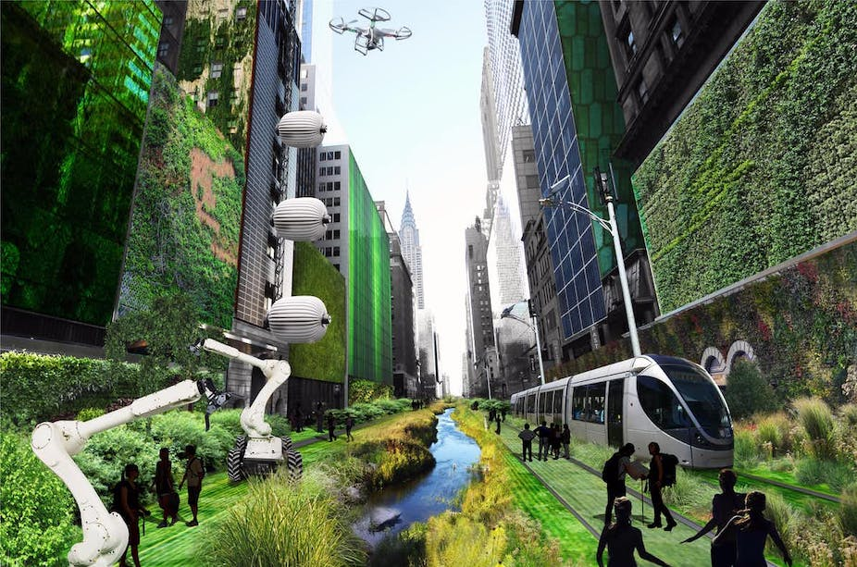

**Work in groups of four or five students. Making predictions about life in the future. Then present to class what you have discussed.**

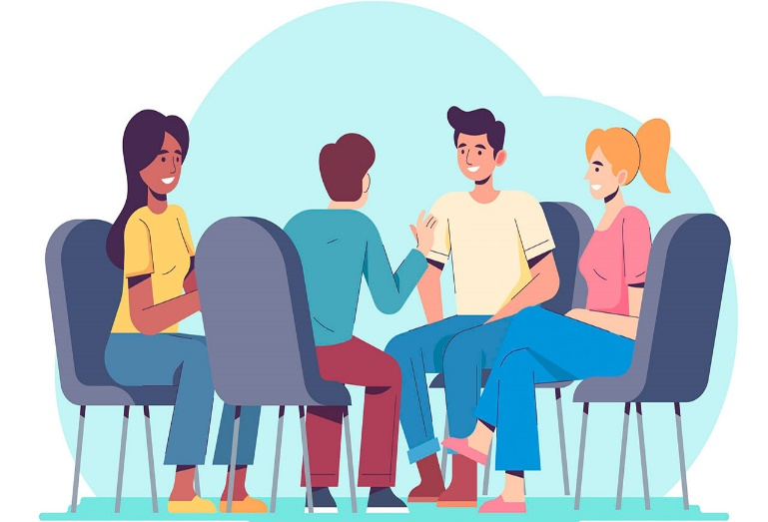

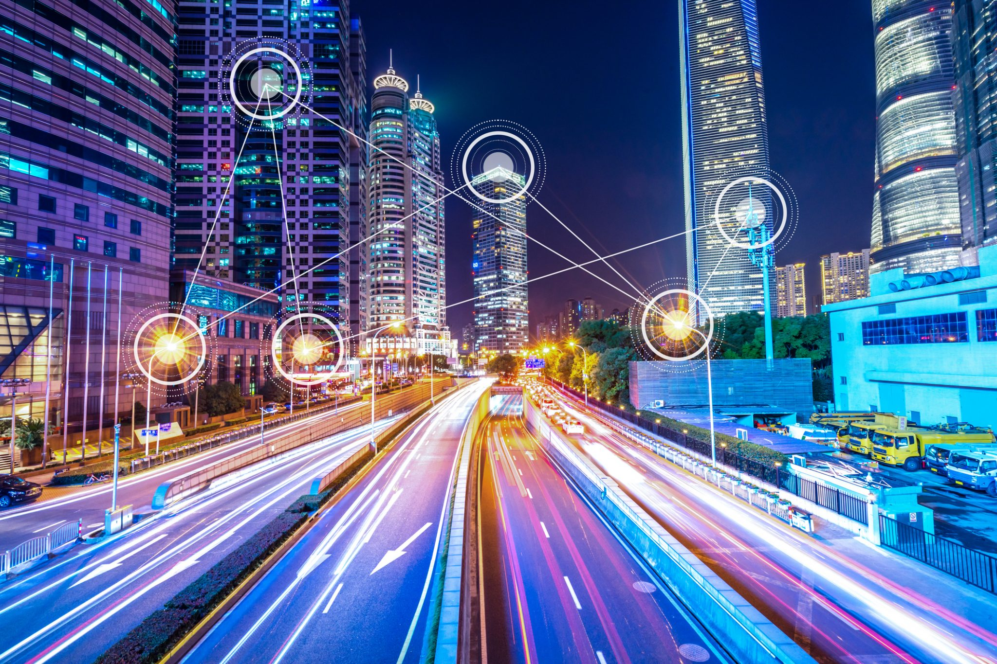

**LESSON 5E WRITING**

***I. Rewrite the sentences using the given words.***

1. To /begin /transportation/ become / with, /more/ will /environmentally-friendly./

____________________________________________________________________________________________________

1. I /strongly /that / ways./cities /technololgy/ will/ believe /change/ future /in/ many /

____________________________________________________________________________________________________

1. However,/ cities/ future/ will/ parks./ fewer / have/green/ spaces /and /

____________________________________________________________________________________________________

1. The/ city /of/ exciting /the/ future/ will/ be /place./ a /very / and/ high-tech/

____________________________________________________________________________________________________

1. I/ predict/attend that /students /in/will /classrooms./only / school/ digital/

____________________________________________________________________________________________________

1. Drones/ will/packages/probably/ deliver/ future./ all/ in/ the

____________________________________________________________________________________________________

1. Maybe /windows/buildings/ will/ have/ solar /all / in/ the /future. /

____________________________________________________________________________________________________

1. enegy-efficient./fast /be / and / will/ Transport/

____________________________________________________________________________________________________

1. In /people/ in/ cities /socialise /very/won’t / much. / addition,/

____________________________________________________________________________________________________

1. will /allow/ Digital / classrooms/ students/ to /from/ anywhere. /learn/

____________________________________________________________________________________________________

ANSWERS

1. To begin with, transportation will become more environmentally-friendly.
2. I strongly believe that technololgy will change future cities in many ways.
3. However, future cities will have fewer green spaces and parks.
4. The city of the future will be a very exciting and high-tech place.
5. I predict that students will only attend school in digital classrooms.
6. Drones will probably deliver all packages in the future.
7. Maybe all buildings will have solar windows in the future.
8. Transport will be fast and enegy-efficient.
9. In addition, people in cities won’t socialise very much.
10. Digital classrooms will allow students to learn from anywhere.

*Tài liệu được chia sẻ bởi Website VnTeach.Com*

*https://www.vnteach.com*