School: ……………………………………….. | Date:……………………………………..
Class: ……………………………..................... | Period: …………………………….........

UNIT 2: HEALTH
Lesson 2.3 – Pronunciation and Speaking (Page 17)

I. OBJECTIVES
By the end of the lesson, Ss will be able to:
1.1. Language knowledge and skills
- recognize and practice the sound changes in phrase “Do you…?”.
- practice a conversation about health problem and then ask for / give advice.
- ask about someone else’s health.
- offer help politely.
1.2. Competences
- improve listening and speaking skills.
1.3. Attributes
- know how to ask for advice and give advice.
- lead a healthy life.
- know how to take care of themselves.

II. TEACHING AIDS AND LEARNING MATERIALS
1. Teacher’s aids: Student book and Teacher’s book, class CDs, Digital Book (DCR phần mềm tương tác SB, DHA (từ vựng/ cấu trúc) phần mềm trò chơi tương tác), projector/interactive whiteboard / TV (if any), PowerPoint slides, handouts.
2. Students’ aids: Student’s book, workbook, notebook, handouts.

III. ASSESSMENT EVIDENCE
Performance Tasks | Performance Products | Assessment Tools
- Listen and notice the sound changes of the underlined words.  - Listen and cross out the sentence doesn’t follow the note in Task a.  - Read the sentences with the sound changes noted in Task a to a partner.  - Practice the conversation between a doctor and a patient. Swap the roles and repeat.  - Role-play: A doctor is giving advice to a sick patient, using questionnaire.  - Swap the roles, answer the questions in the questionnaire and write down the advice. | - Ss’ performance and answers.  - Ss’ answers.  - Ss’ performance.  - Ss’ performance.  - Ss’ performance /  Presentation.  - Ss’ performance /  Presentation. | - T’s observation.  - T’s feedback/Peers’ feedback.  - T’s feedback/Peers’ feedback.  - T’s feedback/Peers’ feedback.  - T’s observation, T’s feedback/Peers’ feedback.  - T’s observation, T’s feedback/Peers’ feedback.

IV. PROCEDURES
A. Warm up: (5’)
a) Objective: Introduce the new lesson and set the scene for Ss to acquire new language; get students' attention at the beginning of the class by enjoyable and short activities as well as to engage them in the follow-up steps.
b) Content: Introduce the phrase: “Do you…?”
c) Expected outcomes: Ss have good preparation for the new lesson.
d) Organization of the activity:
TEACHER’S ACTIVITIES | STUDENTS’ ACTIVITIES
- Option 1:  - Play a video clip with a lot of questions beginning with “Do you…?”  - Have watch, listen and pay attention to the way he sings: “Do you…?”  - Call Ss to make comment on the way the singer sings: “Do you…?”  - Give feedback and lead to the new lesson: sound change in the phrase: “Do you…?”  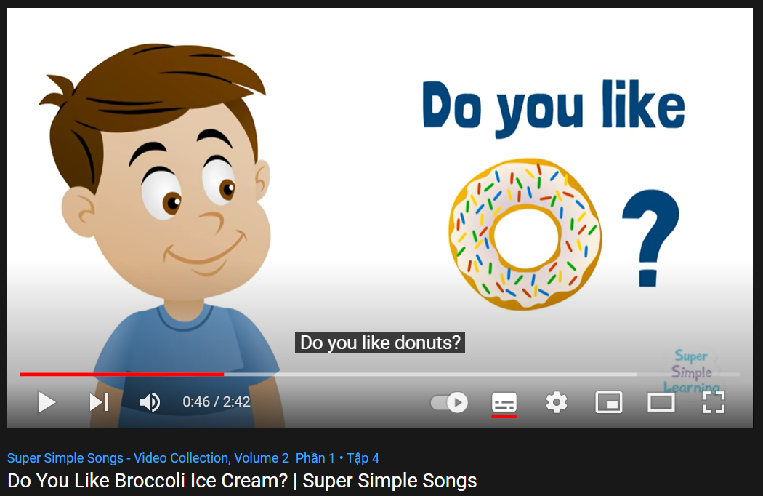  *Link: https://www.youtube.com/watch?v=frN3nvhIHUk  - Option 2:  - Divide class into 4 groups.  - Have Ss in each group write as many as possible questions beginning with “Do you…?.  - Set a limit time (about 2-3 minutes).  - Have 4 group representatives write answers on the board, or hang their extra-boards on the main board to check.  - Check Ss’ answers, give feedback and evaluation.  - Announce the winner.  - Give a small present or extra marks to the winner.  àIntroduce the new lesson: sound change in the phrase: “Do you…?” | - Listen and watch, pay attention to the way the singer sings: “Do you…?”.  - Give answers.  - Listen.  - Take part in the class activity in groups.  - Listen.

B. New lesson (35’)
- Activity 1: Pre-Speaking: Pronunciation (8’)
a) Objective: Introduce sound change in the phrase: “Do you…?”
b) Content:
- recognize the sound change in the phrase: “Do you…?”
- listen and check, find mistakes.
- practice.
c) Expected outcomes: Ss distinguish sound change in the phrase: “Do you…?”and use it naturally in their speaking.
d) Organization of the activity:
TEACHER’S ACTIVITIES | STUDENTS’ ACTIVITIES
Task a + b. Notice the sound changes of the underlined words.  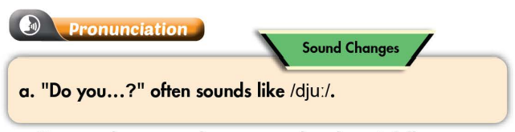  - Play the recording (CD1, track 21) using DCR.  - Ask Ss to listen and notice how sound changes of the underlined words.  - Play the recording again, have Ss listen and repeat with a focus on the pronunciation feature.  Task c + d. Listen and cross out the sentence that doesn’t follow the sound feature, then read the sentences with the sound changes of the phrase “Do you..?” to a partner.  - Play the recording (CD 1 – Track 22) using DCR, have Ss listen and cross out the option that doesn’t follow the sound feature in “a”.  - Call Ss to give answers.  - Play the recording again and check answers as a whole class.  - Then have Ss practice saying the examples with a partner, using the pronunciation feature.  - Call some Ss to read the sentences in front of the class.  - Ask Ss to make some more questions with the phrase “Do you..?” and practice reading them with the right sound feature of the lesson. | - Listen.  - Listen again and repeat.  - Listen and cross out.  - Give answers.  Answer keys  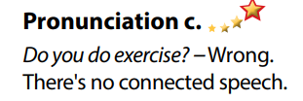  - Listen again and check.  - Work in pairs.  - Present.  - Give answers.
- Activity 2: While-speaking (21’)
a) Objective: Students can ask for advice and give advice.
b) Content:
- Practice the conversation between a doctor and a patient. Swap the roles and repeat.
- Role-play: A doctor is giving advice to a sick patient, using questionnaire.
- Swap the roles, answer the questions in the questionnaire and write down the advice.
c) Expected outcomes: Ss produce the new language successfully and have a good role play.
d) Organization of the activity:

TEACHER’S ACTIVITIES | STUDENTS’ ACTIVITIES
PRACTICE  Practice the conversation. Swap the roles and repeat.  - Use DCR to show the task.  - Demonstrate the activity by practicing the role-play with a student.  - Have pairs practice the conversation.  - Remind Ss the way to offer help politely at the beginning of the conversation and give + ask for advice with “should” and “shouldn’t”.  - Have Ss swap roles and repeat, using the ideas on the right.  - Have some pairs demonstrate the activity in front of the class.  - Give feedback and evaluation.  SPEAKING: How Are You Feeling Today?  Task a. Student B, go to page 118 - file 2. Student A, you’re a doctor giving advice to a sick patient. Ask your patient questions, complete the questionnaire, and give advice if you need to for each question.  - Use DCR to show the task.  - Demonstrate the activity by practicing role-play with a student.  - Have Ss work in pairs.  - Have student B go to page 118 - file 2.  - Have students ask and answer to complete the questionnaire.  - Have some students share the ideas with the class.  - Observe, give help if necessary.  Task b. Swap roles. Student A, now you’re the patient. Answer the doctor’s questions and write down their advice.  - Have students swap roles and repeat.  - Observe, give help if necessary.  - T may call 1-2 pairs to present their role-play in front of the class.  - Give feedback and evaluation. | - Observe, listen.  - Work in pairs to practice the conversation.  - Swap roles and continue the task.  - Present.  - Observe and listen.  - Work in pairs to ask and answer to complete the questionnaire.  - Swap roles and repeat.  - Present.

- Activity 3: Production (6’)
a) Objective: Help Ss remember questions about health beginning with “Do you…?
b) Content: Retell some questions about health beginning with “Do you…?” that the doctor uses to ask his / her patient.
c) Expected outcomes: Ss produce the new language successfully in everyday speaking and writing.
d) Organization of the activity:
TEACHER’S ACTIVITIES | STUDENTS’ ACTIVITIES
Extra Task. Retell some questions about health beginning with “Do you…? that the doctor uses to ask his / her patient.  - Have Ss close all books and notebooks.  - Ask Ss to retell some questions about health beginning with “Do you…?” that the doctor uses to ask his / her patient.  - Pay attention to the way to pronounce the sound change in the phrase “Do you…?”.  - Give feedback and evaluation. | - Close all books and notebooks.  - Remember and retell.  - Give answers.  - Listen.

C. Consolidation and homework assignments (5’)
* Consolidation:

* Homework:
- Make 2 questions with the phrase “Do you…?”and practice reading them.
- Complete the questionnaire for those who haven’t finished it in class.
- Prepare: Lesson 3 – Listening and Reading (page 18– SB).
- Review the vocabulary and grammar notes in Tiếng Anh 7 i-Learn Smart World Notebook
(pages 12 & 13).
- Play consolation games in Tiếng Anh 7 i-Learn Smart World DHA App on www.eduhome.com.vn
D. Reflection
a. What I liked most about this lesson today:
…………………………………………………………………………………………
- What I learned from this lesson today:
…………………………………………………………………………………………
c. What I should improve for this lesson next time:
…………………………………………………………………………………………

