Full name: ……………………………………………….  Class: …………………………………………………….  School: …………………………………………………. | Mark:

SPEAKING TEST 2 (UNITS 3 & 4)

TASK 1 |  |  | Let’s talk about your community activities.  The following questions may help you.
 | 1. | What activity do you often take part in to help your community?
 | 2. | Who do you often work with in this activity?
 | 3. | How often do you do it?
 | 4. | When did you last join a community activity?
 | 5. | What was your impression?

TASK 2 | Work in pairs. Each of you receives a card. Use the clues on your card to make questions about your friend’s picture. Use the picture on your card to answer your friend’s questions.

CARD A
Ask your friend about his / her picture. Listen to his / her answers

1. | What / the students / doing?
2. | Where/ they/ see/ the pictures?
3. | How often / this activity / take place?
4. | Which kind of picture / you / prefer / a photo or a painting? | 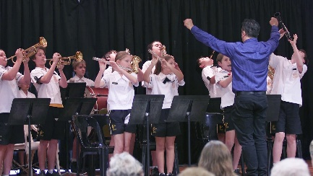
5. | What art exhibition / you / often / visit?
 |  | Answer your friend’s questions about this picture.

CARD B
Ask your friend about his / her picture. Listen to his / her answers.

1. | What / the students / doing?
2. | Where / they / perform?
3. | How often / this activity / take place?
4. | Which musical instrument / you / prefer / flute or piano? | 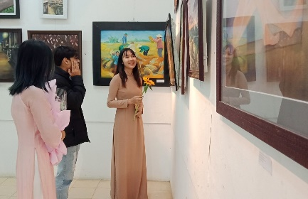
5. | What performance / you / often / take part in?
 |  | Answer your friend’s questions about this picture.

