Date of preparing: ………………………………….
Date of teaching: ………………………………….

Period……
UNIT 10: CITIES AROUND THE WORLD
Lesson 2 - Part 2 (Page 82) – Grammar

I. OBJECTIVES
By the end of the lesson, Ss will be able to…
1. Knowledge
- use the comparative and superlative adjectives to compare things;
2. Ability
- improve the use of language (Main skills: Writing - Speaking);
- develop the ability to communicate and cooperate with their partners, to self-study;
3. Quality
- have positive attitude in learning and actively participate in all classroom activities related to grammatical points.
II. TEACHING EQUIPMENT AND LEARNING MATERIALS.
Lesson plan, PPT slides, Student’s book, workbook, notebook, personal computer (if any), projector/ TV, speakers, DCR & DHA on Eduhome, CD player, handouts…
III. PROCEDURES
A. Warm up and introduce new language: (15’)
a) Objectives: To introduce what Ss are going to learn in the lesson;
To develop Ss’ collaboration and communication.
b) Content: reviewing and introducing new grammatical points – Comparative and Superlative adjectives
c) Product: Students can use the comparative and superlative adjectives to compare things.
d) Competence: Collaboration and communication
e) Organization of the activity:
Teacher’s activities | Students’ activities
* Option 1:  - Put some pairs of things on the table with different size or age.  + books: one is large, the other is small.  + pens: one is new, the other is old.  + phones: one is expensive, the other is cheap.  - Ask students to look at those pairs of things and describe them.  - Get them to guess the structure they will learn today.  - Lead to the new lesson.  * Option 2:  - Have Ss look at the picture.  - Have Ss guess what they are talking about.  - Play the audio and have Ss listen and read the speech bubbles.  - Play the audio again.  - Ask Ss to listen and repeat.  * Option 3:  - Ask Ss to have a look at the grammar explanation and discuss the grammar explanation in pairs.  - Have some Ss read the comparative and superlative adjectives aloud.  - Have Ss give the rule of using comparative and superlative adjectives.  - Ask Ss to write the new language in their notebooks. | - Look at those pairs of things and describe them.  - Guess the structure they will learn today.  - Look at the pictures.  - Have discussion about cities.  - Listen and read the speech bubbles.  - Listen and repeat.  - Look at the table and discuss the grammar explanation in pairs.  - Read the comparative and superlative adjectives aloud.  - Give the rule of using comparative and superlative adjectives.  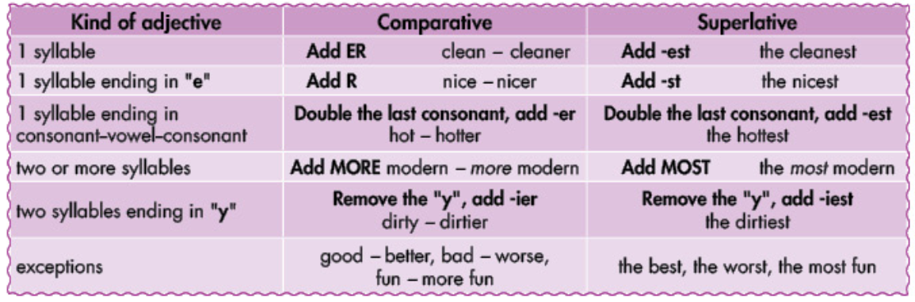

B. New lesson (35’)
- Activity 1: Practice new language (20’)
a) Objective:
- To use the new grammatical points in communicative situations;
- To develop communicative and critical thinking skills.
b) Content:
- Learning and using grammar: Comparative and Superlative adjectives;
- Filling gaps.
c) Products: Students can use the comparative and superlative adjectives to compare things.
d) Competence: Collaboration, communication, and imagination
e) Organization of the activity:
Teacher’s activities | Students’ activities
b. Fill in the blanks.  - Help students how to do the exercise.  - Demonstrate the activity using the example.  - Ask Ss to fill in the blanks.  - Have Ss check their work in pairs.  - Invite some Ss to share their answers with the class.  - Correct and give feedback.  c. Fill in the blanks.  - Help students how to do the exercise.  - Demonstrate the activity using the example.  - Have Ss fill in the blanks.  - Let them check their work in pairs.  - Get some Ss to share their answers with the class.  - Correct and give feedback. | - Listen to T’s demonstration and write the sentence in notebooks.  - Fill in the blanks using the prompts.  - Then work in pairs to check each other’s work.  - Share their answers with the class.  - Check their answers and correct.  + Expected answer:  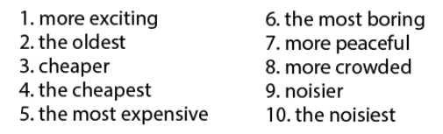  - Listen to T’s demonstration and write the sentence in notebooks.  - Fill in the blanks using the prompts.  - Then work in pairs to check each other's work.  - Share their answers with the class.  - Check their answers and correct.  + Expected answer:  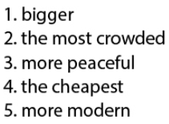

- Activity 2: Speaking Skill (7’)
a) Objectives: To apply the grammatical points they have learnt to practise converastion skill and act out the dialogue in close pairs and then in open pairs;
To develop communication, cooperation, and raise cultural awareness (improving the different ideas – each student may live a different condition).
b) Content: Asking and answering questions
c) Products: Students can use the grammatical points in the speaking.
d) Competence: Collaboration, communication, and imagination
e) Organization of the activity:
Teacher’s activities | Students’ activities
d. Now, compare your city with another city:  * Option 1:  + Help Ss deepen the new language.  - Divide the class into pairs.  - Have Ss prepare for talking something about their cities (using the grammatical points and vocabulary items they learned).  - Ask some pairs to read aloud the words in front of the class.  * Option 2:  + Help Ss improve their competence in using new language in their speeches.  - Have Ss compare their city with another city.  - Call on some pairs demonstrate the activity in front of the class.  - Correct and give feedback. | - Work in pairs (close pairs).  - Work in pairs (open pair)..  - Work in pairs (their own conversations)  - Read aloud the words in front of the class.  - Work in pairs to check each other's work.  - Share their answers with the class.

C. Homework (5’)
- Learn how to use the comparative and superlative adjectives to compare things.
- Do exercises on page 59 (WB).
- Prepare for the new lessons – Pronunciation and Speaking on page 83 (SB).

