Week : Date of preparing:
Period: Date of teaching:

UNIT 2: SENSATIONS

Lesson 1: Vocabulary: Senses

I can ask and answer questions related to the senses.
I./. OBJECTIVES
1. Knowledge: By the end of the lesson, students will be able to:

ask and answer questions about the senses
- learn more sensations’ vocabularies.
2. Skills: Speaking, listening, reading, writing.
3. Attitude: Students know how to learn English in the right way.
4. Competence: Communication, self-learning capability, creative capacity, ability to use language……
II./. PREPARATION:
1. Teacher: pictures, textbooks, PowerPoint slides, ….
2. Students: textbook, notebook.
III./. TEACHING METHODS: Communicative approach, group Ss and T’s activities, play as a character, teaching methods with game, teaching methods by visual, teaching methods by practising, discussion group, technical present….
IV./.PROCEDURE:
1. Check–up: during the lesson
2. New lesson

Teacher’s and students’ activities | Contents
ACTIVITY 1: WARM-UP  ❖ Aims: Students can talk about all sensations of people  ❖ Contents: Students apply their knowledge to the situations, then work in individual and groups to answer the questions.  ❖ Products: Students answers  ❖ Organization:  - Students work in pairs to ask and answer questions  - Teacher gives students time to work in pairs  - Teacher invites students to speak in front of the class  - Teacher checks answers and gives feedback.  ACTIVITY 2: KNOWLEDGE FORMATION  ❖ Aims: Teacher presents new words related to senses  ❖ Contents: Students listen and repeat new words individual/pairs/groups.  ❖ Products: Students can understand the meaning of new words.  ❖ Organization:  - Teacher shows new words and uses some techniques of teaching vocabulary to teach them, then asks students to listen and repeat.  - Students listen to the teacher and repeat the words.  - Students copy down these words into their notebooks.  - Check-up: Matching  ACTIVITY 3: PRACTICE  ❖ Aims: Students can apply the knowledge which they have learnt to do the tasks given.  ❖ Contents: Students work in individual/pairs/groups to complete the tasks.  ❖ Products: Students’ answers  ❖ Organization  Exercise 1:  - Teacher gives students time to complete the task.  - Students look at photos and do matching.  - Teacher invites some students to answer the exercise  - Teacher checks students’ answers.  Exercise 2:  - Students read the magazine and complete the exercise.  - Teacher gives students time to do the exercise.  - Teacher plays the audio again and checks students’ answers.  Exercise 3:  - Students work in pairs to do the quiz by asking their partner and answering questions  - Teacher gives students time to complete the task.  -Teacher invites some pairs of students to speak in front of the class and checks answers with the class.  Exercise 4:  - Teacher plays the video/audio and gives students time to listen and answer.  - Teacher opens the audio again and checks answers with the class.  ACTIVITY 4. PRODUCTION  ❖ Aims: Students can write a questionnaire for your class about their favourite senses.  ❖ Contents: Students work in groups.  ❖ Products: Students’ opinions  ❖ Organization:  Exercise 5:  - Students work in pairs to ask and answer the questions with their partner.  - Students use key phrases of like and dislike to ask and answer questions.  - Teacher invites some pairs of students to speak in front of the class and give feedback.  ACTIVITY 5. HOMEWORK  -Learn by heart all the new words.  -Prepare for the next lesson – Reading | THINK! How many senses are there? Which do you think you use most? Which is your strongest sense?  (Students’ own answers.)  🕮 New words  - hearing (n): thính giác  - sight (n): thị giác  - smell (n): khứu  - taste (n): vị giác  - touch (n): xúc giác  1. Look at photos 1–5 and match them with the senses in the box    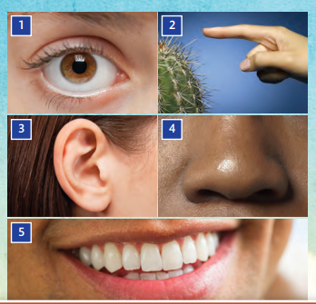  Suggested answers  1. sight 2. touch 3. hearing 4. smell 5. taste  2. Read the magazine quiz and complete the  table with the words in blue. Listen and check  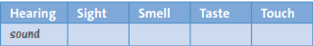  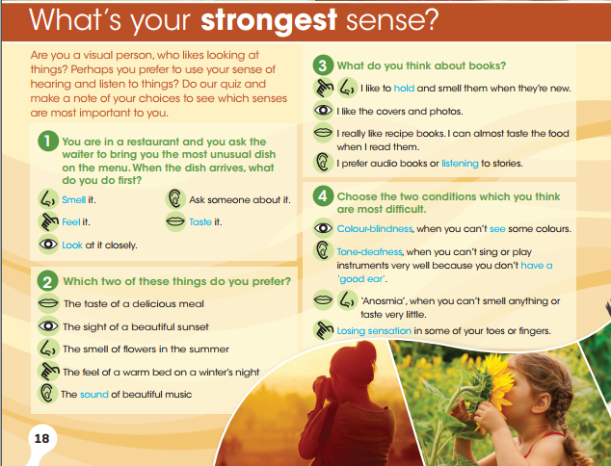  Suggested answers:  Hearing Sight Smell Taste Touch  Sound Listening Tone-deafness Have a good ear Look Colour-blindness See Smell Feel Taste Hold Losing sensation  3. Do the quiz. Which sense is the most important for you? Compare your result with a partner's.  (Students’ own answers.)  4. Watch or listen. What is each person talking about? Match speakers: Alicia, Emma, Will, Paul and Zara with photos A–E  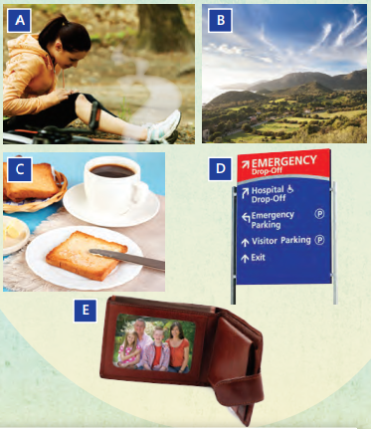  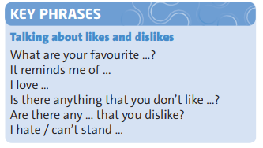  Suggested answers  Alicia: B  Emma: C  Will: D  Paul: E  Zara: A  5. USE IT! Work in groups. Ask and  answer the questions. Use some of the  key phrases.  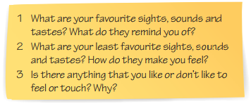  (Students’ own answers.)  Suggested answers  1. I love the sea, the sound of the waves and the taste of the salt vapour. It reminds me of summer days with my family swimming in the sea.  2. I hate going to noisy places, it makes me uncomfortable and headache  3. My favorite city is Paris, I wish I could see the Eiffel Tower once

*Feedback:............................................................................................................................
...............................................................................................................................................
...............................................................................................................................................
...............................................................................................................................................
...............................................................................................................................................
...............................................................................................................................................
...............................................................................................................................................

Week : Date of preparing:
Period: Date of teaching:

UNIT 2: SENSATIONS

Lesson 2: Reading: The importance of smell

I can identify the main idea in a paragraph.
I./. OBJECTIVES
1. Knowledge: By the end of the lesson, students will be able to:
- identify the main idea in the text
- learn more vocabulary about the smell
- understand the content of the text “Follow your nose”
- Talk about their favourite smell and the connection between their memories and that smell.
2. Skills: Speaking, listening, reading, writing.
3. Attitude: Students know how to learn English in the right way.
4. Competence: Communication, self-learning capability, creative capacity, ability to use language……
II./. PREPARATION:
1. Teacher: book, planning, TV
2. Students: books, notebooks
III./. TEACHING METHODS: Communicative approach, group Ss and T’s activities, play as a character, teaching methods with game, teaching methods by visual, teaching methods by practicing, discussion group, technical present….
IV./.PROCEDURE:
1. Check–up: during the lesson
2. New lesson:

Teacher’s and Students’ activities | Contents
ACTIVITY 1: WARM-UP  ❖ Aims: Students can talk about their favourite smell and the connection between their memories and the smell they like.  ❖ Contents: Students work individually/work in pairs.  ❖ Products: Students’ answers  ❖ Organization:  - Teacher divides the class into pairs.  - Teacher gives the student time to talk with their partner.  - Teacher invites some pairs of students to speak in front of the class  - Teacher gives feedback.  ACTIVITY 2: KNOWLEDGE FORMATION  ❖ Aims: Teacher presents new words related to smell  ❖ Contents: Students listen and repeat new words individually/in pairs/groups.  ❖ Products: Students can understand the meaning of new words.  ❖ Organization:  -Teacher introduces some new words “Before reading, there are some new words in the text.”  - Teacher uses some techniques of teaching vocabulary to teach them, then asks students to listen and repeat.  - Students listen to the teacher and repeat the words.  - Students copy down these words into their notebooks.  ACTIVITY 3: PRACTICE  ❖ Aims: Students can apply the knowledge which they have learnt to do the tasks given as well as develop reading skills.  ❖ Contents: Students work in individual/ pairs/ groups.  ❖ Products: Students’ answers  ❖ Organization  Pre-reading  Exercise 1:  - Teacher has students open their books to page 20.  - Teacher explains some vocabulary before students read the text.  While reading  - Teacher gives students time to read the text and complete their tasks.  - Teacher invites some students to answer the questions.  - Teacher checks the answer with the class.  Exercise 2:  - Teacher gives students time to read the questions and do the exercise.  - Teacher invites students to answer the questions in front of the class,  - Teacher checks answers with the class.  Exercise 3:  - Teacher has students close their books and not use any electronic devices to look up the dictionary  - Then, teacher divides the class into some groups  - Students work in groups, read the text again and discuss the exercise.  - Teacher invites some groups to answer the questions. The group with the highest score will get good points.  Exercise 4:  - Teacher gives students time to look up the blue vocabulary in the dictionary  - Teacher invites some students to explain the meaning of those words.  - Teacher checks the meaning of those words with students.  ACTIVITY 4. PRODUCTION  ❖ Aims: Teacher helps students consolidate the lesson  ❖ Contents: Students work in individual  ❖ Products: Students’ speaking  ❖ Organization:  Post-reading  Exercise 5:  - Teacher gives the question:  “Which objects and places smell best to you. Which of them bring back memories?”  - Students work in individual, they may ask for help if necessary.  - Teacher gives students time to prepare their answers.  - Teacher invites some students to talk about their answers and gives feedback.  ACTIVITY 5. HOMEWORK  - Learn by heart all the new words.  - Do exercises (in the workbook).  - Prepare new lesson. | THINK! What smells can you remember from when you were younger? Is there a connection between smells and memory?  (Students’ own answers.)  🕮 New words  - connection (n): kết nối, liên kết  - difference (n): sự khác biệt  - deaf (adj): điếc  - blind (adj): mù  - extraordinary (adj): phi thường  - odour (n): mùi thơm  - scent (n): mùi, sự đánh hơi  - perfume (n): nước hoa  - fragrance (n): hương thơm ngát  - flavour (n): mùi vị  - texture (n): kết cấu  - anosmic (n): người bị mất khứu giác  1. Read the article. Then complete the headings for paragraphs A–C with the words in the box  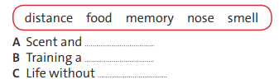  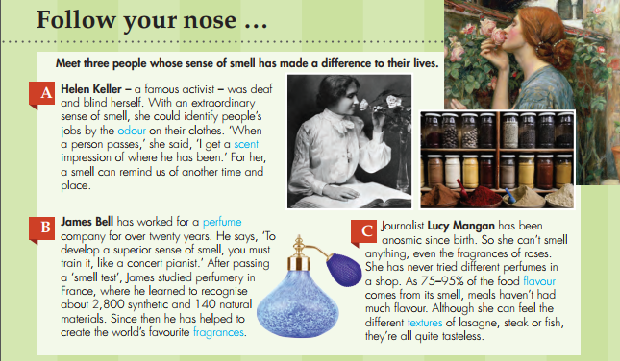  Suggested answers  - Scent and memory  - Training a smell  - Life without food  2. Read and listen to the article again and  write true or false. Correct the false sentences  1. Helen Keller had a good sense of smell.  2. She says there’s a connection between  smells and memory.  3. A person with a normal sense of smell can  become a professional perfumer.  4. James Bell failed his first ‘smell test’ at the  perfume company.  5. Lucy could smell everything when she was  a baby  Suggested answers  1. T 2. T 3. F 4. F 5. F  3. Find synonyms in the text for the words below  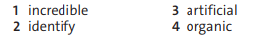  Suggested answers  - incredible = extraordinary  - identify = recognise  - artificial = synthetic  - organic = natural materials  4. VOCABULARY PLUS Use a dictionary to check the meaning of the words in blue in the text.  - odour (n): mùi thơm  - scent (n): mùi, sự đánh hơi  - perfume (n): nước hoa  - fragrance (n): hương thơm ngát  - flavour (n): mùi vị  - texture (n): kết cấu  5. USE IT! Talk about which objects and  places smell best to you. Which of them bring  back memories?  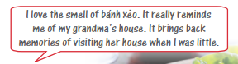  Suggest answer:  The scent I like the most is the smell of the rice fields. It reminds me of my childhood memories with my friends and neighbours when my hometown was still in the countryside.

*Feedback:............................................................................................................................
...............................................................................................................................................
...............................................................................................................................................
...............................................................................................................................................
...............................................................................................................................................
...............................................................................................................................................
...............................................................................................................................................

Week : Date of preparing:
Period: Date of teaching:

UNIT 2: SENSATIONS

Lesson 3: Language Focus: Present perfect: affirmative and negative * for and since

I can talk about experiences that started in the past.
I./. OBJECTIVES
1. Knowledge: By the end of the lesson, students will be able to:
- understand how to use present perfect tense
- can talk about their experiences using present perfect
- can compare and know how to use “for” and “since” in present perfect.
2. Skills: Speaking, listening, reading, writing.
3. Attitude: Students know how to learn English in the right way.
4. Competence: Communication, self-learning capability, creative capacity, ability to use language……
II./. PREPARATION:
1. Teacher: book, planning, TV
2. Students: books, notebooks
III./. TEACHING METHODS: Communicative approach, group Ss and T’s activities, play as a character, teaching methods with game, teaching methods by visual, teaching methods by practising, discussion group, technical present….
IV./.PROCEDURE:
1. Check–up: during the lesson
2. New lesson:

Teacher’s and Students’ activities | Contents
ACTIVITY 1: KNOWLEDGE FORMATION  ❖ Aims: Help students learn the structures: PRESENT PERFECT.  ❖ Contents: Students work in individual  ❖ Products: Students’ answers  ❖ Organization:  Exercise 1:  - Teacher teaches students about present perfect, and gives them structure, form, and examples about this tense.  - Teacher invites students to read aloud the article on page 20.  - Teacher gives students time to complete the exercise 1.  - Teacher checks students’ answers.  ACTIVITY 3: PRACTICE  ❖ Aims: Help students apply the structures of present perfect they have learnt and distinguish between “for” and “since” to do the tasks given.  ❖ Contents: Students work in individual/ pairs/groups  ❖ Products: Students’ answers  ❖ Organization  Exercise 2:  - Students read the sentences in exercise 1 again.  - Teacher gives students time to read the questions and do the task.  - Teacher invites some students to answer the exercise in front of the class,  - Teacher checks the answers with the class.  Exercise 3:  - Teacher gives students time to read the text and do their exercise.  - Students manipulate what they have learnt about present perfect to conjugate the verb.  - Teacher invites some students to answer the exercise in front of the class,  - Teacher checks the answers with the class.  Exercise 4:  - Teacher gives students time to read the text and do their exercise.  - Students look up the dictionary to conjugate the right present perfect verb.  - Teacher invites some students to answer the exercise in front of the class.  - Teacher checks the answers with the class and gives feedback.  Exercise 5:  - Teacher gives students time to read and do their exercise.  - Students read the examples and complete the rules with “for” and “since”.  - Teacher invites some students to answer the exercise in front of the class.  - Teacher checks answers.  Exercise 6:  - Teacher gives students time to complete their exercise.  - Students apply what they have learnt about “for” and “since” to do their task.  - Teacher invites some students to answer the exercise in front of the class.  - Teacher checks answers and gives feedback.  ACTIVITY 4. PRODUCTION  ❖ Aims: Help students consolidate the structures: PRESENT PERFECT by describing their unforgettable experiences.  ❖ Contents: Students work in pairs  ❖ Products: Students’ presentation  ❖ Organization:  Exercise 7:  - Teacher asks students to work in pairs.  - Each student will write some sentences about their unforgettable experiences and write questions to ask a partner.  - Students will ask their partner about his/her experiences and then do the reverse.  - Teacher gives some pairs of students to speak in front of the class.  - Teacher gives feedback.  ACTIVITY 5. HOMEWORK  - Learn by heart all structures.  - Prepare the next lesson | Present perfect: affirmative and negative  🕮 GRAMMAR.  Present perfect ( Thì hiện tại hoàn thành) diễn tả một hành động, hoặc sự việc đã xảy ra ở quá khứ và vẫn kéo dài tới hiện tại.  (+) S + HAS/HAVE + V-ED/V3  (-) S+ HAS/HAVE + NOT + V-ED/V3  She / He / It + Has + V-ed/V3  I/ You / We / They + Have + V-ed/V3  Ex: (+) I have been in Hanoi for 3 months (Tôi ở Hà Nội kể từ 3 tháng trước)  (-) I haven’t been in Hanoi for 3 months (Tôi không ở Hà Nội kể tù 3 tháng trước)  1. Cover the article on page 20. Complete the sentences with the words in the box. Then check your answers  - He has…………to create fragrances.  - She has………… anosmic since birth.  - She has never…….. different perfumes.  - Meals haven’t……… much flavour  Suggested answers  - helped  - tried  - smelled  - had  2. Read the sentences in exercise 1 again. Then choose the correct words to complete the rules.  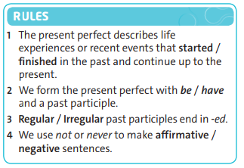  Suggested answers  - started  - have  - Regular  - negative  3. Complete the sentences with the correct present perfect form of the verbs in brackets  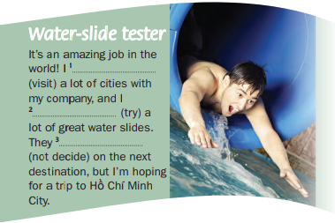  Suggested answers  1. have visited  2. have tried  3. haven’t decided  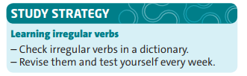  4. Read the Study Strategy. Complete the  sentences using the present perfect form of  the verbs  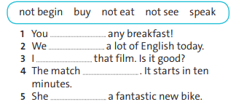  Suggested answers:  - haven’t eaten  - have spoken  - haven’t seen  - hasn’t begun  - has bought  For and Since  5. Study the examples and complete the rules  with for and since  🕮 GRAMMAR  Since: We use “since” to talk about the point in time an activity started, (chỉ mốc thời gian)  For: We use “for” to talk about the period of time up to the future. (chỉ khoảng thời gian)  Ex:  - We have watched this film since 2022. (Chúng tôi xem phim này vào năm 2022)  - We have watched this film for 3 weeks. (chúng tôi xem phim này khoảng 3 tuần trước)  6. Complete the sentences with the present  perfect form of the verbs in brackets and for  or since  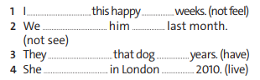  Suggested answers:  1. I haven’t felt this happy for weeks.  2. We haven’t seen him since last month.  3. They have had that dog for years.  4. She has lived in London since 2010.  7. USE IT! Talk about experiences using the  present perfect. Use the time expressions below.  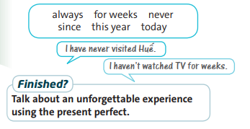  (Students’ own answers.)  Suggested answers:  - I have never gone to Paris before.  - I have done this difficult exercise for weeks.

*Feedback:............................................................................................................................
...............................................................................................................................................
...............................................................................................................................................
...............................................................................................................................................
...............................................................................................................................................
...............................................................................................................................................
...............................................................................................................................................

Week : Date of preparing:
Period: Date of teaching:

UNIT 2: SENSATIONS

Lesson 4: Vocabulary and Listening: Sensations and experiences

I can use prediction skills when listening for specific information.
I./. OBJECTIVES
1. Knowledge: By the end of the lesson, students will be able to:
- can listen to the dialogue and do the exercises
- learn more vocabulary about their feelings
- can talk about their feelings and experiences
2. Skills: Speaking, listening, reading, writing.
3. Attitude: Students know how to learn English in the right way.
4. Competence: Communication, self-learning capability, creative capacity, ability to use language……
II./. PREPARATION:
1. Teacher: book, planning, TV
2. Students: books, notebooks
III./. TEACHING METHODS: Communicative approach, group Ss and T’s activities, play as a character, teaching methods with game, teaching methods by visual, teaching methods by practising, discussion group, technical present….
IV./.PROCEDURE:
1. Check–up: during the lesson
2. New lesson:

Teacher’s and Students’ activities | Contents
ACTIVITY 1: WARM-UP  ❖ Aims: Help students learn how to describe your feelings and experiences  ❖ Contents: Students work in pairs  ❖ Products: Students’ answers  ❖ Organization:  Exercise 1:  - Teacher divides the class into pairs, and explain the rule:  + Group members will ask and answer together 5 questions from the book. The student that gets the information from his/her partner the fastest and remembers the most information will be the winning group.  + The winning team will get bonus points.  - Students will ask and answer on their own with their partner.  - When the exchange is over, the students will send the information they took notes from their partner to the teacher.  - After that, the teacher will ask for and compare the information recorded on the papers of those students.  ACTIVITY 2: KNOWLEDGE FORMATION  ❖ Aims: Teacher presents new words related to feelings  ❖ Contents: Students listen and repeat new words in individual/pairs/groups.  ❖ Products: Students can understand the meaning of new words.  Pre-listening  ❖ Organization:  -Teacher introduces some new words “Before listening, there are some new words in the text.”  - Teacher uses some techniques of teaching vocabulary to teach them, then asks students to listen and repeat.  - Students listen to the teacher and repeat the words.  - Students copy down these words into their notebooks.  Exercise 1:  - Teacher gives students time to complete the exercise  - Students use the blue words in the exercise Feeling questionnaire to do the tasks  Teacher opens the audio for students to listen and check their answers.  - Teacher asks some students to show their answers to the class and asks the class to correct any mistakes.  - Teacher gives feedback.  ACTIVITY 3: PRACTICE  ❖ Aims: Help students improve their listening skills and apply the knowledge they have learnt to do the tasks given.  ❖ Contents: Students work in individual/pairs/groups  ❖ Products: Students’ answers  ❖ Organization  While listening  Exercise 2:  - Teacher gives students time to look at photos in books.  - Teacher opens the audio twice  - Students listen and order photos A-C  - Teacher invites students to answer the questions in front of the class.  - Teacher checks students’ answers.  Exercise 3:  - Teacher allows students time to read sentences 1–5 in exercise 4 and guest type of answers they should be listening.  - Teacher invites some students to answer the questions.  - Teacher checks students’ answers and explain why we need to use those type of answers.  Exercise 4:  - Teacher allows students time to read the questions, then play the audio again.  - Students listen and answer the questions.  - Teacher invites some students to answer the questions.  - Teacher checks answers with the class.  - Teacher points out the answers in the recording.  ACTIVITY 4. PRODUCTION  ❖ Aims: Help students consolidate the lesson  ❖ Contents: Students work in groups  ❖ Products: Students’ opinion  ❖ Organization:  - The teacher invites some students to submit their work from the first game for grading  ACTIVITY 5. HOMEWORK  - Learn by heart all the new words.  - Do exercises (in the workbook).  - Prepare new lesson. | GAME:  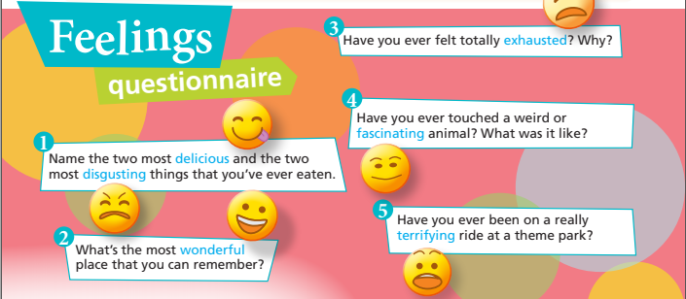  THINK! When was the last time that you had a memorable day? What did you do?  (Students’ own answers.)  🕮 New words  - delicious (adj): ngon  - disgusting (adj): ghê tởm  - wonderful (adj); tuyệt vời  - exhausted (adj): kiệt sức, mệt lử  - fascinating (adj): hấp dẫn  - terrifying (adj): kinh hãi, khiếp sợ  1. Match adjectives 1–6 with the extreme adjectives in blue in the questionnaire. Then listen and check.  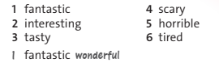  Suggested answers:  2. interesting = fascinating  3. tasty = delicious  4. scary = terrifying  5. horrible = disgusting  6. tired = exhausted  2. Listen and order photos A–C. Which  questions from the questionnaire are the  people answering?  Suggested answers  - B  - A  - C  3. Read sentences 1–5 in exercise 4. Decide  what type of answer you should be listening  for: age, noun, distance, reason or adjective.  Suggested answers  - age  - adjective  - distance  - noun  - reason  4. Listen again and complete the sentences. Were your answers in exercise 3 correct?  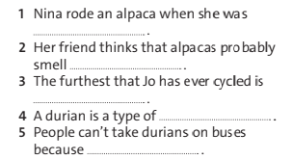  Suggested answers:  - six years old  - disgusting  - 100 kilometres  - food  - it smells so bad  5. USE IT! Work in pairs. Read the  Feelings questionnaire again and answer the  questions for you. Then ask and answer the  questions with a partner  (Students’ own answer )

*Feedback:............................................................................................................................
...............................................................................................................................................
...............................................................................................................................................
...............................................................................................................................................
...............................................................................................................................................
...............................................................................................................................................
...............................................................................................................................................

Week : Date of preparing:
Period: Date of teaching:

UNIT 2: SENSATIONS

Lesson 5: Language focus

• Present perfect: questions

• Present perfect and past simple

I can ask people about their experiences.
I./. OBJECTIVES
1. Knowledge: By the end of the lesson, students will be able to:
- can distinguish between past simple and present perfect to do their task.
- understand the structure of present perfect questions.
2. Skills: Speaking, listening, reading, writing.
3. Attitude: Students know how to learn English in the right way.
4. Competence: Communication, self-learning capability, creative capacity, ability to use language……
II./. PREPARATION:
1. Teacher: book, planning, TV
2. Students: books, notebooks
III./. TEACHING METHODS
Communicative approach, group Ss and T’s activities, play as a character, teaching methods with game, teaching methods by visual, teaching methods by practicing, discussion group, technical present….
IV./.PROCEDURE
1. Check–up: during lesson
2.New lesson:

Teacher’s and Students’ activities | Contents
ACTIVITY 1: KNOWLEDGE FORMATION  ❖ Aims: Help students review how to use PRESENT PERFECT and learn present perfect questions.  ❖ Contents: Students pay attention to the structures and work individually.  ❖ Products: Students understand the structures.  ❖ Organization:  - Teacher explains the grammar to students.  - Teacher gives students examples of this tense.  - Students copy down to their notebooks.  Exercise 1:  - Teacher gives students time to complete the sentences with the correct words.  - Students apply what they learnt about present perfect to do the exercise.  - Teacher invites some students to do the exercise.  - Teacher checks the answers.  ACTIVITY 3: PRACTICE  ❖ Aims: Help students apply the knowledge about present perfect and past simple to do the tasks given.  ❖ Contents: Students work in individual/pairs/groups  ❖ Products: Students’ answers  ❖ Organization  Exercise 2:  - Teacher gives students time to do the task  - Students read the sentences in exercise 1 again and choose the answer.  - Teacher checks students’ answers.  Exercise 3:  - Teacher divides students into pairs to order the words to make questions.  - After that, students ask and answer the questions with their partner.  - Teacher gives students time to complete the task  - Teacher asks two students in one group to speak in front of the class.  - Teacher checks students’ answers and gives feedback.  Exercise 4:  - Teacher gives students time to read the exercise.  - Students make questions based on the answers in the box  - Teacher invites some students to answer their questions.  - Teacher checks answers with the class and makes sure students understand everything.  Exercise 5:  - Teacher gives students time to read the sentences.  - Students read the questions and answers based on the above sentences.  - Teacher calls some students to give the answers and then gives feedback.  Exercise 6:  - Teacher gives students time to read the exercise and complete their task  - After students finish their task, teacher plays the audio and checks answers with students.  ACTIVITY 4. PRODUCTION  ❖ Aims: Help students consolidate  ❖ Contents: Students work individually/in pairs  ❖ Products: Students’ answers  ❖ Organization:  Exercise 7:  - Teacher allows students time to talk with their partners.  - Then, students work in pairs to ask and answer the questions.  - Students use the present perfect and past simple to make the dialogue.  - Teacher checks students’ answers.  ACTIVITY 5. HOMEWORK  - Learn by heart the structures.  - Make sentences about your family using comparative adjectives.  - Prepare for the next lesson – Speaking | Present perfect: questions  🕮 GRAMMAR: Review  Present perfect ( Thì hiện tại hoàn thành) diễn tả một hành động, hoặc sự việc đã xảy ra ở quá khứ và vẫn kéo dài tới hiện tại.  (+) S + HAS/HAVE + V-ED/V3  (-) S+ HAS/HAVE + NOT + V-ED/V3  (?) HAS/HAVE + S+ V-ED/V3?  She / He / It + Has + V-ed/V3  I/ You / We / They + Have + V-ed/V3  Ex: (+) I have been in Hanoi for 3 months (Tôi ở Hà Nội kể từ 3 tháng trước)  (-) I haven’t been in Hanoi for 3 months (Tôi không ở Hà Nội kể tù 3 tháng trước)  (?) Have you been in Hanoi for 3 months? (Bạn ở Hà nội từ 3 tháng trước sao?)  1. Complete 1–5 with the words in the box. How  do you say ever in Vietnamese?  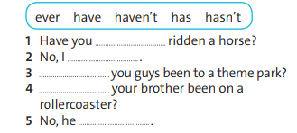  Suggested answers  - ever  - haven’t  - Have  - Has  - hasn’t  2. Read the sentences in exercise 1 again. Then  choose the correct answer to complete the rule.  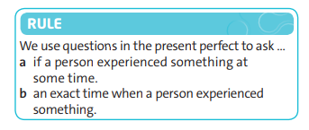  Suggested answers: a  3. Order the words to make questions.  Then ask and answer the questions with a  partner.  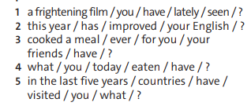  Suggested answers  1. a frightening film / you / have / lately / seen / ?  → Have you seen a frightening film lately?  2. this year / has / improved / your English / ?  → Has your English improved this year?  3. cooked a meal / ever / for you / your  friends / have / ?  → Have your friends ever cooked a meal for you?  4. what / you / today / eaten / have / ?  → What have you eaten today?  5. in the last five years / countries / have /  visited / you / what / ?  → What countries have you visited in the last five years?  - Ask and answer with a partner:  (Students’ own answer )  4. Write questions for the answers using the present perfect and the words in brackets  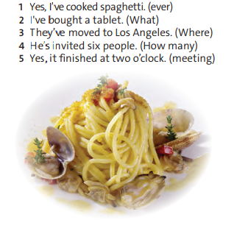  Suggested answers  1. Have you ever cooked spaghetti?  2. What have you bought?  3. Where have they moved to?  4. Has the meeting finished?  Present perfect and past simple  🕮 GRAMMAR: Review  - To be:  (+) S +WAS / WERE + ADJ/ N  (-) S+ WASN’T/ WEREN’T + ADJ/N  (?) WAS/WERE + S + ADJ/N?  Eg: (+) My mom was a nurse  (-) My mom wasn’t a nurse  (?) Was your mom a nurse?  - Regular verb:  (+) S + V-ED/V2  (-) S+ DIDN’T + V(BARE)  (?) DID + S + V(BARE)?  Eg: (+) They visited their parents last Sunday  ( -) They didn’t visit their parents last Sunday  (?) Did they visit their parents last Sunday?  5. Study examples a–d. Then answer questions  1–3  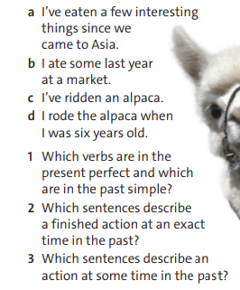  Suggested answers  1.  Past simple Present perfect  ate eaten  rode ridden  2. sentence b, d  3. sentence a,c  6. Read the dialogue and choose  the correct words. Then listen and check  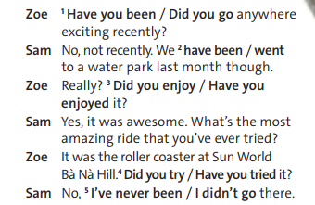  Suggested answers:  1. Have you ever  2. went  3. Did you enjoy it  4. Have you tried  5. I’ve never been  7. USE IT! Make a dialogue with a partner  on either idea A or B. Use the present perfect  and past simple forms.  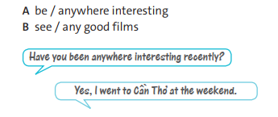  (Students’ own answer)

*Feedback:............................................................................................................................
...............................................................................................................................................
...............................................................................................................................................
...............................................................................................................................................
...............................................................................................................................................
...............................................................................................................................................
...............................................................................................................................................

Week : Date of preparing:
Period: Date of teaching:

UNIT 2: SENSATIONS

Lesson 6: Speaking: Planning free time

I can discuss ideas about how to spend free time.
I./. OBJECTIVES
1. Knowledge: By the end of the lesson, students will be able to:
- can discuss ideas about how to spend free time with their partner.
- develop students’ speaking skills.
2. Skills: Speaking, listening, reading, writing.
3. Attitude: Students know how to learn English in the right way.
4. Competence: Communication, self-learning capability, creative capacity, ability to use language……
II./. PREPARATION:
1. Teacher: book, planning, TV
2. Students: books, notebooks
III./. TEACHING METHODS
Communicative approach, group Ss and T’s activities, play as a character, teaching methods with game, teaching methods by visual, teaching methods by practising, discussion group, technical present….
IV./.PROCEDURE
1. Check–up: during lesson
2. New lesson:

Teacher’s and Students’ activities | Contents
ACTIVITY 1: WARM-UP  ❖ Aims: Help students brainstorm and lead in the new lesson  ❖ Contents: Students use language materials simply. Students work individually  ❖ Products: Students’ performance  ❖ Organization:  - Teacher reads the questions with the class and encourages students to talk about their  own opinions and experiences  - Teacher invites some students to answer.  - Students answer on their own.  ACTIVITY 2: KNOWLEDGE FORMATION  ❖ Aims: Help students pay attention to the content of the dialogue.  ❖ Contents: Students choose the correct words in the dialogue individually  ❖ Products: Students’ answers  ❖ Organization:  Pre-speaking  Exercise 1:  - Teacher gives students time to read through the gapped dialogue and do the exercise.  - Teacher plays the video or audio for students to watch or listen and check their answers.  - Teacher plays the video again and checks students’ answers.  - Teacher asks the questions to the class and invites some students to answer the questions.  - Then, teacher checks the answers.  Exercise 2:  - Students read the dialogue in exercise 1 again and complete the Key phrases.  - Teacher plays the audio for students to watch or listen.  - Teacher could pause after some of the sentences and questions for students to check the answers.  - Teacher makes sure that students understand the key phrases.  ACTIVITY 3: PRACTICE  ❖ Aims: Help students can discuss ideas to spend their free time and improve their speaking skill.  ❖ Contents: Students work in pairs/groups  ❖ Products: Students’ performance  ❖ Organization  While-speaking  Exercise 3:  - Students work in pải and practice speaking the dialogue  - Teacher gives students time to do task  - teacher invites some pairs of students to speak in front of the class.  Exercise 4:  - Teacher plays the audio for students to listen to and note down.  - Students listen and complete the exercise.  - Teacher checks answers with the class.  - Play the audio again, pausing for students to repeat individually and chorally.  Exercise 5:  - Teacher divides students into pairs to speak based on situations that have been listed in exercise 5.  - Students work in pairs to ask and answer questions about spending free time after school.  - Teacher monitors while students are working  - Teacher invites some pairs of students to speak and gives general feedback at the end.  ACTIVITY 4. PRODUCTION  ❖ Aims: Help students consolidate the way to discuss ideas on how to spend their free time.  ❖ Contents: Students work in pairs  ❖ Products: Students’ conversation  ❖ Organization:  Post-speaking  Exercise 6:  - Students work in pairs to prepare a new  dialogue using key phrases.  - Students swap roles and practise  again.  - Teacher asks some students to perform their dialogues for the class.  ACTIVITY 5. HOMEWORK  - Learn by heart all the structures.  - Do exercises (in the workbook).  - Prepare a new lesson. | THINK! What do you like doing in the evening and at the weekend?  (Students’ own answers.)  1. Choose the correct words in the dialogue. Then watch or listen and check. What does Louise want to do next weekend? Where does Grace suggest going for lunch?  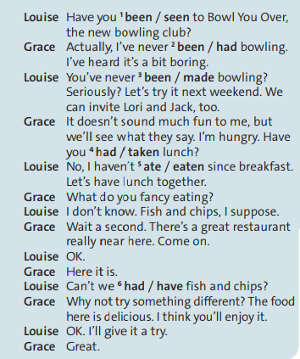  Suggested answers  1. been  2. been  3. been  4. had  5. eaten  6. have  What does Louise want to do next week?  → She wants to go to play bowling  Where does Grace suggest going for lunch?  → Grace suggests going for lunch in a great restaurant really near here.  2. Cover the dialogue and complete the Key Phrases. Watch or listen again and check  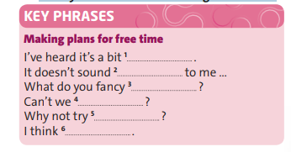  Suggested answers  1. boring  2. much fun  3. eating  4. have fish and chips  5. something different  6. you’ll enjoy it  3. Practise the dialogue with your partner  (Students’ own answers.)  4. PRONUNCIATION: Stress for  emphasis. Listen and repeat the sentences.  Which sentence has more stressed words?  Why?  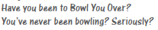  Suggested answers:  1. Have you been to Bowl You Over?  2. You’ve never been bowling? Seriously?  ⇒ sentence 2  5. Work in pairs. Read situations 1–3. Take  turns to suggest doing something after  school. Use the key phrases.  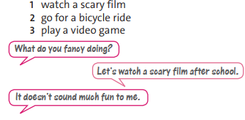  (Students’ own answers.)  Suggested answers:  A: What do you fancy doing?  B: I think we should play a video game after school.  A: Why not try to go for a bicycle ride?  B: It doesn’t sound much fun to me.  6. USE IT – Work in pairs. Read the situation. Then prepare and practise a new dialogue. Use the key phrases and the dialogue in exercise 1 to help you.  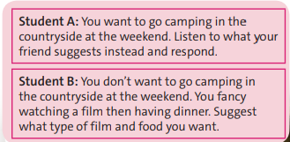  (Students’ own answers.)

*Feedback:............................................................................................................................
...............................................................................................................................................
...............................................................................................................................................
...............................................................................................................................................
...............................................................................................................................................
...............................................................................................................................................
...............................................................................................................................................

Week : Date of preparing:
Period: Date of teaching:

UNIT 2: SENSATIONS

Lesson 7: Writing: A competition entry

I can use intensifiers to add interest to my writing.
I./. OBJECTIVES
1. Knowledge: By the end of the lesson, students will be able to:
- understand the magazine advert “ Experience the Mekong Delta in Southern Việt Nam”
- use key phrases to describe your hometown’s highlights
- use intensifiers in writing exercises
- understand how to write their answer and opinions
2. Skills: Speaking, listening, reading, writing.
3. Attitude: Students know how to learn English in the right way.
4. Competence: Writing, self-learning capability, creative capacity, ability to use language……
II./. PREPARATION:
1. Teacher: book, planning, TV
2. Students: books, notebooks
III./. TEACHING METHODS
Communicative approach, group Ss and T’s activities, play as a character, teaching methods with game, teaching methods by visual, teaching methods by practicing, discussion group, technical present….
IV./.PROCEDURE
1. Check–up: during the lesson
2. New lesson:

Teacher’s and Students’ activities | Contents
ACTIVITY 1: WARM-UP  ❖ Aims: Help students give their opinions about special sights and sounds of their hometown.  ❖ Contents: Students use language materials simply. Students work in pairs  ❖ Products: Students’ answers  ❖ Organization:  - Teacher divides the class into pairs and encourages students to answer about their own opinions based on the reading “ Experience the Mekong Delta in Southern Việt Nam”  - Teacher invites some pairs of students to answer.  - Students answer on their own.  ACTIVITY 2: KNOWLEDGE FORMATION  ❖ Aims: Help students pay attention to the content, and understand how to use key phrases and intensifiers.  ❖ Contents: Students work in pairs and tell their partner what special sights and sounds are in their hometown using key phrases expressing recommendations and intensifiers.  ❖ Products: Students’ answers  ❖ Organization:  Pre-doing exercise:  -Teacher introduces some new words “Before doing exercises, there are some new words in the text.”  - Teacher uses some techniques of teaching vocabulary to teach them, then asks students to listen and repeat.  - Students listen to the teacher and repeat the words.  - Students copy down these words into their notebooks.  Exercise 1:  - Teacher gives students read the game rule and the magazine “Experience the Mekong Delta in Southern Việt Nam”  - Students read the questions and answer  - Teacher invites some students to answer the questions and give feedback.  Exercise 2:  - Teacher gives students time to read the magazine  - Teacher explains the meaning of some intensifiers.  - Teacher gives students time to complete the task  - Teacher invites students to answer the questions.  - Teacher consolidates where the intensifiers are placed.  ACTIVITY 3: PRACTICE  ❖ Aims: Help students understand how to use intensifiers in some cases related to normal and extreme adjectives and write about their opinions using expressing recommendations.  ❖ Contents: Students work in individual  ❖ Products: Students’ answers  ❖ Organization  Exercise 3:  - Teacher gives students time to do the exercises.  - Teacher invites some students to answer the questions.  - Teacher checks answers with the class.  Exercise 4:  - Teacher gives students time to complete the exercises.  - Students use the first two key phrases to write about their town.  - Teacher invites some students to speak their answers and give feedback.  Exercise 5:  - Teacher checks that students know how to write the text based on the note in section B  - Students use their notes from section B and the headings from model text to write their text.  - Teacher gives students time to write the text  - Teacher monitors while students are working and give general feedback at the end.  - Students use key phrases, and intensifiers to write the text.  ACTIVITY 4. HOMEWORK  - Learn by heart all the structures.  - Do exercises (in the workbook).  - Prepare new lesson. | ? THINK! What do you like about the place where you live? Has it got any special sights and sounds?  (Students’ own answers.)  Suggested answered:  I was born and raised in Hue where the famous Huong River and Ngu Binh Mountain are located. Here, I like the Hue citadel the most, where the Nguyen kings worked and lived. This architecture has existed for a long time, retaining the ancient and solemn features of the nobility. I am very proud to have been born here.  1. Read the magazine advert and last year’s  winning entry about the Mekong Delta. What  do you have to do to enter the competition?  What’s the prize? What do we learn about  the residents in Southern Việt Nam?    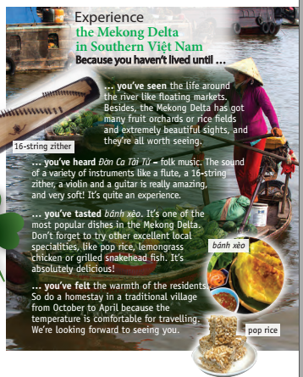  (Students’ own answers.)  New words:  - floating markets (n): chợ nổi  - fruit orchards (n): vườn cây ăn trái  - rice fields (n): cánh đồng lúa  - worth (adj): xứng đáng, đáng  - folk music (n): âm nhạc dân gian  - instruments (n): nhạc cụ  - flute (n): sáo  - 16-string zither (n): đàn tranh 16 dây  - violin (n): đàn vĩ cầm  - Mekong Delta (n): Đồng bằng sông Cửu Long  - temperature (n): nhiệt độ  Suggested answers:  1. What do you have to do to enter the competition?  → We have to describe the sights, sounds, tastes and feelings that visitors to our country can experience  2. What’s the prize?  → The winner will send two weeks in Australia  3. What do we learn about the residents in Southern Việt Nam?  → The residents in Southern Việt Nam are so warm.  LANGUAGE POINT: INTENSIFIERS  2. Find the words in the box in the Experience the Mekong Delta in Southern Việt Nam text. What type of word (adjective, noun or verb) do they always come before?    Suggested answers  - It’s absolutely delicious!  - The sound of a variety of instruments like a flute, a 16-string zither, a violin and a guitar is really amazing and very soft  ⇒ Intensifiers often come before adjectives  3. Study the examples and answer the questions.  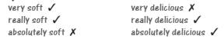  1. Which adjective is an extreme adjective  (it describes a strong opinion): soft or delicious?  2. Do we use very with normal or extreme  adjectives?  3. Can we use really with both normal and extreme adjectives?  4. What other intensifiers can we use with  adjectives? Find examples in the text  Suggested answers:  1. Delicious  2. No, we don’t. We use very with normal adjectives  3. Yes, we can  4. quite, extremely  4. Read the key phrases and find them in the Experience the Mekong Delta in Southern Việt Nam text. Think of how to complete the first two phrases about your town.  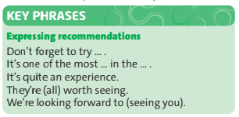  Suggested answers:  1. It’s one of the most popular dishes in the Mekong Delta  2. Don’t forget to try other excellent local specialities, like pop rice, lemongrass chicken or grilled snakehead fish,  ⇒ Don’t forget to try Bun Bo Hue when you come to Hue. It is one of the most delicious food in my hometown.  5. USE IT! Follow the steps in the writing guide.  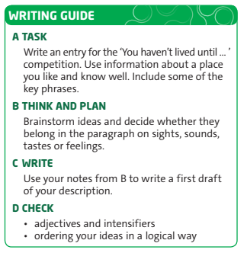  (Students’ own answers.)

*Feedback:............................................................................................................................
...............................................................................................................................................
...............................................................................................................................................
...............................................................................................................................................
...............................................................................................................................................
...............................................................................................................................................
...............................................................................................................................................

