**II. Interview :SPEAKING ENGLISH 7-UNIT 9 : FESTIVALS**

a

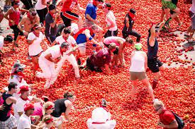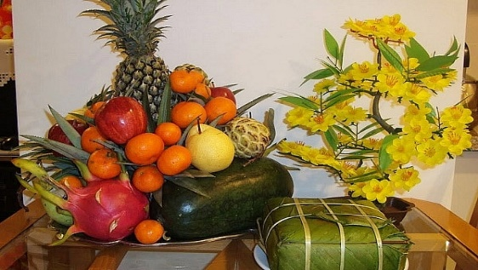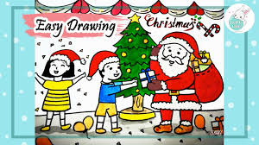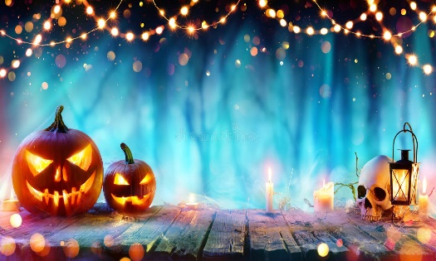

e

h

f

l

k

j

i

g

d

c

1. What festival is this?
2. What do they prepare for this festival?
3. Which events do you think happen at this festival?
4. It is the symbol of the winner’s prize.
5. You can watch this traditional dance on Mid-Autumn Festival….
6. It is a noun that mean “Two children born to the same other at the same time”.

3

2

1

1

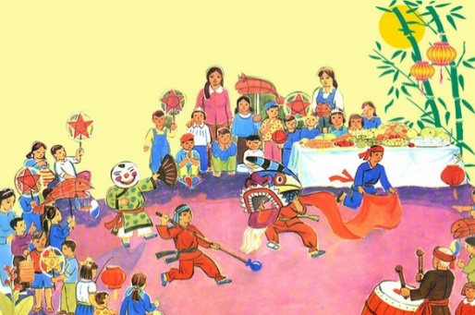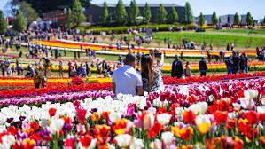

5

1

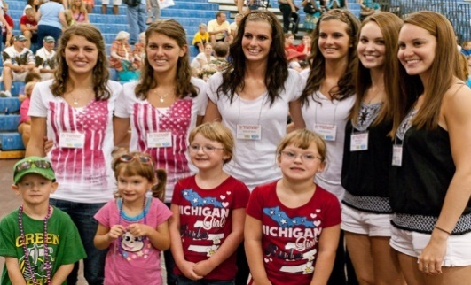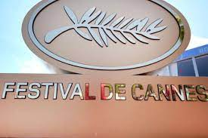

4

6

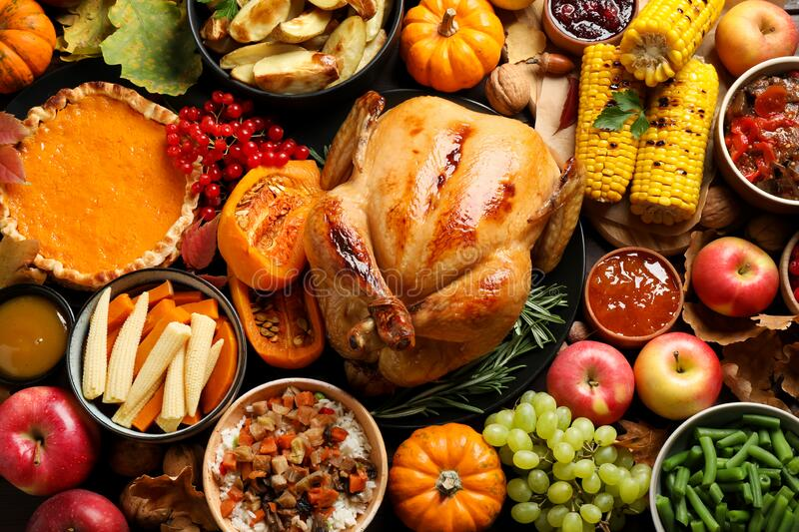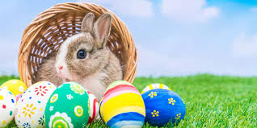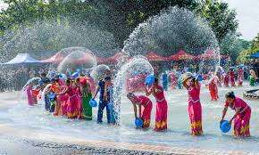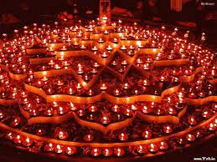

3

3

3

3