UNIT 1. HOBBIES
PART 1. THEORY
I. VOCABULARY
No. | English | Type | Pronunciation | Vietnamese
1 | building dollhouses | phrase | /'bɪldɪη 'dɒl,haʊsɪz/ | xây nhà búp bê
2 | chatting with friends | phrase | /’tʃætɪη wɪð frendz/ | nói chuyện với bạn bè
3 | collect | v | /kə'lekt/ | thu thập, sưu tập
4 | collecting coins | phrase | /kə'lektɪη kɒɪnz/ | sưu tầm tiền xu
5 | collecting dolls | phrase | /kə'lektɪη dɒlz/ | sưu tầm búp bê
6 | collecting stamps | phrase | /kə'lektɪη stæmpz/ | sưu tầm tem
7 | collecting teddy bears | phrase | /kə'lektɪη 'tedɪ beəz/ | sưu tầm gấu bông
8 | do judo | phrase | /du: 'dʒu:dəʊ/ | tập Ju-đô
9 | do yoga | phrase | /du: 'jəʊgə/ | tập Y-ô-ga
10 | do gymnastics | phrase | /du: dʒɪm'næstɪks/ | tập thể dục
11 | do sports | phrase | /du: spɔːts/ | tập thể thao
12 | do gardening | phrase | /du: 'gɑːdnɪη/ | làm vườn
13 | go jogging | phrase | /gəʊ 'dʒɒgɪη/ | chạy bộ
14 | go swimming | phrase | /gəʊ 'swɪmɪη/ | đi bơi
15 | go camping | phrase | /gəʊ 'kæmpɪη/ | đi cắm trại
16 | go mountain-climbing | phrase | /gəʊ 'maʊntən 'klaɪmiɪη/ | đi leo núi
17 | go shopping | phrase | /'gəʊ 'ʃɒpɪη / | đi mua sắm
18 | go skateboarding | phrase | /gəʊ 'skeɪtbɔːdɪη/ | đi trượt ván
19 | hang out | v | /hæη aʊt/ | đi chơi
20 | hang out with friends | phrase | / hæη aʊt wɪð frendz / | đi chơi với bạn bè
21 | horse riding | phrase | /hɔːrs 'raɪdɪη/ | cưỡi ngựa
22 | listening to music | phrase | /'lɪsnɪη tə'mju:zɪk/ | nghe nhạc
23 | making models | phrase | /'meɪkɪη 'mɒdlz/ | làm mô hình
24 | paint | v | /peɪnt/ | vẽ
25 | playing board games | phrase | /'pleɪɪη bɔːd geimz/ | chơi những trò chơi dùng đến bảng (chơi cờ,...)
26 | playing chess | phrase | /'pleɪɪη tʃes/ | chơi cờ
27 | playing computer games | phrase | /'pleɪɪη kəm'pju:tə(r) geɪmz/ | chơi trò chơi trên máy tính
28 | playing the guitar | phrase | /'pleɪɪη ðə gɪ'tə(r)/ | chơi đàn ghi ta
29 | playing the piano | phrase | /'pleɪɪη ðə pɪ'ænəʊ/ | chơi đàn piano
30 | playing the violin | phrase | /'pleɪɪη ðə ,vaɪə'lɪn/ | chơi đàn violin
31 | reading books | phrase | /'ri:dɪη bʊks/ | đọc sách
32 | taking photos | phrase | /'teɪkɪη 'fəʊtəʊz/ | chụp ảnh
33 | walking the dog | phrase | /'wɔːkɪη ðə dɒg/ | dắt chó đi dạo
34 | watching television | phrase | /'wɒtʃɪη 'telɪvɪʒn/ | xem TV

II. GRAMMAR
1. PRESENT SIMPLE TENSE (Thì hiện tại đơn)
a. Form (cấu trúc)
 | Normal verb | Be
(+) | I, you, we, they + V-inf  He, she, it + V(s/es) | I + am  You, we, they + are He, she, it + is
(-) | I, you, we, they + don’t + V-inf  He, she, it + doesn’t + V-inf | I am not  You, we, they + aren’t He, she, it + isn't
(?) | Do + I, you, we, they + V-inf?  Does + he, she, it + V-inf ? | Am + I...?  Are + you, we, they ...?  Is + he, she, it...?
Ex: I go to school every day.
Does she go to school every day?
She doesn't work for that company.

b. Usage
Dùng để chỉ thói quen hàng ngày, hành động lặp đi lặp lại ở hiện tại
Ex: I usually go to bed at 11 p.m.
(Tôi thường đi ngủ vào lúc 11 giờ.)
Dùng để chỉ một sự việc, một sự thật hiển nhiên.
Ex: The Sun rises in the East and sets in the West.
(Mặt trời mọc ở phía Đông và lặn ở phía Tây.)
Dùng để chỉ một sự việc sẽ xảy ra trong tương lai theo thời gian biểu hoặc lịch trình.
Ex: The plane takes off at 3 p.m this afternoon.
(Máy bay hạ cánh lúc 3 giờ chiều nay.)

c. Signals
Cụm từ với "every": every day (mọi ngày), every year (mọi năm), every month (mọi tháng), every afternoon (mọi buổi chiều), every morning (mọi buổi sáng), every evening (mọi buổi tối)...
Cụm từ chỉ tần suất: once a week (1 lần 1 tuần), twice a week (2 lần một tuần), three times a week (3 lần một tuần), four times a week (4 lần một tuần), five times a week (5 lần một tuần), once a month (1 lần một tháng), once a year (một lần một năm)...
Trạng từ chỉ tần suất: always, usually, often, sometimes, never, rarely...
d. How to add "s/es" to verbs
Thông thường ta thêm "s" vào sau các động từ.
work works
read reads
Những động từ tận cùng bằng -s; -sh; -ch; -z; -x; -o: ta thêm "es".
miss misses
watch watches
mix mixes
wash washes
buzz buzzes
go goes
Những động từ tận cùng là "y":
+ Nếu trước "y” là một nguyên âm (a, e, i, 0, u): ta giữ nguyên "y" + "s"
play plays
buy buys
pay pays
+ Nếu trước "y” là một phụ âm - ta đổi "y" thành "i" + "es”
fly flies
cry cries
fry fries
2. VERBS OF LIKING (ĐỘNG TỪ CHỈ SỞ THÍCH)
- Sau các động từ chỉ ý thích, ta thường dùng danh động từ (động từ thêm “-ing”). Dưới đây là các động từ chỉ ý thích được sắp xếp theo thứ tự giảm dần độ thích.
adore | mê, thích | 
love | yêu, thích
like | thích
enjoy | thích thú
fancy | mến, thích
prefer | thích hơn
don’t mind | không ghét lắm
dislike | không thích
don’t like | không thích
hate | ghét
detest | ghét cay ghét đắng
Ex: She likes drawing. (Cô ấy thích vẽ.)
He likes playing sports at recess. (Cậu ấy thích chơi thể thao vào giờ giải lao.)
They like riding the bikes in the park. (Họ thích đi xe đạp trong công viên.)
iii. PHONETICS

Sound /ə/ and /ɜ:/

1. Cách phát âm âm /ə/ và âm /ɜ:/
a. Cách phát âm âm /ə/
/ə/ là một nguyên âm ngắn rất phổ biến trong tiếng Anh. Để phát âm âm /ə/, ta mở miệng nhẹ và đơn giản. Môi và lưỡi được thư giãn và phát âm /ə/. (Tương tự như âm “ơ” trong tiếng Việt) | 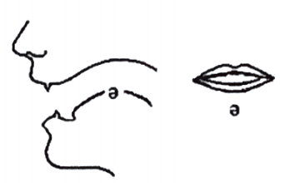

b. Cách phát âm âm /ɜ:/
/ɜ:/ là một nguyên âm dài. Để phát âm âm /ɜ:/, ta mở miệng tự nhiên, lưỡi cao vừa phải (cao hơn âm /ə/ một chút). Âm /ɜ:/ phát âm dài hơn âm /ə/ | 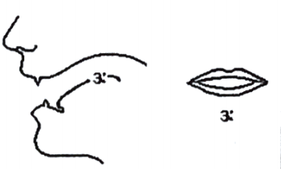
2. Listen and repeat these words. Track 01
/ə/ | desert | must | common | injure
 | /‘dezət/ | /məst/ | /'kɒmən/ | /'ɪndʒə(r)/
/ɜ:/ | bird | search | third | heard
 | /bɜ:d/ | /sɜ:tʃ/ | /θɜ:d/ | /hɜ:d/

PART 2. LANGUAGE
I. VOCABULARY
Exercise 1. Find the odd one out among A, B, C or D.
1. A. cycling B. cooking C. evening D. gardening
2. A. play B. swim C. collect D. photo
3. A. horse-riding B. challenging C. bird-watching D. mountain-climbing
4. A. usual B. write C. walk D. eat
5. A. pottery B. enjoy C. flower D. wood
Exercise 2. Complete the phrases with a suitable V-ing.
chatting | hanging out | taking |  | going | reading
doing | playing | arranging |  | collecting | listening
1. ____________ flowers  2. ____________ with friends  3. ____________ dolls  4. ____________ gymnastics  5. ____________ camping |  |  | 6. ____________ with friends  7. ____________ to music  8. ____________ board games  9. ____________ books  10. ____________ photos
Exercise 3. Look at the photos and put the correct words/ phrases under them.
playing the piano | playing board games | going skateboarding
collecting coins | building dollhouses | going jogging
horse riding | walking the dog

 | 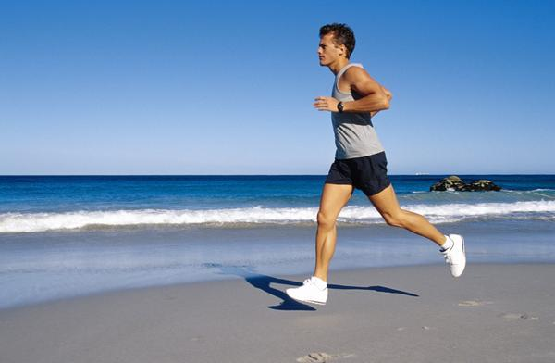 | 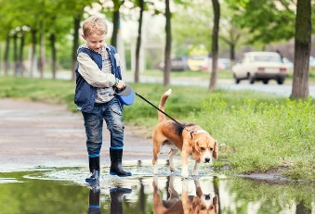 | 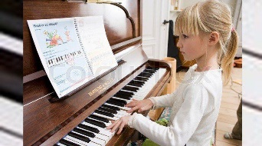
1. _______________ | 2. _______________ | 3. _______________ | 4. _______________
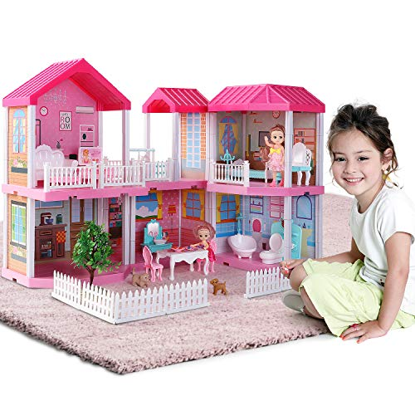 | 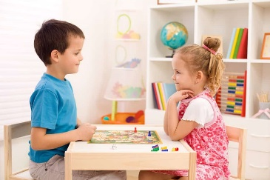 | 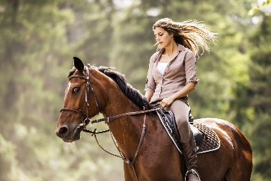 | 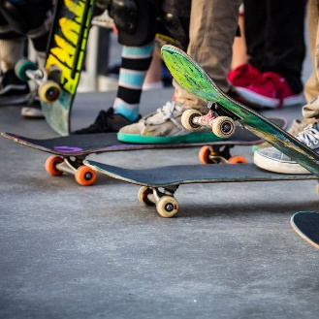
5. _______________ | 6. _______________ | 7. _______________ | 8. _______________
Exercise 4. Look at the photos and write the correct words/ phrases under them. The first letter is a hint for you. (All words/ phrases start with V-ing)
 | 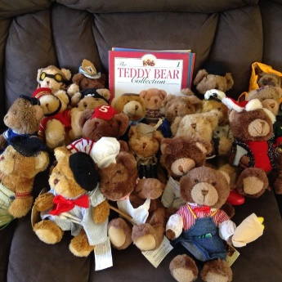 |  | 
1. p__________  p__________ | 2. c_____t_____  b. __________ | 3. h__________  w_____f_____ | 4. r__________  b __________
 | 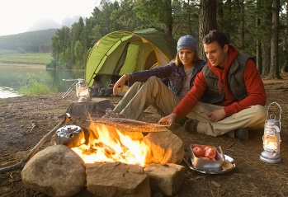 | 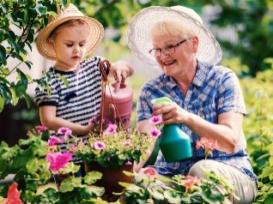 | 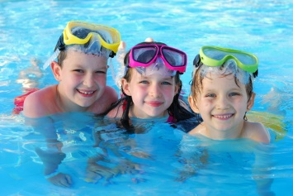
5. g__________  s__________ | 6. g__________  c__________ | 7. d__________  g__________ | 8. g__________  s__________
Exercise 5. Fill in each blank with a word/phrase in the box.
gymnastics | bottles | fishing | photos | painting
camping | gardening | the guitar | dolls | horse-riding
1. I always take a lot of ____________ when I go on holidays.
2. A: Can you play ____________?
B: No, I can’t, but I can play the piano.
3. My brothers hobby is watching ____________, he likes horses very much.
4. Her brother likes collecting ____________, especially glasses.
5. I like drawing very much. My hobby is ____________.
6. My sister likes collecting ____________. Now she has more than 100 dolls.
7. Her hobby is ____________. She plants many beautiful flower trees in her garden.
8. My father likes ____________. He often goes to the lakes or rivers when he has
9. When we have some days off, my close friends and I often go ____________.
10. My sister likes doing ____________. She looks very fit.
II. GRAMMAR

Exercise 1. Put the verbs in brackets into the Present Simple.
1. I ____________ (not visit) my parents very often.
2. ____________ (Mai/ go) to school every day? - No, she ____________ (go) to school from Monday to Friday.
3. The teachers at our school ____________ (give) us lots of homework.
4. My brother ____________ (play) tennis, but he (not like) it.
5. How often ____________ (they/ go) jogging?
6. We ____________ (not study) chemistry because it ____________ (be) difficult.
7. ____________ (your parents/ watch) TV every night?
8. Mark’s class ____________ (do) sport on Monday and Wednesday.
9. Children often ____________ (use) a computer for school work.
10. Mike ____________ (usually/ not play) computer games during the week.

Exercise 2. Complete the sentence with the words in the box. Remember to put it in the present simple.
open | take | wake up | drink | play
speak | do | cause | live | close
1. Ann handball very well.
2. I never coffee.
3. The swimming pool at 7:00 in the morning.
4. My cloth shop at 9:00 in the evening.
5. Bad driving many accidents.
6. My parents in a very small flat.
7. The Olympic Games place every four years.
8. They are good students. They always their homework.
9. My students a little English.
10. I always early in the morning.
Exercise 3. Underline the mistake in the following sentences and correct it.
Sentences | Your answers
1. What does they wear at their school? | __________________
2. Do he go to the library every week? | __________________
3. Windy always watch TV at 9 p.m before going to bed at 10 p.m. | __________________
4. Sometimes, we goes swimming together with her family. | __________________
5. How does Linda carries such a heavy bag? | __________________

Exercise 4. Write complete sentences basing on the given words.
1. Minh/ not/usually/ sleep/early/at weekends.
_______________________________________________________________________.
2. You/ understand / questions from/ teacher?
_______________________________________________________________________.
3. Her husband/ his colleague/ play/ tennis/ whenever/ they/ free.
_______________________________________________________________________.
4. My family/ normally/ eat/ breakfast/ 6.30.
_______________________________________________________________________.
5. James/ not/ phone/ mother/ Monday.
_______________________________________________________________________.

Exercise 5. Put the verbs in brackets in the correct form.
1. (You/ think) ___________ collecting stamps costs much money?
2. My father thinks mountain climbing (be) ___________ more dangerous than skating.
3. Every year, my mother (give) ___________ me a nice doll on my birthday.
4. My brother (not like) ___________ collecting stamps, he likes collecting glass bottles.
5. My sister likes (cook) ___________ very much. She can cook many good foods.
6. Does your brother like (listen) ___________ to music in his free time?
7. I think in the future, more people (enjoy) ___________ going out by bicycles.
8. My father says when he's retired, he (go) ___________ back to his village to do the gardening.
9. We are planting trees around our school now. Our school (be) ___________ surrounded by a lot of green trees.
10. Lan says she loves collecting pens but she (not/continue) ___________ this hobby from next year.
Exercise 6. Complete the sentences, using the “-ing” form of the verbs in the box.
watch | play | fly | cook | wait
make | tidy | go | read | take
1. Do you fancy ___________ out tomorrow?
2. I like ___________ tennis on Sunday.
3. Phong enjoys ___________ photos of himself and his friends.
4. Ann’s father doesn’t like ___________ tennis on TV.
5. My mother hates ___________, so we eat out every often.
6. Do you like ___________ pottery?
7. He dislikes ___________ his room every day.
8. My children love ___________ adventure books.
9. I can’t stand ___________ for buses in the rain.
10. We detest ___________, so we usually travel by train or coach.
III. PHONETICS
Divide the words into two columns. TRACK 2
word | burst | courtesy |  | open | worse
apartment | search | capacity |  | work | freedom
herd | sofa | famous |  | bird | compare
pardon | early | burden |  | surgeon | burden
balance | suggest | circuit |  | national | answer
were | curtain | silent |  | continue | handsome
/ɜ:/ |  |  | /ə/

PART 3. COMMUNICATION SKILLS
I. LISTENING
Listen and do the tasks followed. Track 03
Exercise 1. Listen and complete the sentences.
1. ___________ likes going bowling.
2. ___________ like going to the cinema.
3. ___________ does not like playing table tennis.
4. ___________ likes watching football.
5. ___________ likes playing table tennis.

Exercise 2. Listen again and decide if each statement is True (T) or False (F).
1. Sarah and her friends have completed deciding what they want to do at the weekend. ________
2. Sarah doesn’t like soccer. ________
3. Sarah’s friends like going to see a movie. ________
4. No one likes playing bowling. ________
5. Lizzie likes playing table tennis this weekend. ________
II. SPEAKING
Exercise 1. Read the conversation and answer the questions.
Huyen: What’s your favorite hobby, Linh?
Linh: Well, it’s drawing.
Huyen: How many paintings do you draw?
Linh: Er... I don't remember. It’s around 100.
Huyen: Is your painting on the wall?
Linh: Yes, it is. It’s one of my favorite ones.
Huyen: How nice it is! I love the colors in your picture.
Linh: Thanks. And what’s your hobby, Huyen?
Huyen: Er,... I cant draw. But my hobby is collecting pictures and paintings.
Linh: Really? I will give you one.
Huyen: Thank you.
Questions:
1. Does Linh like drawing?
______________________________________________________________________.
2. How many paintings does she draw?
______________________________________________________________________.

3. Are there any paintings on the wall?
______________________________________________________________________.
4. What is the painting like?
______________________________________________________________________.
5. What’s Huyen’s hobby?
______________________________________________________________________.
Exercise 2. Write questions for the underlined parts.
1. A: __________________________________________________________________.
B: My hobby is swimming.
2. A: __________________________________________________________________.
B: I started my hobby two years ago.
3. A: __________________________________________________________________.
B: I enjoy my hobby because I think it’s healthy.
4. A: __________________________________________________________________.
B: I spend three hours a day on my hobby.
5. A: __________________________________________________________________.
B: James usually plays football in his free time.
6. A: __________________________________________________________________.
B: He plays volleyball twice a week.
7. A: __________________________________________________________________.
B: He often plays football at the stadium.
8. A: __________________________________________________________________.
B: He likes to play football with his friends.
III. READING
Exercise 1. Complete the passage with a suitable word from the box.
reads | collecting | likes | enjoys | listening
cooks | have | cycling | gets | goes
My family has six people. We (1) ___________ different hobbies. My grandfather (2) ___________ reading newspapers. He (3) ___________ newspapers every morning after breakfast. My grandmother doesn’t like reading them. She (4) ___________ to the market near my house every morning. She buys a lot of food. She (5) ___________ very well. Oh, I love all her food. My father likes (6) ___________. He (7) ___________ up early and cycles around the West Lake all the year round. My mother doesn’t like this sport. She (8) ___________ walking. She walks about four or five kilometers every morning. My brother doesn’t like any sports. He likes (9) ___________ to music and playing drums. He is a member of the Green Band. It is a well-known band in my country.
I don’t like reading, cooking or playing sports. I love (10) ___________ things, such as stamps and coins.

Exercise 2. Read and decide T (true) or F (false) for each statement.
Our life would be hard without rest and recreation. And people have many different ideas of how to spend their free time. If you enjoy doing a thing or activity in your free time, then you have a hobby. A hobby is an activity, interest, enthusiasm, or pastime that is undertaken for pleasure or relaxation, done during one’s own time. A persons hobbies depend on his age, character and personal interests. An interesting thing to one person can be boring to another. That’s why some people prefer reading, cooking, knitting, collecting, playing a musical instrument, photography or playing computer games while others prefer dancing, travelling, camping or sports.
No. | Statements | True (T) or False (F)
1. | A hobby is anything that you enjoy doing in your free time. | ______________
2. | Different people have the same hobbies. | ______________
3. | A hobby can provide US with relaxation. | ______________
4. | Your hobby may be changed as you get older. | ______________
5. | One person’s hobby maybe a boring thing to another person. | ______________
6. | Playing sports is not a hobby. | ______________
IV. WRITING
List five activities that you like and five activities that you don’t like, state the reason while you like/ don’t like. The answer may vary.
No. | Things you like | Reason
1. | ______________________ | _________________________________________
2. | ______________________ | _________________________________________
3. | ______________________ | _________________________________________
4. | ______________________ | _________________________________________
5. | ______________________ | _________________________________________
No. | Things you dislike | Reason
1. | ______________________ | _________________________________________
2. | ______________________ | _________________________________________
3. | ______________________ | _________________________________________
4. | ______________________ | _________________________________________
5. | ______________________ | _________________________________________

