UNIT 8: SPORTS AND GAMES

Lesson 1: Getting Started – At the gym

I. Objectives
By the end of this lesson, students will be able to:

1. Knowledge
- Have an overview about the topic Sports and games
- Use the vocabulary and talk about sports and games

2. Core competence
- Develop communication skills and creativity
- Be collaborative and supportive in pair work and team work
- Actively join in class activities

3. Personal qualities
Develop self-study skills

II. Materials
- Grade 6 textbook, Unit 8, Getting started
- Computer connected to the internet
- Projector/ TV/ pictures and cards
- hoclieu.vn

Language analysis

Form | Pronunciation | Meaning | Vietnamese equivalent
1. gym (n) | /dʒɪm/ | a place or club where you can go to exercise using machines, weights or other equipment | phòng tập thể dục
2. equipment (n) | /ɪˈkwɪpmənt/ | a set of necessary tools, clothing… for a particular purpose | thiết bị, dụng cụ
3. karate (n) | /kəˈrɑːti/ | A sport, originally from Japan, in which people fight using their arms, legs, hands, and feet | võ ka-ra-te

Anticipated difficulties | Solutions
Students may have underdeveloped speaking and co-operating skills. | - Play the recording many times if necessary.  - Encourage students to work in groups so that they can help each other.  - Give short, clear instructions and help if necessary.

Board Plan

Date of teaching

UNIT 8: SPORTS AND GAMES

Lesson 1: Getting started

* Warm-up
I. Vocabulary
1. gym (n)
2. equipment (n)
3. karate (n)
II. Practice
Task 1: Listen and read.
Task 2: Put ONE word from the conversation in each gap.
Task 3: Name these sports and games, using the words from the box.
Task 4: Work in pairs. Ask your partner these questions to find out how sporty they are.
* Homework

Procedure

Stage | Stage aim | Procedure | Interaction | Time
Warm-up | - To set the context for the listening and reading text.  - To introduce the topic of the unit. | - Teacher writes the words SPORTS AND GAMES on the board and asks students to give any words relating to the topic.  - Teacher may allow students to give a Vietnamese word and asks other students in the class if they know the equivalent in English.  - Teacher writes on the corner of the board a list of the words which students cannot translate into English and asks them to keep a record for later reference when the unit finishes.  - Teacher lets students open their books and starts the lesson. | T-Ss | 5 mins
Lead-in | To help students get the main idea of the text. | - Teacher draws students’ attention to the picture in the textbook and asks them questions about the picture:  1. Where are the two kids?  2. What sports are they going to play?  Suggested answers:  1. They are in the gym/ school gym.  2. They are going to run. | T-Ss | 4 mins
Presentation  (Vocab  pre-teaching) | To prepare  students with  vocabulary. | VOCABULARY  - Teacher introduces the vocabulary by:  + providing definitions of the words.  + showing the pictures  illustrating the words.  1. gym (n): [picture]  2. equipment (n): [definition]  3. karate (n): [definition] | T-Ss | 5 mins
Practice | To have students know the topic.  To have students get specific  information of the text and understand the conversation  better.  To help students revise/ learn some sports and games through pictures.  To help students practice speaking and learn about how sporty they are. | Task 1: Listen and read.  - Teacher plays the recording twice.  - Students listen and read.  - Teacher checks students’ prediction.  - Teacher calls 3 students to read the conversation aloud.  Task 2: Put ONE word from the conversation in each gap.  - Teacher asks students to do this activity independently,  reminds them of the ways to do the activity if needed.  Students may refer back to the conversation for the context of the words they need to fill the gaps.  - - Teacher allows students to share their answers before  discussing in pairs or as a class.  - - Teacher writes the correct answers on the board.  - - Teacher explains the meanings of some words if necessary. Students practise saying the sentences together.  Answer key:  1. fit  2. gym  3. table tennis  4. Club  5. cycle  Task 3: Name these sports and games, using the words from the box.  *Pelmanism  - - Teacher divides the class into groups of fours, prepares each group with 2 sets of cards, one includes pictures of sports and games and the other includes their names.  - - Students work in groups and label the pictures with the  correct words given. The group matches faster and  correctly is the winner.  - - Teacher checks with the whole class, asks them for the meanings of the words. Provide them with the meanings of the words they don’t know. Teacher may also ask them if they play these sports and games or if people in Viet Nam play them.  Answer key:  1. cycling  2. aerobics  3. table tennis  4. swimming  5. chess  6. volleyball  - Teacher helps students differentiate between a sport and a game:  A sport: an activity that you do for pleasure and that needs physical exercise.  A game: an activity or a sport with rules in which people or teams compete against each other.  - - Teacher may ask students to give the names of some sports and some games they know through a game: - - - -- Teacher divides the class into 2 teams, gives each team a chalk, and asks member from each team to come to the board and write names of some sports and some games in about 2 minutes.  Suggested answers:  Sports: running, cycling, mountain climbing...  Games: chess, football, card games, computer games...  Task 4: Work in pairs. Ask your partner these questions to find out how sporty they are.  - Teacher lets students work in pairs (or in groups) to ask and answer the questions. Some pairs (or groups) may report their results to the class. (In their groups, how many students with answers “A”, how many with answers “B” and who is the sportiest in their groups.)  - Teacher may want to find out how sporty the class is by  writing the results on the board. | T-Ss  S  Ss-Ss  T-Ss  Group work  T-Ss  Team work  Pair work/ Group work | 5 mins  6 mins  8 mins  7 mins
Consolidation | To consolidate what students have learnt in the lesson. | Teacher asks students to talk about what they have learnt in the lesson. | T-Ss | 3 mins
Homework | To review the  lesson and prepare for the next  lesson. | - Do exercise in the workbook.  - Name some sports and games that you know. | T-Ss | 2 mins

UNIT 8: SPORTS AND GAMES

Lesson 2: A closer look 1

I. Objectives
By the end of this lesson, students will be able to:

1. Knowledge
- Use the lexical items related to the topic Sports and games
- Pronounce correctly the sounds /e/ and /æ/

2. Core competence
- Develop communication skills and creativity
- Be collaborative and supportive in pair work and team work
- Actively join in class activities

3. Personal qualities
- Be ready to make and share ideas among classmates.
- Develop self-study skills

II. Materials
- Grade 6 textbook, Unit 8, A closer look 1
- Projector/ Pictures
- hoclieu.vn

Language analysis

Form | Pronunciation | Meaning | Vietnamese equivalent
1. racket (n) | /ˈræk.ɪt/ | an object used for hitting the balls in some sports | vợt (cầu lông/ tennis…)
2. goggles (n) | /ˈɡɒɡ.əlz/ | special glasses used to protect the eyes from chemicals, wind, water… | kính bảo hộ
3. competition (n) | /ˌkɒm.pəˈtɪʃ.ən/ | a situation in which someone tries to win  something or be more successful than someone else | cuộc thi
4. champion (n) | /ˈtʃæm.pi.ən/ | someone or something has beaten all other  competitors in a competition | nhà vô địch
5. marathon (n) | /ˈmær.ə.θən/ | a running race of slightly over 26 miles (~42 km) | chạy đua ma-ra-tông/ chạy đường dài

Anticipated difficulties | Solutions
1. Students may have difficulties in distinguishing the two sounds /e/ and /æ/. | Provide students some tips by identifying the letters which may include each sound.
2. Some students will excessively talk in the class. | - Define expectations in explicit detail.  - Have excessively talkative students practise.  - Continue to define expectations in small chunks (before every activity).

Board Plan

Date of teaching

UNIT 8: SPORTS AND GAMES

Lesson 2: A closer look 1

* Warm-up

Brainstorming
I. Vocabulary
1. racket (n)
2. goggles (n)
3. competition (n)
4. champion (n)
5. marathon (n)
Task 1: Write the right words under the pictures.
Task 2: What sports are these things for? Match each thing in column A with a sport in column B.
Task 3: Fill each blank with the words from the box.
II. Pronunciation
Task 4: Listen and repeat. Pay attention to the sounds /e/ and /æ/.
Task 5: Listen and repeat. Underline the words with the sounds /e/ and /æ/.
III. Production
Game: Who is faster?
* Homework

Procedure

Stage | Stage aim | Procedure | Interaction | Time
Warm-up | To activate  students’ prior knowledge and vocabulary  related to the topic. | *Brainstorming  - Teacher divides the class into two teams. One member from each team, in turns, comes to the board and lists all the sports and games they have learnt.  - The team with more correct answers in two minutes is the winner.  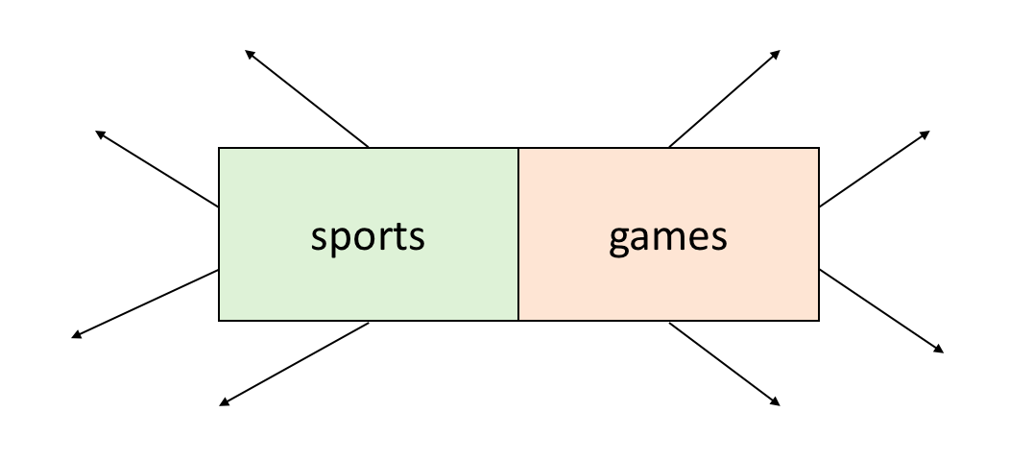 | Teamwork | 3 mins
Presentation  (Vocab  pre-teaching) | To enrich  students’  vocabulary. | VOCABULARY  - Teacher introduces the vocabulary by:  + providing explanations of the words;  + showing pictures illustrating the words.  - racket (n): [picture]  - goggles (n): [picture]  - competition (n): [definition]  - champion (n): [definition]  - marathon (n): [definition] | T-Ss | 5 mins
Practice | To revise/ teach the names of some equipment to be used in some sports/ games.  To revise/ teach the names of some sports/ games and the equipment to  be used with them.  To give students practice on how to use words  related to sports/ games in context. | Task 1: Write the right words under the pictures.  - Teacher asks students to look at the pictures and see if they can write the words under the pictures.  - Teacher lets students work individually, tells them to put the words and phrases given under the right pictures.  - Teacher calls a student to come and write their answer on the board. The rest of the class may compare.  - Teacher checks the answer with the whole class and  explains the meanings to them if necessary. If there is enough time, let students give examples.  Answer key:  1. ball  2. sports shoes  3. boat  4. racket  5. goggles  Task 2: What sports are these things for? Match each thing in column A with a sport in column B.  - Teacher tells students to do the task independently first, then calls on some students to write their answers on the board, then checks their answers as a class.  - Teacher checks with the whole class, asks students to give more names of sports and equipment to be used with them.  For example:  - table tennis – bats  - running – sports shoes  - chess – chess board + chess pieces...  Answer key:  1. c  2. d  3. a  4. b  5. e  Task 3: Fill each blank with the words from the box.  - Teacher has students read the sentences and fill the blanks with the words given, then read the sentences carefully and look for clues so that they can choose the right words to complete the sentences.  - Teacher calls one student to write the words on the board, then gives correction.  - For more able students, teacher asks them to make sentences with the words. Other students and teacher give comments.  Answer key:  1. competition  2. champion  3. congratulations  4. sporty  5. marathon | T-Ss  S  T-Ss  T-Ss  T-Ss | 16 mins
Presentation  (Pre-teach the sounds /e/ and /æ/) | To help students have concept and identify the sounds /e/ and /æ/. | PRONUNCIATION  - Teacher introduces 2 sounds /e/ and /æ/ to students and lets them watch a video about how to pronounce these two sounds.  *Video link:  https://www.youtube.com/watch?v=d98t4b3XLjg  https://www.youtube.com/watch?v=NavmTDkd8Z8  - Teacher asks students to give some words they know  containing these sounds.  Suggested answers:  - /e/: get, elephant, pet…  - /æ/: racket, hat, cat…  - Teacher draws students attention to the letters  containing the sounds and helps them identify the sounds. | T- Ss | 5 mins
Practice | To help students identify and practise the sounds /e/ and /æ/.  To help students practise the sounds /e/ and /æ/ in  sentences. | Task 4: Listen and repeat. Pay attention to the sounds /e/ and /æ/.  - Teacher asks students listen and repeat.  - Students work in individually.  Task 5: Listen and repeat.  Underline the words with the sounds /e/ and /æ/.  - Before listening, teacher lets students discuss in pairs and find the words with the sounds /e/ and /æ/.  - Teacher plays the recording for students to check and  repeat the sentences.  Answer key:  1. They cannot take part in this contest.  2. They began the match very late.  3. Please get the racket for me.  4. We play chess every  Saturday.  5. My grandpa is old, but he’s active. | T-Ss  S  Pair work  T- Ss | 6 mins
Production | To give students chance to apply what they have learnt. | *Game: Who is faster?  - Teacher divides students into groups of four, gives each group a piece of paper, ask them to write sentences  including 2 features: sports and games and one of the sounds /e/ or /æ/.  (E.g. My favourite sport is table tennis.)  - Teacher asks each group to hand in their paper and checks, the group with more correct sentences is the winner.  - Teacher invites the winner to read aloud their entences. | Group work  T-Ss | 5 mins
Consolidation | To consolidate what students have learnt in the lesson. | Teacher asks students to talk about what they have learnt in the lesson. | T-Ss | 3 mins
Homework | To revise what they have learnt. | - Rewrite the sentences into notebooks.  - Find 3 more sports or games that have the sound /e/ or /æ/. | T-Ss | 2 mins

UNIT 8: SPORTS AND GAMES

Lesson 3: A closer look 2

The past simple & Imperatives

I. Objectives
By the end of this lesson, students will be able to:

1. Knowledge
Use the past simple tense and imperatives

2. Core competence
- Develop communication skills and creativity
- Be collaborative and supportive in pair work and teamwork
- Actively join in class activities

3. Personal qualities
Develop self-study skills

II. Materials
- Grade 6 textbook, Unit 8, A closer look 2
- Projector/ Pictures, sets of word cards
- hoclieu.vn

Language analysis
- Past simple tense
 | Form | Example
to be | S + was/ were + … . | They were friends.
 | S + wasn’t/ weren’t + … . | She wasn’t at home last night.
 | Was/ Were + S + … ? | Were you good at French?
 | W/H + was/ were + S + … ? | Who was with you at the party?
to verb | S + Ved + … . | She played tennis yesterday  morning.
 | S + didn’t + Vinf + … . | He didn’t work yesterday.
 | Did + S + Vinf + … ? | Did they go to school last Monday?
 | W/H + did + S + Vinf + … ? | When did you go to the  supermarket?

- Imperatives
 | Form | Example
Positive | V | Open the door.
Negative | Don’t + V | Don’t play outside.

Anticipated difficulties | Solutions
1. Students may be confused about when to use regular or irregular verbs in past simple tense. | Give students a set of common irregular verbs and ask them to look the words up when they need.
2. Students may be confused when making imperative sentences with be. | Give more examples.
3. Students may have underdeveloped speaking and co-operating skills. | - Give clear instruction, give examples before letting students work in groups.  - Provide feedback and help if necessary.

Board Plan

Date of teaching

UNIT 8: SPORTS AND GAMES

Lesson 3: A closer look 2

* Warm-up

Game: Pelmanism
I. Grammar focus
- The Past simple tense
- Imperatives
II. Practice
Task 1: Choose the correct answer A, B or C.
Task 2: Write the correct form of verbs to complete the conversation.
Task 3: Work in groups. Ask and answer questions about your last weekend.
Task 4: Look at each picture and choose the correct answer.
Task 5: Tell your friends what to do and what not to do at the gym.
* Homework

Procedure

Stage | Stage aim | Procedure | Interaction | Time
Warm-up | To activate students’ prior knowledge related to the targeted grammar of past simple tense and to increase students’ interest. | * Game: Pelmanism  - Teacher divides the class into groups of fours, prepares each group with 2 sets of cards, one includes activities in infinitive forms and the other includes those of past simple form.  - Students work in groups and match the card with  infinitive form with its correct past simple form. The group matches faster and correctly is the winner.  watch TV watched TV  play computer games played computer games  have lunch had lunch  drink water drank water  teach English taught English  learn French learnt French  go to school went to school  do homework did homework  be at home was/ were at home  - Teacher may use projector and lets students play the game in teams. | Group work | 5 mins
Lead-in | To introduce targeted grammar of past simple tense. | Teacher draws students’ attention to the form of the verbs in the game and asks them whether they know the target tense. | T-Ss | 1 min
Presentation | To help students know and understand the use of past simple tense. | 1. The past simple tense: Elicit past simple tense  - Teacher provides or confirms the answers and leads in the grammar focus of the lesson:  To verb To be  Positive S + Ved + … . S + was/ were + … .  Negative S + didn’t + Vinf + … . S + wasn’t/ weren’t + … .  Interrogative Did + S + Vinf + … ? Was/ Were + S + … ?  Answer Yes, S + did. No, S + didn’t. Yes, S + was/ were. No, S + wasn’t/ weren’t.  W/H questions W/H + did + S + Vinf + … ? W/H + was/were + S + ...?  Notes  There are regular and irregular verbs in past simple tense.  - Teacher asks students to give the rules and lets them study the grammar box. | T-Ss | 5 mins
Practice | To help  students  practise with the correct form of the past simple.  To help  students  practise using the past  simple in  context.  To help  students  practise using the past  simple in real situation. | Task 1: Choose the correct answer A, B or C.  - Teacher lets students do the task individually and then compares their answers in pairs.  - Teacher tells students that when they do the multiple choice questions, they should first read the sentences (stems) and the options carefully. After that they should choose the answer that they think is correct by eliminating each clearly wrong answer. Then they get the most possibly correct  answer.  - Teacher checks and confirms students’ answers.  Answer key:  - C  - B  - C  - A  - B  Task 2: Write the correct form of the verbs.  - Teacher lets students do the task individually, asks them to read the conversation first, so that they understand the context to use the verbs given in the correct form.  - Teacher may call on some students separately to read out their answers and corrects their answers if they’re wrong, gives explanation if necessary.  - Teacher then calls some pairs to read the conversation with the correct verb form, corrects their pronunciation and intonation if necessary.  Answer key:  - went  - had  - did you do  - visited  - ate  - scored  Task 3: Look at each picture and choose the correct  answer.  - Teacher divides the class into groups of 4, then lets students take turns to ask and answer questions about their last weekend.  - Teacher encourages them to give as many sentences as possible, tell them to use all the three forms (affirmative, negative, and question).  - Some more able students can report to the class about one of their friends’ last weekend.  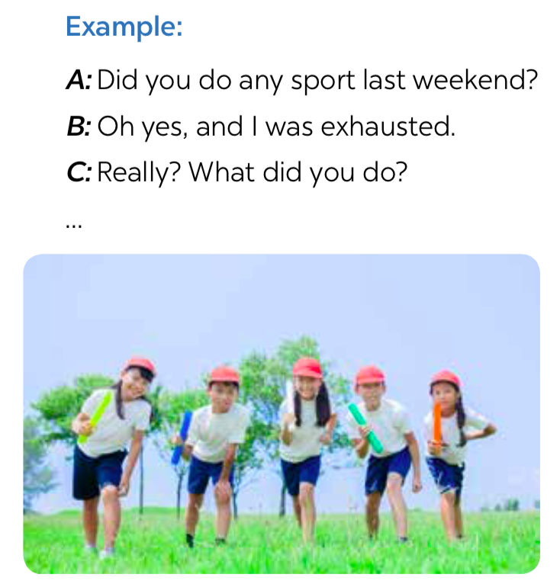 | S  Ss-Ss  T-Ss  S  T-Ss  Group work | 15 mins
Presentation | To help  students know and understand the use of  imperatives. | 2. Imperatives  - Teacher sets context to lead in the lesson: There is an obese kid, let’s tell the kids what to do/ what not to do to stay fit and healthy by using imperatives.  Do more exercise. Don’t spend much time on computer games.  - Teacher asks students to give the rules and when to use imperatives: use imperatives to tell someone to do something or to give direct order.  Positive V  Negative Don’t + V | T-Ss | 4 mins
Practice | To help  students use the correct form of the  imperative in different  situations.  To help  students  practise using imperatives to tell someone to do  something in real context. | Task 4: Look at each picture and choose the correct  answer.  - Teacher tells students to work in pairs, gives them about 2 – 3 minutes to do the task.  - Teacher goes round, observes the class and gives help if necessary.  - Teacher calls on some students to read their answers, then checks their answers as a class.  Answer key:  1. Don’t park  2. Close  3. Tidy up  4. Don’t use  5. Try  Task 5: Tell your friends what to do and what not to do at the gym.  - Teacher lets students work in groups of four, gives each group a piece of paper, asks them to take turns to tell their friends what to do and what not to do at the gym and write down the answer in the paper in 3 minutes.  - Teacher gives help and lets them give as many sentences as possible.  - Teacher calls some groups to read aloud their answer and check with the whole class.  Some possible sentences:  + Pay your fee first.  + Put on your trainers/ sports shoes.  + Listen to the instructor carefully.  + Don’t litter.  + Don’t eat or drink at the gym.  - If there is still time, teacher may ask students to draw a picture illustrating one of the gym rules in the blank space at the bottom of their notebook page. Make sure that students write the rules somewhere in the picture. (This may be done as homework.) | Pair work  T-Ss  Group work  T-Ss | 10 mins
Consolidation | To consolidate what students have learnt in the lesson. | Teacher asks students to talk about what they have learnt in the lesson. | T-Ss | 3 mins
Homework | To review knowledge that students have gained in this lesson. | - Make 3 sentences about yourself, using the past simple.  - Give 3 orders or tell your friends to do an activity/ everyday routine.  - Do exercises in the workbook. | T-Ss | 2 mins

UNIT 8: SPORTS AND GAMES

Lesson 4: Communication

I. Objectives
By the end of this lesson, students will be able to:

1. Knowledge
- Use the lexical items related to the topic Sports and games
- Express and respond to congratulations
- Talk about sports and games that they like

2. Core competence
- Develop communication skills and creativity
- Be collaborative and supportive in pair work and teamwork
- Actively join in class activities

3. Personal qualities
- Be ready to make and share ideas among classmates.
- Develop self-study skills

II. Materials
- Grade 6 textbook, Unit 8, Communication
- Pictures/ Projector
- hoclieu.vn

Anticipated difficulties | Solutions
1. Students may have underdeveloped speaking and co-operating skills. | - Encourage students to work in pairs, in groups so that they can help each other.  - Provide feedback and help if necessary.
2. Some students will excessively talk in the class. | - Define expectations in explicit detail.  - Have excessively talkative students practise.  - Continue to define expectations in small chunks (before every activity).

Board Plan

Date of teaching

UNIT 8: SPORTS AND GAMES

Lesson 4: Communication

* Warm-up

Game: Lucky numbers
I. Everyday English
Expressing and responding to congratulations.
Congratulations.
Thank you.
Task 1: Listen and read the conversation.
Task 2: Role play.
II. The sports/ games you like
- Task 3: Work in pairs. Do the quiz.
Task 4: Work in groups. Interview your partners using the following questions. You may ask for more information.
* Homework

Procedure

Stage | Stage aim | Procedure | Interaction | Time
Warm-up | To activate students’ prior knowledge and to increase students’ interest. | * Lucky numbers  - Class is divided into 2 teams.  - Teacher prepares 7 numbers which includes 5 questions about their school, and 2 lucky numbers.  - Each team takes turns, chooses a number and answers the question behind the number. If the team answers the question correctly, they will get 1 point. If the team chooses the lucky number, they get 1 point without answering the question and get another turn.  Suggested question:  1. Lucky number  2. Complete the following imperative:  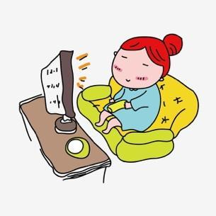  ….. watch TV more than 3 hours a day. It’s bad for your eyes.  Answer key: Don’t  3. Complete the question:    ….. you have dinner with your parents yesterday?  Answer key: Did  4. Look at the picture and complete the sentence:  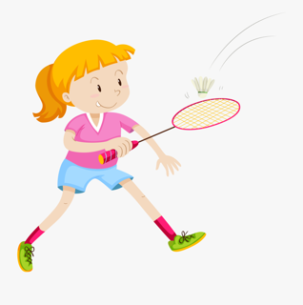  Jane ... with her brother last weekend.  Answer key: played badminton  5. Lucky number  6. Look at the picture and complete the sentence:    … to the instructor at the gym.  Answer key: Listen  7. Translate the following sentence into English:    Tôi chiến thắng trong cuộc thi đánh vần Thứ Hai tuần trước.  Answer key: I won in the spelling contest last Monday. | Teamwork | 6 mins
Lead-in | To lead in the lesson about vocabulary and pronunciation. | - Teacher leads students into the lesson by repeating the answer in question 7 of the game (I won in the spelling contest last Monday.) and asks students how they will respond in such situation. | T-Ss | 2 mins
* EVERYDAY ENGLISH
Presentation | To introduce the structure of expressing and responding to congratulations. | Expressing and responding to congratulations.  Task 1: Listen and read the short conversation below, paying attention to the highlighted parts.  - Teachers lets students listen and read the dialogue, asks them what the characters say when they hear good news from other people.  - Teacher calls some students to share their opinions.  - Teacher gives more explanations and writes down the structure of expressing and responding to congratulations.  + Congratulations.  + Thank you. | T-Ss | 7 mins
Practice | To practise the structure of expressing and responding to congratulations. | Task 2: Work in pairs. Student A has won a prize in the school’s singing contest/ sports competition. Student B congratulates him/her. Make a similar dialogue.  Remember to use the highlighted sentences in  Task 1. Then change roles.  - Teacher allows students to work in pairs, practise the situation, using structures above.  - Teacher calls some pairs to present their answers.  - Teacher gives feedback and corrections (if necessary). | Pair work  T-Ss | 8 mins
* THE SPORTS/ GAMES YOU LIKE
Practice | - To have  students  revise/ learn some knowledge of sports/ games.  - To help  students  communicate through a quiz about sports/ games. | Task 3: Work in pairs. Do the quiz.  - Teacher asks students to work in pairs and find the  answers to the quiz.  - Teacher checks and gives the correct answers.  Answer key:  1. There are usually  22 players (11 on each side).  2. It normally lasts 90 minutes (divided into two halves).  3. They take place every four years.  4. A marathon is 42.195  kilometres long (26 miles and 385 yards).  5. They took place in Olympia (in Ancient Greece) (in 776 BC). | Pair work  T-Ss | 8 mins
Production | To help students ask and answer questions about themselves  concerning the field of sports/ games. | Task 4: Work in groups. Interview your partners using the following questions. You may ask for more  information.  - Teacher divides the class into groups of 5 or 6.  - Teacher appoints one student to be the interviewer, others to be the interviewees, then gives students plenty of time to ask and answer questions. Encourage them to talk and raise as many questions as possible.  - Teacher goes round the class and gives support if  necessary.  - After a fixed amount of time, choose the interviewer of some groups to present to the class. Teacher and other students listen and make comments. | Group work  T-Ss | 10 mins
Consolidation | To consolidate what students have learnt in the lesson. | Teacher asks students to talk about what they have learnt in the lesson. | T-Ss | 3 mins
Homework | To revise what they have learnt in the lesson. | Write down the results and feedback of the previous  interviews. | T-Ss | 1 min

UNIT 8: SPORTS AND GAMES

Lesson 5: Skills 1

I. Objectives
By the end of this lesson, students will be able to:

1. Knowledge
- Develop reading skill for general and specific information about Pelé
- Talk about famous sportspeople

2. Core competence
- Develop communication skills and creativity
- Be collaborative and supportive in pair work and teamwork
- Actively join in class activities

3. Personal qualities
- Be ready to make and share ideas among classmates
- Develop self-study skills

II. Materials
- Grade 6 textbook, Unit 8, Skills 1
- Pictures, cards
- hoclieu.vn

Language analysis
Form | Pronunciation | Meaning | Vietnamese equivalent
1. career (n) | /kəˈrɪər/ | the job or series of jobs that you do during your working life | sự nghiệp
2. goal (n) | /ɡəʊl/ | a point score in some sports, such as football, when a player get the ball into this area | bàn thắng
3. score (v) | /skɔːr/ | to win or get a point | ghi bàn

Anticipated difficulties | Solutions
1. Students may lack knowledge about some lexical items. | Provide students with the meaning and pronunciation of words.
2. Students may have underdeveloped reading, speaking and co-operating skills. | - Let students read the text again (if needed).  - Create a comfortable and encouraging environment for students to speak.  - Encourage students to work in pairs, in groups so that they can help each other.  - Provide feedback and help if necessary.
3. Some students will excessively talk in the class. | - Define expectations in explicit detail.  - Have excessively talkative students practise.  - Continue to define expectations in small chunks (before every activity).

Board Plan

Date of teaching

UNIT 8: SPORTS AND GAMES

Lesson 5: Skills 1

* Warm-up
Game: Hidden picture
I. Reading
Task 1: Work in pairs. Discuss the questions.
Vocabulary
- career (n)
- goal (n)
- score (v)
Task 2: Read the dialogue and quickly check your ideas in Task 1.
Task 3: Read the text again and answer the questions.
II. Speaking
Task 4: Read the following facts about two famous sportspeople.
Task 5: Choose one sportsperson in Task 4. Talk about him/ her. Use the
following cues.
* Homework

Procedure
Stage | Stage aim | Procedure | Interaction | Time
Warm-up | To introduce the topic of reading and also revise the previous lesson. | *Game: Hidden picture  (Who is this?)  - Class is divided into 2 teams.  - Teacher prepares 6 cards numbered from 1 to 6.  - Each team takes turns to choose a number and answer the  question behind the number. If the team answers the question correctly, they will get 1 point.  - There is a hidden picture under the 6 cards, the team finds the hidden picture first will be the winner.  - (The hidden picture is Pelé.)    Suggested questions:  1. How many players are there in a football match?  2. How long does a football match last?  3. Is football in America the same sport as football in other countries?  4. Who is this man?    5. Which sport happens in a ring?  6. Who is this girl?    Answer key:  1. 22.  2. 90 minutes.  3. No, it isn’t.  4. Quang Hải – a Vietnamese footballer.  5. Boxing.  6. Ánh Viên – a Vietnamese swimmer. | Team work | 5 mins
Pre-Reading | To activate  students’ knowledge of the topic of the reading text. | - Teacher leads students into the lesson by showing the picture of Pelé, and lets students know they are going to read a conversation about him.  Task 1: Work in pair, discuss the questions.  1. What do you know about Pele?  2. What is special about him?  - Teacher has students work in pairs and discuss the questions about Pelé. It is not important whether they know much or little information about Pelé as long as they concentrate and talk with each other. | T-Ss  Pair work | 3 mins
Presentation  (Vocab  pre-teaching) | To prepare  students with vocabulary. | VOCABULARY  Teacher introduces the vocabulary by providing definitions of the words.  1. career (n): [definition]  2. goal (n): [definition]  3. score (v): [definition] | T-Ss | 4 mins
While-  Reading | To develop reading skill for general information  (skimming).  - To help  students  develop their reading skill for specific  information (scanning).  - To help  students broaden and deepen their knowledge of the famous football star Pelé. | Task 2: Read the dialogue quickly to check your ideas in  Task 1.  - Teacher tells students to read the text quickly and check their ideas in Task 1.  - Teacher sets a strict time limit to ensure that students read quickly for information.  - Teacher encourages students to give any piece of information they can remember (and it is not so important if they cannot say any true information as long as they speak English).  Example:  - ... best footballer  - ... from Brazil  - ... won the World Cup  - ... the King of Football  - ...  Task 3: Read the text again and answer the questions.  - Teacher gives students some time to practise reading the  dialogue. Students listen to teacher (or students) read aloud while tracking the dialogue with their fingers.  - Teacher asks students to read in chorus the new and difficult words/ phrases in the dialogue, then checks with students the meanings of the new words. Explain to them if necessary.  - Teacher asks students to find the key words in each question, then find the information in the dialogue to answer the questions.  - Teacher confirms the correct answers to the class.  Answer key:  1. Pelé was born in 1940.  2. His father did. / His father taught him.  3. He scored 1,281 goals in total.  4. (He became Football Player of the Century) in 1999.  5. They call him “The King of  Football”. | T-Ss  S  T-Ss | 12 mins
Pre-Speaking | To help students form the ideas for their speaking. | Task 4: Read the following facts about two famous sportspeople.  - Students work by themselves and read the fact files of two  famous sportspeople. Teacher may ask them whether they know these sportspeople, and what else they know about them.  - Teacher explains any new words to students if necessary, makes sure students understand everything and they can use these facts to prepare for the next speaking activity. | S | 4 mins
While-  Speaking | To help  students  practise  speaking about a famous sportsperson. | Task 5: Choose one sportsperson in Task 4. Talk about him/ her. Use the following cues.  - Teacher has students work in groups of four, lets them take turns to talk about the sportsperson they have chosen.  - Teacher lets students have freedom to choose what  information to mention. (They can skip some points, or add some of their own.)  - While students are talking, teacher goes round the class and monitors, remembers not to stop them in order to correct their mistakes.  - When the talking time is over, teacher collects common errors and discusses them with the whole class. | Group work  T-Ss | 8 mins
Post-Reading and Speaking | To check  students’  understanding and develop their speaking skill. | - Students work in pairs. One student is an interviewer and the other is a famous sportsperson. Students role-play an interview.  - Teacher and students can brainstorm possible interview questions before the activity.  - Teacher calls some pairs and gives feedback. | Pair work  T-Ss | 6 mins
Consolidation | To consolidate what students have learnt in the lesson. | Teacher asks students to talk about what they have learnt in the lesson. | T-Ss | 2 mins
Homework | To review the lesson they have learnt and prepare for the next lesson - Skills 2. | Teacher asks students to write down their opinion about a  famous sportsperson. | T-Ss | 1 min

UNIT 8: SPORTS AND GAMES

Lesson 6: Skills 2

I. Objectives
By the end of this lesson, students will be able to:

1. Knowledge
- Use the lexical items related to the topic Sports and games
- Listen for general and specific information about people’s favourite sports
- Write a passage about your favourite sport

2. Core competence
- Develop communication skills and creativity
- Be collaborative and supportive in pair work and team work
- Actively join in class activities

3. Personal qualities
- Develop self-study skills

II. Materials
- Grade 6 textbook, Unit 8, Skills 2
- Pictures, CD
- hoclieu.vn

Anticipated difficulties | Solutions
1. Students may have underdeveloped listening skills. | - Play the recording many times if any necessary.  - Encourage students to work in pairs, in groups so that they can help each other.  - Provide feedback and help if necessary.
2. Some students will excessively talk in the class. | - Define expectations in explicit detail.  - Have excessively talkative students practise.  - Continue to define expectations in small chunks (before every activity).
Board Plan

Date of teaching

UNIT 8: SPORTS AND GAMES

Lesson 6: Skills 2

* Warm-up

Spin the wheel
I. Listening
Task 1: Listen to the passages. Who are they about?
Task 2: Listen to the passages again. Tick (✔) T (True) or F (False).
Task 3: Listen again and fill each blank with a word to complete each sentence.
* Summarize the information of the listening part.
II. Writing
Task 4: Work in pairs. Talk about the sport/ game you like. Use the following questions as cues.
Task 5: Write a paragraph of 40-50 words about the sport/game you talked about in Task 4.
* Homework

Procedure

Stage | Stage aim | Procedure | Interaction | Time
Warm-up | - Check  students’  vocabulary from previous lessons.  - To introduce the topic of listening. | * Spin the wheel  - Teacher divides the class into 2 teams.  - Each team takes turns to spin the wheel. Under each number is picture of a famous sportsperson. If the team gives the correct name of sport which the person plays, they’ll get one point.  - The team with more points is the winner.  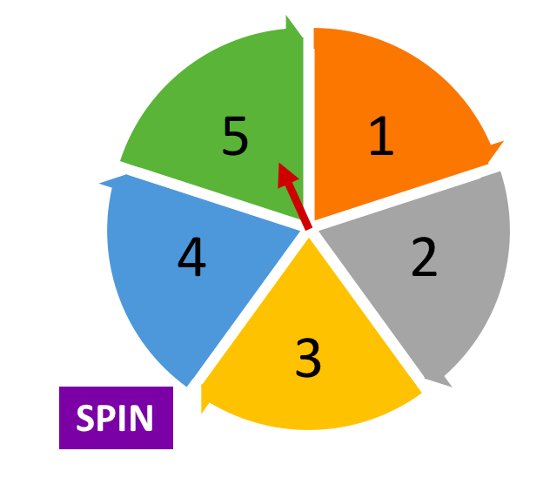    1. Football (David Beckham)    2. Tennis (Roger Federer)    3. Badminton  (Phạm Hồng Nam)    4. Ice skating  (Yuzuru Hanyu)  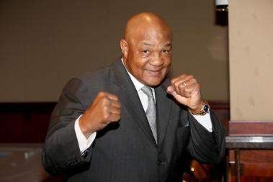  5. Boxing  (George Foreman) | Teamwork | 5 mins
Pre-Listening | - To activate students’ knowledge of the topic of the listening text.  - To help  students  develop their skill of listening for general  information. | Task 1: Listen to the passages. Who are they about?  - Teacher plays the recording once only, asks students to listen and say who are mentioned in the passages.  - Teacher confirms the correct answer as a class.  Answer key:  The listening passages are about Hai and Alice. | T-Ss | 3 mins
While-Listening | To develop  students’ skill of listening for specific  information (scanning).  To develop  students’ skill of listening for specific  information (scanning), and identify the  exact words to fill the blanks. | Task 2: Listen to the passages again. Then tick (✔) T (True) or F (False) for each sentence.  - Teacher asks students to read the sentences carefully and find the key words.  - Teacher plays the recording again, tells students that while they listen, they have to write down T or F for each sentence.  - Teacher calls on some students to read the answers and gives explanations to their choice.  - Teacher confirms the correct answers as a class.  Answer key:  1. F  2. T  3. T  4. T  5. F  Task 3: Listen again and fill each blank with a word to complete each sentence.  - Teacher asks students to read the sentences and find the key words.  - Teacher plays the recording the third time (or more if needed). Tell students that they have to identify the exact words in the listening passages to fill the blanks, and that the words must be correctly spelled.  - Students can share their answers in pairs before listening to the recording a final time to check the answers as a class.  Answer key:  1. volleyball  2. three  3. Alice  4. chess  Audio script:  Hello. My name’s Hai. I love sport. I play volleyball at school and I often go cycling with my dad at the weekend. But my favourite sport is karate. I practise it three times a week. It makes me strong and confident. My name’s Alice. I’m twelve years old. I don’t like doing sport very much, but I like watching sport on TV. My hobby is playing chess. My friend and I play chess every Saturday. I sometimes play computer games, too. I hope to create a new computer game one day. | T-Ss  T-Ss  Pair work | 8 mins
Post-Listening | To check students’  understanding of the listening part. | * Summarize the information of the listening part.  - Students work in groups of four.  - Teacher asks students to summarize the information in the listening part and talk about it.  - Teacher helps if necessary. | Group work | 4 mins
Pre-Writing | To help students  brainstorm ideas for their writing. | Task 4: Work in pairs. Talk about the sport/ game you like. Use the following questions as cues.  - Teacher has students work in pairs and talk about the sport/ game they like. They can use the cues given or their own ideas.  - Teacher asks them to note down the important and  interesting things in their notebooks.  - Teacher goes round and gives help if necessary, then calls on some students to read their notes in front of the class. Teacher and other students listen and make comments. | Pair work  T-Ss | 5 mins
While-Writing | To help students  practise writing a paragraph about the sport/ game they like. | Task 5: Write a paragraph of 40 - 50 words about the sport/ game you talked about in Task 4. You can also refer to the listening passages.  - Teacher asks students to write a paragraph about the sport/ game they talk about in Task 4. Allow students to refer to the listening passages and other sections for useful language for writing. Note interesting expressions and language on the board.  - Teacher tells students to write a draft first, based on the ideas they have talked about in Task 4. Then students actually write a paragraph of 40 – 50 words (or more if they can), covering as many ideas as possible. Tell them to pay special attention to punctuation, structural  elements, linking words, etc.  - If there is enough time, teacher may collect some students’ writings and mark them, then give comments to the class. Remember to tell them how to improve their writings. | T-Ss  S  T-Ss | 12 mins
Post-Writing | To cross check and final check students’ writing. | - Teacher has the groups swap and give feedback on each other’s writing.  - Teacher then gives feedback on one writing as a model. | Group work | 5 mins
Consolidation | To consolidate what students have learnt in the lesson. | Teacher asks students to talk about what they have learnt in the lesson. | T-Ss | 2 mins
Homework | To prepare for the next lesson. | Prepare for project. | T-Ss | 1 min

UNIT 8: SPORTS AND GAMES

Lesson 7: Looking back & Project
I. Objectives
By the end of this lesson, students will be able to:

1. Knowledge
- Review the vocabulary and grammar of Unit 8
- Apply what they have learnt (vocabulary and grammar) into practice through a project

2. Core competence
- Develop communication skills and creativity
- Be collaborative and supportive in pair work and teamwork
- Actively join in class activities

3. Personal qualities
- Develop self-study skills

II. Materials
- Grade 6 textbook, Unit 8, Looking back & Project
- Pictures, paper
- hoclieu.vn

Anticipated difficulties | Solutions
1. Students may have underdeveloped speaking, writing and co-operating skills when doing project. | - Encourage students to work in pairs, in groups so that they can help each other.  - Provide feedback and help if necessary.
2. Some students will excessively talk in the class. | - Define expectations in explicit detail.  - Have excessively talkative students practise.  - Continue to define expectations in small chunks (before every activity).

Board Plan

Date of teaching

UNIT 8: SPORTS AND GAMES

Lesson 7: Looking back & Project
* Warm-up
Mind map
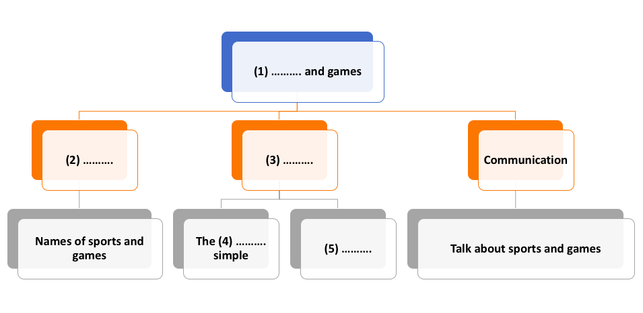
I. Looking back
Task 1: Find one odd word/ phrase in each question.
Task 2: Put the correct form of the verbs play, do or go in the blanks.
Task 3: Put the verbs in brackets in the correct form.
Task 4: What do you say in these situations?
Task 5: Fill each blank with ONE word to complete the passage.
II. Project
Task 6: Read the passage about the game Blind man’s bluff.
Task 7: Choose one of the following sports/ games (or one of your own) and write about it.
* Homework

Procedure

Stage | Stage aim | Procedure | Interaction | Time
Warm-up | To revise what students have learnt in Unit 8 and lead in the next part of the lesson. | * Mind map  - Teacher divides the class into groups of four, gives each group a mind map, asks them to fill the missing words in the map.  - The fastest group giving out the correct answer is the winner.  Answer key:  1. Sports  2. Vocabulary  3. Grammar  4. past  5. Imparatives | Group work | 5 mins
Looking back | To help students revise the vocabulary items they have learnt in the unit.  To help students revise the combination of the verbs play, do and go with names of  different sports/ games.  To help students revise the use of the past simple tense in context.  To help students revise the use of imperatives (positive and negative) in different situations.  To help students revise what sports and games are. | Task 1: Find one odd word/ phrase in each question.  - Students do this task individually.  - Teacher calls on some students to read the answers aloud and then confirms the correct  answers as a class. Let the whole class read the words/ phrases correctly.  Answer key:  1. C  2. A  3. C  4. B  5. B  Task 2: Put the correct form of the verbs play, do or go in the blanks.  - Teacher tells students that in English, sports and games may go after one of three verbs: play, do and go. Students have to remember these combinations and use them correctly in  different contexts.  - Teacher allows students time to do the task individually.  - Teacher calls some students to write the answers on the board, then lets the class comment, and gives them the correct answers.  - Teacher may call some students to read the sentences.  Answer key:  1. do  2. is playing  3. goes  4. went  5. played  6. are doing  Task 3: Put the verbs in brackets in the correct form.  - Teacher lets students work in pairs and put the verbs in brackets in the correct form of the past simple.  - Teacher tells students to pay attention to the point of time given in the sentences.  - Teacher checks the answers as a class.  Answer key:  1. took  2. started  3. didn’t like  4. did you do, cycled, watched  Task 4: What do you say in these situations?  - Teacher gives students some time to work by themselves, asks them to revise how to use  imperatives (positive and negative) in these situations.  - Teacher calls some students to read their sentences.  - Teacher lets other students give comments, then confirms the correct sentences.  Answer key:  1. Please stop making noise.  2. Go out to play with your friends.  3. Don’t feed the animals.  4. Stand in line, boys!  5. Don’t touch the dog.  Task 5: Fill each blank with ONE word to complete the passage.  - Teacher gives students some time to work individually.  - Teacher calls some students to read their sentences.  - Teacher lets other students give comments, then confirms the correct sentences.  Answer key:  1. play  2. hear  3. favourite  4. sports  5. famous | S  T-Ss  T-Ss  S  T-Ss  Pair work  T-Ss  S  T-Ss  S  T-Ss | 20 mins
Project | To allow students to apply what they have learnt (vocabulary and grammar) into practice through  a project.  To help students practise writing about a traditional game (what it needs and its rules). | Task 6: Read the passage about the game Blind man’s bluff.  - Teacher has students read the passage carefully.  - Teacher explains new words for students and makes sure they understand everything  thoroughly: the equipment and location, the rules and different steps.  Task 7: Choose one of the following sports/ games (or one of your own) and write about it.  - Teacher divides the class into 4 teams, and gives each team a piece of paper to make a poster.  - Each team chooses a traditional game and discusses the game’s rules, then writes down the rules and decorates in the poster.  Examples: Tug of war, Skipping, Marbles…  - Each team takes turns to present their talk in front of the class.  - Teacher gives comments and feedback to all 4 posters and awards special prize to the group which has the most impressive and easiest-to-understand rules.  - If it is short of time, let students complete the task as homework under teacher’s guidance. | T-Ss  Team work  T-Ss | 17 mins
Consolidation | To consolidate what students have learnt in the lesson. | Teacher asks students to talk about what they have learnt in the lesson. | T-Ss | 2 mins
Homework | To prepare for the next lesson. | Prepare for the next lesson: Unit 9 – Getting started. | T-Ss | 1 min
*Source of pictures: Internet

