**LEARNING**

**Exercise 1. Choose the words that do not collocate with the nouns in bold.**

**1**  ***higher / people / private*** education

2 ***attend/have/go*** lessons

3 ***language/communication/person*** skills

4 ***further/long/rewarding*** career

5 ***pass/fail/prove*** exams

6 ***master’s/university/course*** degree

**Exercise 2: Complete the sentences. The first letters are given.**

Next year we're going to **t***ake* our exams.

1 They get on well with everyone as they have good p__________ skills.

2 I'm doing a b__________ degree in Computer Science. After that, I'd like to do a master's degree.

3 Matt usually goes to lessons, but occasionally he s__________ them in summer because he's crazy about cricket.

4 I think f__________ education is important, so I'd like to go to university.

5 She's done really well and had a s__________ career as a teacher for over twenty years.

**Exercise 3: Complete the sentences with the correct form of the verbs below. There are two extra verbs.**

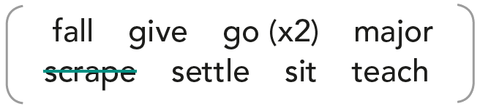

Eg. I've never failed an exam, though I only ***scrape*** through sometimes!

1 After high school, he __________ on to do a course in Accountancy.

2 I __________ behind in Maths after I was ill for two weeks, but now I've caught up.

3 When Yen's older, she wants to __________ into teaching.

4 My English teacher was great, she never __________ up on me, even when I didn't make much progress.

5 At university, Alex wants to __________ in law, but he wants to study a language too.

6 I argued with my sister and then found it hard to __________ down to study. I couldn't concentrate.

**Exercise 4: Complete the tips with the correct form of the phrasal verbs from Exercise 3.**

TIPS FOR SUCCESSFUL STUDY

* Have a long-term plan. What do you want to go into after you finish your studies? Working towards a goal can inspire you to work hard now.
* Motivate yourself. If you find it hard to 1__________ and study at home, then give yourself a treat after you finish. For example, listening to music or having a hot chocolate.
* Talk to your teachers and find out how you are doing. If you have 2__________ the other students, ask for help to catch up.
* Make a study plan. Only 3__________ the second task when you have finished the first, and so on. That way you will complete all your work.
* Take responsibility for your learning. If you have taken an exam or test and just 4__________, then focus on how you can improve. Passing isn't enough, try to get good marks!
* Choose subjects you enjoy to 5__________. You'll work harder if you like a subject – and be more likely to 6__________ the subject if you hate it.

**ANSWER KEY**

**Exercise 1.**

1. people 2. go 3. person 4. further 5. prove 6. course

**Exercise 2.**

1. people 2. bachelor’s 3. skips 4. further

5. successful

**Exercise 3.**

1. went 2. fell 3. go

4. gave 5. major 6. settle

**Exercise 4.**

1-settle down 2. fallen behind 3. go on to

4. scrape through 5. major in 6. give up on