UNIT 9: FESTIVALS AROUND THE WORLD
Lesson 3: A closer look 2

I. OBJECTIVES
By the end of this lesson, Ss will be able to:
1. Knowledge:
- Practice Yes/No questions
2. Core competence:
- Develop communication skills and creativity
- Be collaborative and supportive in pair work and teamwork
- Actively join in class activities
3. Personal qualities
- Develop self-study skills

II. PREPARATIONS
1. Teacher
- Grade 7 textbook, laptop, TV/Projector/ pictures and cards, speakers, lesson plan, sachmem.vn…
2. Students
- Grade 7 textbook, notebooks, school things….
III. TEACHING PROCEDURES
Notes
In each activity, each step will be represented as following
*Deliver the task
** Implement the task
*** Discuss
 Giving comments or feedback
ACTIVITY 1 – WARM – UP & INTRODUCTION (5’)
a) Aims:
- To activate students’ prior knowledge related to the targeted grammar: Yes/No questions.
- To increase students’ interest.
- To enhance students’ skills of cooperating with team mates.
b) Contents: Play the game: Sentence puzzling
c) Products: Ss’ answers
d) Teaching steps:
Teacher’s and students’ activities | Content
* Teacher divides the class into 4 groups.  - Teacher delivers different sets of word cards to each group.  - Each group has to arrange the word cards to make meaningful sentences.  - 1 point for each correct answer.  ** Students play the game in groups.  *** Teacher and students discuss the answers.   Teacher confirms the answers and gives feedback.  Set 1:  Are you eating moon cakes?  Set 2:  Did they eat moon cakes at the festival last year?  Set 3:  Can he eat all these moon cakes? | Game: Sentence puzzling  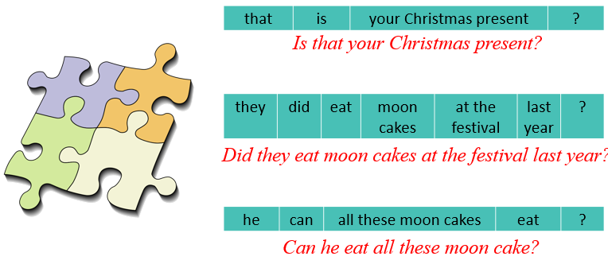

ACTIVITY 2 – PRESENTATION (15’)
a) Aims:
- To introduce the targeted grammar: Yes/No questions.
- To have students get to know about the Yes/No questions.
b) Contents:
- Teach the vocabularies
- Teach the points of grammar
c) Products:
- Lists of vocabularies
- Answer key
d) Teaching steps:
Teacher’s and students’ activities | Content
* Teacher asks students to study the Grammar box.  - Teacher draw students’ attention to the use and how to form a Yes/No question with an auxiliary verb or with a modal verb.  ** Teacher then asks some more able students to give some more examples.  Yes/No questions  We use put the auxiliary verb or modal verb before the subject.  *** Teacher and students discuss the answers.   Teacher confirms the answers and gives feedback. | GRAMMAR  Yes/ No questions  *These questions need either a Yes/No answer.  * We form a Yes/ No questions with an auxiliary verb (be, do or have). We put the auxiliary verb or modal verb before the subject.  Aux verb + S + V (-inf) + O?  Examples:  - Are you tired?  - Did you get many Christmas presents?  - Can you eat all the cakes?
ACTIVITY 3 – PRACTICE (18’)
a) Aims:
- To check students’ understanding of the Yes/No questions.
- To help Ss practise making Yes/No questions.
- To give further practice with Yes/No questions.
- To give further practice with Yes/No questions.
b) Contents:
- Fill in each blank with a correct auxiliary verb or modal verb.
- Change the sentences into Yes/No questions.
- Match the questions in column A with their answers in column B.
- Mark is talking to Trang about the Mid-autumn Festival. Fill in the blanks with Trang’s answers below.
c) Products:
- Answer key
d) Teaching steps:
Teacher’s and students’ activities | Content
* Teacher has students work individually.  ** Students work individually to complete the sentences.  *** Teacher lets students work in pairs and exchange the answers before checking with the whole class (explain each sentence if necessary).   Teacher confirms the answers and gives feedback.  * Teacher has students work individually.  ** Students work individually to complete the sentences.  *** Teacher lets students work in pairs and exchange the answers before checking with the whole class (explain each sentence if necessary).   Teacher confirms the answers and gives feedback.  * Teacher asks students to read the instruction.  ** Teacher asks students to do the exercise individually and match the questions in column A with the answers in column B.  *** Teacher then has them work in pairs, comparing their sentences. Teacher can go around to help students.   Teacher confirms the answers and gives feedback.  *Teacher divides the class into 2 teams. Each team will send a leader to play the game on the board.  - Teacher explains the instructions of the game:  - Teacher gives each team a set of cards with phrases from the box.  - The two leaders of the teams come to the board and pin the cards under the correct number.  - Who can finish faster with the correct answer will be the winner.  ** Students play the games in team mode.  *** Teacher has students to write down the correct answer.   Teacher confirms the answers and gives feedback. Teacher can ask for translation to check their understanding. | Task 1: Fill in each blank with a correct auxiliary verb or modal verb (p.95).  Answer key:  1. Do  2. Did  3. Are  4. Can  5. Does  Task 2: Change the sentences into Yes/No questions (p.95).  Answer key:  1. Can your mother make a costume for you?  2. Will she bake a birthday cake for him?  3. Are the dragon dances interesting?  4. Does the Rio Carnival take place every year in Brazil?  5. Did they see a fireworks display on New Year’s Eve?  Task 3: Match the questions in column A with their answers in column B (p.95).  Task 4: Mark is talking to Trang about the Mid-autumn Festival. Fill in the blanks with Trang’s answers below (p.95).  Game: Who is faster?  Answer key:  1. b  2. e  3. a  4. c  5. d
ACTIVITY 4 – PRODUCTION (5’)
a) Aims:
- To help Ss practise producing Yes/No questions.
b) Contents:
- Work in groups. One student thinks of a festival he/she likes. Other students ask Yes/No questions to find out what the festival is.
c) Products:
- Ss’ conversations
d) Teaching steps:
Teacher’s and students’ activities | Content
* Teacher has students work in groups.  ** One student thinks of a festival that he/she likes. Other students ask Yes/No questions to find out what the festival is.  The group leader keeps a record of the group’s performance.  *** Teacher moves around to observe and pays attention to Ss’ yes/no questions.   Teacher asks some groups to perform in front of the class, confirms the answers and gives feedback. | Task 5: Game. Festival mystery. Work in groups. One student thinks of a festival he/she likes. Other students ask Yes/No questions to find out what the festival is (p.95).  Example:  A: Do many countries celebrate the festival?  B: Yes, they do.  A: Do children like the festival?  B: Do they paint eggs?  A: Yes, they do.  C: Is it Easter?  B: Yes, it is.
IV. WRAP-UP & HOMEWORK (3’)
- Teacher summarises the main points of the lesson:
+ Yes/No questions
- Teacher asks Ss to make Yes/No questions about Festival
- Teacher asks Ss to do exercise in Workbook
- Teacher asks Ss to prepare the next lesson “Unit 9 – Communication”
V. FEEDBACK

……………………….…, ngày………….tháng…………..năm 2022
Duyệt của Tổ chuyên môn

