Họ và tên: ....................................................  Lớp: ............................................................. | PHIẾU GHI BÀI CHUYÊN ĐỀ HÓA HỌC 11  Bài 8: CHẾ BIẾN DẦU MỎ
MỞ ĐẦU
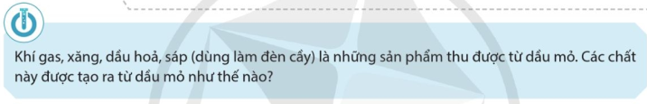
..........................................................................................................................................................................
..........................................................................................................................................................................

I. CÁC GIAI ĐOẠN CHẾ BIẾN DẦU MỎ
..........................................................................................................................................................................
..........................................................................................................................................................................
..........................................................................................................................................................................
..........................................................................................................................................................................
..........................................................................................................................................................................
..........................................................................................................................................................................
..........................................................................................................................................................................
..........................................................................................................................................................................
..........................................................................................................................................................................
..........................................................................................................................................................................
..........................................................................................................................................................................
..........................................................................................................................................................................
..........................................................................................................................................................................
..........................................................................................................................................................................
..........................................................................................................................................................................
..........................................................................................................................................................................
..........................................................................................................................................................................
..........................................................................................................................................................................
..........................................................................................................................................................................
..........................................................................................................................................................................
..........................................................................................................................................................................
..........................................................................................................................................................................
..........................................................................................................................................................................
..........................................................................................................................................................................
..........................................................................................................................................................................
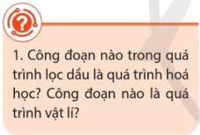 | ....................................................................................................................  ....................................................................................................................  ....................................................................................................................  ....................................................................................................................  ....................................................................................................................
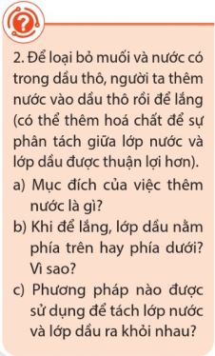 | ....................................................................................................................  ....................................................................................................................  ....................................................................................................................  ....................................................................................................................  ....................................................................................................................  ....................................................................................................................  ....................................................................................................................  ....................................................................................................................  ....................................................................................................................  ....................................................................................................................
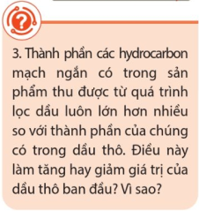 | ....................................................................................................................  ....................................................................................................................  ....................................................................................................................  ....................................................................................................................  ....................................................................................................................  ....................................................................................................................  ....................................................................................................................
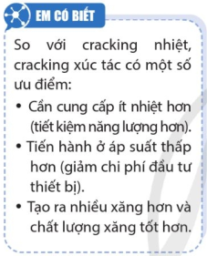

II. CÁC SẢN PHẨM CỦA QUÁ TRÌNH CHẾ BIẾN DẦU MỎ
..........................................................................................................................................................................
..........................................................................................................................................................................
..........................................................................................................................................................................
..........................................................................................................................................................................
..........................................................................................................................................................................
..........................................................................................................................................................................
..........................................................................................................................................................................
..........................................................................................................................................................................
..........................................................................................................................................................................
..........................................................................................................................................................................
..........................................................................................................................................................................
..........................................................................................................................................................................
..........................................................................................................................................................................
..........................................................................................................................................................................
..........................................................................................................................................................................
..........................................................................................................................................................................
..........................................................................................................................................................................
..........................................................................................................................................................................
..........................................................................................................................................................................
..........................................................................................................................................................................
..........................................................................................................................................................................
..........................................................................................................................................................................
..........................................................................................................................................................................
..........................................................................................................................................................................
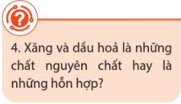 | ....................................................................................................................  ....................................................................................................................  ....................................................................................................................  ....................................................................................................................
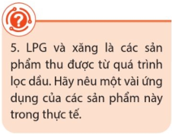 | ....................................................................................................................  ....................................................................................................................  ....................................................................................................................  ....................................................................................................................  ....................................................................................................................

III. CHỈ SỐ OCTANE CỦA XĂNG
....................................................................................................................  ....................................................................................................................  ....................................................................................................................  ....................................................................................................................  ....................................................................................................................  ....................................................................................................................  ....................................................................................................................  ....................................................................................................................  ....................................................................................................................  ....................................................................................................................  ....................................................................................................................  ....................................................................................................................  ....................................................................................................................  ....................................................................................................................  ....................................................................................................................  ....................................................................................................................  .................................................................................................................... |  | 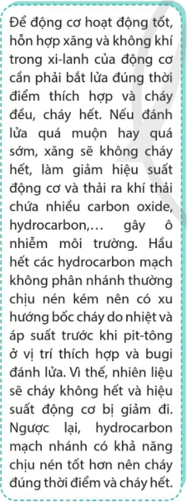
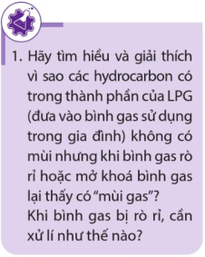 | 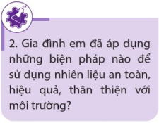 | 