**Mã đề 9.1.27**

**ĐỀ KIỂM TRA CUỐI HỌC KỲ I – NĂM HỌC : 2022-2023**

**MÔN : TIẾNG ANH 9**

**Thời gian: 45 phút**

**A. LISTENING COMPREHENSION (2,0 pts)**

**I. You will hear five short conversations. You will hear each conversation twice. There is one question for each conversation. For questions 1-5, put a tick (✓) under the right answer (1,0 pt)**

1. What’s Steven doing now? (NHẬN BIẾT)

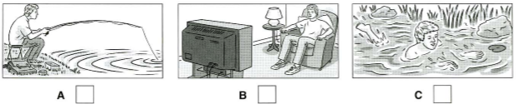

2. How are they going to get to the countryside? (THÔNG HIỂU)

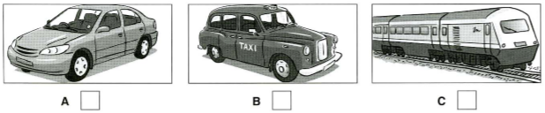

3. What will the woman do tonight? (NHẬN BIẾT)

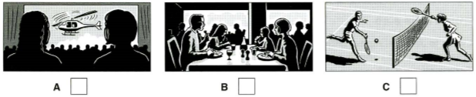

4. Where is the cat now? (NHẬN BIẾT)

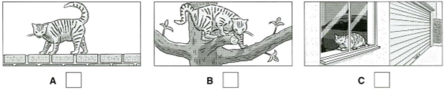

5. What job does Mary’s brother do? (THÔNG HIỂU)

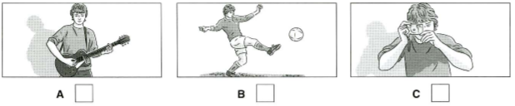

**II. Listen to a woman talking to a policeman. Listen and complete questions 1-5. You will hear the conversation twice (1,0 pt)**

|  |  |
| --- | --- |
| **NOTES** | |
| ***Lost the bag in:***  ***Money in the bag:***  ***The bag was :***  ***Time she lost:***  ***The policeman will telephone her in the:*** | (1) …………………..centre. (NHẬN BIẾT)  (2) £ …………………(THÔNG HIỂU)  (3) …………………(THÔNG HIỂU)  (4) about ……………(NHẬN BIẾT)  (5) ………………… (THÔNG HIỂU) |

**B- LANGUAGE (2 POINTS)**

**I. Choose the word whose underlined part pronounced differently from that of the others by circling A, B, C or D (0.4 point)**

1. A. lantern**s** B. drum**s** C. painting**s** D. hat**s**(NHẬN BIẾT)

2. A. **c**raft B. **c**itadel C. **c**avern D. **c**alm (NHẬN BIẾT)

**II. Choose the best option (A, B, C or D) to complete these sentences. (1.6 points)**

1. If you have a problem, you can ______ Magic Number 18001567 for help.

(TỪ VỰNG)(NHẬN BIẾT)

A. go B. do C. call D. wonder

­2. Children are very creative, they are good at ______ stories. (TỪ VỰNG)(THÔNG HIỂU)

A. dancing B. acting out C. keeping D. using

3. They cancelled the trip to Tay Ho village ______ it was raining hard.

(NGỮ PHÁP) (THÔNG HIỂU)

A. so that B. though C. since D. because of

**4.** When he lived in the city, he_________to the theater twice a week.

(NGỮ PHÁP) (THÔNG HIỂU)

A. used to go B. uses to go

C. was going D. be used to going

5. Schools in the past didn’t have classes for ______ age groups. (TỪ VỰNG)( THÔNG HIỂU)

A. difference B. different C. differ D. differently

6**.** I suggest__________a picnic on the weekend.(NGỮ PHÁP) (NHẬN BIẾT)

A. having B. should have C. have D. had

7. Khanh’s grandfather is ______ artisan in my village. (NGỮ PHÁP) (THÔNG HIỂU)

A. older B. the older C. old D. the oldest

8. Many people in Tang Tien commune in Viet Yen district live _____ selling bamboo weaving products. (TỪ VỰNG)(NHẬN BIẾT)

A. on B. up C. down D. in

**C- READING (2 POINTS)**

**I. Read the following passage and mark the letter A, B, C or D on your answer sheet to indicate the correct word for each of the blanks. (1.0 point)**

Sociologists have been carrying out research into the social pressures of being a teenager. Many adolescents are unhappy at school because they find it difficult to (1)______ friends. This stress can bring on illness or result in poor grades. They may also worry about their appearance and often feel (2)______ enormous pressure to dress, talk and behave the same as (3)_____. This phenomenon is called peer pressure, and it is very common in today’s society. Advertising contributes a lot to the social pressures teenagers feel. Advertisers know how important it is to feel that you belong to a group when you are in your teens, so they try to persuade teenagers that certain products will make them (4)______ with their classmates. Sadly, many teenagers act irresponsibly and even do dangerous things just to make others accept them. Peer pressure is often the reason for teenage smoking, drug (5)______ or dangerous driving. Teenagers need to learn to say “no” to social pressure and to find friends who they can talk things over with when they have a problem.

**1**. A. keep B. create C. remain D. make (NHẬN BIẾT)

**2**. A. in B. under C. over D. below (THÔNG HIỂU)

**3**. A. another B. the other C. others D. other (NHẬN BIẾT)

**4**. A. common B. popular C. open D. favorite (VẬN DỤNG)

**5.** A. abuse B. overdose C. addicted D. overuse (NHẬN BIẾT)

**II. Read the passage. Circle A, B or C, D to answer each question. ((1.0 point)**

          Ha Long Bay is a UNESCO World Heritage site in Quang Ninh province, in the northeast of Viet Nam. It has got over 1,600 islands and islets. Among the many ancient fishing villages in Ha Long Bay, only Cua Van floating village remains. All the houses and buildings in the village float on huge wooden rafts.

The villagers spend their days fishing and looking after the sea life. Then **they** sail to the mainland to trade their fish for things like food, drinking water or clothes. Most children go to floating schools and then spend the rest of their time learning important skills like swimming and fishing. They also help out their parents as much as they can.

Their lifestyle may seem strange to many people, but it’s so wonderful to live among such natural beauty and know you are protecting it. The villagers are able to help preserve their bay because they live directly on the water.

**1.** The word “**they**” in paragraph 2 is closest in meaning to _____. (THÔNG HIỂU)

  A. the villagers           B. the builders          C. the schools        D. the houses

**2.** According to the passage, the villagers’ lifestyle may seem _____ to many people.

(NHẬN BIẾT)

  A. dangerous            B. strange       C. boring          D. Tiring

**3.** The villagers not only fish but also _____ the sea life. (THÔNG HIỂU)

  A. look after      B. look at                 C. pollute         D. damage

**4.** The villagers are able to help preserve their beautiful bay because _____.

(NHẬN BIẾT)

  A. they live far from the sea B. they live directly on the water

  C. they live on the land D. They don’t live directly on the water

**5.** Which of the following sentences is NOT true about Halong Bay? (VẬN DỤNG)

A. It is a World Heritage B. It is in the northeast of Viet Nam

  C. It has got nearly 1,600 islands and islets. D. Cua Van is a floating village

**D- WRITING (2 POINTS)**

**I. Choose the underlined word or phrase (A, B, C or D) that needs correcting. (0.4 pt)**

**1.** Bat Trang is one of the more famous traditional craft villages of Ha Noi. (NHẬN BIẾT)

**A B C D**

**2.** My neighbor usually looks up my dog when I am away on holiday. (NHẬN BIẾT)

**A B C D**

**II. Finish each of the following sentences in such a way that it means the same as the sentence printed before it. (0.6 pt)**

3. I don’t have a computer. (VẬN DỤNG)

→ I wish _______________________________________________________.

4. In the past, children in my village always walked to school. (VẬN DỤNG)

→ In the past, children in my village used _____________________________.

5. “What are you doing, Hoa?” Lan asked. (VẬN DỤNG)

→ Lan asked Hoa________________________________________________.

**III- Write a paragraph (80-100 words) to describe some disadvantages of living in the city. (1.0 pt)**

**You may use the following cues :**

- noise  
- high cost of living  
- traffic jams  
- air pollution

……….

(VẬN DỤNG CAO)

|  |  |
| --- | --- |
|  | **ĐÁP ÁN**  **ĐỀ KIỂM TRA CUỐI HỌC KỲ I – NĂM HỌC : 2022-2023**  **MÔN : TIẾNG ANH 9**  *Thời gian làm bài: 45 phút* |

**A. LISTENING (2,0 pts)**

1. **Listen then tick under the right answer. (1pt, 0.2 for each)**

1. C 2. A 3. B 4. A 5.C

1. **Listen and give short answers to these questions. (1pt, 0.2 for each)**

1. TOWN 2. 20

3. old, not expensive

4. 10 o’clock 5. morning

**B. VOCABULARY - GRAMMAR**

**I. Choose the word whose underlined part pronounced differently from that of the others by circling A, B, C or D (0.4 point)**

1. D

2. B

**II) Choose the best answer  A, B or C to complete each sentence. (1.6pts, 0.2 for each)**

1. C 2. B3. C 4. A5.B

6. A 7. D 8. A

**C- READING (2 POINTS)**

**I. Read the following passage and mark the letter A, B, C or D on your answer sheet to indicate the correct word for each of the blanks. (1pt, 0.2 for each)**

|  |  |  |  |  |
| --- | --- | --- | --- | --- |
| 1. D | 1. B | 1. C | 1. B | 1. B |

**II. Read the passage. Circle A, B or C, D to answer each question. (1pt, 0.2 for each)**

1. A 2. B 3. A 4. B 5.C

**D- WRITING (2 POINTS)**

**I. Choose the underlined word or phrase (A, B, C or D) that needs correcting.**

**(0.4 pt,0.2 for each)**

**1.** A **2.** B

**II. Finish each of the following sentences in such a way that it means the same as the sentence printed before it. (0.6 pt; 0.2 for each)**

3. I wish I had a computer

4. In the past, children in my village used to walk to school

5. Lan asked Hoa what she was doing then.

**III- Write a paragraph (80-100 words) to describe some disadvantages of living in the city. (1.0 pt)**

- correct form: 0.2 p - reasonable ideas: 0.3 p

- accurate grammar: 0.3 p - appropriate vocabulary: 0.2 p