Họ và tên: ....................................................  Lớp: ............................................................. | PHIẾU GHI BÀI HÓA HỌC 11 CÁNH DIỀU  Bài 2: SỰ ĐIỆN LI TRONG DUNG DỊCH NƯỚC  THUYẾT BRØNSTED–LOWRY VỀ ACID–BASE
MỞ ĐẦU
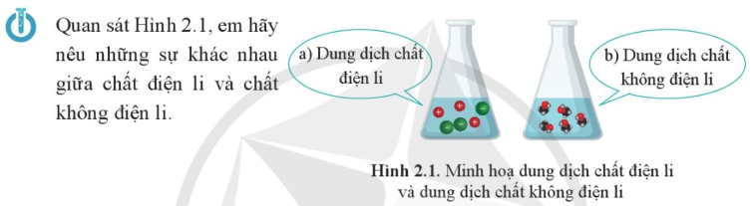
..........................................................................................................................................................................
..........................................................................................................................................................................

I. SỰ ĐIỆN LI, CHẤT ĐIỆN LI VÀ CHẤT KHÔNG ĐIỆN LÍ
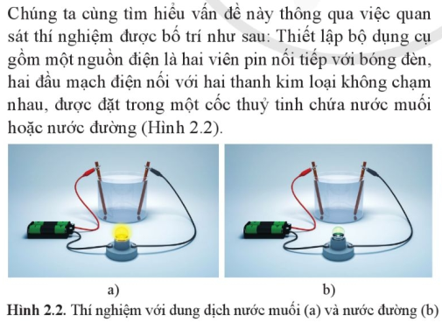 |  | 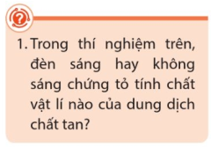  .............................................................  .............................................................  .............................................................  .............................................................  .............................................................
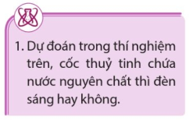 | ................................................................................................................  ................................................................................................................  ................................................................................................................  ................................................................................................................
..........................................................................................................................................................................
..........................................................................................................................................................................
..........................................................................................................................................................................
■ Sự điện li: ....................................................................................................................................................
■ Chất điện li: .................................................................................................................................................
■ Chất không điện li: .....................................................................................................................................
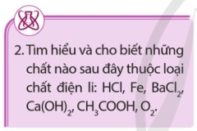 | ..................................................................................................................  ..................................................................................................................  ..................................................................................................................  ..................................................................................................................
II. THUYẾT BRØNSTED–LOWRY VỀ ACID–BASE
1) Thuyết Brønsted - Lowry về acid - base
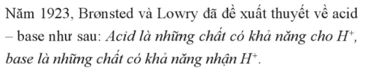 | 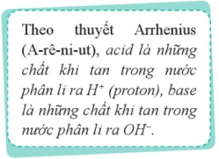
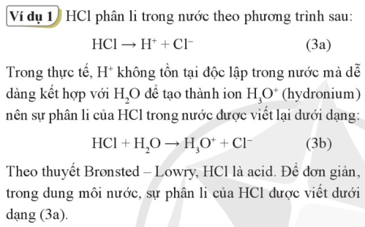 | 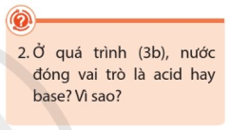  ..............................................................  ..............................................................  ..............................................................  ..............................................................
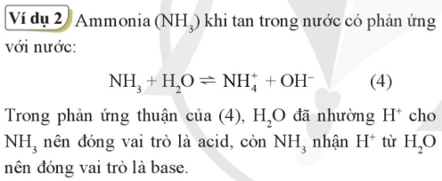 | 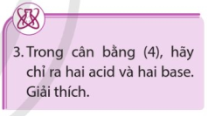  ..............................................................  ..............................................................  ..............................................................  ..............................................................
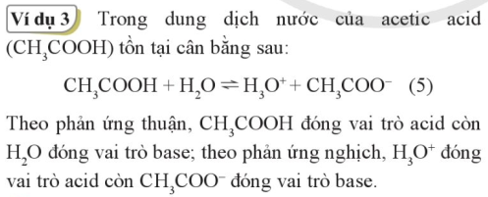
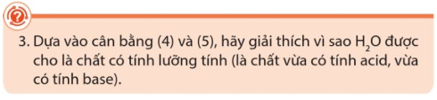
......................................................................................................................................................................
......................................................................................................................................................................
......................................................................................................................................................................
......................................................................................................................................................................
2) Acid mạnh/base mạnh và acid yêu/base yếu
- Acid mạnh và base mạnh ..............................................................................................................................
- Acid yếu và base yếu ......................................................................................................................................
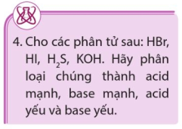 | ............................................................  ............................................................  ............................................................  ............................................................ |  | 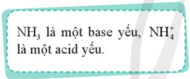
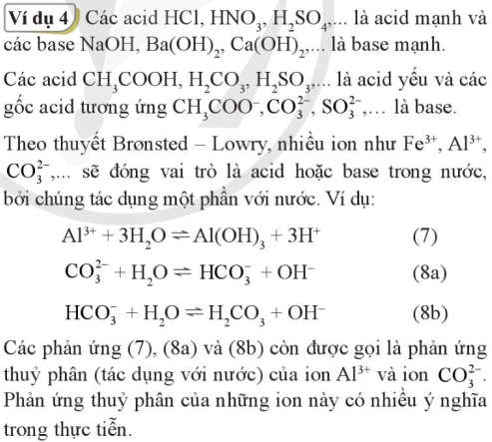 |  |           

