PHÒNG GIÁO DỤC VÀ ĐÀO TẠO……..  ĐỀ CHÍNH THỨC | ĐỀ KIỂM TRA __________  Năm học: 20__ - 20__  Tiếng Anh - Lớp 7  Thời gian làm bài: 60 phút
Trường: ________________________  Họ tên: _______________________  Lớp: _____________ | Điểm | Nhận xét của giáo viên

 | Tiếng Anh 7 i-Learn Smart World - Unit 2.1  Time allotted: 60 | Mã đề: a

PART 1 | Pronunciation (4 questions)
Choose the word whose underlined part is pronounced differently.
1. A. lunch B. hurt C. junk D. much
2. A. give B. get C. ginger D. good
Choose the word that has a different stressed syllable from the rest.
3. A. advice B. tired C. toothache D. fever
4. A. vitamin B. medicine C. favorite D. overweight

PART 2 | Vocabulary and Grammar (12 questions)
Choose the best option (A, B, C or D) to complete each of the following questions.
5. You should ______________ regular exercise, go swimming and lead an active life.
A. take B. have C. do D. play
6. Fruit and vegetables are good for you because they provide ______________ vitamins.
A. lots of B. much C. few D. a little
7. I can’t eat ______________ dairy foods like cheese and butter because they make me sick.
A. much B. a few C. some D. any
8. My grandma has ______________ good books about food and cooking.
A. any B. some C. a little D. much
9. Jackson always ______________ scrolling through Facebook and Instagram. That’s why he feels tired in the morning.
A. stays up late B. gets some sleep C. takes vitamins D. takes medicine
10. You should ______________ during winters, or you may catch a cold.
A. have a cough B. do exercises C. see a doctor D. keep warm
11. Student A: “I have a really bad ______________. It hurts so much that I can’t eat.”
Student B: “Why don’t you see your dentist?”
A. fever B. sore throat C. toothache D. headache
12. Student A: “Why are you drinking warm water?”
Student B: I have a ______________ and it feels better when my neck’s warm.”
A. sore throat B. headache C. earache D. sick
13. My dad hurt his ______________ when he was moving the sofa yesterday. It hurt so much that he couldn’t stand up.
A. head B. back C. stomach D. ear
14. Student A: “I’m not feeling well. I think I have a fever.”
Student B: “______________”
A. You shouldn’t eat junk food. B. You shouldn’t take vitamins.
C. You should go home and get some rest. D. You should get enough sleep every day.
Choose the best option (A, B, C or D) to complete each of the following questions.
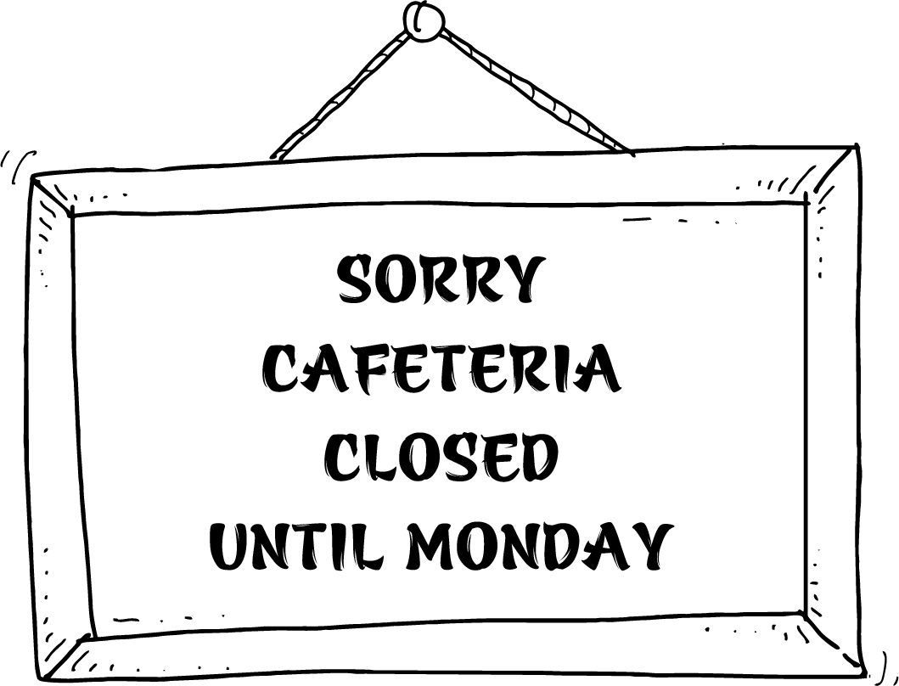
15. What does the sign mean?
A. You can’t eat or drink in the cafeteria on Mondays. B. The cafeteria opens every day except Monday.
C. The cafeteria opens every Monday. D. The cafeteria opens next Monday.
Choose the best option (A, B, C or D) to complete each of the following questions.
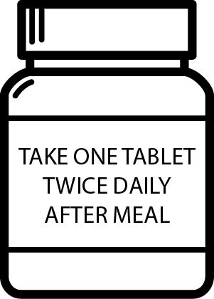
16. Read the prescription and choose the correct statement.
A. You should take the medicine after eating, twice a day. B. You should drink two tablets after every meal.
C. You shouldn’t take tablets after you finish your meal. D. You should take one tablet per day after you eat.

PART 3 | Word Formation (6 questions)
Write the correct form of the words in brackets.
17. It’s very ___________ to eat fried food every day. You can become overweight. (HEALTH)
18. If you want to be strong, you should have ___________ meals with good ingredients. (HEALTH)
19. Last night, Andy ate too much and had a terrible ___________. (STOMACH)
20. You should eat ___________ every day and you shouldn’t skip breakfast. (PROPER)
21. Mike couldn’t sleep last night. Today he was really tired, so he fell ___________ in math class. (SLEEP)
22. Louisa never does any exercise. She’s ___________and feels tired all the time. (FIT)

PART 4 | Reading (10 questions)
Read the following passage and complete the poster with suitable information. Write NO MORE THAN THREE WORDS AND/ OR A NUMBER. (5 questions)
HOW TO BECOME HEALTHIER
Firstly, you should eat balanced meals. You should eat lots of fruit and vegetables because they are full of important vitamins. You shouldn’t eat too much fatty food. Things like chips and burgers have a lot of fat. Also, be careful with sugar. If you eat a lot of sweet food, the sugar gives you energy for a short time, but afterwards you will feel more tired. Secondly, exercise should be part of your daily routine. Don’t hurt yourself, start with gentle exercise. Exercise for at least 15 minutes every day. Or you can try a team sport or join a gym. Exercise can also be cycling instead of taking the bus, or using the stairs instead of the lift. Moreover, staying healthy requires enough sleep. It’s sometimes OK to go to bed late; but if you stay up late too often, it will be bad for your health. Try to sleep eight hours every night. Lastly, every year, you should go to the doctor for regular check-ups. When you get fit and healthy, you will feel great.
1..2..3…LET’S BE HEALTHY!
1/ Eat lots of (23)___________ .
Don’t eat too much (24)___________ or sugary food.
2/ Exercise regularly.
Cycle or use (25)___________
Avoid taking the bus or using the lift.
3/ Sleep (26)___________ a day.
4/ Have medical check-ups every (27)___________ .
Read the online post and choose the word/ phrase that best suits each blank. (5 questions)
WHAT SHOULD I DO?
My name is Libby and I’m 12 years old. I never manage to go to bed early during the week. I know I (28)___________ use my phone or tablet late at night, but I always do. I find it (29)___________ to fall asleep, but I don’t know why. I often miss breakfast, so I’m hungry by the morning break. In my school, you don’t need to go far for unhealthy food. There is a vending machine with (30)___________ sugary snacks and fizzy drinks like Coke or soda. My mum says I should eat some fruit or yogurt for a snack, but I keep forgetting to bring it to school with me. I also feel (31)___________ and have no energy during the day, which is really annoying. I really need to get fit and healthy for the school bicycle race. What do you think I should do to prepare for the race? Please give me (32)___________ advice on how to become a better me.
(28) A. should B. shouldn’t C. don’t D. must
(29) A. difficult B. easy C. harder D. healthy
(30) A. much B. a little C. few D. lots of
(31) A. healthy B. strong C. weak D. a fever
(32) A. an B. some C. many D. a few

PART 5 | Writing (14 questions)
Rewrite the following sentences without changing their meaning. Use the given word(s) if any.
33. My little brother doesn’t eat many vegetables.
→ My little brother eats only___________
34. There is no milk in the refrigerator.
→ We don’t have___________
35. The bottle is nearly empty of water.
→ There is not___________
36. It’s important for you to do exercise if you want to get fit.
→ You should___________
37. It’s not a good idea to sell drinks that contain lots of sugar in school cafeterias.
→ School cafeterias___________
Use the given words or phrases to make complete sentences.
38. Eating / lot/ candies / cookies/ is not good/ you/.
→ Eating___________
39. How/ slices / pizza/ you/ want/?
→ ___________
40. Soda/ not/ give/ you/ energy/ and/ be/ bad/ teeth.
→ Soda___________

PART 6 | Listening (10 questions)
You will listen to an interview with James Olive. Fill in each blank with NO MORE THAN TWO WORDS. (5 questions)
According to James Olive:
- Many school cafeterias sell fast food like pizza, (41)___________ and soda. These foods contain lots of (42)___________ and salt, so students will get (43)___________ and have difficulty listening in class.
- Cafeterias should sell “brain food” like fruits and (44)___________. These foods help students (51)___________ and feel healthier.
You will hear Tom talking to his friend about his visit to the doctor. Listen and decide whether the following statements are True (T) or False (F). (5 questions)

Answers | True | False
52. Tom had a headache yesterday morning. | ◯ | ◯
53. The doctor advised Tom to stay in bed. | ◯ | ◯
54. The doctor asked Tom to take some medicine. | ◯ | ◯
55. The doctor told Tom not to stay up late every night. | ◯ | ◯
56. Tom is going to play tennis tonight. | ◯ | ◯
---THE END---

