MOCK TEST 5
Mark the letter A, B, C, or D on your answer sheet to indicate the word whose underlined part differs from the other three in pronunciation in each of the following questions.
1. A. ancient B. basic C. campus D. agent
2. A. takes B. breathes C. stays D. blows
Mark the letter A, B, C, or D on your answer sheet to indicate the word that differs from the other three in the position of primary stress in each of the following questions.
3. A. metro B. pursue C. visit D. carry
4. A. communal B. density C. performance D. majestic
Mark the letter A, B, C, or D on your answer sheet to indicate the correct answer to each of the following questions.
5. ______ the newest A24 movie? - Not yet. I haven’t had the time.
A. Have you seen B. Are you seeing C. Were you seeing D. Will you see
6. He told me he ______ watch a movie with me after work the next day.
A. did B. will C. would D. had
7. My deskmate, ______ pencilcase is always full, lent me an extra pen when mine ran out of ink.
A. whom B. whose C. who D. which
8. The researcher’s ______ to the problem was innovative and effective.
A. approach B. approached C. approaching D. approaches
9. "Can you help me with this project this weekend?” – “______”
A. "Sure, I’d be happy to help."
B. “I need to buy more ink for the printer.”
C. “OK! The movie starts at 7 p.m.”
D. "Why don't you tell your professor?”
10. The boss ______ our deadline by a week which means we have more time to reach the quota.
A. pushed back B. pushed away C. pushed over D. pushed forward
11. There were ______ people at the concert than we expected.
A. less B. fewer C. much D. little
12. Had we known about the traffic jam, we ______ an earlier departure.
A. plan B. had planned C. would plan D. would have planned
Read the following announcement and mark the letter A, B, C, or D on your answer sheet to indicate the correct option that best fits each of the numbered blanks from 13 to 16.

WHAT TO DO IN A MEDICAL EMERGENCY
Be prepared to take the following actions:
● Determine the location and quickest route to the nearest emergency department before an emergency happens.
● Keep emergency phone numbers (13) _______ in your home where you can easily access them. Also enter the numbers into your cell phone. These numbers include: fire department, police department, poison control center, ambulance center, your health care provider's phone numbers, contact numbers of neighbors or nearby friends or relatives, and work phone numbers.
● Know at which hospital(s) your provider practices and, if (14) _______, go there in an emergency.
● Wear a medical identification tag if you have (15) _______ chronic condition or look (16) _______ one on a person who has any of the symptoms mentioned.
● Get a personal emergency response system if you're an older adult, especially if you live alone.
(Adapted from https://medlineplus.sov/ency/article/001927.htm)

13. A. posting B. posted C. poster D. post
14. A. musical B. whimsical C. practical D. ethical
15. A. ∅ B. a C. an D. the
16. A. into B. for C. at D. around
Mark the letter A, B, C, or D on your answer sheet to indicate the correct answer to the questions from 17 to 18.
17. Put the sentences (a-c) in the correct order, then fill in the blank to make a logical text.
S’more is easy to make and brings a sweet, nostalgic touch to any outdoor experience. To make a s'more, take a long stick, put a marshmallow on the end, and roast it over a fire. _______
a. Girl Scouts later popularized it and called it “some more,” which turned into "s’more.”
b. The s'more first appeared in a 1920s cookbook as a “graham cracker sandwich.”
C. When it’s toasted to your liking, place it between two pieces of graham cracker with some chocolate.
A. b-c-a B. b-a-c C. a-c-b D. c-b-a
18. Choose the sentence that can end the text (in Question 17) most appropriately.
A. Some people even use a microwave to quickly make s’mores.
B. Also, there are even recipes for s’more-flavored ice cream and other desserts.
C. This tasty treat remains a favorite at campfires and outdoor gatherings.
D. You can add different types of chocolate or using flavored marshmallows.
Mark the letter A, B, C, or D on your answer sheet to indicate the correct answer that best fits each of the numbered blanks.
Many people seem to think that the Artifical Intelligence only exists on the digital cloud. (19) ______, the Al and other digital medias take up huge amounts of space (20) ______ as data centers. It is estimated that approximately 7,000 data center have been built or are in (21) ______ all around the world. These centers require much more energy than the average factory. Researchers have found that one ChatGPT request is equivalent to (22) ______ a light bulb for 15 minutes, or talking on the phone for an hour. This much energy requires data servers to run hotter (23) ______ creates negative effects to the surrounding environment. Even Microsoft has expressed worries that their quest for Al may (24) ______ their plan to go carbon negative by 2030.
19. A. In reality B. In hindsight C. In case D. In retrospect
20. A. known B. called C. seen D. accepted
21. A. reduction B. enforcement C. development D. production
22. A. powered B. powering C. powers D. power
23. A. when B. what C. who D. which
24. A. reduce B. restrict C. hinder D. loosen
Mark the letter A, B, C or D on your answer sheet to indicate the sentence that is closest in meaning to the original sentence in each of the following questions.
25. This project accounts for 70% of your final grade. You must pick the topic carefully.
A. This project accounts for 70% of your final grade; however, you must pick the topic carefully.
B. Although this project accounts for 70% of your final grade, you must pick the topic carefully.
C. This project accounts for 70% of your final grade that you must pick the topic carefully.
D. Since this project accounts for 70% of your final grade, you must pick the topic carefully.
26. That picture reminds me of our first family holiday abroad.
A. I think of our first family holiday abroad when I see that picture.
B. That is a picture of our first family holiday abroad.
C. I think of that picture on our first family holiday abroad.
D. That picture was taken on our first family holiday abroad.
Mark the letter A, B, C or D on your answer sheet to indicate the sentence that is best written from the words/phrases given.
27. He/ advise/ his friend/ apologize/ her mistake.
A. He advised his friend apologizing for her mistake.
B. He advised his friend to apologize for her mistake.
C. He advised his friend that she will apologize for her mistake.
D. He advised his friend to have apologized for her mistake.
28. We/ hope/ ourcountry/ switch to/ sustainable fossil fuel alternatives/ future.
A. We hope our country would have switched to sustainable fossil fuel alternatives in the future.
B. We hope our country would switched to sustainable fossil fuel alternatives in the future.
C. We hope our country had switched to sustainable fossil fuel alternatives in the future.
D. We hope our country will switch to sustainable fossil fuel alternatives in the future.
Read the following sign or notice and mark the letter A, B, C, or D on your answer sheet to indicate the correct answer to each of the following questions.
29. What does the sign say?
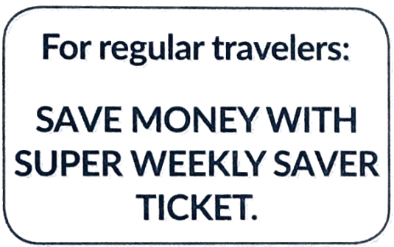 | A. You need a special type of ticket if you travel regularly.  B. The Super Weekly Saver ticket can help all travellers to save money.  C. Cheaper tickets are available for people who travel often.  D. You must not buy the ticket if you are a one-time traveller.
30. Students who do not sign up before Friday lunchtime …
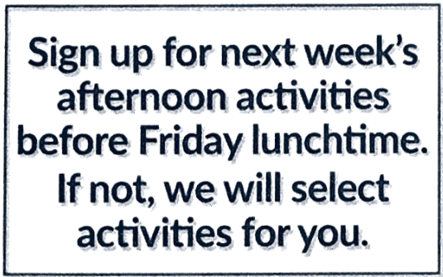 | A. won’t be able to choose their afternoon activities next week.  B. will not be able to do afternoon activities next week.  C. will have to work in the afternoons next week.  D. will be selected for certain activities next week.

Read the following passage and mark the letter A, B, C, or D on your answer sheet to indicate the correct answer to each of the following questions from 31 to 36.

COFFEE
We all know that a cup of coffee helps to wake you up in the morning, but several studies show that drinking coffee helps to prevent some illnesses like diabetes and Parkinson’s disease. Experts say that you can safely drink three cups of espresso during the day, but if you drink too much coffee it can make you feel anxious or keep you awake at night

SUNLIGHT
Spending a long time in the sun is dangerous and can give you skin cancer. But on the other hand, not spending enough time in the sunlight is also bad for you, as it helps US to produce vitamin D. This vitamin is essential for strong bones and a healthy immune system, and it also makes people feel happier. Nowadys many people don’t get enough sunlight because they wear sunscreen all the time, especially on their faces. However, don’t spend too long in the Sun - 15 minutes a day without sunscreen is a healthy amount, and not at midday.

COMPUTER GAMES
You probably worry about how much time you or your children waste playing computer games. But in fact some studies show that these games can help US learn important skills. It seems that computer games stimulate the brain and that people who often play them are probably better at solving problems and making quick decisions. But don't spend too many hours in front of the computer - not more than about two hours a day.
(Adapted from English File, Oxford University Press)
31. What is the best title for the passage?
A. Daily Dangers B. Everything Bad is Good for You
C. Too Little Too Much D. Best in Small Doses
32. According to the passage, what are TWO positive effects of sunlight?
A. They can strengthen your bones and immune system.
B. They prevent diabetes.
C. They can improve problem-solving and critical thinking.
D. They are more prone to skin cancer.
33. According to the passage, which of the following is true about spending time in the sun?
A. Wearing sunscreen is unnecessary as long as you are in the sun for less than 15 minutes a day.
B. Spending too much time in the sun is beneficial for vitamin D production.
C. Spending 15 minutes a day in the sun without sunscreen is considered healthy.
D. Sunscreen is not needed if you are only in the sun during midday.
34. The word "essential" in paragraph 2 is OPPOSITE in meaning to _______.
A. crucial B. fundamental C. trivial D. necessary
35. The word “stimulate” in paragraph 3 is CLOSEST in meaning to _______.
A. activate B. encourage C. delay D. trigger
36. Which of the following is NOT mentioned in the passage?
A. Digital games teaches players quick thinking.
B. You shouldn’t drink more than three cups of expresso per day.
C. Wearing sunscreen has prevented people from getting enough sunlight.
D. Coffee can increase your heart rate.
Four phrases/sentences have been removed from the text below. For each question, mark the letter A, B, C, or D to indicate the correct option that best fits each of the numbered blanks from 37 to 40.
The Hague has made history by becoming the first city globally to pass a law banning advertisements for fossil fuel products and high-carbon services. Effective from the start of next year, this groundbreaking legislation will eliminate all public and private ads for petrol, diesel, aviation, and cruise ships from the city's streets, including billboards and bus shelters. (37) _______. While some cities like Edinburgh have limited high-carbon advertising through voluntary agreements or council motions, (38) _______. It excludes political advertising and general brand promotions but targets ads for high-carbon products and services. The legislation, (39) _______, is seen as a bold step in addressing climate change. Advocates believe it will redirect government resources from combating the effects of fossil fuel advertising to supporting sustainable alternatives like public transport. (40) _______.
(Adapted from "The Guardian")
A. The Hague's action is expected to inspire similar initiatives worldwide, with proposals also being considered in Toronto, Graz, and Amsterdam.
B. the Hague's ban is legally binding and marks the first local legislation of its kind
C. which took two years to pass
D. This move follows a call from UN Secretary-General Antonio Guterres earlier this year for governments to implement similar bans as those for tobacco.
37. ___________ 38. ___________ 39. ___________ 40. ___________

